René C. Rinfret  
UBC #34929091  
November 19, 2013

MECH463 – ADAMS ASSIGNMENT 2

# Given Parameters

$m=60kg$

$$m_{e}=0.3kg$$

$$k=\frac{600,000N}{m}$$

# Calculations

$$f_{n}=natural frequency=\frac{1}{2π}\sqrt{\frac{k_{eq}}{m_{eq}}}=\frac{1}{2π}\sqrt{\frac{\frac{600,000N}{m}}{60.3kg}}$$

$$=15.876Hz$$

$$ω_{n}=f_{n}*2π=\frac{99.75rad}{s}$$

$$c=damping for resonance case=2πζ\left(2mω_{n}\right)=2π\left(1\right)\left(2*60.3kg*\frac{99.75rad}{s}\right)=\frac{75.59Ns}{mm}$$

In my ADAMS models, I used natural frequency of 15Hz as instructed. This lead to beating, which was also expected.

# Graph Output

Three different cases were studied in regards to critical speed, or critical frequency. For each case, different zeta values (i.e. damping values) were used to investigate which one would best reduce vibration amplitudes.

## Case 1. Below critical speed

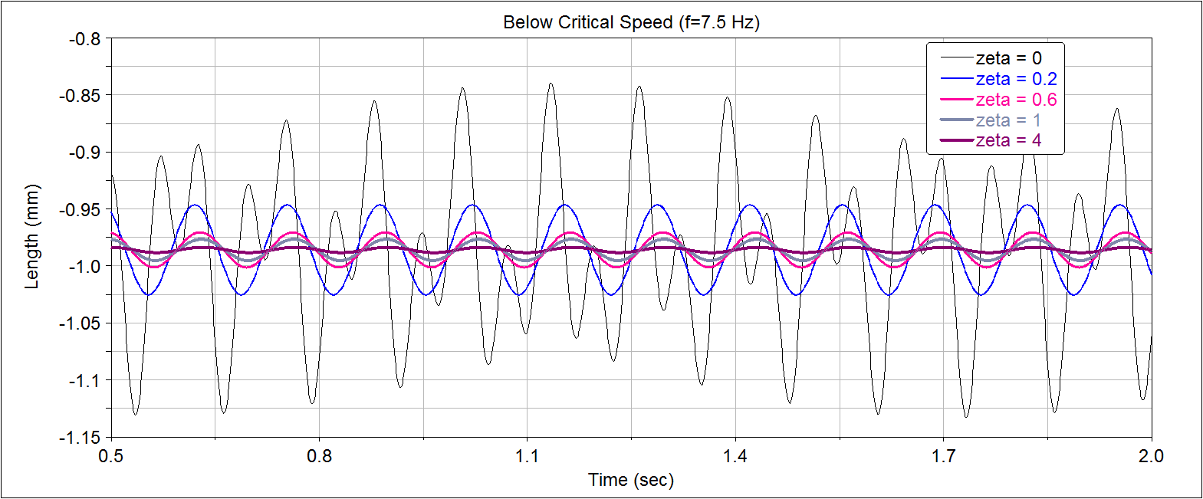

At a fixed speed of 7.5Hz, or half the critical speed, different zeta values were plotted to observe their respective effects on displacements.

## Case 2. At critical speed

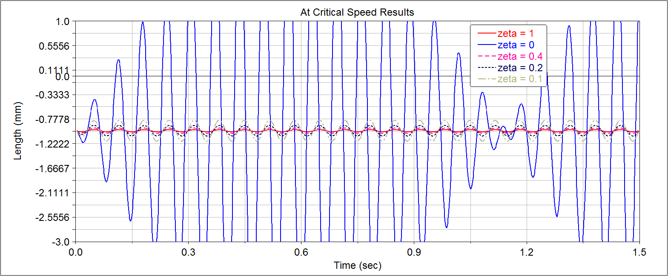

When the system is operating at critical speed (approximately 15Hz), it was found that displacements were minimized at values of zeta greater than 0.1. In other words, adding any form of damping reduced the displacement greatly. It can be noticed how much of an effect damping has as opposed to no damping at all (zeta = 0) on the displacement of the SDOF system. From this outcome, I would select a zeta between 0.6 and 1. The graph is not properly formatted due to an axis issue I had, but it still shows the trends properly.

## Case 3. Above critical speed

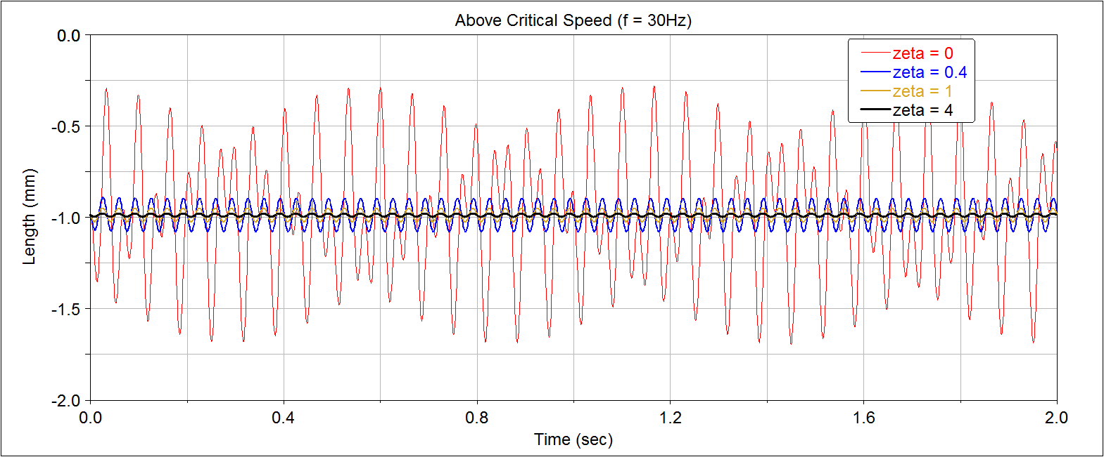For Case 3, the critical speed was double and the displacement plot as a function of zetas are shown above.

# Summary

It is very evident in all three cases that as the damping coefficient increases, then the displacements of your system’s vibrations decrease. However, there is a certain limit to how much you can damp in terms of practicality. So, I would strongly suggest using zeta=1, or critical damping.

This gives a final design damping of 75.59Ns/mm for my system.