Ratthamnoon Prakitpong

63205165

Lab 2 Prelab

1.

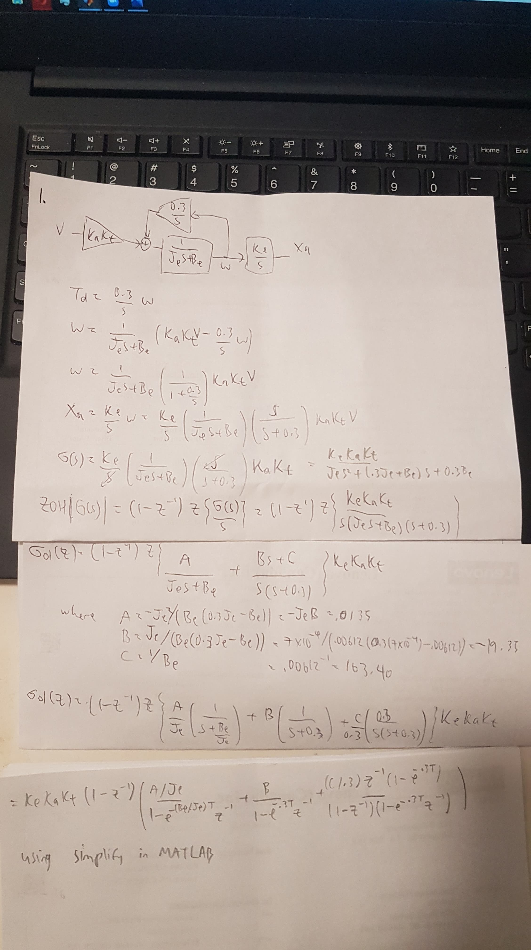

Gol(z) = (- 36815089485105837637632\*z^2 + 295893773333445411469845848991744\*z + 295715445383194920270586923145785)/(125660\*(40564819207303340847894502572032\*z^2 - 81056336091977936091986433933312\*z + 40491521136657423974514928887805))

Divide numerator and denominator by 125660\*40564819207303340847894502572032

Gol(z) = ((-7.2223621e-15)z^2+(.5804826e-4)z+(.5801327e-4)) /

(z^2+(-1.99819295823)z+(0.99819306305))

Using c2d, we get this:

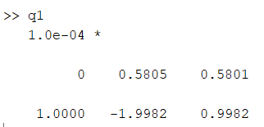

This matches the coefficients we get from doing the s to z conversion ourselves.