MECH467 Prelab #3

Ratthamnoon Prakitpong

#63205165

A1.

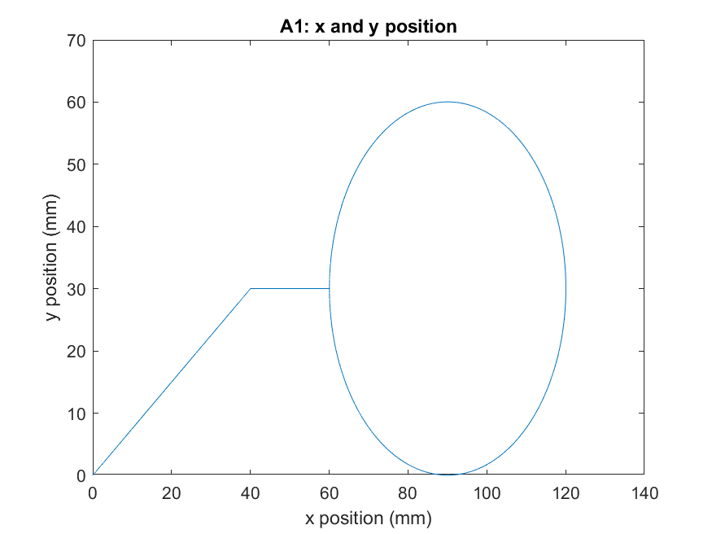

Fig A1: X and Y position of sample trajectory

A2.

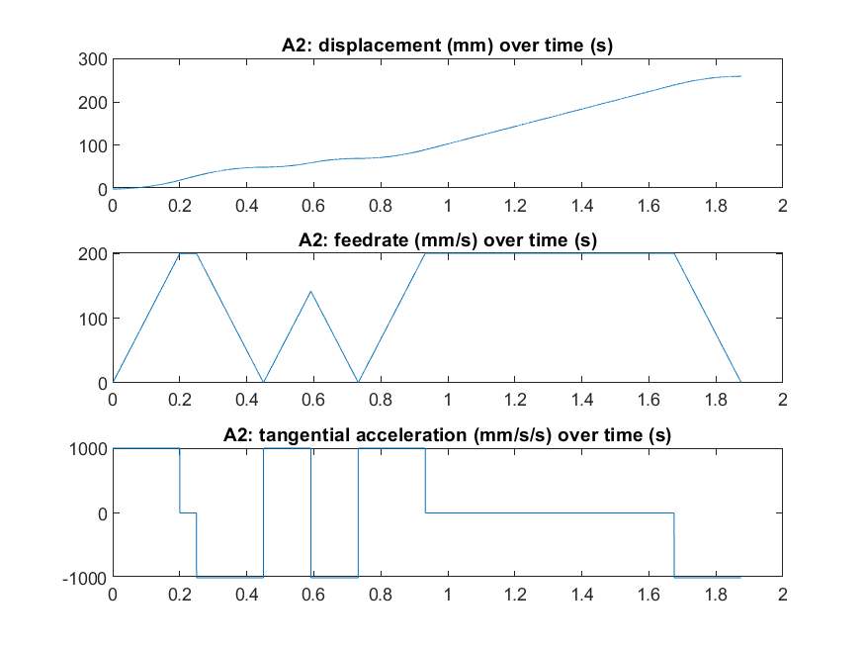Fig A2: Displacement, feedrate, and tangential acceleration of sample trajectory

A3.

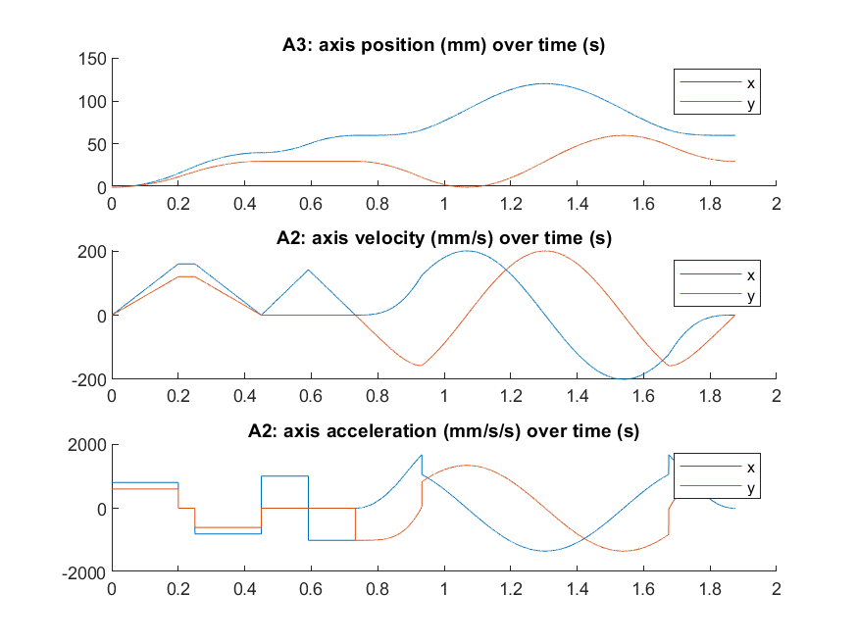Fig A3: Axis position, velocity, and acceleration of sample trajectory

B1.

|  |  |
| --- | --- |
|  |  |
|  |  |

Fig B1: Lead-Lag-Integrator of X and Y axis motors, for LBW and HBW

The parameters of LLI controllers are written in the plot. They can be used in the equations like shown here:

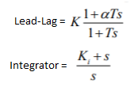

B2.

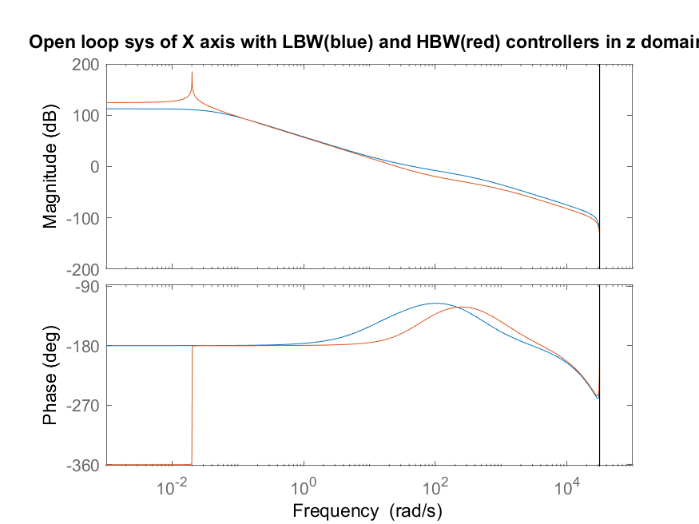

Fig B2.1: Open loop system of X axis with LBW and HBW controllers, in z domain

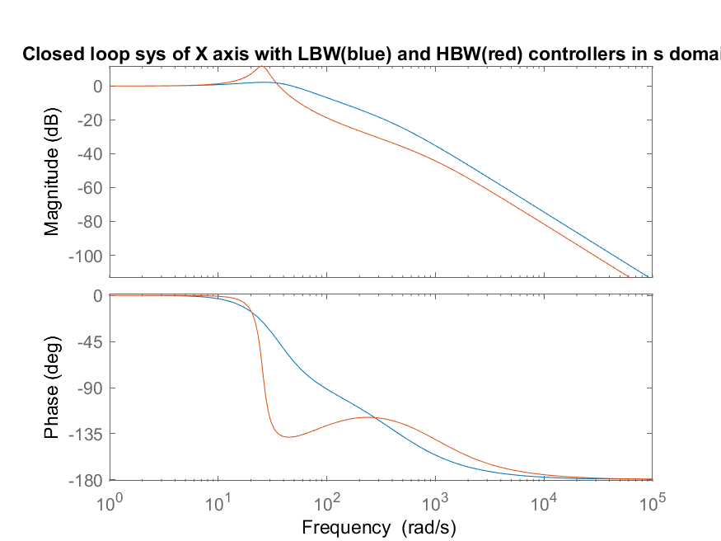Fig B2.2: Close loop system of X axis with LBW and HBE controllers, in s domain

B3.

Table B3: Bandwidth, zeros, poles, rise time, and overshoot for each combination of bandwidth, axis, and domain in a closed loop system

C1.

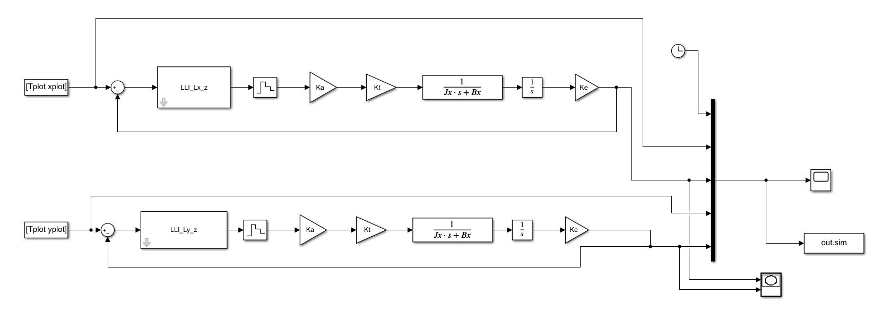Fig C1.1: Simulink model

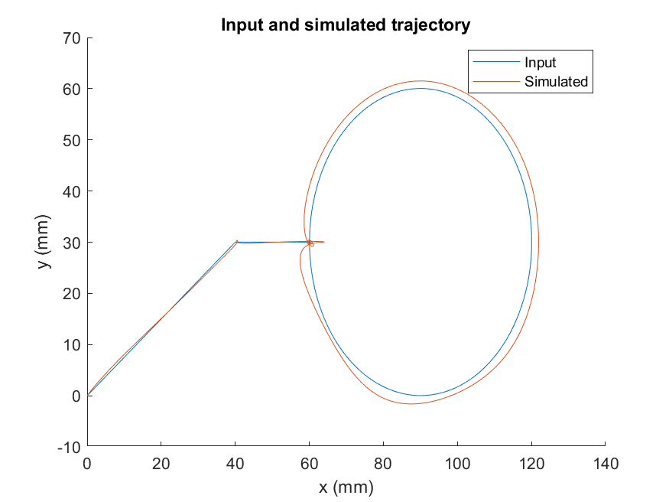

Fig C1.2: Input and simulated toolpath

Controllers has some issues at the point where the circle starts due to overshoot of P2-to-P3 path, and consequently causes misalignment in the rest of the tool path. To reduce error, it is recommended that gain is increased. Likely that the rule-of-thumb used to get Ki (Ki = wc / 10) resulted in Ki that is not large enough to eliminate steady state error.

C2.

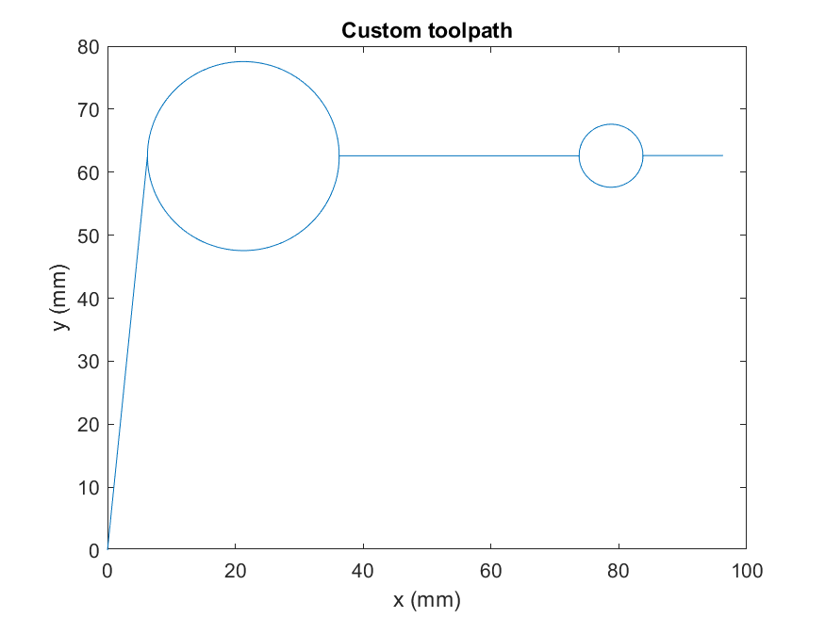Fig C2: Custom toolpath

The toolpath takes multiple cuts around the circles to ensure nicer finish.

Appendix:

1. Part A Matlab code
2. Part B Matlab code
3. Part C Matlab code
4. myTraj.m (attached separately to this pdf)