MATLAB section:

I wrote the variables in Matlab then load it into Simulink.

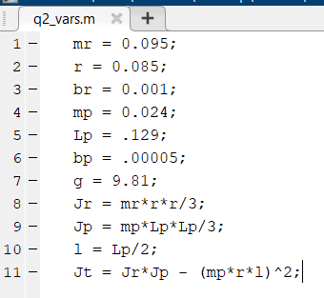

Fig 1: Matlab code

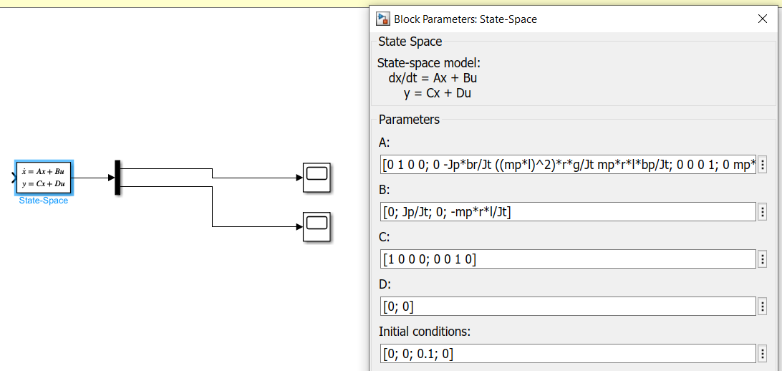

Fig 2: Simulink model

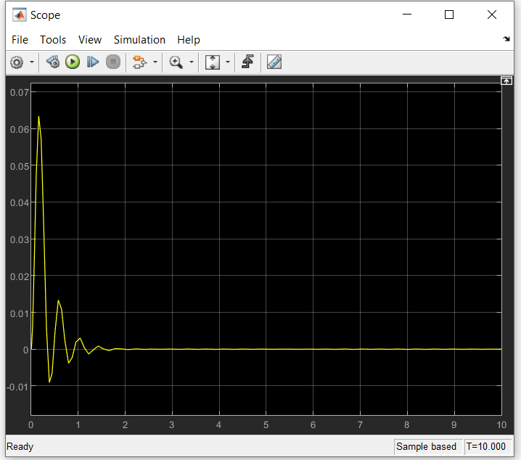

Fig 3: Angle over time

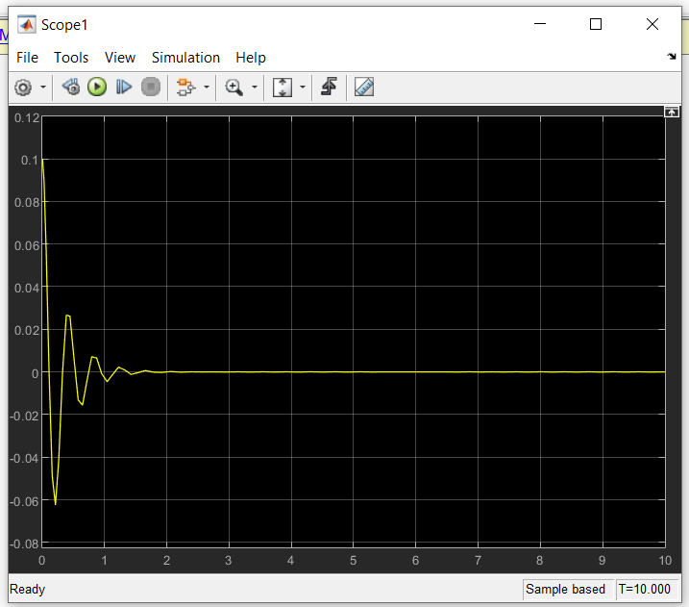

Fig 4: Speed over time