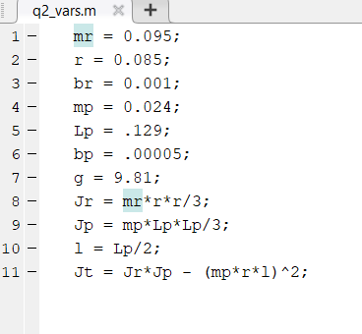2b.

Fig 1: Matlab code

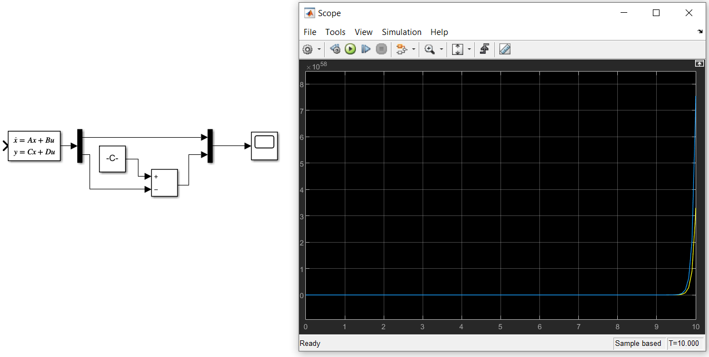Fig 2: Simulink model, and plot (theta over time (yellow) and alpha over time (blue))

2c.

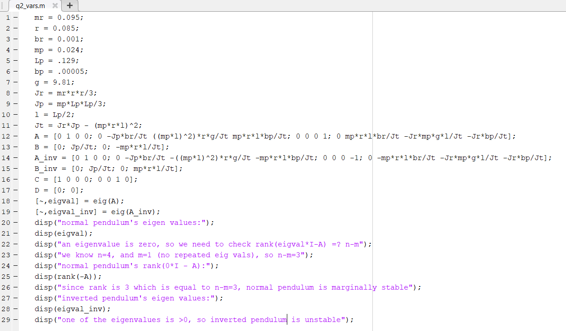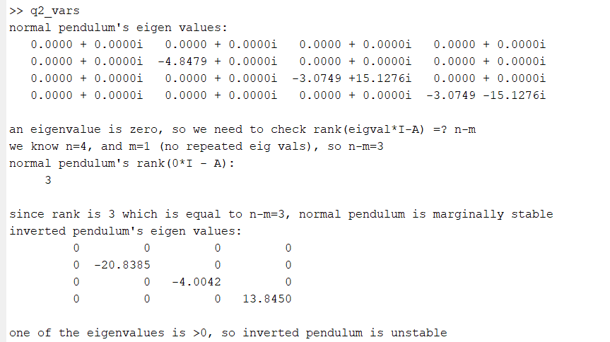

Fig 3: Matlab code and computed values