Ratthamnoon Prakitpong

#63205165

SF:

polevec_K = [-20 -40 -1.5-.1500j -1.500+.1500j];

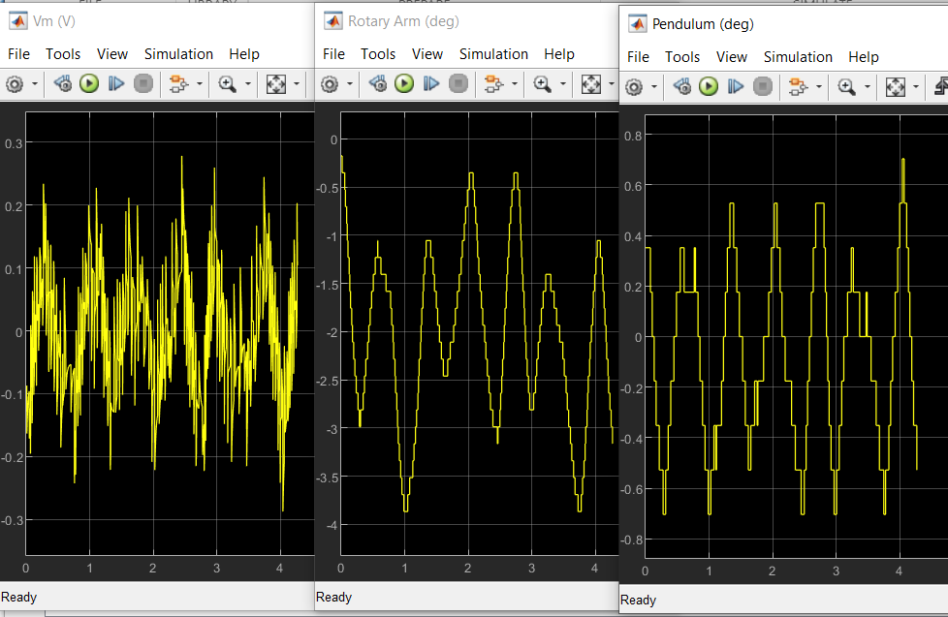

SF with observer:

polevec_K = [-20 -40 -1.5-.1500j -1.500+.1500j];

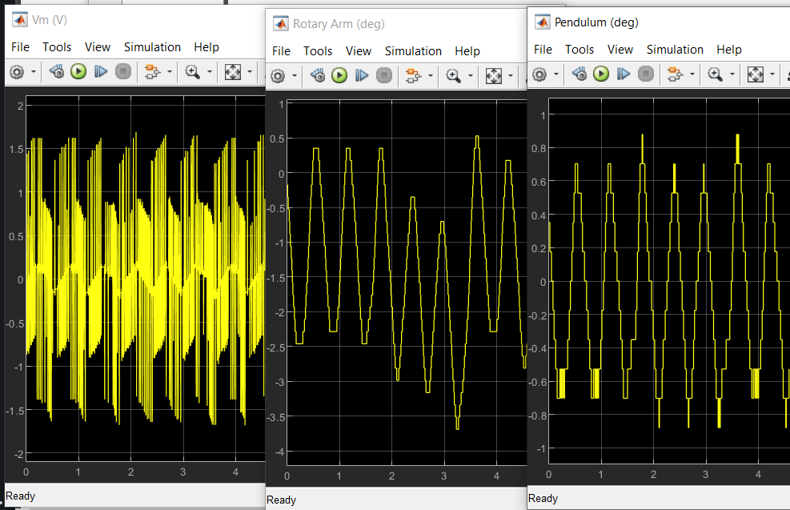polevec_L = [-500 -501 -502 -503];

Servo:

polevec_Kaug = [-15 -10 -5 -1.5-.15j -1.5+.15j];

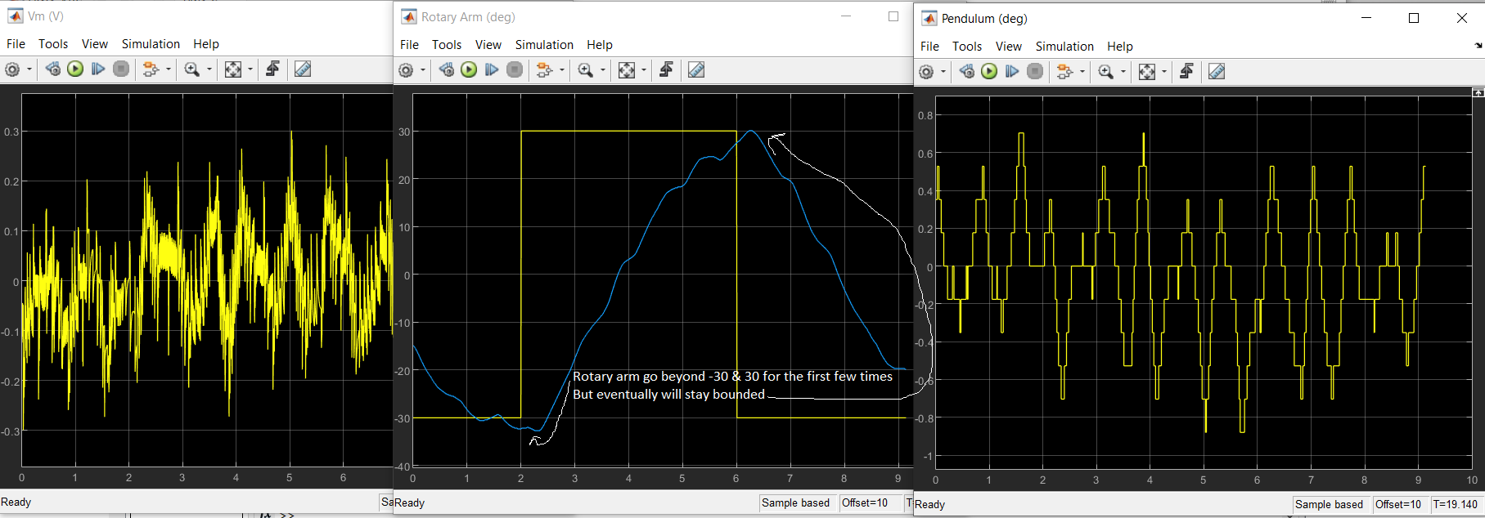

Servo with observer:

polevec_Kaug = [-15 -10 -5 -1.5-.15j -1.5+.15j];

polevec_L = [-500 -501 -502 -503];

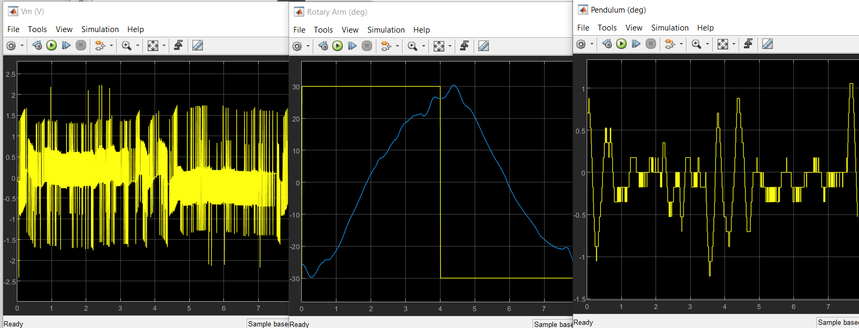

Similar with previous answer, where rotary arm starts out going beyond 30 & -30 deg limit, but eventually stays bounded.