Ratthamnoon Prakitpong

#63205165

HW5

Q1. LQR

Q = [1 1 1 1; 1 1 1 1; 1 1 1 1; 1 1 1 1];

R = [1];

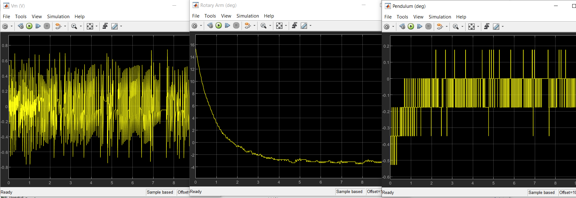

For this question, I comment out line 51 and 52 to make sure K doesn’t get overwritten.

%Kaug = lqr(sysdaug,Qaug,Raug);

%K = Kaug(1:end-1); Ka = Kaug(end);

Q2. LQR with servo

Qaug = 0.00000025\*[1 1 1 1 1; 1 1 1 1 1; 1 1 1 1 1; 1 1 1 1 1; 1 1 1 1 1];

Raug = [1];

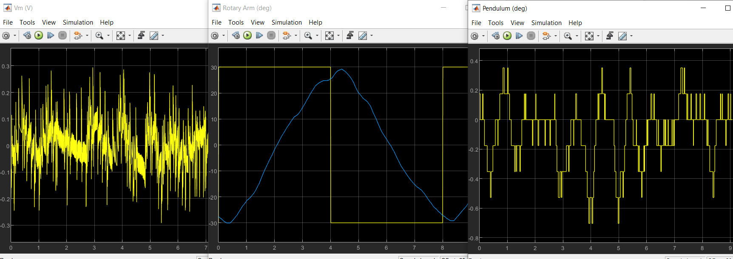

Rotary arm angle start out going over 30 and -30 deg, but eventually (after ~10 s) will stay between 30 and -30 deg.

Q3. LQG

Qn = [1000];

Rn = [1];

Q = 0.00001\*[1 1 1 1; 1 1 1 1; 1 1 1 1; 1 1 1 1];

R = [1];

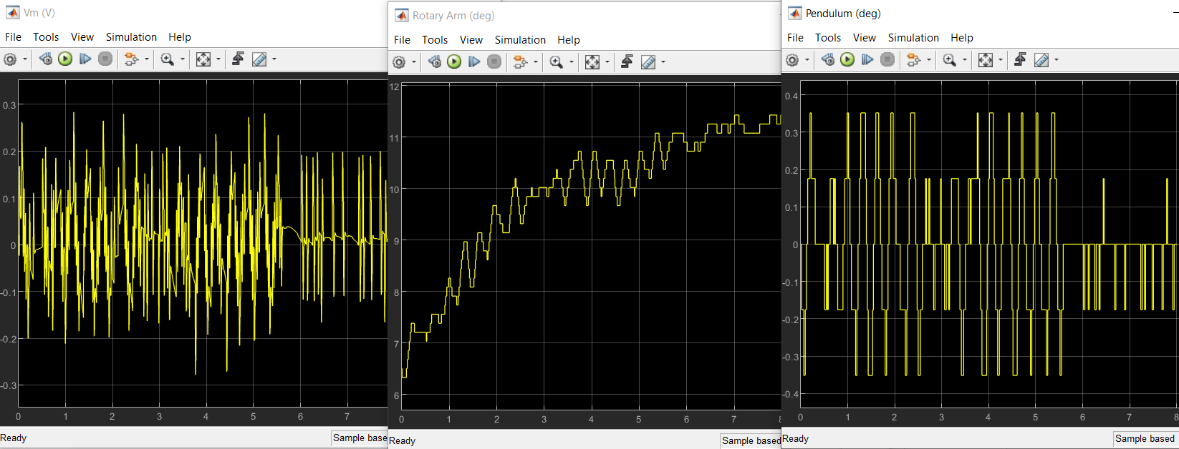

For this question, I comment out line 51 and 52 to make sure K doesn’t get overwritten.

%Kaug = lqr(sysdaug,Qaug,Raug);

%K = Kaug(1:end-1); Ka = Kaug(end);

Q4. LQG with servo

Qn = [1000];

Rn = [1];

Qaug = 0.00000035\*[1 1 1 1 1; 1 1 1 1 1; 1 1 1 1 1; 1 1 1 1 1; 1 1 1 1 1];

Raug = [1];

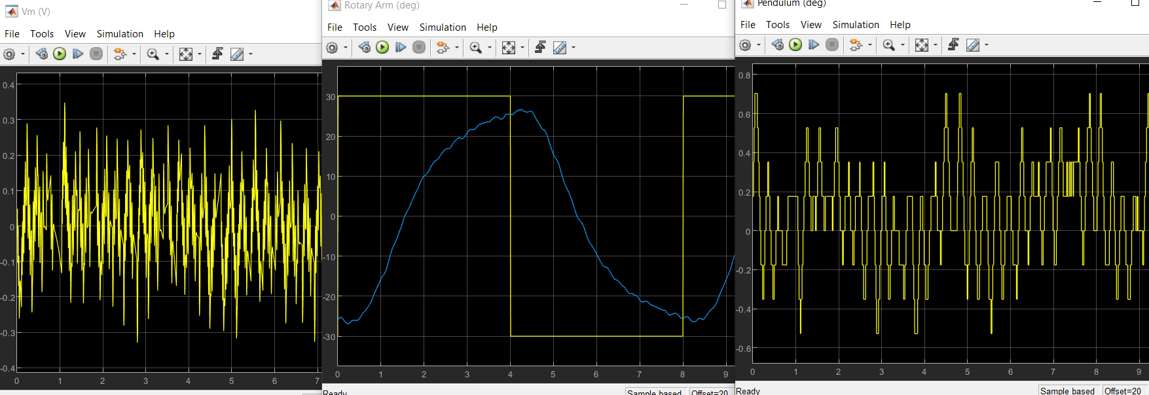

Similar issue to Q2, where rotary arm angle start out going over 30 and -30 deg, but eventually it will stay between 30 and -30 deg.