MECH 467 - Project 1: Modeling and Identification of Motion Control Mechanism

Ratthamnoon Prakitpong
63205165
rprakitpong@gmail.com

Abstract:
The purpose of this lab is to model the behavior of a ball screw feed drive, by finding associated constants needed to model the behavior, then verifying the model with real data. In part A, we found friction constant(s) by varying the table’s linear velocities and comparing its angular velocities to input voltages. In part B, we found inertia constant by guessing inertia constant in order to balance a torque equation, given measurements in the equation. In part C, we verify our model by comparing them to real data in a bode plot.

Introduction:
For some precision application, a conversion from rotation movement to linear movement is needed. Consequently, ball screw feed drives – using a screw, balls, and other specialized parts – are designed to do said conversion, as well as provide other useful features such as low friction, high thrust load, and simple design and parts availability. Because of multiple positive features, this is a drive system popular in applications such as steering (aircraft, car) or machining (CNC, 3D printer). Without a method to accurately model such a widely-used system, all these designs using ball screw drive would be much more laborious as all system behaviors would need to be learned using experiment.
Part A:
1)
Measured data are calculated and plotted as following:

Angular velocity = (2pi rad/rot)*Linear velocity/(20 mm/rot)
Torque = (106/120 A/V)*Vin*(.72Nm/A)

Table A.1: Calculated Values
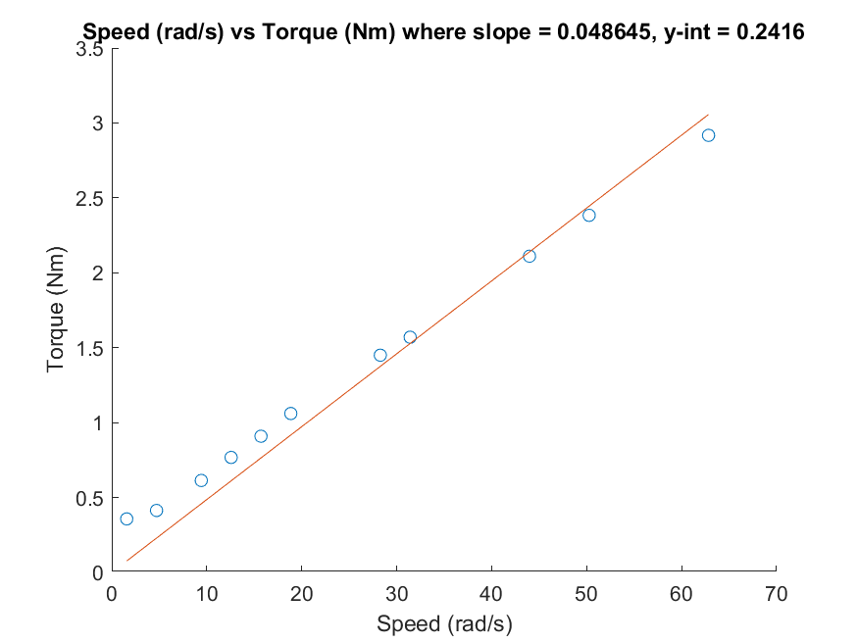
Figure A.1: Speed vs Torque of Positive Velocity Movements
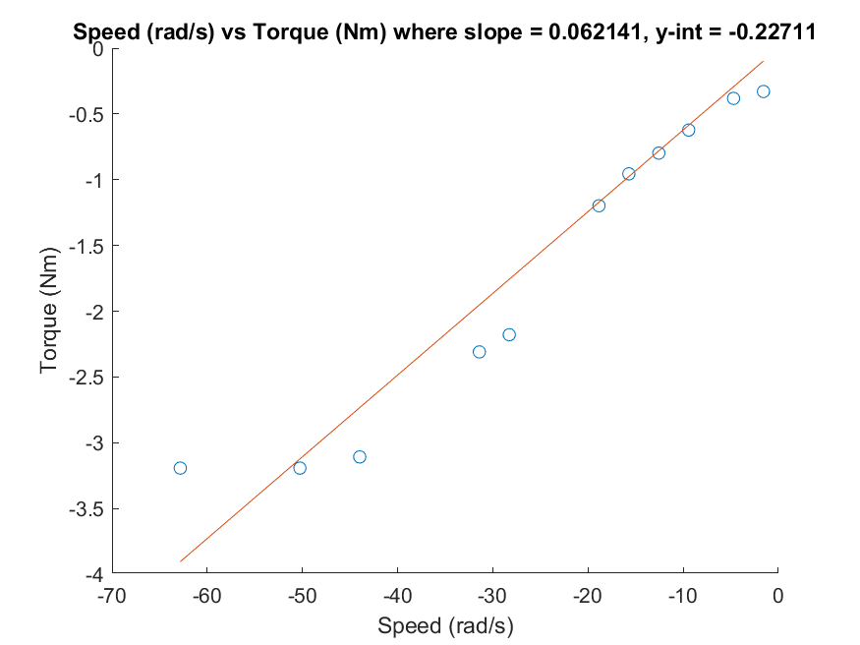
Fig A.2: Speed vs Torque of Negative Velocity Movements
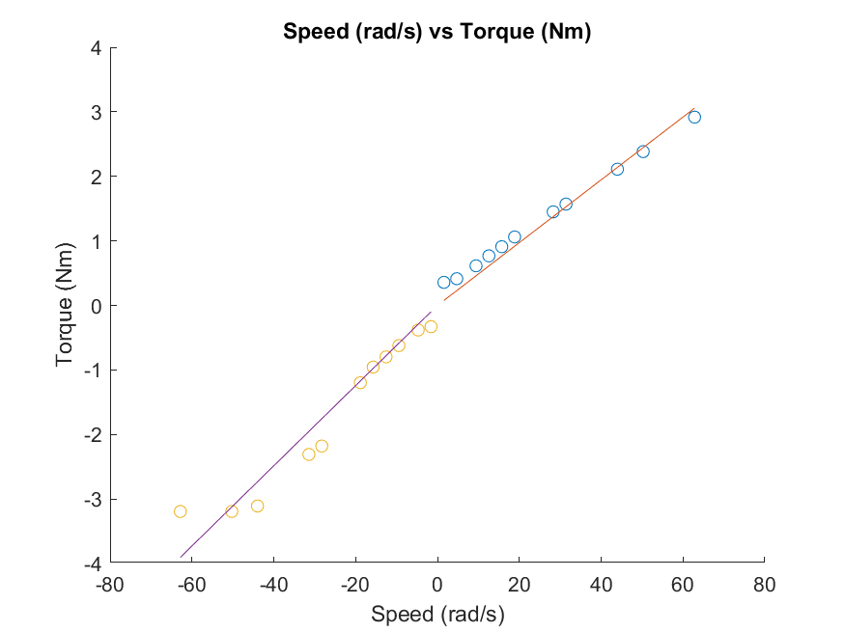
Figure A.3: Speed vs Torque

2)
Be = (0.048645 + 0.062141) / 2 = 0.055393 Nm/(rad/s)

3)
µk+ = 0.2416
µk- = 0.2271
µk = 0.23435
From the lab video, the screw’s shape results in different amount of friction in different movement directions.
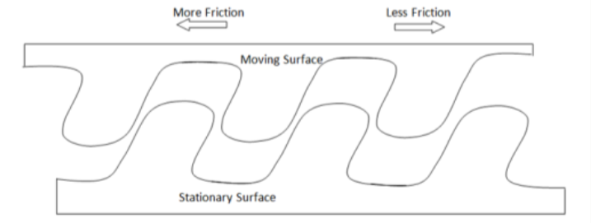

Figure A.4: Screw friction

4)
a (green). Friction is a straight line since it’s a function of sign(w).
b (orange). Friction is higher at very near w=~0 due to initial static friction.
c (red). Due to viscous friction increasing per speed, there’s a slope in friction curve.
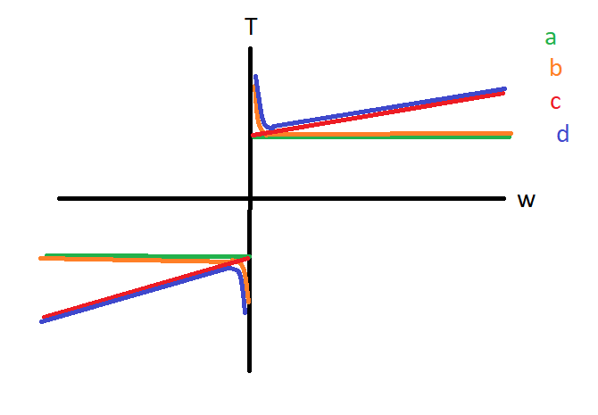
d (blue). Combining c and d curves, you get a more accurate modeling of friction based on Stribeck curve.

Figure A.5: Friction curves

Part B:
Given the data and the equation in the lab manual, I’ve guessed and checked the value of Je to be 7 Nm/(rad/(ss)).
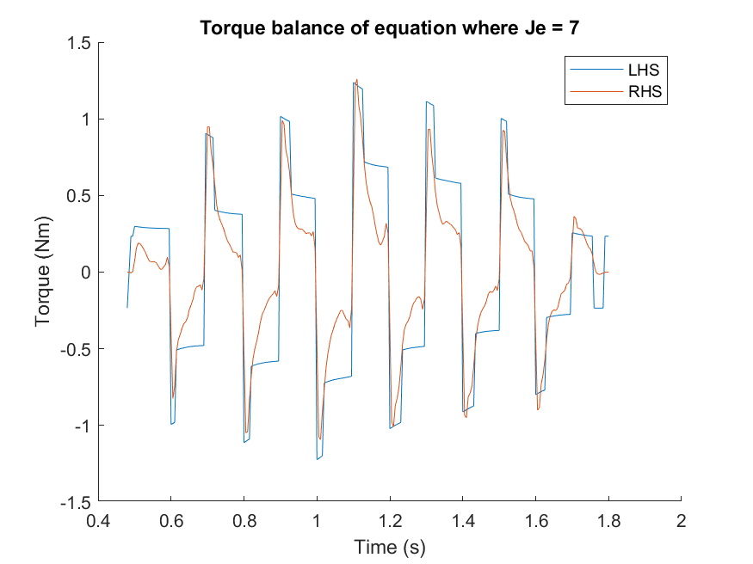

Figure B.1: LHS and RHS of the torque balance equation

Part C:
1) Discussion:
It’s necessary to move the table before applying sine wave, so to remove the effect of static friction at low velocity (w = ~0) when initially starting the table. Even if we assume system has no Coulomb or viscous friction, the table still wouldn’t move as pure sine wave as given in Vin because of static friction. If we also assume no static friction, then the table would also move as pure sine wave as given in Vin.

3)
It’s important to use later cycles (3rd or 4th), so the initial effect of static friction would have worn off and not affect the data.

5)
Unfortunately, the data did not line up. Likeliest cause of this issue is with the theoretical plot, possibly with its derivation. The equation I used was:
w(s)/Vin(s) = KtSg/(Je*s + Be)

Another possible issue was with the accuracy of peak identification of real data. While I did use 4th peak when possible, choosing the peak visually proved to be difficult. While I did retry many times, the phase data looked random and without trend due to this issue. The magnitude data had a visible trend that matches how it should be.

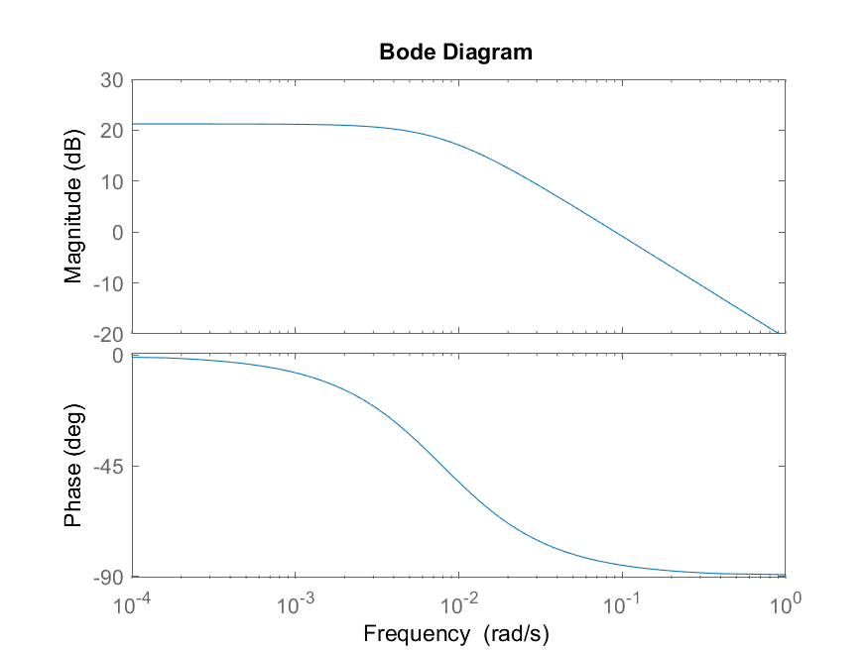
Figure C.1: Theoretical bode plot

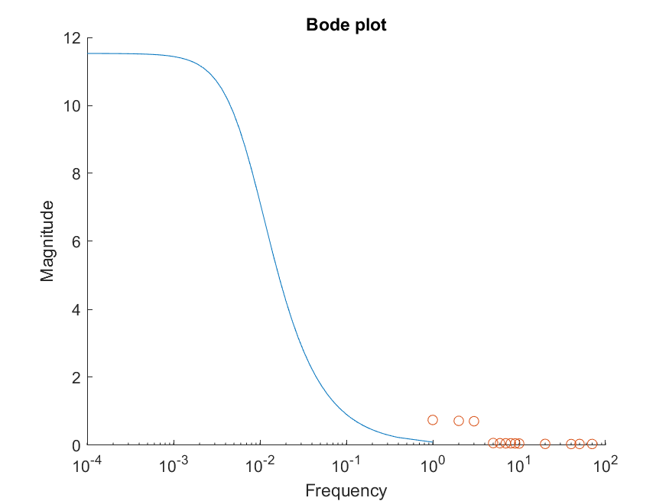
Figure C.2: Theoretical magnitude plot with real data
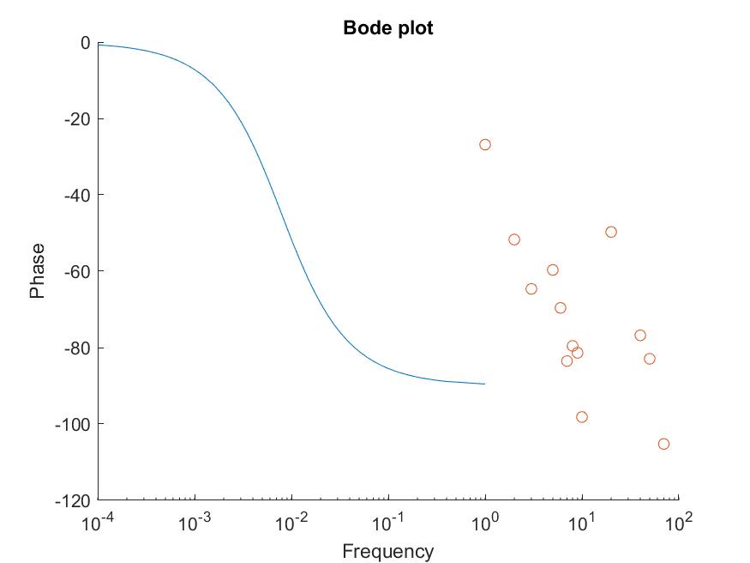
Figure C.3: Theoretical phase plot with real data
Conclusion:
Modeling a drive system can give engineers representation of how a drive system performs. While this report is flawed in some parts, it shows an important insight, that modeling can sometimes fail and more iterations sometimes are needed to be done (iteration is often outside the scope of a class lab). A simple system was analyzed, so the experimental design did not need to be more complex than just identifying and isolating data for wanted constants, and the modeling methods did not need to be more complex than a second order ODE or a bode plot; however, for more complex systems, more complex models and experimental design may be required to give an accurate model.

Appendix:
MATLAB scripts are attached in with the submission.

