Network Intrusion Detection
Written Report
CIC-IDS2018 Dataset | Random Forest + PyTorch DNN

1. Data Preprocessing
The dataset came in three CSV files that were combined into one. The first thing I noticed was that m_2.csv and m_3.csv had their header row repeated as a data row, so those were filtered out first.
The Timestamp column was dropped because it contains the time the traffic was recorded, not anything about the traffic itself. Including it would not be useful for classifying traffic type.
A few features had zero variance across the whole dataset, meaning they were the same value for every row. These were removed since they carry no information.
Finally, StandardScaler was applied to normalize all features. The scaler was fit on the training set only, then applied to the test set. This is important because fitting the scaler on all the data before splitting would cause data leakage.

2. Confusion Matrix Graphs

Task 1 - Random Forest (Binary)

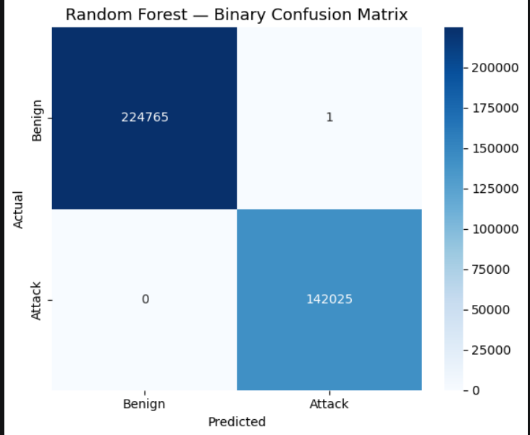Figure 1: Random Forest Binary Confusion Matrix

Task 2 - DNN (Multi-Class)

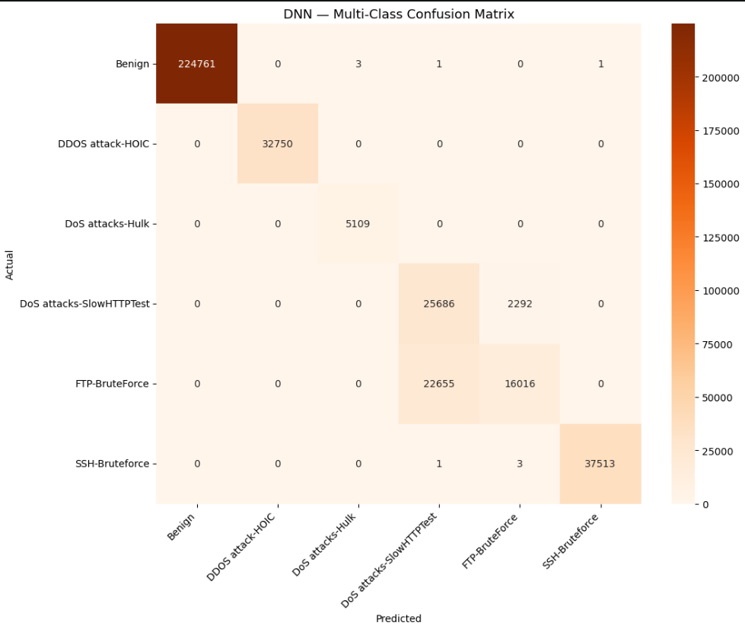Figure 2: DNN Multi-Class Confusion Matrix

3. Precision, Recall, and F1-Score

Task 1 - Random Forest (Binary Classification)

Class | Precision | Recall | F1-Score | Support
Benign | 1.00 | 1.00 | 1.00 | 224,766
Attack | 1.00 | 1.00 | 1.00 | 142,025
Accuracy |  |  | 1.00 | 366,791

The Random Forest got almost perfect results. It only misclassified 1 sample out of 366,791. Random Forest handles this kind of data well.

Task 2 - DNN (Multi-Class Classification)

Class | Precision | Recall | F1-Score | Support
Benign | 1.00 | 1.00 | 1.00 | 224,766
DDOS attack-HOIC | 1.00 | 1.00 | 1.00 | 32,750
DoS attacks-Hulk | 1.00 | 1.00 | 1.00 | 5,109
DoS attacks-SlowHTTPTest | 0.53 | 0.92 | 0.67 | 27,978
FTP-BruteForce | 0.87 | 0.41 | 0.56 | 38,671
SSH-Bruteforce | 1.00 | 1.00 | 1.00 | 37,517
DDOS attack-LOIC-UDP | N/A | N/A | N/A | 0
Accuracy (6 classes) |  |  | 0.93 | 366,791

The DNN got 0.93 accuracy overall. Most classes were classified perfectly. The two problem classes were DoS attacks-SlowHTTPTest and FTP-BruteForce. Looking at the confusion matrix, 22,655 FTP-BruteForce samples were predicted as SlowHTTPTest. Both of these attack types have similar flow patterns so the model had trouble telling them apart.

4. DNN Hyperparameters

Hyperparameter | Value
Input Dimension | Determined after preprocessing (zero-variance columns removed)
Hidden Layer 1 | 128 neurons
Hidden Layer 2 | 64 neurons
Output Layer | 6 neurons (LOIC-UDP removed during preprocessing)
Activation | ReLU after each hidden layer
Dropout Rate | 0.3
Loss Function | CrossEntropyLoss with balanced class weights
Optimizer | Adam
Learning Rate | 0.001
Epochs | 50
Batch Size | 512
Train/Test Split | 80/20 stratified

One thing worth noting is that the validation loss started increasing around epoch 30 while the training loss stayed flat, which is a sign of overfitting. The best point was around epoch 25. Adding early stopping would have improved the final results.

5. Class Imbalance Effect on DNN Performance
DDOS attack-LOIC-UDP was only 0.05% of the original dataset, which is around 1,500 samples. After the preprocessing steps (replacing -1 values and dropping NaN rows), all of those samples were removed. The class never appeared in the training or test set, so the model never learned it. This shows that aggressive data cleaning can accidentally remove minority classes entirely. For the classes that did survive, class weighting was used in the loss function to help the model pay more attention to rarer classes. This worked well for classes like DoS attacks-Hulk which had far fewer samples than Benign. The remaining confusion between SlowHTTPTest and FTP-BruteForce was not a class imbalance issue but a feature overlap issue.

6. AI Discussion and Verification
AI tools were used to help write parts of the code, especially the PyTorch training loop and DataLoader setup.
One case where I had to verify and correct the AI output was with the feature scaling step. The original code scaled the entire dataset before splitting it into train and test sets:

scaler = StandardScaler()
X_scaled = scaler.fit_transform(X)

This is a data leakage problem. The scaler learns statistics from the test set too, which means the model has seen information about the test data before evaluation. I corrected it by splitting first and then fitting the scaler only on the training set:

X_train, X_test, y_train, y_test = train_test_split(X, y, ...)
scaler = StandardScaler()
X_train_scaled = scaler.fit_transform(X_train)
X_test_scaled = scaler.transform(X_test)

