PROGRAM 1: Record.py
Description
This program creates a Staff class to manage staff information. It allows users to enter multiple staff records. The data is stored in a CSV file. It uses try-except blocks to handle file-related errors. Users can also view all the saved staff records
Working
- file is opened in read mode
- csv reader is used to read data
- Each row is displayed in formatted form
- Exception handling is used for file errors
SAMPLE OUTPUT

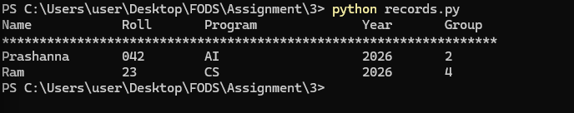
PROGRAM 2: Input_record.py
Description
This program defines a function to add student records it takes input details from the user. The data is stored in a csv file where it writes headers if the file is empty.
Finally, it confirms that the record is saved.
Working
- user inputs student details
- file is opened in append mode
- new data is written as a row
- file is saved automatically
SAMPLE OUTPUT
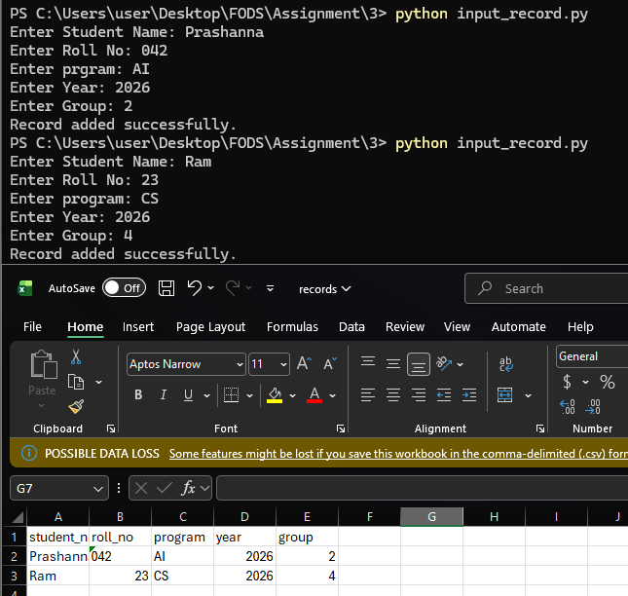

PROGRAM 3: Input_maths.py
Description
This program accepts a list of integers from the user; it carries out addition subtraction multiplication and division. The results are recorded in a file along with the current date and time, it continues running until the user enters exit. After exiting it displays all stored results in a neat format.
Working
- user inputs numbers repeatedly
- program calculates sum subtraction multiplication and division
- results are saved with timestamp
- loop continues until user exits
- file content is displayed at the end
SAMPLE OUTPUT

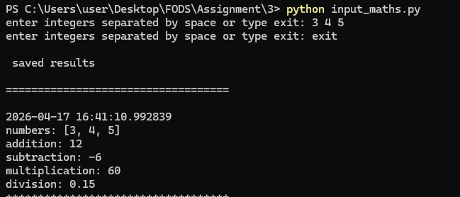
PROGRAM 4: Copy.py
Description
This program transfers data from one file to another. The user provides the source and destination file names. It uses try except blocks for error handling it displays an error if the input file is missing. It also notifies if the output file already exists.
Working
- user enters source and destination file names
- program reads data from source files
- writes data into new files
- checks if source exists and destination already exists
- displays proper error messages
SAMPLE OUPUT

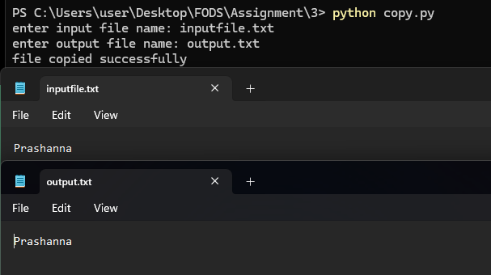

PROGRAM 5: Learner.py
Description
This program creates a learner class. It keeps basic information about a learner.
The user provides all necessary inputs an object is initialized using those inputs
Finally, it prints the learner’s information.
Working
- class is defined with attributes
- user inputs all details
- object is created
- Details are displayed using method
SAMPLE OUTPUT
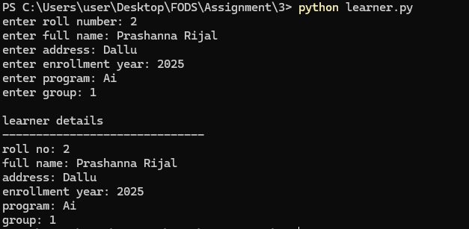

PROGRAM 6: Cook_book.py
Description
This program uses OOP to create a dish class and a cookbook class to manage multiple dishes.
Working
- dish class stores individual dish details
- cookbook class manages collection
- user adds multiple dishes
- all dishes are displayed
SAMPLE OUTPUT

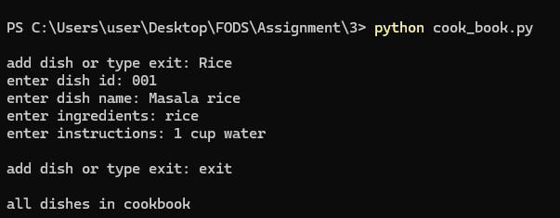
PROGRAM 7: Staff.py
Description
This program creates a Staff class to manage staff information. It allows users to enter multiple staff records. The data is stored in a CSV file. It uses try-except blocks to handle file-related errors. Users can also view all the saved staff records
Working
- user inputs multiple staff details
- data is written into staff.csv
- program reads files and displays all records
- try except handles file errors
SAMPLE OUTPUT
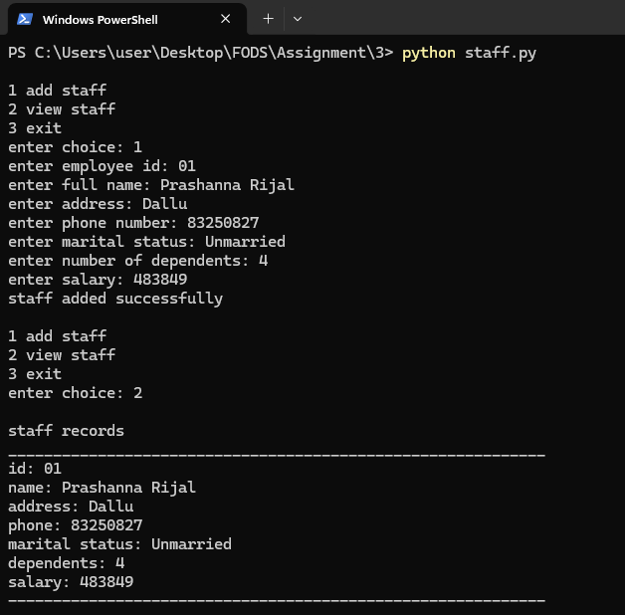
PROGRAM 8: Library.py
Description
This program builds a simple library system. It lets users search, borrow, and return books information is saved in a file. It applies object-oriented programming concepts it also handles errors using try except.
Working
- book class stores book details
- library class manages operations
- books are stored in files
- user can search for borrowing and return books
- exception handling ensures safe file operations
SAMPLE OUTPUT
