PROGRAM 1: NumPy_array.py
Description
This program creates a NumPy array and performs basic computations on it. It finds sum, meaning, maximum, and minimum values.
working
- a numpy array is created with predefined values
- sum of elements are calculated using numpy function
- mean value is calculated
- largest and smallest values are identified
- results are displayed on screen
SAMPLE OUTPUT
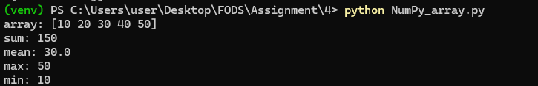
PROGRAM 2: Slicing_operations.py
Description
Program accepts a list of numbers from the user. It sorts the list and applies slicing operations.
working
- user inputs at least 12 numbers
- list is sorted in ascending order
- slicing is performed for index ranges 3–6 6–9 and 4–10
- results are displayed
SAMPLE OUTPUT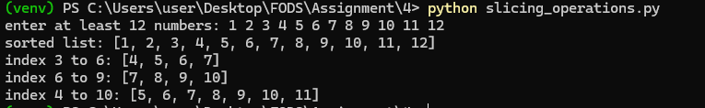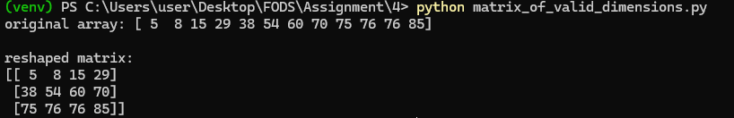

PROGRAM 3: matrix_of_valid_dimensions.py
Description
This program generates a random NumPy array. It arranges the array in sorted order and converts it into a matrix
working
- random integers are generated using numpy
- array is sorted
- array is reshaped into 3x4 matrix
- results are displayed
SAMPLE OUTPUT


PROGRAM 4: Mathematics operators.py
Description
Program performs operations on matrices. It checks dimension compatibility before carrying out calculations
working
- user inputs dimensions and elements of matrices
- program checks if matrices can be added or subtracted
- checks compatibility for multiplication
- perform operations if valid
- shows error if dimensions mismatch
SAMPLE OUTPUT

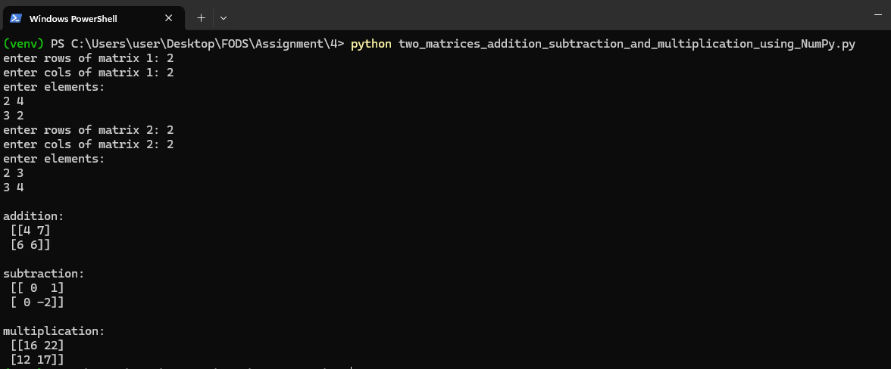

PROGRAM 5: Health_data.py
Description
This program loads data from a csv file and generates scatter plots. It visualizes the relationships among different health variables
working
- csv file is loaded using pandas
- scatter plots are created using matplotlib
- relationships plotted:
  - weight vs Height
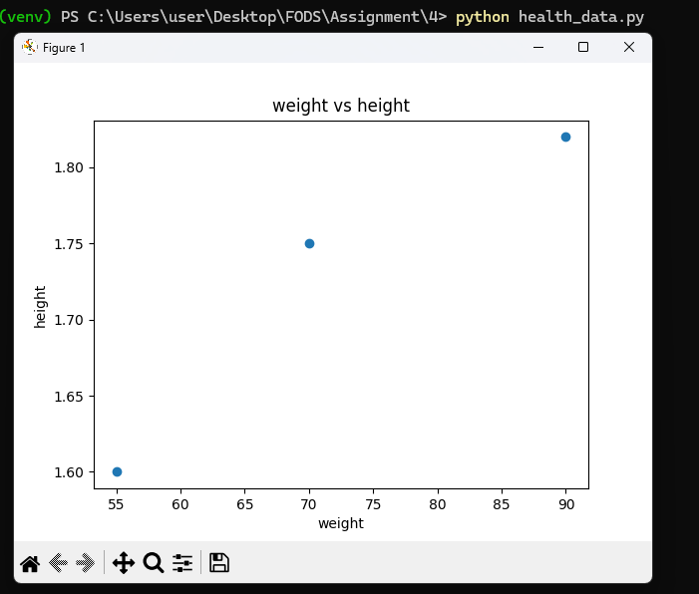
  - age vs weight
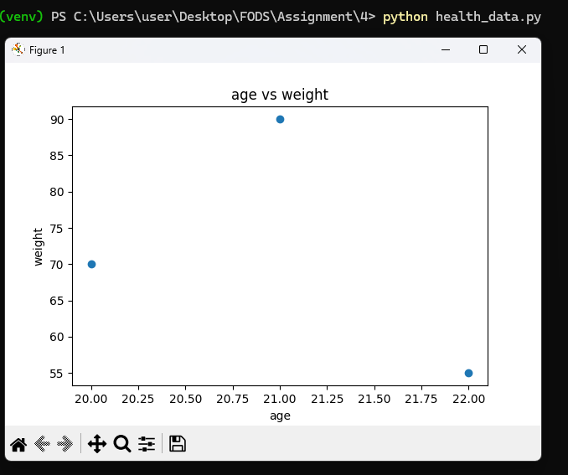
  - height vs age

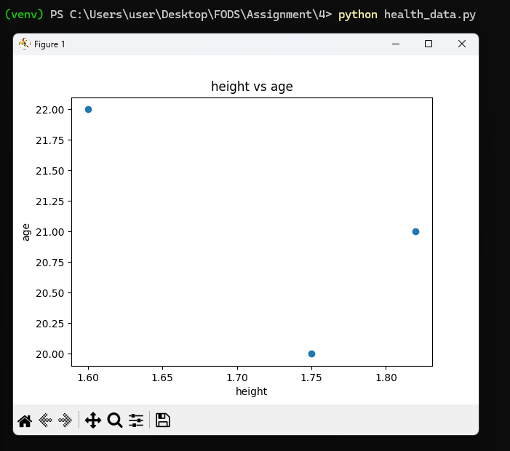

  - gender vs heigh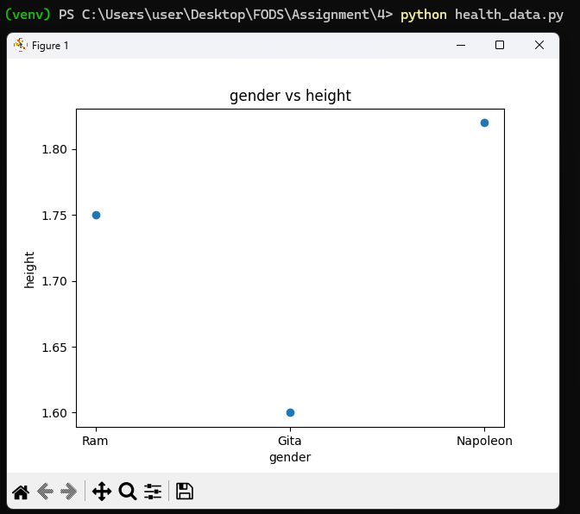

  - gender vs weight 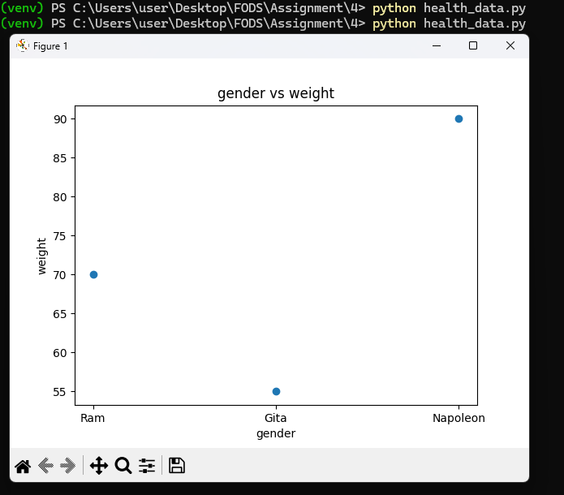

PROGRAM 6: BMI AND HEALTH STATUS ANALYSIS
Description
This program computes Bim and determines health categories. It creates additional columns in the data frame
working
- csv file is loaded into data frame
- BMI column is calculated using formula
- health status column is assigned using conditions
- updated data frame is displayed
SAMPLE OUTPUT
