# Workshop 2_Nonlinear Models

Rachel Prokopius 1/23/2020

# Objectives

The objective of the analysis was to fit light-response curves to data collected at Harvard Forest in Massachusetts in order to better estimate net ecosystem exchange (NEE) during periods of photosynthesis (day) and plant respiration (night). These estimations will inform researchers about the photosynthetic potential and ecosystem respiration for the studied area of Harvard Forest.

# Methods

## Site Information (include a map of the harvard forest site)

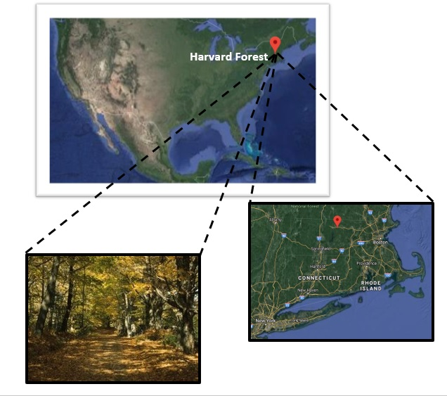

site image and map

###### Images from Google Maps and <https://harvardforest.fas.harvard.edu/about-us>

Harvard Forest is a deciduous forest that is part of the sciences program at Harvard College. The specific study site is found at the following GPS coordinates:

Latitude: 42.53 Longitude: -72.19 Elevation: 330

The study site is a cool and moist temperature forest, with mean annual temperatures ranging from -7°C to 20°C. Precipitation is fairly consistent throughout the year.The dominant tree species found in the area are Red oak (*Quercus rubra*), Red maple (*Acer rubrum*), Black birch (*Betula lenta*), White pine (*Pinus strobus*)and Eastern hemlock (*Tsuga canadensis*).

Data was collected from Environmental Measurement Station Eddy Flux Towers (EMS) in the study area. The data set used in the analysis includes hourly measurements of NEE in exchange per unit ground area, air temperature in °C, and photosynthetically active radiation (PAR) in nanometers. Measurements were attempted every hour by the EMS tower beginning at 1 am on January 1st, 1991, and concluding at midnight on January 1st, 2017.

## Photosynthetic Potential

The equation used to estimate photosynthetic potential of the study site was NEE ~ (a1 * PAR * ax)/(a1 * PAR + ax) + r, where a1, ax and r are all parameters that need to be estimated for the model.

### Estimate initial values for the photosynthetic potential model using selfStart:

lrcModel <- function(PAR, a1, ax, r) { NEE <- (a1 * PAR * ax)/(a1 * PAR + ax) + r return(NEE) }

lrc.int <- function (mCall, LHS, data){ x <- data $PARy<−data$ NEE r <- max(na.omit(y), na.rm=T) ax <- min(na.omit(y), na.rm=T) a1 <- (r + ax)/2

a1

$$a1 0$$

<- -0.1 r

$$r 50$$

<- ax*-1 r

$$r \< 0$$

<- 1 value = list(a1, ax, r) names(value) <- mCall

$$c(“a1”,“ax”,“r”)$$

return(value) }

SS.lrc <- selfStart(model=lrcModel,initial= lrc.int)

iv <- getInitial(NEE ~ SS.lrc(‘PAR’, “a1”, “ax”, “r”), data = day

$$which(day$MONTH == 07),$$

) iv ### Create a dataframe to store month parameter values a1, ax and r (parms.Month):

parms.Month <- data.frame( MONTH=numeric(), a1=numeric(), ax=numeric(), r=numeric(), a1.pvalue=numeric(), ax.pvalue=numeric(), r.pvalue=numeric(), stringsAsFactors=FALSE, row.names=NULL) parms.Month

$$1:12,1$$

<- seq(1,12,1)

### Write a function to fit the model and extract paramter values a1, ax and r (nee.day):

nee.day <- function(dataframe){ y = nls( NEE ~ (a1 * PAR * ax)/(a1 * PAR + ax) + r, dataframe, start=list(a1= iv $a1,ax=iv$ ax, r= iv$r), na.action=na.exclude, trace=F, control=nls.control(warnOnly=T))

y.df <- as.data.frame(cbind(t(coef(summary(y))

$$1:3,1$$

), t(coef(summary(y))

$$1:3,4$$

))) names(y.df) <-c(“a1”,“ax”, “r”, “a1.pvalue”, “ax.pvalue”, “r.pvalue”) return (y.df )}

### Write a loop to fit monthly curves and add paramters to a dataframe (parms.Month):

try(for(j in unique(day$MONTH)){

iv <- getInitial(NEE ~ SS.lrc(‘PAR’, “a1”, “ax”, “r”), data = day

$$which(day$MONTH == j),$$

)

y3 <- try(nee.day(day

$$which(day$MONTH == j),$$

), silent=T)

try(parms.Month

$$c(parms.Month$MONTH == j ), 2:7 $$

<- cbind(y3), silent=T) rm(y3) }, silent=T) parms.Month ## Ecosystem Respiration

# Results (at least 1 plot and one table)

library(knitr) kable(head(parms.Month

$$1:7,1:12$$

),“markdown”, table.attr = “id=”parms.Month_table"”)

# Discussion (1 paragrapgh)