

5274749

Rachel Prokopius



Rachel Prokopius

STA 6746

Assignment 3

19th October 2020

**Problem 1:**

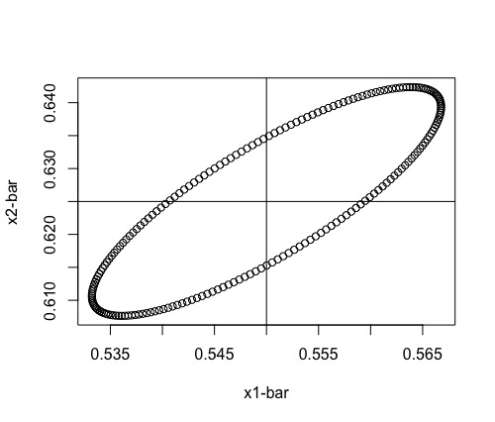

**b.**

**The tsquared value (1.89) is less than the critical value (10.655), so we fail to reject the null hypothesis and at the 1% confidence level, mu is not significantly different from the numbers given for testing. This is consistent with the ellipse from part a because (0.56,0.62) falls within the 99% confidence interval.**

**Rcode for Problem 1:**

mean1 = c(0.550,0.625)

> mean1

[1] 0.550 0.625

> cov1 = matrix(c(0.014,0.012,0.012,0.015), nrow = 2, ncol = 2)

> cov1

[,1] [,2]

[1,] 0.014 0.012

[2,] 0.012 0.015

> library(mixtools)

> library(matlib)

> ellipse(mean1,cov1, alpha = .01, npoints = 200, newplot = TRUE, draw = TRUE, xlab = "x1-bar", ylab = "x2-bar")

> abline(v = 0.550)

> abline(h = 0.625)

> value1 = c(0.56, 0.62)

> dev1 = mean1 - value1

> matrixdev1 = matrix(dev1, nrow = 2, ncol = 1)

> matrixdev1

[,1]

[1,] -0.010

[2,] 0.005

> transposematrixdev1 = t(matrixdev1)

> transposematrixdev1

[,1] [,2]

[1,] -0.01 0.005

> inversecov1 = inv(cov1)

> inversecov1

[,1] [,2]

[1,] 227.2727 -181.8182

[2,] -181.8182 212.1212

> tsquared1 = 41 *transposematrixdev1 %*% inversecov1 %*% matrixdev1

> qf(0.99, 2, 39)

[1] 5.194413

> (40*2)/39

[1] 2.051282

> tcrit1 = 2.051282 * qf(0.99,2,39)

> tcrit1

[1] 10.65521

> tsquared1 < tcrit1

[,1]

[1,] TRUE

> abline(v = 0.56, h = 0.62)

**Problem 2: Exercise 5.7**

**The simultaneous 95% T2 confidence intervals for the data are as follows:**

**3.398 is less than/equal to mu1 is less than/equal to 5.882**

**35.052 is less than/equal to mu2 is less than/equal to 55.748**

**8.571 is less than/equal to mu3 is less than/equal to 11.359**

**The simultaneous 95% Bonferroni confidence intervals for the data are as follows:**

**4.071 is less than/equal to mu1 is less than/equal to 5.209**

**40.659 is less than/equal to mu2 is less than/equal to 50.141**

**9.326 is less than/equal to mu1 is less than/equal to 10.604**

**The Bonferroni intervals are slightly smaller than the T2, so they are less conservative than the T2**

**Rcode for Problem 2**

sweat = table5.7[,2]

sweat

sodium = table5.7[,3]

potassium = table5.7[,4]

table5.7123 = cbind(sweat,sodium,potassium)

table5.7123

matrix5.7 = matrix(c(sweat, sodium, potassium), nrow = 20, ncol = 3)

matrix5.7

xbar2 = matrix(c(mean(sweat), mean(sodium), mean(potassium)), nrow = 3, ncol = 1)

xbar2

cov2 = cov(matrix5.7)

cov2

qf(0.95, 3, 17)

(3*19)/17

tcrit2 = qf(0.95, 3, 17) * (3*19)/17

tcrit2

sqrttcrit = sqrt(tcrit2)

sqrttcrit

sqrtss1n = sqrt(2.879368/20)

sqrtss1n

mu1lower = 4.640 - (sqrttcrit * sqrtss1n)

mu1lower

mu1upper = 4.640 + (sqrttcrit * sqrtss1n)

mu1upper

sqrtss2n = sqrt(199.7884/20)

sqrtss2n

mu2lower = 45.400 - (sqrttcrit * sqrtss2n)

mu2lower

mu2upper = 45.400 + (sqrttcrit * sqrtss2n)

mu2upper

sqrtss3n = sqrt(3.627658/20)

sqrtss3n

mu3lower = 9.965 - (sqrttcrit * sqrtss3n)

mu3lower

mu3upper = 9.965 + (sqrttcrit * sqrtss3n)

mu3upper

conmatrix5.7lower = matrix(c(3.398,35.052,8.571), nrow = 3, ncol = 1)

conmatrix5.7lower

conmatrix5.7upper = matrix(c(5.882,55.748,11.359), nrow = 3, ncol = 1)

conmatrix5.7upper

tcrit0.05 = qt((1-0.05/2*3),19)

bonmu1lower = 4.640 - (tcrit0.05 * sqrtss1n)

bonmu1lower

bonmu1upper = 4.640 + (tcrit0.05 * sqrtss1n)

bonmu1upper

bonmu2lower = 45.400 - (tcrit0.05 * sqrtss2n)

bonmu2lower

bonmu2upper = 45.400 + (tcrit0.05 * sqrtss2n)

bonmu2upper

bonmu3lower = 9.965 - (tcrit0.05 * sqrtss3n)

bonmu3lower

bonmu3upper = 9.965 + (tcrit0.05 * sqrtss3n)

bonmu3upper

**Problem 3: Exercise 5.9**

**a. The simultaneous 95% T2 confidence intervals for the data are as follows:**

**69.553 is less than/equal to mu1 is less than/equal to 121.487**

**152.173 is less than/equal to mu2 is less than/equal to 176.587**

**49.607 is less than/equal to mu3 is less than/equal to 61.773**

**83.488 is less than/equal to mu4 is less than/equal to 103.292**

**16.547 is less than/equal to mu5 is less than/equal to 19.413**

**29.035 is less than/equal to mu6 is less than/equal to 33.225**

**b. The 95% confidence ellipse for weight and girth is as follows:**

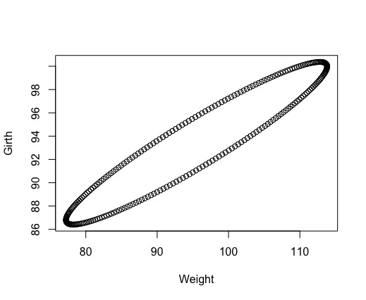

1. **The simultaneous 95% Bonferroni confidence intervals for the data are as follows:**

**76.201 is less than/equal to mu1 is less than/equal to 114.839**

**155.298 is less than/equal to mu2 is less than/equal to 173.462**

**51.164 is less than/equal to mu3 is less than/equal to 60.216**

**86.023 is less than/equal to mu4 is less than/equal to 100.757**

**16.914 is less than/equal to mu5 is less than/equal to 19.046**

**29.571 is less than/equal to mu6 is less than/equal to 32.689**

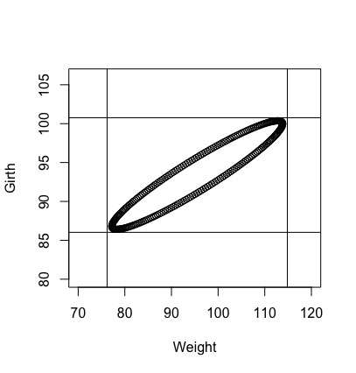

**The Bonferroni minima and maxima for weight and girth are slightly higher and lower than the confidence ellipse from part b.**

1. **The 95% Bonferroni confidence interval for mean head width minus mean head length is as follows:**

**12.523 is less than/equal to (mu6-mu5) is less than/equal to 13.777**

**Rcode for Problem 3:**

> sample5.9 = matrix(c(95.52,164.38,55.69,93.39,17.98,31.13), nrow = 6, ncol = 1)

> sample5.9

[,1]

[1,] 95.52

[2,] 164.38

[3,] 55.69

[4,] 93.39

[5,] 17.98

[6,] 31.13

> cov5.9 = matrix(c(3266.46,1343.97,731.54,1175.50,162.68,238.37,1343.97,721.91,324.25,537.35,80.17,117.73,731.54,324.25,179.28,281.17,39.15,56.80,1175.50,537.35,281.17,474.98,63.73,94.85,162.68,80.17,39.15,63.73,9.95,13.88,

+ 238.37,117.73,56.80,94.85,13.88,21.26), nrow = 6, ncol = 6)

> cov5.9

[,1] [,2] [,3] [,4] [,5] [,6]

[1,] 3266.46 1343.97 731.54 1175.50 162.68 238.37

[2,] 1343.97 721.91 324.25 537.35 80.17 117.73

[3,] 731.54 324.25 179.28 281.17 39.15 56.80

[4,] 1175.50 537.35 281.17 474.98 63.73 94.85

[5,] 162.68 80.17 39.15 63.73 9.95 13.88

[6,] 238.37 117.73 56.80 94.85 13.88 21.26

> sqrtchisquare5.9 = sqrt(qchisq(0.95,6))

> sqrtchisquare5.9

[1] 3.548463

> sqrts11n = sqrt(3266.46/61)

> sqrts22n = sqrt(721.91/61)

> sqrts33n = sqrt(179.28/61)

> sqrts44n = sqrt(474.98/61)

> sqrts55n = sqrt(9.95/61)

> sqrts66n = sqrt(21.26/61)

> simmatrix5.9 = matrix(c(sqrtchisquare5.9*sqrts11n,sqrtchisquare5.9*sqrts22n,sqrtchisquare5.9*sqrts33n,sqrtchisquare5.9*sqrts44n,sqrtchisquare5.9*sqrts55n,sqrtchisquare5.9*sqrts66n), nrow = 6, ncol = 1)

> simmatrix5.9

[,1]

[1,] 25.966535

[2,] 12.207222

[3,] 6.083328

[4,] 9.901773

[5,] 1.433134

[6,] 2.094869

> lower5.9 = sample5.9 - simmatrix5.9

> lower5.9

[,1]

[1,] 69.55347

[2,] 152.17278

[3,] 49.60667

[4,] 83.48823

[5,] 16.54687

[6,] 29.03513

> upper5.9 = sample5.9 + simmatrix5.9

> upper5.9

[,1]

[1,] 121.48653

[2,] 176.58722

[3,] 61.77333

[4,] 103.29177

[5,] 19.41313

[6,] 33.22487

> ## parb b

> sample5.9b = c(95.52,93.39)

> cov5.9b = matrix(c(3266.46,1175.50,1175.50,474.98), nrow = 2, ncol = 2)

> ellipse(sample5.9b,cov5.9b, alpha = 0.95, newplot = TRUE, xlab = "Weight", ylab = "Girth")

> ## part c

> qnorm((1-0.95)/12)

[1] -2.638257

> zscorecrit5.9 = 2.64

> zscorecrit5.9

[1] 2.64

> bonmatrix5.9 = matrix(c(zscorecrit5.9*sqrts11n,zscorecrit5.9*sqrts22n,zscorecrit5.9*sqrts33n,zscorecrit5.9*sqrts44n,zscorecrit5.9*sqrts55n,zscorecrit5.9*sqrts66n), nrow = 6, ncol = 1)

> bonmatrix5.9

[,1]

[1,] 19.318690

[2,] 9.081980

[3,] 4.525900

[4,] 7.366763

[5,] 1.066229

[6,] 1.558550

> bonlower5.9 = sample5.9 - bonmatrix5.9

> bonlower5.9

[,1]

[1,] 76.20131

[2,] 155.29802

[3,] 51.16410

[4,] 86.02324

[5,] 16.91377

[6,] 29.57145

> bonupper5.9 = sample5.9 + bonmatrix5.9

> bonupper5.9

[,1]

[1,] 114.83869

[2,] 173.46198

[3,] 60.21590

[4,] 100.75676

[5,] 19.04623

[6,] 32.68855

> qnorm((1-0.95)/12)

[1] -2.638257

> ## part d

> sample5.9b = c(95.52,93.39)

> cov5.9b = matrix(c(3266.46,1175.50,1175.50,474.98), nrow = 2, ncol = 2)

> ellipse(sample5.9b,cov5.9b, alpha = 0.95, newplot = TRUE, xlab = "Weight", ylab = "Girth", xlim = c(70,120), ylim = c(80,106))

> abline(v = 76.201, h = 86.023)

> abline( v = 114.839, h = 100.757)

> ## part e

> widthminuslength = 31.13 - 17.98

> zscore5.9e = -qnorm((1-0.95)/12)

> sqrt12n = sqrt((9.95-13.88-13.88+21.26)/61)

> sqrt12n

[1] 0.2378179

> coninterval5.9e = zscore5.9e * sqrt12n

> lower5.9e = widthminuslength - coninterval5.9e

> lower5.9e

[1] 12.52258

> upper5.9e = widthminuslength + coninterval5.9e

> upper5.9e

[1] 13.77742

**Problem 4: Exercise 5.18**

1. **The tsquared value (224.034) is greater than the critical value (83.33), so we reject the null hypothesis and at the 5% confidence level, mu is significantly different from the numbers given for testing. The t-test results show that mu is not equal to these numbers, so the students in the table are scoring differently than the average college students over the past 10 years.**
2. **The lengths and directions for the 95% confidence ellipsoids are as follows:**

**Social science and history: length = 47.463, direction = 0.994, 0.104, 0.038**

**Verbal: length = 4.966, direction = 0.105, -0.994, -0.012**

**Science: length = 2.365, direction = 0.037, -0.014, 0.999**

1. **The QQ plot for social science and history is as follows:**

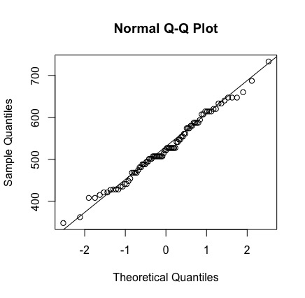

**The QQ plot for verbal is as follows:**

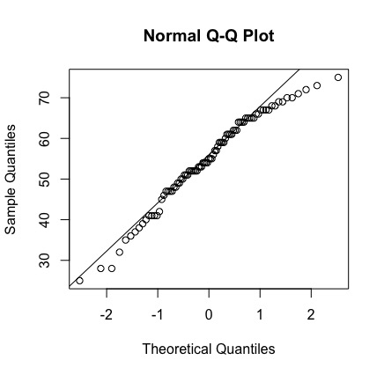

**The QQ plot for science is as follows:**

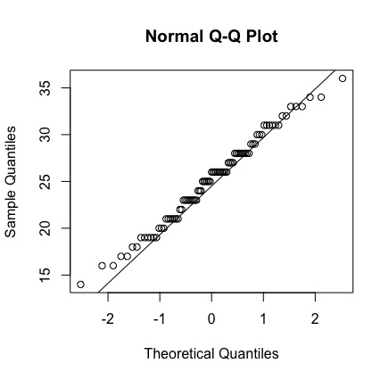

**A scatter plot comparing social science and history to verbal is as follows:**

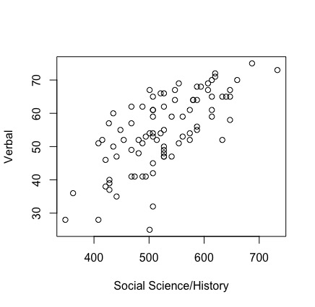

**A scatter plot comparing social science and history to science is as follows:**

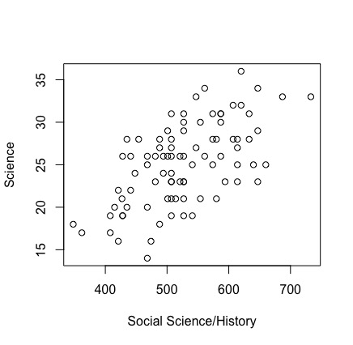

**A scatter plot comparing verbal to science is as follows:**

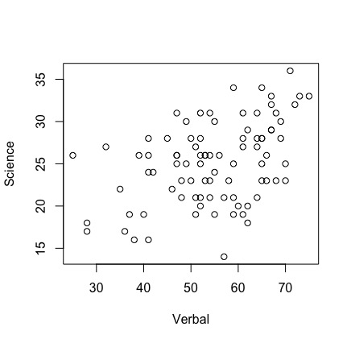

**The data in general seems to be normally distributed, with a clear positive relationship between all of the variables judging by the scatter plots and fairly normal QQ plots, all following a linear progression. If any variable is not normally distributed it would be verbal, judging by most of the data being on one side of the qqline in the corresponding QQ plot.**

**Rcode for Problem 4:**

> sciencehistory = table4[,2]

> verbal = table4[,3]

> science = table4[,4]

> matrix5.18 = matrix(c(sciencehistory, verbal, science), nrow = 87, ncol = 3)

> matrix5.18

[,1] [,2] [,3]

[1,] 468 41 26

[2,] 428 39 26

[3,] 514 52 21

[4,] 547 67 33

[5,] 614 61 27

[6,] 501 67 29

[7,] 421 46 22

[8,] 527 50 23

[9,] 527 55 19

[10,] 620 72 32

[11,] 587 68 31

[12,] 541 59 19

[13,] 561 53 26

[14,] 468 62 20

[15,] 614 65 28

[16,] 527 48 21

[17,] 507 32 27

[18,] 580 64 21

[19,] 507 59 21

[20,] 521 54 23

[21,] 574 52 25

[22,] 587 64 31

[23,] 488 51 27

[24,] 488 62 18

[25,] 587 56 26

[26,] 421 38 16

[27,] 481 52 26

[28,] 428 40 19

[29,] 640 65 25

[30,] 574 61 28

[31,] 547 64 27

[32,] 580 64 28

[33,] 494 53 26

[34,] 554 51 21

[35,] 647 58 23

[36,] 507 65 23

[37,] 454 52 28

[38,] 427 57 21

[39,] 521 66 26

[40,] 468 57 14

[41,] 587 55 30

[42,] 507 61 31

[43,] 574 54 31

[44,] 507 53 23

[45,] 494 41 24

[46,] 541 47 25

[47,] 362 36 17

[48,] 408 28 17

[49,] 594 68 23

[50,] 501 25 26

[51,] 687 75 33

[52,] 633 52 31

[53,] 647 67 29

[54,] 647 65 34

[55,] 614 59 25

[56,] 633 65 28

[57,] 448 55 24

[58,] 408 51 19

[59,] 441 35 22

[60,] 435 60 20

[61,] 501 54 21

[62,] 507 42 24

[63,] 620 71 36

[64,] 415 52 20

[65,] 554 69 30

[66,] 348 28 18

[67,] 468 49 25

[68,] 507 54 26

[69,] 527 47 31

[70,] 527 47 26

[71,] 435 50 28

[72,] 660 70 25

[73,] 733 73 33

[74,] 507 45 28

[75,] 527 62 29

[76,] 428 37 19

[77,] 481 48 23

[78,] 507 61 19

[79,] 527 66 23

[80,] 488 41 28

[81,] 607 69 28

[82,] 561 59 34

[83,] 614 70 23

[84,] 527 49 30

[85,] 474 41 16

[86,] 441 47 26

[87,] 607 67 32

> meansciencehistory = mean(sciencehistory)

> meanverbal = mean(verbal)

> meanscience = mean(science)

> mean5.18 = matrix(c(meansciencehistory, meanverbal, meanscience), nrow = 3, ncol = 1)

> mean5.18

[,1]

[1,] 526.58621

[2,] 54.73563

[3,] 25.12644

> cov5.18 = cov(matrix5.18)

> cov5.18

[,1] [,2] [,3]

[1,] 5808.0593 601.4940 222.02967

[2,] 601.4940 127.3595 23.77800

[3,] 222.0297 23.7780 23.11173

> invcov5.18 = solve(cov5.18)

> invcov5.18

[,1] [,2]

[1,] 0.0004305755 -0.001561110

[2,] -0.0015611099 0.015378562

[3,] -0.0025303362 -0.000824634

[,3]

[1,] -0.002530336

[2,] -0.000824634

[3,] 0.068424888

> dev5.18 = c(meansciencehistory-500, meanverbal-50, meanscience-30)

> dev5.18

[1] 26.586207 4.735632 -4.873563

> dev5.18transpose = t(dev5.18)

> ttest5.18 = 87*dev5.18transpose %*% solve(cov5.18) %*% dev5.18

> ttest5.18

[,1]

[1,] 224.0341

> library(robustbase)

> library(pcaPP)

> library(rrcov)

> qf(0.95, 3, 84)

[1] 2.713227

> (86*3)/84

[1] 3.071429

> tcrit15.18 = (86*3)/84 * qf(0.95, 3, 84)

> tcrit15.18

[1] 8.333483

> T2.test(matrix5.18, mu = c(500,50,30), conf.level = 0.95, test = "f")

One-sample Hotelling test

data: matrix5.18

T2 = 224.034, F = 72.941, df1 = 3,

df2 = 84, p-value < 2.2e-16

alternative hypothesis: true mean vector is not equal to (500, 50, 30)'

sample estimates:

[,1] [,2] [,3]

mean x-vector 526.5862 54.73563 25.12644

> ## Yes, the t-test results show that mu is not equal to these numbers,

> ## so the students in the table are scoring differently than the average

> ## college students over the past 10 years

> ## part b no f

> eigen5.18 = eigen(cov5.18)

> eigen5.18

eigen() decomposition

$values

[1] 5879.56342 64.37503 14.59216

$vectors

[,1] [,2] [,3]

[1,] 0.99383877 0.10454897 -0.03679688

[2,] 0.10408080 -0.99446427 -0.01442193

[3,] 0.03810098 -0.01050322 0.99921869

> sqrtscihiseigen = sqrt(5879.56342)

> sqrtvereigen = sqrt(64.37503)

> sqrtscieigen = sqrt(14.59216)

> fstat5.18 = ((qf(0.95,3,84))*(3*(87-1)))/(87*(87-3))

> sqrt5.18 = sqrt(fstat5.18)

> lengths5.18 = matrix(c(2*sqrtscihiseigen*sqrt5.18,2*sqrtvereigen*sqrt5.18,2*sqrtscieigen*sqrt5.18), nrow = 3, ncol = 1)

> lengths5.18

[,1]

[1,] 47.463110

[2,] 4.966408

[3,] 2.364522

> eigenscihis = eigen5.18$vectors[,1]

> eigenscihis

[1] 0.99383877 0.10408080 0.03810098

> eigenver = eigen5.18$vectors[,2]

> eigenver

[1] 0.10454897 -0.99446427 -0.01050322

> eigensci = eigen5.18$vectors[,3]

> eigensci

[1] -0.03679688 -0.01442193 0.99921869

> ## part c

> scihistoryQQ = qqnorm(sciencehistory)

> qqline(sciencehistory)

> verQQ = qqnorm(verbal)

> qqline(verbal)

> sciQQ = qqnorm(science)

> qqline(science)

> plot(sciencehistory,verbal, xlab = "Social Science/History", ylab = "Verbal")

> plot(sciencehistory,science, xlab = "Social Science/History", ylab = "Science")

> plot(verbal,science, xlab = "Verbal", ylab = "Science")

**Problem 5: Exercise 5.20**

1. **The 95% confidence ellipse for tail length and wing length is as follows:**

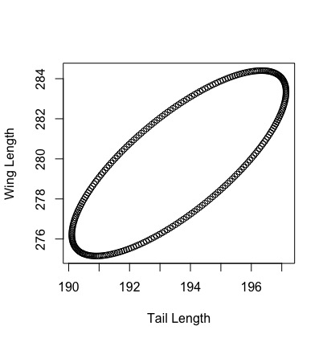

**The tsquared value (5.54) is less than the critical value (6.58), so we fail to reject the null hypothesis and at the 5% confidence level, mu is not significantly different from the numbers given for testing. So, statistically male and female values are not different and the male values are plausible for estimating the female values, and vise versa. Though mu values are not in the ellipse pictured above, though it is close. Therefore, the t-test and the confidence ellipse do not exactly match up and further testing is required.**

1. **The simultaneous 95% T2 confidence intervals for the data are as follows:**

**189.614 is less than/equal to mu1 is less than/equal to 197.631**

**274.508 is less than/equal to mu2 is less than/equal to 285.047**

**The simultaneous 95% Bonferroni confidence intervals for the data are as follows:**

**189.951 is less than/equal to mu1 is less than/equal to 197.293**

**274.953 is less than/equal to mu2 is less than/equal to 284.603**

**The T2 intervals are larger and therefore more conservative than Bonferroni.**

1. **The following is a scatter diagram for comparing tail length and wing length**

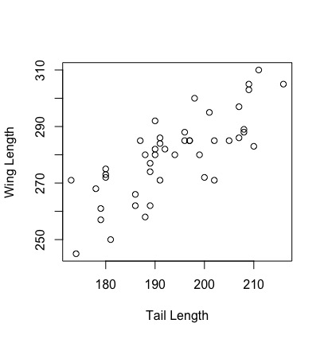

**The following is a QQplot for tail length.**

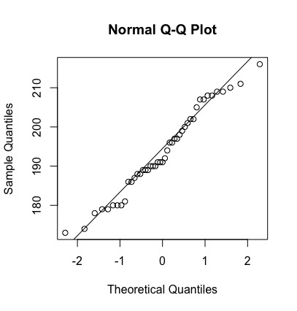

**The following is a QQplot for wing length.**

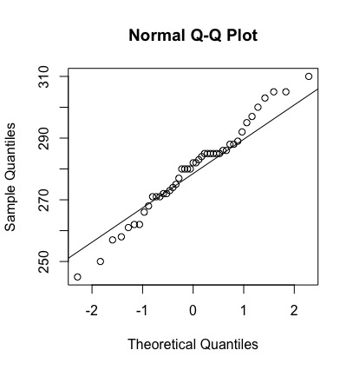

**There seems to be a pretty linear relationship between the two variables in the scatter plot, and both variables follows a pretty linear relationship based on their respective QQ plots, so a bivariate normal distribution seems to be a viable plot for this data.**

**Rcode for Problem 5:**

> meantaillength = mean(table5[,1])

> meantaillength

[1] 193.6222

> meanwinglength = mean(table5[,2])

> meanwinglength

[1] 279.7778

> mean5.20 = c(meantaillength,meanwinglength)

> mean5.20

[1] 193.6222 279.7778

> matrix5.20 = matrix(c(table5[,1],table5[,2]), nrow = 45, ncol = 2)

> cov5.20 = cov(matrix5.20)

> cov5.20

[,1] [,2]

[1,] 120.6949 122.3460

[2,] 122.3460 208.5404

> ellipse(mean5.20,cov5.20, alpha = 0.95, newplot = TRUE, xlab = "Tail Length", ylab = "Wing Length")

> value5.20 = c(190,275)

> dev5.20 = mean5.20 - value5.20

> dev5.20

[1] 3.622222 4.777778

> matrixdev5.20 = matrix(dev5.20, nrow = 2, ncol = 1)

> matrixdev5.20

[,1]

[1,] 3.622222

[2,] 4.777778

> transposematrixdev5.20 = t(matrixdev5.20)

> invcov5.20 = solve(cov5.20)

> tsquared5.20 = 45*transposematrixdev5.20 %*% invcov5.20 %*% matrixdev5.20

> tsquared5.20

[,1]

[1,] 5.54313

> tcritinternal5.20 = qf(0.95, 2, 43)

> tcritinternal5.20

[1] 3.21448

> (2*44)/43

[1] 2.046512

> tcrit5.20 = 2.046512 * tcritinternal5.20

> tcrit5.20

[1] 6.578473

> tsquared5.20 < tcrit5.20

[,1]

[1,] TRUE

> ## Fail to reject null hypothesis. So, statistically male and female values

> ## are not different and male values are plausible for female values

> ## part b

> sqrtchisq5.20 = sqrt(qchisq(0.95,2))

> sqrtchisq5.20

[1] 2.447747

> s11n5.20 = sqrt(120.6949/45)

> s22n5.20 = sqrt(208.5404/45)

> tcritmatrix5.20 = matrix(c(sqrtchisq5.20*s11n5.20,sqrtchisq5.20*s22n5.20), nrow = 2, ncol = 1)

> tcritmatrix5.20

[,1]

[1,] 4.008711

[2,] 5.269329

> meanmatrix5.20 = matrix(c(meantaillength,meanwinglength), nrow = 2, ncol = 1)

> mu5.20lower = meanmatrix5.20 - tcritmatrix5.20

> mu5.20lower

[,1]

[1,] 189.6135

[2,] 274.5084

> mu5.20upper = meanmatrix5.20 + tcritmatrix5.20

> mu5.20upper

[,1]

[1,] 197.6309

[2,] 285.0471

> zscore5.20 = -qnorm((1-0.95)/4)

> zscore5.20

[1] 2.241403

> bonmatrix5.20 = matrix(c(zscore5.20*s11n5.20, zscore5.20*s22n5.20), nrow = 2, ncol = 1)

> bonlower5.20 = meanmatrix5.20 - bonmatrix5.20

> bonlower5.20

[,1]

[1,] 189.9514

[2,] 274.9527

> bonupper5.20 = meanmatrix5.20 + bonmatrix5.20

> bonupper5.20

[,1]

[1,] 197.2930

[2,] 284.6029

> ## Tsquared interval is wider than Bonferroni, so is less conservative

> ## part c

> library(matlib)

> QQ5.20x1 = qqnorm(table5[,1])

> qqline(table5[,1])

> QQ5.20x2 = qqnorm(table5[,2])

> qqline(table5[,2])

> plot(table5[,1], table5[,2], xlab = "Tail Length", ylab = "Wing Length")

> line=abline(0,1)

**Problem 6: Exercise 5.23**

1. **The following is a QQplot for maxbreath of Egyptian skulls:**

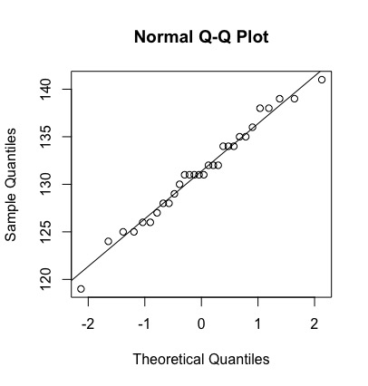

**The following is a QQplot for basheight of Egyptian skulls:**

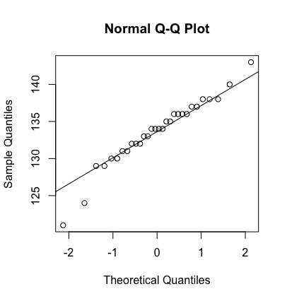

**The following is a QQplot for baslength of Egyptian skulls:**

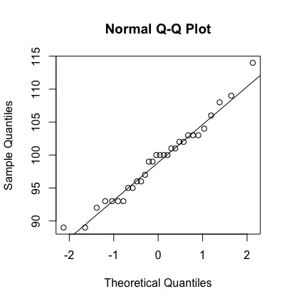

**The following is a QQplot for nasheight of Egyptian skulls:**

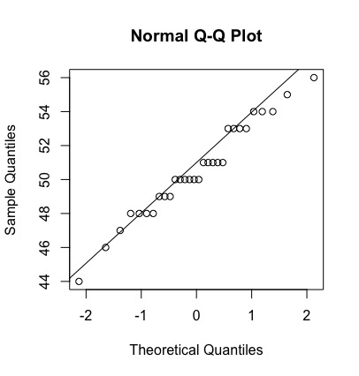

**The following is a chisquare plot is for data of Egyptian skulls:**

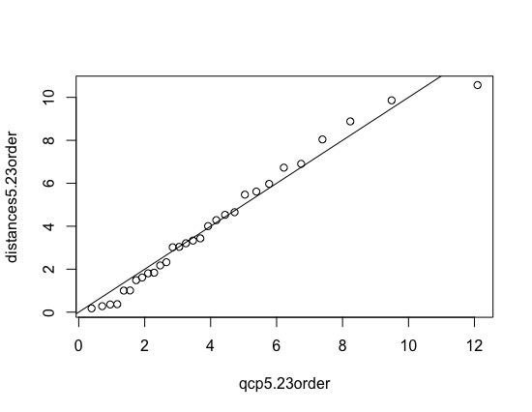

**All the QQ plots and the chi square plot follow a fairly straight line, so the data appear to be pretty normally distributed.**

1. **Analysis was conducted using small sample analysis because n-p was less than 30. The simultaneous 95% Bonferroni confidence intervals for the data are as follows:**

**128.873 is less than/equal to mu1 is less than/equal to 133.801**

**131.427 is less than/equal to mu2 is less than/equal to 135.773**

**96.305 is less than/equal to mu3 is less than/equal to 102.028**

**49.190 is less than/equal to mu4 is less than/equal to 51.877**

**The simultaneous 95% T2 confidence intervals for the data are as follows:**

**128.091 is less than/equal to mu1 is less than/equal to 134.642**

**130.746 is less than/equal to mu2 is less than/equal to 136.454**

**95.409 is less than/equal to mu3 is less than/equal to 102.925**

**48.768 is less than/equal to mu4 is less than/equal to 52.298**

**As with previous problems, the Bonferroni intervals are slightly smaller than the T2 intervals, making the T2 intervals slightly more conservative.**

**Rcode for Problem 6:**

maxbreath = table6[,1]

> basheight = table6[,2]

> baslength = table6[,3]

> nasheight = table6[,4]

> matrix5.23 = matrix(c(maxbreath,basheight,baslength,nasheight), nrow = 30, ncol =

> qqmaxbreath = qqnorm(table6[,1])

> qqline(table6[,1])

> qqbasheight = qqnorm(table6[,2])

> qqline(table6[,2])

> qqbaslength = qqnorm(table6[,3])

> qqline(table6[,3])

> qqnasheight = qqnorm(table6[,4])

> qqline(table6[,4])

> XX5.23 = cbind(maxbreath - mean(maxbreath), basheight - mean(basheight), baslength-mean(baslength), nasheight-mean(nasheight))

> KK5.23 = (as.matrix(XX5.23) %*% solve(cov(matrix5.23)) %*% t(as.matrix(XX5.23)))

> mKK5.23 = round(diag(KK5.23),4)

> mKK5.23

[1] 4.5321 3.4359 0.1764 8.0418 5.9720 6.7272 8.8815 3.3321

[9] 0.3571 0.2784 1.8359 9.8617 5.6144 0.3716 5.4713 2.3262

[17] 1.6127 1.8078 4.0060 1.0095 2.1748 4.2841 6.9045 1.0040

[25] 1.4885 3.0208 3.2070 3.0395 10.5731 4.6524

> J5.23 = seq(1:30)

> qcp5.23 = qchisq((30-J5.23+.5)/30,4)

> qcp5.23order = sort(qcp5.23)

> distances5.23order = sort(mKK5.23)

> distances5.23order

[1] 0.1764 0.2784 0.3571 0.3716 1.0040 1.0095 1.4885 1.6127

[9] 1.8078 1.8359 2.1748 2.3262 3.0208 3.0395 3.2070 3.3321

[17] 3.4359 4.0060 4.2841 4.5321 4.6524 5.4713 5.6144 5.9720

[25] 6.7272 6.9045 8.0418 8.8815 9.8617 10.5731

> plot(qcp5.23order,distances5.23order)

> line = abline(0,1)

> ## part b

> mean5.23 = matrix(c(mean(maxbreath), mean(basheight), mean(baslength), mean(nasheight)), nrow = 4, ncol = 1)

> mean5.23

[,1]

[1,] 131.36667

[2,] 133.60000

[3,] 99.16667

[4,] 50.53333

> matrix5.23 = matrix(c(maxbreath,basheight,baslength,nasheight), nrow = 30, ncol = 4)

> cov5.23 = cov(matrix5.23)

> cov5.23

[,1] [,2] [,3] [,4]

[1,] 26.309195 4.1517241 0.4540230 7.2459770

[2,] 4.151724 19.9724138 -0.7931034 0.3931034

[3,] 0.454023 -0.7931034 34.6264368 -1.9195402

[4,] 7.245977 0.3931034 -1.9195402 7.6367816

> tcrit0.055.23 = qt((1-0.05/8), 29)

> bons11n5.23 = sqrt(26.309195/30)

> bons22n5.23 = sqrt(19.9724138/30)

> bons33n5.23 = sqrt(34.6264368/30)

> bons44n5.23 = sqrt(7.6367816/30)

> bonmatrix5.23 = matrix(c(tcrit0.055.23*bons11n5.23, tcrit0.055.23*bons22n5.23, tcrit0.055.23*bons33n5.23, tcrit0.055.23*bons44n5.23), nrow = 4, ncol = 1)

> bonlower5.23 = mean5.23 - bonmatrix5.23

> bonlower5.23

[,1]

[1,] 128.87267

[2,] 131.42701

[3,] 96.30548

[4,] 49.18965

> bonupper5.23 = mean5.23 + bonmatrix5.23

> bonupper5.23

[,1]

[1,] 133.86067

[2,] 135.77299

[3,] 102.02785

[4,] 51.87702

> tcrit6 = qf(0.95, 4, 26) * (4*29)/26

> sqrttcrit6 = sqrt(tcrit6)

> sqrttcrit6

[1] 3.498026

> tmatrix5.23 = matrix(c(sqrttcrit6*bons11n5.23, sqrttcrit6*bons22n5.23, sqrttcrit6*bons33n5.23, sqrttcrit6*bons44n5.23), nrow = 4, ncol = 1)

> tlower5.23 = mean5.23 - tmatrix5.23

> tupper5.23 = mean5.23 + tmatrix5.23

> bonlower5.23

[,1]

[1,] 128.87267

[2,] 131.42701

[3,] 96.30548

[4,] 49.18965

> bonupper5.23

[,1]

[1,] 133.86067

[2,] 135.77299

[3,] 102.02785

[4,] 51.87702

> tlower5.23

[,1]

[1,] 128.09088

[2,] 130.74584

[3,] 95.40858

[4,] 48.76844

> tupper5.23

[,1]

[1,] 134.64246

[2,] 136.45416

[3,] 102.92475

[4,] 52.29822

**Problem 7: Exercise 5.30**

1. **The separate simultaneous 95% Bonferroni confidence intervals for the data are as follows:**

**0.439 is less than/equal to mu1 is less than/equal to 1.093**

**0.242 is less than/equal to mu2 is less than/equal to 0.774**

**0.292 is less than/equal to mu3 is less than/equal to 0.584**

**0.088 is less than/equal to mu4 is less than/equal to 0.234**

**The total simultaneous 95% Bonferroni confidence interval for the data is as follows:**

**1.174 is less than/equal to the sum of mu is less than/equal to 2.572**

**The simultaneous 95% Bonferroni confidence interval for petroleum minus natural gas is as follows:**

**0.119 is less than/equal to (mu2-mu1) is less than/equal to 0.397**

1. **The separate simultaneous 95% T2 confidence intervals for the data are as follows:**

**0.363 is less than/equal to mu1 is less than/equal to 1.169**

**0.180 is less than/equal to mu2 is less than/equal to 0.836**

**0.258 is less than/equal to mu3 is less than/equal to 0.618**

**0.071 is less than/equal to mu4 is less than/equal to 0.251**

**The total simultaneous 95% T2 confidence interval for the data is as follows:**

**1.011 is less than/equal to the sum of mu is less than/equal to 2.735**

**The simultaneous 95% T2 confidence interval for petroleum minus natural gas is as follows:**

**0.087 is less than/equal to (mu2-mu1) is less than/equal to 0.429**

**As with previous problems, the Bonferroni intervals are slightly smaller than the T2 intervals, making the T2 intervals slightly more conservative.**

**Rcode for Problem 7:**

> mean5.30 = matrix(c(0.766,0.508,0.438,0.161), nrow = 4, ncol = 1)

> mean5.30

[,1]

[1,] 0.766

[2,] 0.508

[3,] 0.438

[4,] 0.161

> cov5.30 = matrix(c(0.856,0.635,0.173,0.096,0.635,0.568,0.127,0.067,0.173,0.128,0.171,0.039,0.096,0.067,0.039,0.043), nrow = 4, ncol = 4)

> cov5.30

[,1] [,2] [,3] [,4]

[1,] 0.856 0.635 0.173 0.096

[2,] 0.635 0.568 0.128 0.067

[3,] 0.173 0.127 0.171 0.039

[4,] 0.096 0.067 0.039 0.043

> s11n5.30 = sqrt(0.856/50)

> s22n5.30 = sqrt(0.568/50)

> s33n5.30 = sqrt(0.171/50)

> s44n5.30 = sqrt(0.043/50)

> innerzscore5.30 = (1-(0.05/(2*4)) )

> innerzscore5.30

[1] 0.99375

> ## zscore for 0.9938

> zscore5.30 = 2.50

> simmatrix5.30 = matrix(c(zscore5.30*s11n5.30, zscore5.30*s22n5.30,zscore5.30*s33n5.30,zscore5.30*s44n5.30), nrow = 4, ncol = 1)

> simmatrix5.30

[,1]

[1,] 0.32710854

[2,] 0.26645825

[3,] 0.14620192

[4,] 0.07331439

> bonlower5.30 = mean5.30 - simmatrix5.30

> bonlower5.30

[,1]

[1,] 0.43889146

[2,] 0.24154175

[3,] 0.29179808

[4,] 0.08768561

> bonupper5.30 = mean5.30 +simmatrix5.30

> bonupper5.30

[,1]

[1,] 1.0931085

[2,] 0.7744583

[3,] 0.5842019

[4,] 0.2343144

> ## part a total

> totalmean5.30 = matrix(0.766+0.508+0.438+0.161)

> covlist5.30 = c(cov5.30)

> covlist5.30

[1] 0.856 0.635 0.173 0.096 0.635 0.568 0.127 0.067 0.173 0.128 0.171

[12] 0.039 0.096 0.067 0.039 0.043

> sumcovlist5.30 = sum(covlist5.30)

> sumcovlist5.30

[1] 3.913

> stotaln5.30 = sqrt(sumcovlist5.30/50)

> simmatrixtotal5.30 = matrix(c(zscore5.30*stotaln5.30), nrow = 1, ncol = 1)

> bontotallower5.30 = totalmean5.30 - simmatrixtotal5.30

> bontotallower5.30

[,1]

[1,] 1.173625

> bontotalupper5.30 = totalmean5.30 + simmatrixtotal5.30

> bontotalupper5.30

[,1]

[1,] 2.572375

> ## part a difference

> pertroleumminusnatural = 0.766 - 0.508

> zscore5.30 = 2.50

> sqrt12n5.30 = sqrt((0.856-0.635-0.635+0.568)/50)

> sqrt12n5.30

[1] 0.05549775

> coninterval5.30a = zscore5.30 * sqrt12n5.30

> bonlower5.30a = pertroleumminusnatural - coninterval5.30a

> bonlower5.30a

[1] 0.1192556

> bonupper5.930a = pertroleumminusnatural + coninterval5.30a

> bonupper5.930a

[1] 0.3967444

> ## part b mean for each

> chsquare5.30 = qchisq(0.95,4)

> chsquare5.30

[1] 9.487729

> sqrtchisq5.30 = sqrt(chsquare5.30)

> sinmatrix5.30b = matrix(c(sqrtchisq5.30*s11n5.30, sqrtchisq5.30*s22n5.30,sqrtchisq5.30*s33n5.30,sqrtchisq5.30*s44n5.30), nrow = 4, ncol = 1)

> sinmatrix5.30b

[,1]

[1,] 0.40302596

[2,] 0.32829956

[3,] 0.18013338

[4,] 0.09032966

> mulower5.30 = mean5.30 - sinmatrix5.30b

> mulower5.30

[,1]

[1,] 0.36297404

[2,] 0.17970044

[3,] 0.25786662

[4,] 0.07067034

> muupper5.30 = mean5.30 + sinmatrix5.30b

> muupper5.30

[,1]

[1,] 1.1690260

[2,] 0.8362996

[3,] 0.6181334

[4,] 0.2513297

> ## parb b total

> totalmean5.30 = matrix(0.766+0.508+0.438+0.161)

> covlist5.30 = c(cov5.30)

> covlist5.30

[1] 0.856 0.635 0.173 0.096 0.635 0.568 0.127 0.067 0.173 0.128 0.171

[12] 0.039 0.096 0.067 0.039 0.043

> sumcovlist5.30 = sum(covlist5.30)

> sumcovlist5.30

[1] 3.913

> stotaln5.30 = sqrt(sumcovlist5.30/50)

> simmatrixtotal5.30b = matrix(c(sqrtchisq5.30*stotaln5.30), nrow = 1, ncol = 1)

> mutotallower5.30 = totalmean5.30 - simmatrixtotal5.30b

> mutotallower5.30

[,1]

[1,] 1.01131

> mutotalupper5.30 = totalmean5.30 + simmatrixtotal5.30b

> mutotalupper5.30

[,1]

[1,] 2.73469

> ## part b difference

> pertroleumminusnatural = 0.766 - 0.508

> chsquare5.30 = qchisq(0.95,4)

> chsquare5.30

[1] 9.487729

> sqrt12n5.30 = sqrt((0.856-0.635-0.635+0.568)/50)

> sqrt12n5.30

[1] 0.05549775

> coninterval5.30b = sqrtchisq5.30 * sqrt12n5.30

> lower5.30b = pertroleumminusnatural - coninterval5.30b

> lower5.30b

[1] 0.08705496

> upper5.930b = pertroleumminusnatural + coninterval5.30b

> upper5.930b

[1] 0.428945

**Problem 8:**

1. **The 90% confidence ellipse for Cr and St is as follows:**

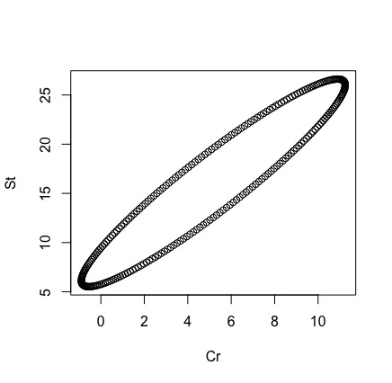

1. **The separate simultaneous 95% T2 confidence intervals for the data are as follows:**

**-6.862 is less than/equal to mu1 is less than/equal to 17.210**

**-4.828 is less than/equal to mu2 is less than/equal to 36.966**

**The tsquared value (1.775) is less than the critical value (7.44), so we fail to reject the null hypothesis and at the 10% confidence level, mu is not significantly different from the numbers given for testing. Based on the data, 10 for Sr is a plausible number.**

1. **The QQ plot for Cr is as follows:**

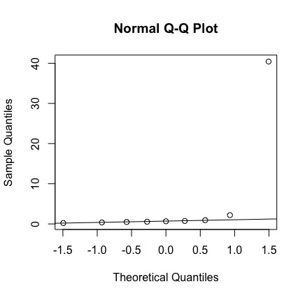

**The QQ plot for St is as follows:**

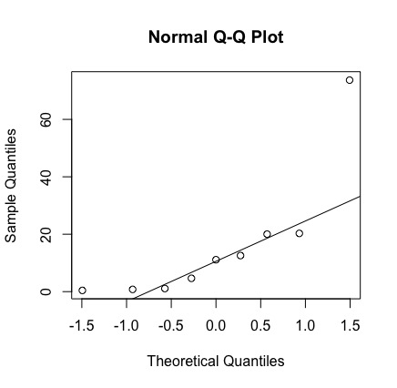

**The scatterplot relating Cr and St is as follows:**

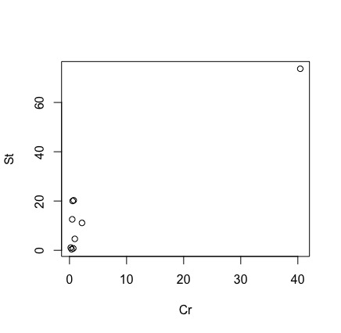

**The dataset has a big outlier, and based on the incredible skew of the QQplots and the scatter plot, this dataset is not normally distributed. Therefore, the confidence intervals and tests we performed in parts a and b of this problem are not accurate.**

1. **The results for the Shapiro-Wilks are as follows:**

**Shapiro-Wilk normality test**

**data: Z**

**W = 0.42294, p-value = 7.91e-07**

**The data are not normally distributed.**

1. **The results for the Shapiro-Wilks test without the outlier are as follows:**

**Shapiro-Wilk normality test**

**data: Z**

**W = 0.73601, p-value = 0.005713**

**The data still are not normally distributed.**

**Rcode for Problem 8:**

> x18 = c(.48,40.43,2.19,.55,.74,.66,.93,.37,.22 )

> x28 = c(12.57,73.68,11.12,20.03,20.29,.78,4.64,.43,1.08)

> meanmatrix8 = matrix(c(mean(x18),mean(x28)), nrow = 2, ncol = 1)

> meanmatrix8

[,1]

[1,] 5.174444

[2,] 16.068889

> mean8 = c(5.174444, 16.068889)

> matrix8 = matrix(c(x18,x28), nrow = 9, ncol = 2)

> matrix8

[,1] [,2]

[1,] 0.48 12.57

[2,] 40.43 73.68

[3,] 2.19 11.12

[4,] 0.55 20.03

[5,] 0.74 20.29

[6,] 0.66 0.78

[7,] 0.93 4.64

[8,] 0.37 0.43

[9,] 0.22 1.08

> cov8 = cov(matrix8)

> cov8

[,1] [,2]

[1,] 175.1217 286.5248

[2,] 286.5248 527.8617

> ellipse(mean8,cov8, alpha = 0.90, newplot = TRUE, xlab = "Cr", ylab = "St")

> ##partb

> sqrtfstat8 = sqrt(((2*8)/7)*qf(0.90,2,7))

> sqrtfstat8

[1] 2.728659

> s11n8 = sqrt(175.1217/9)

> s22n8 = sqrt(527.8617/9)

> simmatrix8 = matrix(c(sqrtfstat8*s11n8,sqrtfstat8*s22n8), nrow = 2, ncol = 1)

> simmatrix8

[,1]

[1,] 12.03644

[2,] 20.89720

> mulower8 = meanmatrix8 - simmatrix8

> mulower8

[,1]

[1,] -6.861995

[2,] -4.828313

> muupper8 = meanmatrix8 + simmatrix8

> muupper8

[,1]

[1,] 17.21088

[2,] 36.96609

> tcrit8 = ((2*8)/7) * qf(0.90,2,7)

> tcrit8

[1] 7.445582

> value8 = matrix(c(.30,10), nrow = 2, ncol = 1)

> dev8 = meanmatrix8-value8

> dev8

[,1]

[1,] 4.874444

[2,] 6.068889

> tsquared8 = 9 * t(dev8) %*% solve(cov8) %*% dev8

> tsquared8

[,1]

[1,] 1.7749

> tsquared8 < tcrit8

[,1]

[1,] TRUE

> ## can't reject normality

> ## part c

> qqnorm(x18)

> qqline(x18)

> qqnorm(x28)

> qqline(x28)

> plot(x18,x28, xlab = "Cr", ylab = "St")

> table8 = cbind(x18,x28)

> table8

x18 x28

[1,] 0.48 12.57

[2,] 40.43 73.68

[3,] 2.19 11.12

[4,] 0.55 20.03

[5,] 0.74 20.29

[6,] 0.66 0.78

[7,] 0.93 4.64

[8,] 0.37 0.43

[9,] 0.22 1.08

> ## part d

> library(mvnormtest)

> mshapiro.test(t(table8))

Shapiro-Wilk normality test

data: Z

W = 0.42294, p-value = 7.91e-07

> ## do reject hypothesis of normality

> ## part e

> x18remove = c(.48,2.19,.55,.74,.66,.93,.37,.22 )

> x28remove = c(12.57,11.12,20.03,20.29,.78,4.64,.43,1.08)

> table8remove = cbind(x18remove,x28remove)

> mshapiro.test(t(table8remove))

Shapiro-Wilk normality test

data: Z

W = 0.73601, p-value = 0.005713