
K.S. INSTITUTE OF TECHNOLOGY, BANGALORE - 560109
II SESSIONAL TEST QUESTION PAPER 2018 – 19 ODD SEMESTER

SET – B
USN

Degree | : | B.E | Semester | : | IV
Branch | : | Computer Science and Engineering | Course Code | : | 17CS43
Course Title | : | Design and Analysis of Algorithms | Date | : | 16/4/2019
Duration | : | 90 Minutes | Max Marks | : | 30

Note: Answer ONE full question from each part.

Q No. |  | Question | Marks | CO mapping | K-  Level
PART-A
1(a) | Design Strassen’s matrix multiplication and derive its time complexity. |  | 5 | CO2 | Applying  (K3)
(b) | Apply the Greedy Knapsack to solve knapsack problem where  i) m=10, n=4, P=(40,42,25,12). W=(4,7,5,3) |  | 5 | CO3 | Understanding, Applying (K2,K3)
(c) | Consider that the country has coins in the denominations of Rs 14, 12, 5, and 1. Show an example value to prove that greedy algorithm always does not generate change with minimum number of coins. |  | 5 | CO3 | Understanding, (K2)
OR
2(a) | Apply quick sort to sort the numbers and Draw the tree of recursive call made  25,10,72,18,40,11,64,58,32,9 |  | 5 | CO2 | Applying  (K3)
(b) | Explain minimum cost spanning tree (MST). Write Prim’s algorithm to construct minimum cost spanning tree. |  | 5 | CO3 | Understanding, (K2)
(c) | Explain job sequencing with deadline problem?  Let n=5, profits=(10,3,33,11,40) and deadlines=(3,1,1,2,2) respectively. Find the optimal solution using greedy method. |  | 5 | CO3 | Understanding  (K2)
PART-B
3(a) | Find out the difference between divide and conquer method and illustrate the topological sorting for the following graphs using DFS method and Source removal method.  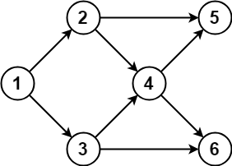 |  | 5 | CO2 | Applying  (K3)
(b) | Apply Prim’s algorithm to construct Minimum Cost Spanning tree. 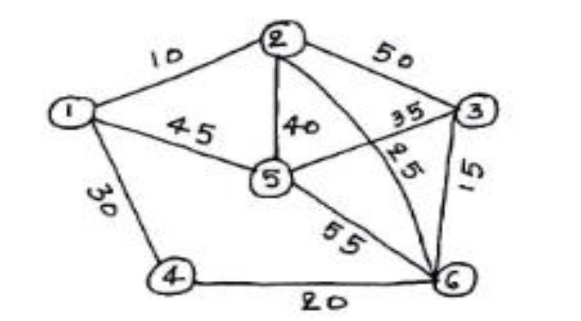 |  | 5 | CO3 | Applying (K3)
(c) | Explain the Dijikstra’s Algorithm to find single source shortest paths . |  | 5 | CO3 | Understanding, (K2)
OR
4(a) | Determine time complexity for QuickSort in worst case. Hint: Define and explain the recurrence relation for worst case and solve the same. |  | 5 | CO2 | Applying  (K3)
(b) | Apply Kruskal’s algorithm to construct Minimum Cost Spanning tree.  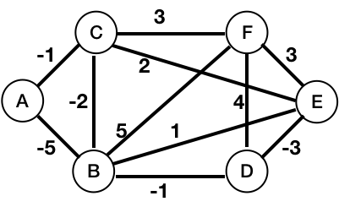 |  | 5 | CO3 | Applying (K3)
(c) | Apply Dijikstra’s algorithm to find the single source shortest path for graph taking ‘a’ as source file.  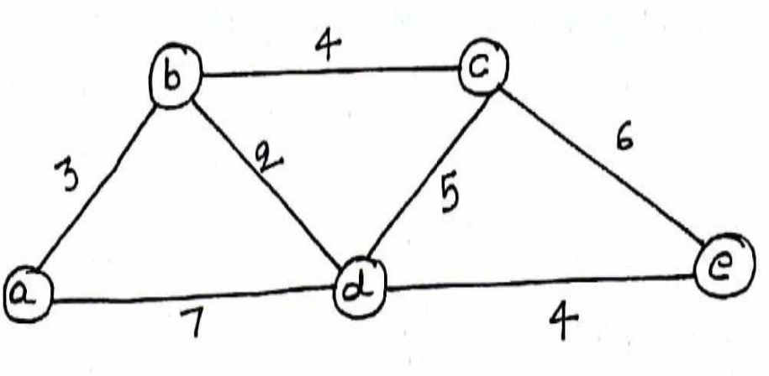 |  | 5 | CO3 | Applying (K3)

Signature of the Faculty Signature of the HOD

