Assignment-1

Information Retrieval
Name: Rudrapratap Singh Rawat
Roll Number: 2410110601

Description of the Assignment:
- Parses clothing product descriptions from the corpus.
- Builds an inverted index containing:
- Term frequency (TF)
- Document frequency (DF)
- Postings lists
- Builds a positional index storing the positions of terms in each document.
- Supports free-text search using the lnc.ltc weighting scheme.
  - Document weight: wd,t = 1 + log10(tf) for tf > 0;
  - Query weight: wq,t = (1 + log10(tf)) × log10(N/df), where N = 100
- Supports exact phrase search.
- Supports ordered proximity search within a specified distance.
- Displays the top results with document ID, title, category, similarity score, and matching positions.

Flow of the Assignment:
src/inverted_index.py: Builds the inverted Index
src/positional_index.py: Builds the positional Index
src/preprocessing.py: Tokenizes, Lemmatizes the queries
corpus.py: Reads the corpus as a dictionary with docid as key
search.py: Executes the Free Search, Exact Search and Positional Search Queries
testing.py: For testing purposes as required by assignment, writes in three txt files present in the Result directory
main.py: Uses branching control statements (switch case), to give the user options to query various searches.

Output Images:
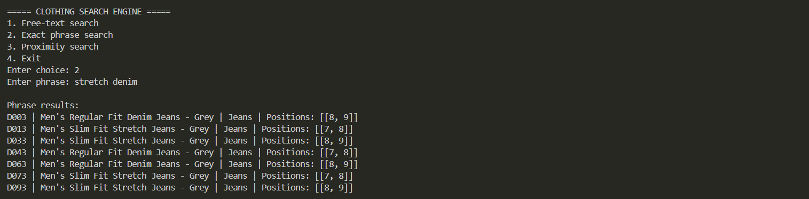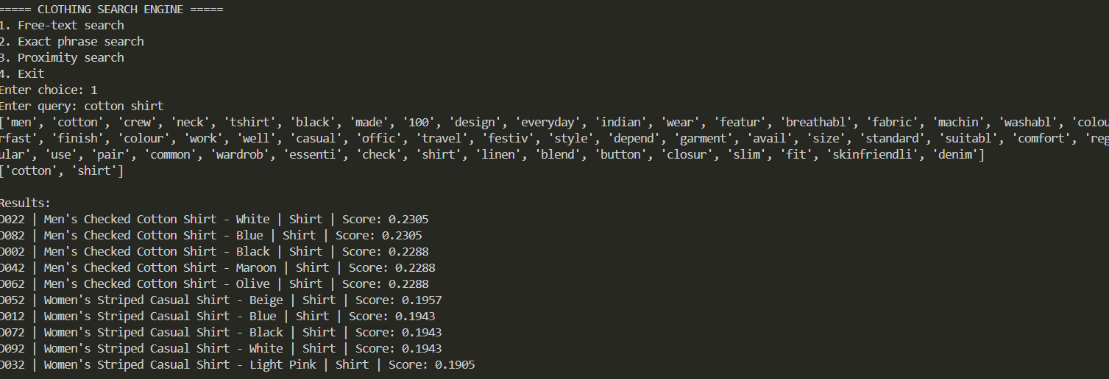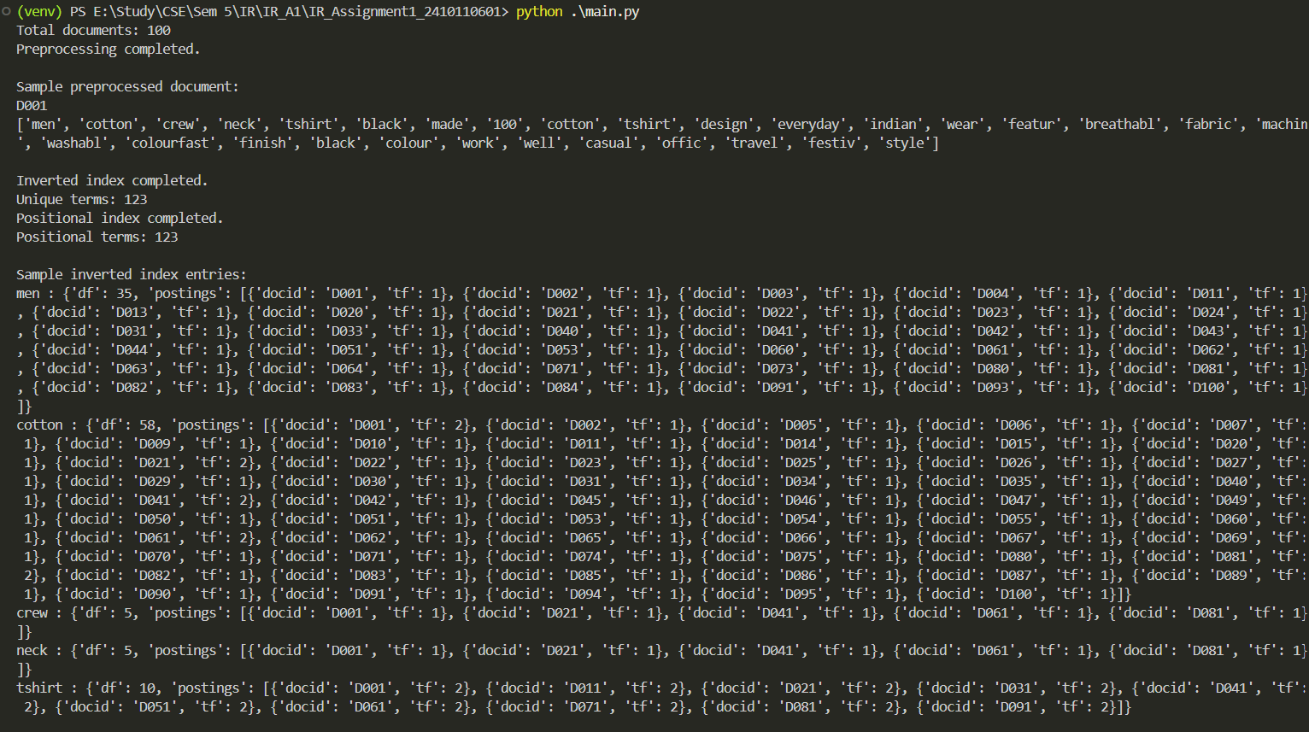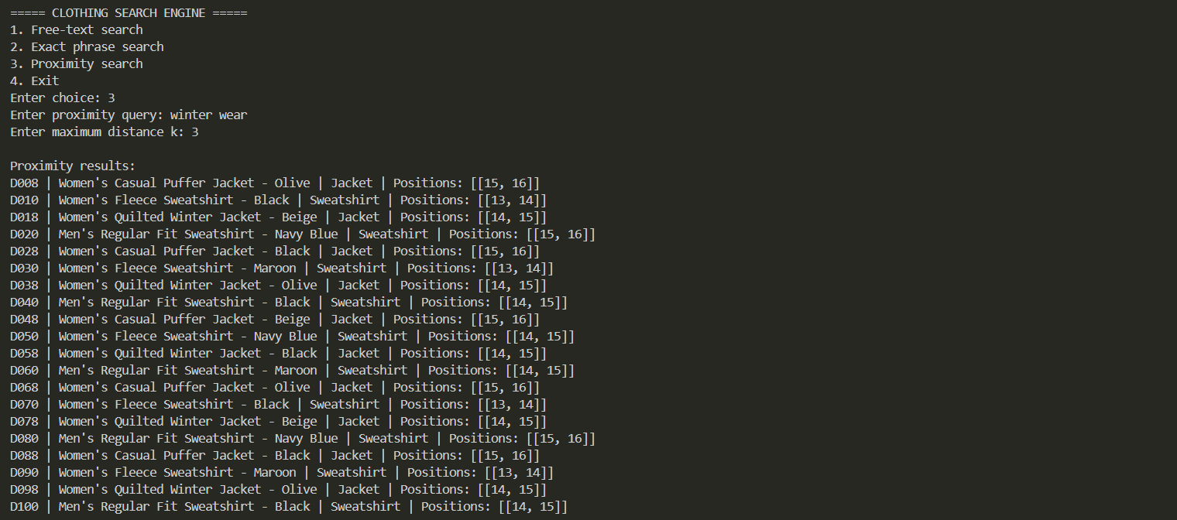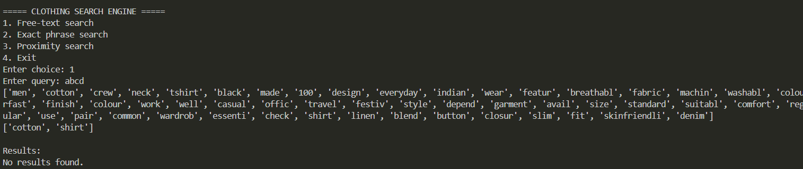

Comparisons:
Case 1: Cotton Shirt
- Free Search Query
Free Search Query only searches for whether the words are present, not their position/ whether they are next to each other
The free search for cotton shirt returned 10 documents:
D022, D082, D002, D042, D062, D052, D012, D072, D092, and D032.
- Exact Search Query:
Exact Search Query sees whether the exact phrase exists.
The exact phrase search returned only 5 documents:
D002, D022, D042, D062, and D082.

<DOCID>D072</DOCID>
<CATEGORY>Shirt</CATEGORY>
<TITLE>Women's Striped Casual Shirt - Black</TITLE>
<TEXT>Women's Striped Casual Shirt - Black. Made from viscose blend, this shirt is designed for everyday Indian wear. It features button closure, slim fit, and minimal shrinkage. The black colour works well for casual, office, travel, or festive styling depending on the garment. Available in size M and other standard sizes. The garment is suitable for comfortable regular use and can be paired with common wardrobe essentials.</TEXT>
</DOC>

D072 appears in Free Search, but NOT in Exact Search. This is as VSM does not require every query word to be present. It ranks documents based on how similar their term-weight vectors are to the query vector.

Case 2: Stretch Denim
- Free-text search
The free query stretch denim returned 10 documents:
D023, D083, D043, D053, D013, D073, D003, D063, D033, D093.

- Exact Search Query

The exact search query stretch denim returned only 7 documents:
D003, D013, D033, D043, D063, D073, D093

<DOCID>D023</DOCID>
<CATEGORY>Jeans</CATEGORY>
<TITLE>Men's Regular Fit Denim Jeans - Grey</TITLE>
<TEXT>Men's Regular Fit Denim Jeans - Grey. Made from cotton denim, this jeans is designed for everyday Indian wear. It features zip fly, durable stitching, and durable stitching. The grey colour works well for casual, office, travel, or festive styling depending on the garment. Available in size L and other standard sizes. The garment is suitable for comfortable regular use and can be paired with common wardrobe essentials.</TEXT>
</DOC>

D023 appears in Free Search, but NOT in Exact Search. This is as VSM does not require every query word to be present. It ranks documents based on how similar their term-weight vectors are to the query vector.

