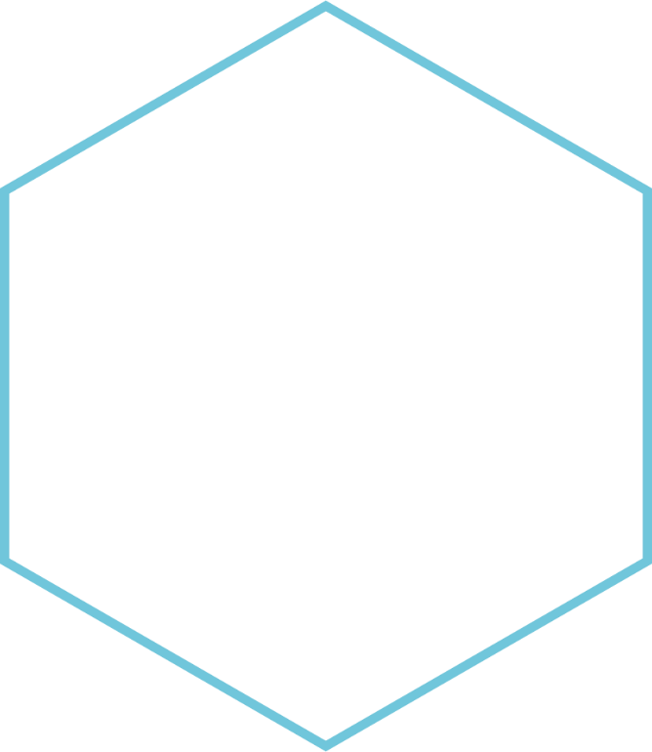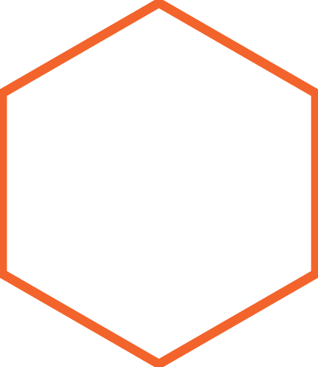

|  |
| --- |
| **Changes in build.xml of fdStatic to reflect dashboard migration from extJS to ReactJS** |
|  |
|  |
|  |



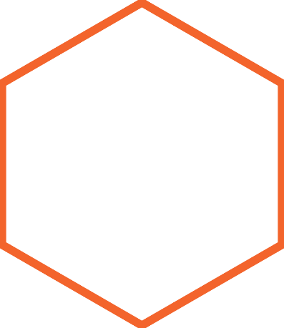

**Prerequisites required**

1. Checkout latest source code from SVN repository
2. Should have nodejs in C:\Program Files as shown below

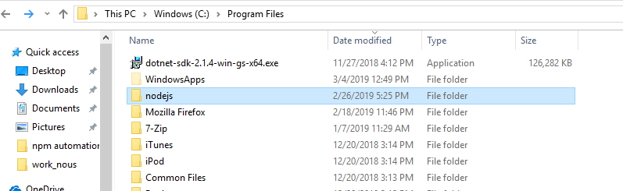

1. Should have fdxReactModules directory in fdStatic/portal folder as shown below

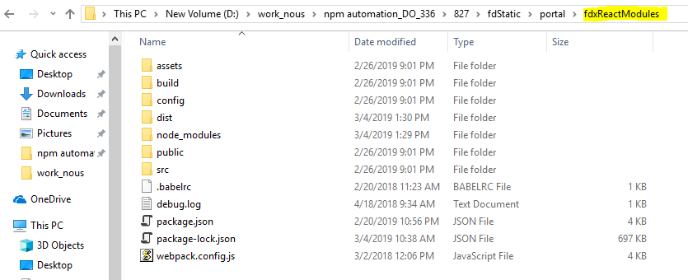

**Run :** mvn   -fae --settings conf/settings.xml --global-settings conf/settings.xml clean install -U antrun:run  -Dmaven.test.skip=true from fdBrokerage as shown below



Result: ReactApp folder generated in \fdStatic\portal\build\production as shown below

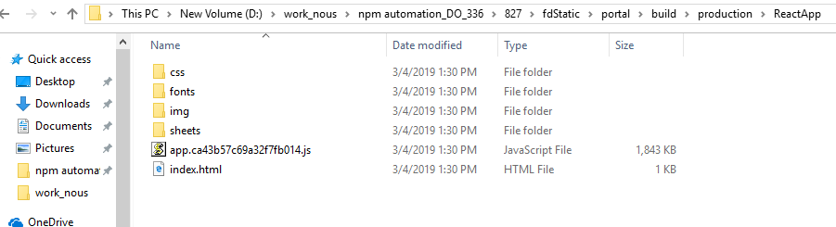

**Configuration Changes done in build.xml**

1. **npm install**

Here under npmcopy target, npm install is done which executes npm.cmd (C:\Program Files\nodejs) with install as argument as shown below

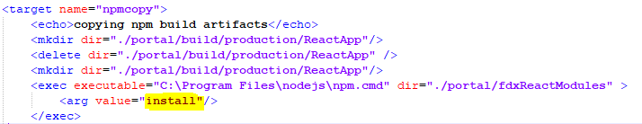

This will create nodeModules folder in \fdStatic\portal\fdxReactModules which contains all third party dependencies downloaded from internet referring to package.json of the same folder

Before executing npm.cmd we are creating ReactApp folder to store content of production folder created after running npm run build

1. **npm run build**

Here npm run build is done which executes npm.cmd (C:\Program Files\nodejs) with run, build as arguments as shown below:

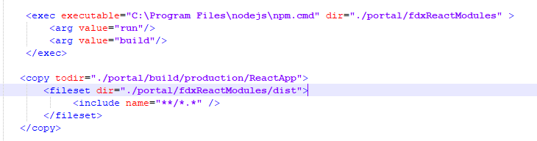

This will create dist folder which contains app.js, index.html and required dependencies (images, fonts etc.) in \fdStatic\portal\fdxReactModules and will be copied to \fdStatic\portal\build\production as shown below:

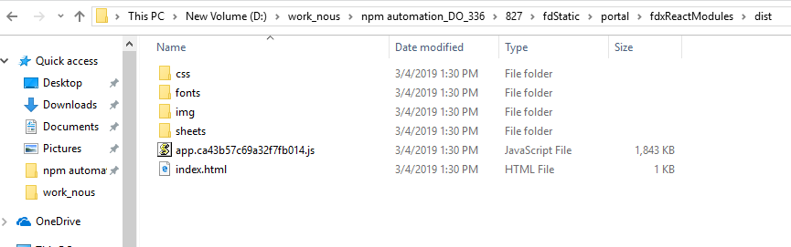

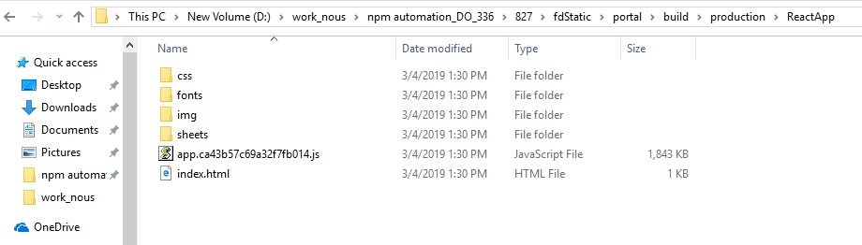

**Excluding nodeModules folder in fdStatic.zip**



**Reasons:**

1. node_modules directory contains third party dependencies which are required only for npm run build and is not required for any further action
2. Size of node_modules folder is also huge (~280MB)