Financial Fraud Detection using Machine Learning

**Adelene Ng, Gareth Jonathan Halim**

# Introduction

With the advent of e-commerce and online purchases, both businesses and consumers alike are increasingly reliant on digital payments for their financial transactions. With the increasing use of online payments, there is a corresponding increase in financial fraud. The sheer volume of transactions together with increasingly sophisticated methods employed by cyber criminals, manual detection or even static rule-based fraud detection is no longer effective. In order to combat increasingly sophisticated methods adopted by cyber-criminals, we will use machine learning and artificial intelligence techniques and tools to fight the war against fraud.

# Problem Framing

We want the machine learning model to be able to predict if a financial transaction is fraudulent or not. Our problem can be best framed as a binary classification problem which predicts if a transaction is genuine or not. The ideal outcome would be to correctly predict a transaction which is fraudulent as actually fraudulent.

Success of the model is measured by the reduction in fraud volume by up to 60% & keeping customers secure with real-time fraud detection.

Our machine learning model is deemed a failure if it fails to detect any fraudulent transactions.

The output from our machine learning model will return true if a given transaction is deemed fraudulent, false otherwise. Our machine learning model will take as input (e.g. transaction amount, transaction type) and the output will be a value of 1 if a transaction is fraudulent, 0 otherwise. The output will be used to decide if the transaction should be approved or denied.

If no machine learning is used, then we either have to resort to manual or rule-based detection, using heuristics such as sudden unusual transaction amounts, unexpected spikes in transactional activities, increased frequency of transactions that are potential red flags.

# Datasets

Since financial datasets cannot be easily collected by individuals, we will use pre-prepared datasets. The lack of public datasets in the financial sector is due to the intrinsically private nature of financial transactions. We will use the dataset from Kaggle, “[Synthetic Financial Datasets For Fraud Detection](https://www.kaggle.com/ealaxi/paysim1)”, which has been generated by the PaySim mobile generator. It simulates mobile money transactions based on a sample of real transactions extracted from one month of financial logs from a mobile money service implemented in an African country. The original logs were provided by a multinational company, who is the provider of the mobile financial service which is currently running in more than 14 countries all around the world.

Table 1 shows the features and their descriptions in the dataset used for this project.

| Features | Description |
| --- | --- |
| step | Maps a unit of time in the real world. In this case 1 step is 1 hour of time. |
| type | CASH-IN, CASH-OUT, DEBIT, PAYMENT and TRANSFER |
| amount | Amount of the transaction in local currency |
| nameOrig | Customer who started the transaction |
| oldbalanceOrg | Initial balance before the transaction |
| newbalanceOrig | New balance after the transaction |
| nameDest | Customer who is the recipient of the transaction |
| oldbalanceDest | Initial balance of recipient before the transaction |
| newbalanceDest | New balance of recipient after the transaction |
| isFraud | This is the transactions made by the fraudulent agents inside the simulation. In this specific dataset the fraudulent behaviour of the agents aims to profit by taking control or customers’ accounts and try to empty the funds by transferring to another account and then cashing out of the system. |
| isFlaggedFraud | The business model aims to control massive transfers from one account to another and flags illegal attempts. An illegal attempt in this dataset is an attempt to transfer more than 200.000 in a single transaction. |

Table 1 – Description of Dataset Features

# Work Breakdown

Table 2 shows how we split the tasks amongst the team members.

|  |  |
| --- | --- |
| Tasks | Person Responsible |
| Exploratory Data Analysis | Both |
| Data Visualization | Adelene Ng |
| Feature Engineering | Adelene Ng |
| Correlation | Adelene Ng |
| Feature Importance | Adelene Ng |
| Preparing the dataset for training & Imbalance dataset handling | Adelene Ng |
| Model Experimentation (LR, GNB) | Gareth Jonathan Halim |
| Model Experimentation (XBoost, DT, RFC, CatBoost, LightGBM, Bagging Classifier) | Adelene Ng |
| Grid Search (CatBoost, LightGBM) | Adelene Ng |
| Web-based Flask Application | Adelene Ng |

Table 2 – Task split amongst team members

# Exploratory Data Analysis

We first determine the types associated with each of the attributes. There are a total of 11 attributes: 5 of which are floats, 3 are integers and there are 3 objects (Table 3).

| Attribute | Type |
| --- | --- |
| step | Int64 |
| type | object |
| amount | float64 |
| nameOrig | object |
| oldbalanceOrg | float64 |
| newbalanceOrig | float64 |
| nameDest | object |
| oldbalanceDest | float64 |
| newbalanceDest | float64 |
| isFraud | int64 |
| isFlaggedFraud | int64 |

Table 3 – Dataset attributes and their types

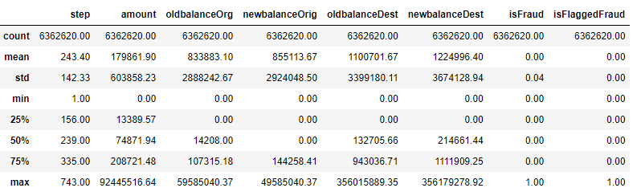

Figure 1 – Statistical Information for this dataset for numerical features

Figure 1 shows the statistical information (count, mean, standard deviation, minimum, maximum, median, 25th and 75th percentile) for each of the numerical features of this dataset.

## Data Distribution

There are **no** missing values in the dataset. There are a total of **6,362,620** rows in the dataset. In the ‘***isFraud’*** column, there are 2 unique values: 0 which represents a normal transaction and 1 a fraudulent transaction. The dataset is highly imbalanced: **6354407** representing normal transactions, **8213** representing fraudulent transactions. This is illustrated by the bar plot shown in Figure 2.

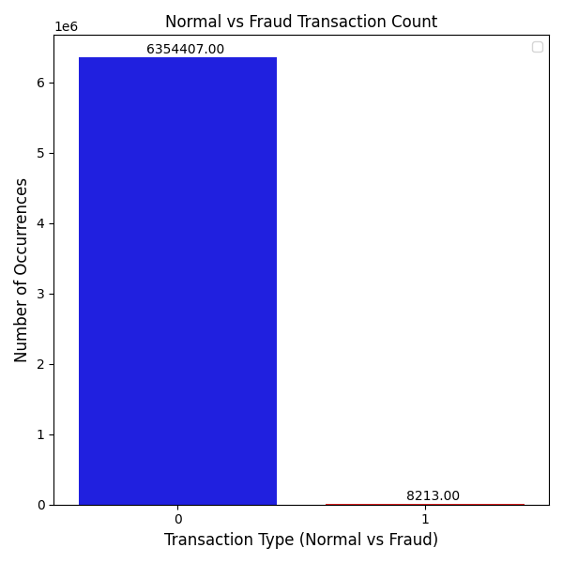

Figure 2 – Counts of Normal vs Fraudulent Transaction Types

Figure 3 shows that there are a total of 5 transaction types and they are:

* Cash Out
* Payment
* Cash In
* Transfer
* Debit

‘Cash Out’ transactions have the largest amount of transactions: **2,237,500**, whilst ‘Debit’ has the smallest amount of transactions at **41,432**.

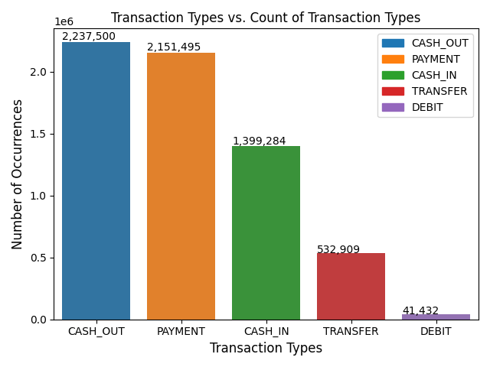

Figure 3 – Distribution of the different Transaction Types

Figure 4 shows a grouping of normal, fraudulent dealings by transaction types. ‘Cash Out’ and ‘Transfer’ have transactions that have been flagged as fraudulent i.e., **4,116** and **4,097** respectively. The remaining transaction types: ‘Cash In’, ‘Debit’ and ‘Payment’ are normal.

Figure 5 shows the fraudulent distribution percentages for ‘Transfer’ (**50.1%**) and ‘Cash Out’ (**49.9%**) as a pie chart. The figures show that their percentages are fairly evenly distributed.

We also examined the transaction originator and recipient of the transaction. There are 4 different types:

* Customer to Customer
* Customer to Merchant
* Merchant to Customer
* Merchant to Merchant

This is the breakdown after analysis (Table 4):

|  | Fraudulent | Normal |
| --- | --- | --- |
| Customer to Customer | 8213 | 4202912 |
| Customer to Merchant | 0 | 2151495 |

Table 4 – Originator to Recipient Transaction Breakdown flagged as Fraudulent, Normal

Table 4 shows that there were **8213** fraudulent transactions committed when the transactions were made from customer to customer (4,202,912 were normal). There were no transactions from merchant to customer and merchant to merchant in this dataset.

There were **287** fraudulent customer-to-customer transactions for amounts of **10,000,000**.

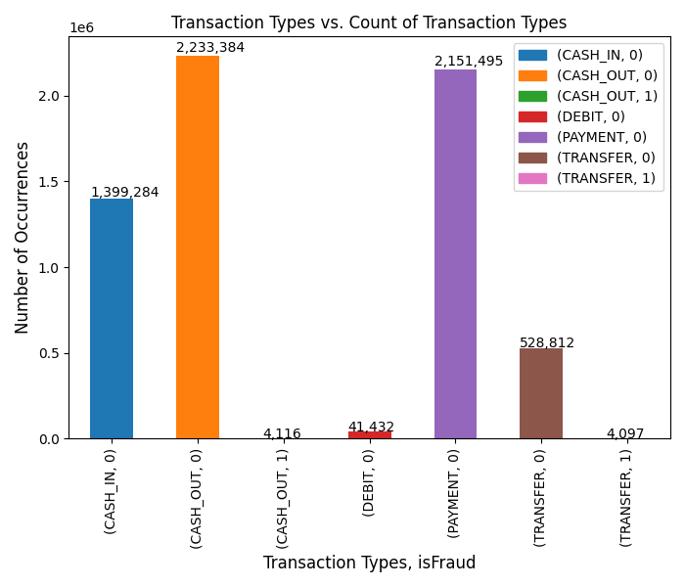

Figure 4 – Distribution of the various transaction types grouped by Normal vs. Fraudulent

In Figure 6, the right column displays the ‘recipient balance amount mismatches’ plot shows **25.6%** mismatch after subtracting the amount transacted from the original balance. The left column shows ‘recipient amount received exceeds available balance’ shows a value of **58.2%** (amount received does not exceed balance in account).

In Figure 7, the right column displays the ‘sender balance amount mismatches’ plot shows **85.1%** mismatch after subtracting the amount transacted from the original balance. The left column shows ‘sender amount transferred exceeds available balance’ shows a value of **64.1%**.

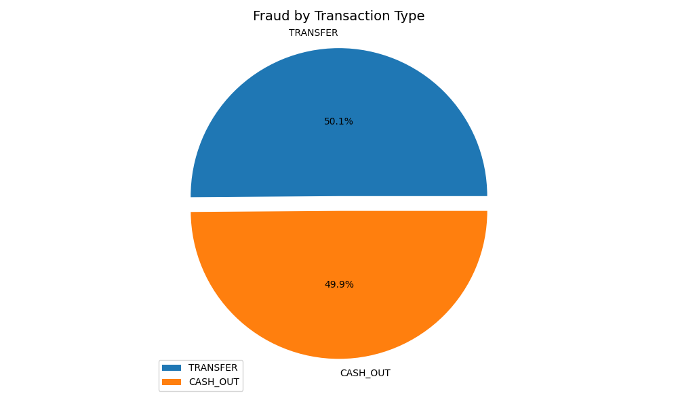

Figure 5 – Transaction Types ‘Transfer’ and ‘Cash Out’ Fraudulent Distributions

| Recipient Amount Transferred Exceeds Available Balance | Recipient Balance Amount Mismatches |
| --- | --- |
|  |  |

Figure 6 – Recipient Balances

| Sender Amount Transferred Exceeds Available Balance | Sender Balance Amount Mismatches |
| --- | --- |
|  |  |

Figure 7 – Sender Balances

## Analysis of the “Step” Feature

Here, we examine the ‘step’ attribute to determine if fraudulent transactions are happening at a particular time of the day or day of the week.

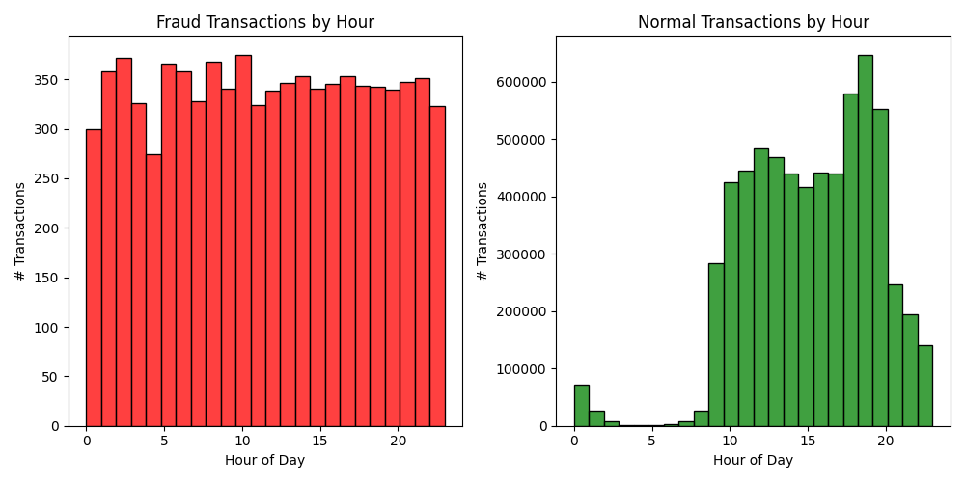

Figure 8 – Hour of day vs # Fraudulent Transactions (left), Hour of day vs # Normal Transactions (right)

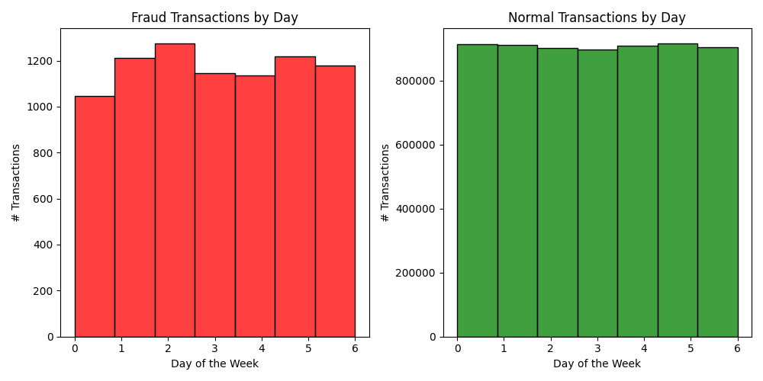

Figure 9 – Day of Week vs # Fraudulent Transactions (left), Day of Week vs # Normal Transactions (right)

Figure 8 shows a plot of hour of day vs fraudulent (in red) / normal transactions (in green). From the graph, fraudulent transactions occurred throughout the day, the minimum number of fraudulent transactions of 270 happening around the 6th hour and the maximum number of fraudulent transactions of around 370 happening at the 11th hour. The number of fraudulent transactions is fairly consistent throughout the day. Normal transactions mostly happen around the 10th hour and maxes out around the 20th hour before tapering off. Nearly no transactions happen between the 3rd to 7th hour.

Figure 9 shows a plot of day of the week vs fraudulent (in red) / normal transactions (in green). Normal transactions are fairly constant across the days of the week. Fraudulent transactions show a fairly consistent trend across the week.

## Skew (Along Columns)

Next, we examine the skewness of this dataset.

| Numerical Features | Skew | Skew (Log) |
| --- | --- | --- |
| Step | 0.38 | -0.98 |
| Amount | 30.99 | 3.43 |
| oldbalanceOrg | 5.25 | 1.66 |
| newbalanceOrig | 5.18 | 1.64 |
| oldbalanceDest | 19.92 | 2.99 |
| newbalanceDest | 19.35 | 2.96 |
| isFraud | 27.78 | 3.32 |
| isFlaggedFraud | 630.60 | 6.45 |

Table 5 – Feature Skewness

Skewness measures the symmetry of a distribution.

If the absolute value of skew < 0.5 then very symmetric.

If the absolute value of skew is between 0.5 and 1 then the data is slightly skewed

If the absolute value of skew is greater than 1 then the data is very skewed (to the right).

From the skewness values, we observe that the majority of the features have values that are bigger than 1 (except step). We can conclude that the dataset is highly skewed.

## Kurtosis (Along Columns)

Here we explore data kurtosis.

| Numerical Features | Kurtosis | Kurtosis (Log) |
| --- | --- | --- |
| Step | 0.33 | -1.11 |
| Amount | 1797.96 | 7.49 |
| oldbalanceOrg | 32.96 | 3.50 |
| newbalanceOrig | 32.07 | 3.47 |
| oldbalanceDest | 948.67 | 6.86 |
| newbalanceDest | 862.16 | 6.76 |
| isFraud | 769.70 | 6.65 |
| isFlaggedFraud | 397659.06 | 12.89 |

Table 6 – Feature Kurtosis

Kurtosis is the measure of outliers present in the distribution. It determines the heaviness of the distribution tails.

High kurtosis in a data set is an indicator that data has heavy outliers.

Low kurtosis in a data set is an indicator that the data has a lack of outliers.

Since the majority of the kurtosis values are greater than 1 (except step), this indicates the distribution is very peaked i.e. is heavy tailed and hence has outliers.

# Feature Engineering

Once exploratory data analysis is done, we drop the following columns:

* Step
* nameOrig
* nameDest
* isFlaggedFraud

and we add the following columns:

**ErrorBalanceOrigin** – Errors in the originating balances taking into the account the amount transacted

**ErrorBalanceDest** – Errors in the destination balances taking into the account the amount transacted

These 2 new features (account balance errors) were added to the dataset because errors in the originating and final destination could be a good indicator of fraudulent transactions. This was later verified when we computed the feature importance(s) (see section 6.2). ‘**ErrorBalanceOrigin**” came out tops and with ‘**ErrorBalanceDest**’ coming in at number 4.

‘**Step**’ was removed because data analysis has shown that fraudulent transactions were not affected by time of day or even day of the week.

‘**nameOrig**’ and ‘**nameDest**’ features were also dropped. Analysis have shown that all the fraudulent transactions occurred between ‘Customer-to-Customer’ (Table 4). The remaining transactions from customer to merchant were all normal. No transactions from merchant to customer and merchant to merchant were found in. the dataset.

Finally, the ‘i**sFlaggedFraud**’ attribute is also discarded. There are only **16** entries for this attribute, indicating that an illegal attempt was made to transfer more than 200.000 in a single transaction.

After applying feature engineering and throwing away the irrelevant attributes, the final features that we are left with are (Table 7):

| Attribute | Type |  |
| --- | --- | --- |
| type | object | Will be one hot encoded since this is a categorical variable |
| amount | float64 |  |
| oldbalanceOrg | float64 |  |
| newbalanceOrig | float64 |  |
| oldbalanceDest | float64 |  |
| newbalanceDest | float64 |  |
| ErrorBalanceOrig | float64 |  |
| ErrorBalanceDest | float64 |  |
| isFraud | int64 | Label |

Table 7 – Results of Feature Engineering

The rows highlighted in yellow are the newly engineered features. Table 8 shows the results after one hot encoding has been applied to the categorical attribute, ‘type’. It has been expanded out to 5 ‘new’ attributes. The row highlighted in green will be used as the label.

| Attribute | Type |
| --- | --- |
| type_CASH_IN | int64 |
| type_CASH_OUT | int64 |
| type_DEBIT | int64 |
| type_PAYMENT | int64 |
| type_TRANSFER | int64 |
| amount | float64 |
| oldbalanceOrg | float64 |
| newbalanceOrig | float64 |
| oldbalanceDest | float64 |
| newbalanceDest | float64 |
| ErrorBalanceOrig | float64 |
| ErrorBalanceDest | float64 |
| isFraud | int64 |

Table 8 – After applying One Hot Encoding

## Correlation

Figure 10 shows the correlation map using the original feature attributes of the dataset. The ‘type’ attribute was one hot encoded before applying the correlation function.

Each square shows the correlation between the variables on each axis. Correlation ranges from -1 to +1. Values closer to zero means there is no linear trend between the two variables. The close to 1 the correlation is the more positively correlated they are; that is as one increases so does the other and the closer to 1 the stronger this relationship is. A correlation closer to -1 is similar, but instead of both increasing one variable will decrease as the other increases. The diagonals are all 1 because those squares are correlating each variable to itself (so it is a perfect correlation). For the rest, the larger the number and darker the colour, the higher the correlation between the two variables. The plot is also symmetrical about the diagonal since the same two variables are being paired together in those squares.

Figure 11 shows the correlation map with additional features: *ErrorBalanceOrigin* and *ErrorBalanceDest* added to the feature set.

From Figure 10, we observe that the following pairs are correlated:

|  |  |
| --- | --- |
| y-axis | x-axis |
| newBalanceOrig | oldBalanceOrg |
| newBalanceDest | oldBalanceDest |

Table 9 – Correlation Pairs based on Figure 10

We only look at the pale orange boxes, which show the highly correlated features.

From Figure 11, we observe that the following pairs are correlated:

|  |  |
| --- | --- |
| y-axis | x-axis |
| newBalanceOrig | oldBalanceOrg |
| newBalanceDest | oldBalanceDest |
| ErrorBalanceOrig | amount |
| ErrorBalanceDest | amount |
| ErrorBalanceOrig | ErrorBalanceDest |

Table 10 – Correlation Pairs based on Figure 11

Likewise, we look at the pale orange boxes, which show the highly correlated features.

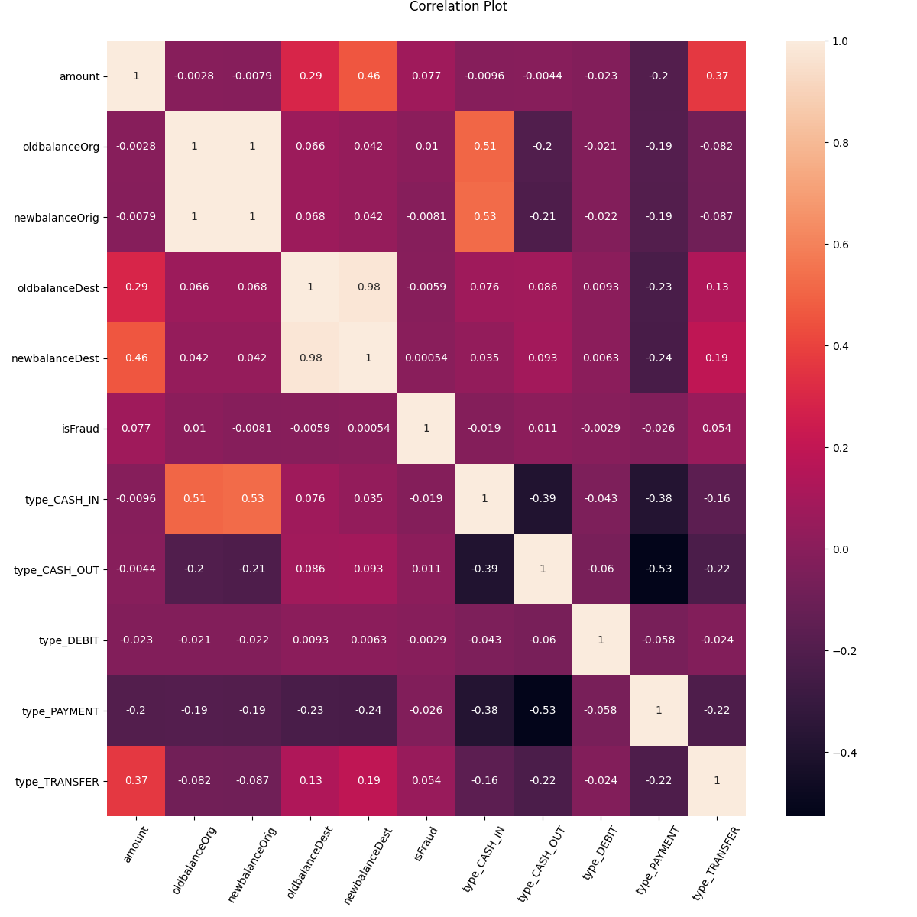

Figure 10 – Correlation Map

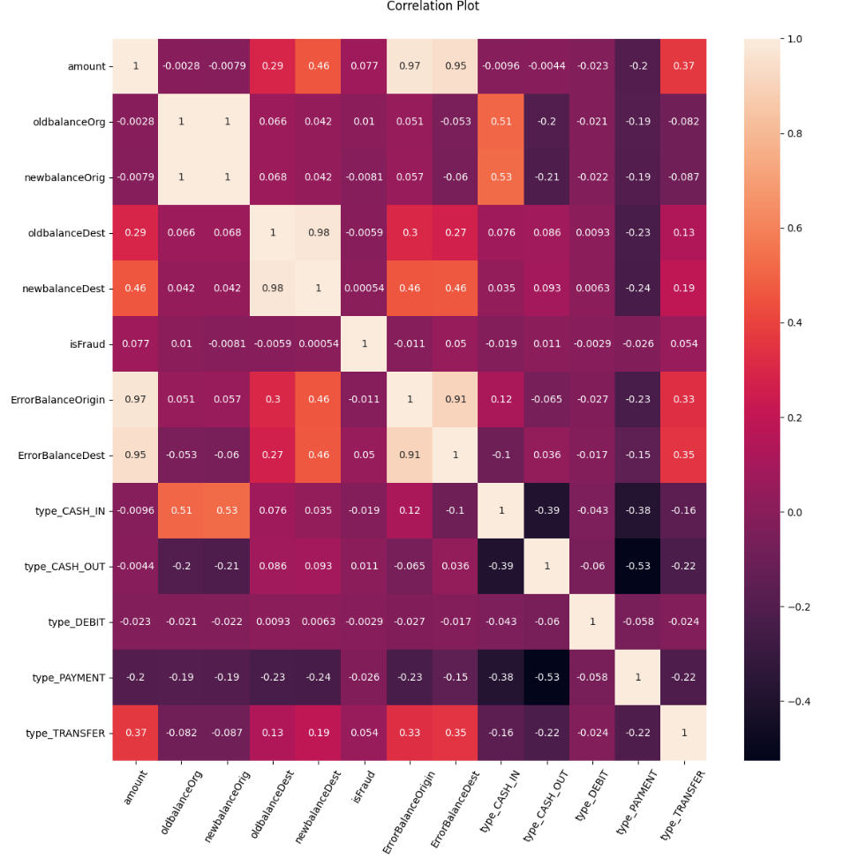

Figure 11 – Correlation Map (feature engineered with ‘ErrorBalanceOrigin’ and ‘ErrorBalanceDest’ added

## Feature Importance

Next, we examine and visualize the import input features of the dataset.

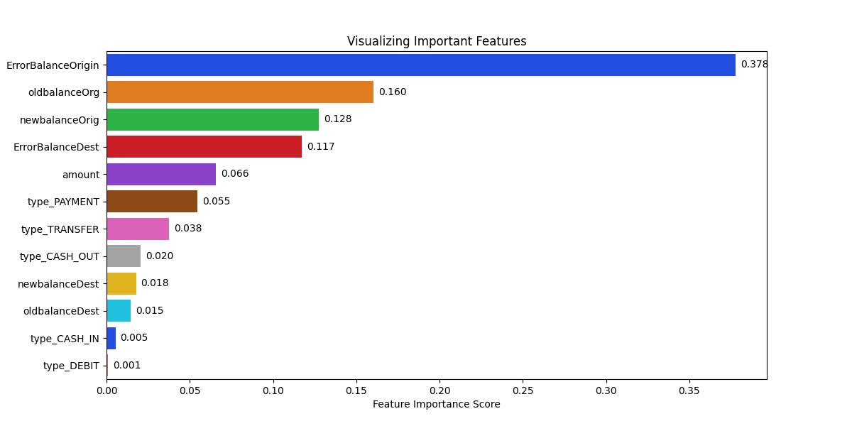

Figure 12 – Feature Importance Distribution

This uses a technique that assigns a score to the input features based on how useful they are at predicting a target variable. We use the *RandomForestClassifier()* algorithm to find out the important features associated with this dataset. After being fit, the model provides a *feature_importances_* property that can be accessed to retrieve the relative importance scores for each input feature. From Figure 12, the top 5 features are:

* ErrorBalanceOrigin
* OldbalanceOrg
* NewbalanceOrg
* ErrorBalanceDest
* Amount

## Preparing the dataset for training & Imbalance dataset handling

We use *StratifiedShuffleSplit()* instead of *train_test_split()* to divide the dataset into train and test sets. *StratifiedShuffleSplit()* is a combination of both *ShuffleSplit()* and *StratifiedKFold()*. Using *StratifiedShuffleSplit()* the proportion of distribution of class labels is almost even between train and test dataset. The major difference between *train_test_split()* and *StratifiedShuffleSplit()* is that the former is pure random sampling without considering any distribution whilst the latter can be understood as a sampling, considering the distribution of categories. *StratifiedShuffleSplit()* is usually recommended for imbalanced datasets.

The dataset is split in the following proportion, 80:20, with “n_splits” set to 1.

In addition to applying *StratifiedShuffleSplit()*, we apply over-sampling techniques such as SMOTE to address the data imbalance problem*.*

# Machine Learning Approaches to Fraud Detection

We will apply supervised learning approaches to the problem of detecting fraudulent financial transactions. We plan to use the following algorithms for building a fraud detection model:

1. Logistic Regression
2. Gaussian Naïve-Bayes
3. XGBoost
4. Decision Tree Classifier
5. Random Forest Classifier
6. CatBoost
7. LightGBM
8. Bagging Classifier

Since this is a classification problem, we start with simple classifiers such as Logistic Regression, Gaussian Naïve-Bayes and Decision Trees. We then go on to try ensemble methods: Bagging (Random Forest Classifier, Bagging Classifier) & Boosting in particular the Gradient Tree Boosting (XGBoost, LightGBM and CatBoost). The Bagging Classifier uses the Decision Tree Classifier as its base class.

# Experiments and Evaluation Metrics

This section presents some of the preliminary results that were obtained when we ran the algorithms.

Accuracy alone is not a good metric for highly skewed datasets. We will have to look at other metrics such as:

* Confusion Matrix
* Precision
* Recall
* F1 Score
* Precision Recall curve

to get more insights into the performance of the model.

Using the above metrics, we find the best values for the different algorithms. The winning algorithm will be the final model that will be deployed in production.

Recall (sensitivity) is a measure of our model correctly identifying true positives. It is particularly pertinent when we need to correctly identify the positive scenarios, like in a cancer detection dataset or in this instance fraud detection. Accuracy or precision will not be that helpful in this case.

A good F1 score means that you have low false positives and low false negatives, so you’re correctly identifying real threats (in this case real fraud cases), and you are not disturbed by false alarms. An F1 score is considered perfect (more accurate) when it is 1, while the model is a total failure when it is 0.

Precision-Recall curves are used in cases of imbalanced datasets (in the case of fraud detection).

AUC-ROC curves are unsuitable for imbalanced datasets because a small number of correct or incorrect predictions can result in a large change in the ROC Curve or ROC AUC score. The AUC-ROC curves are added here for completeness

The confusion matrix (or error matrix) is a summary of prediction results on a classification problem. It a measure of the effectiveness of our model.

## Logistic Regression

The experimental results after running the ‘Logistic Regression’ are shown in Table 11. The confusion matrix and the precision recall curves are shown in Figure 13 and Figure 14 Figure 14respectively. Table 12 shows the hyper-parameters using for the training of the Logistic Regression model.

precision recall f1-score support

0 1.00 0.95 0.97 1270881

1 0.02 0.94 0.04 1643

accuracy 0.95 1272524

macro avg 0.51 0.95 0.51 1272524

weighted avg 1.00 0.95 0.97 1272524

| Score Type | Value |
| --- | --- |
| Precision Score | 0.023 |
| Recall Score | 0.943 |
| F1 Score | 0.044 |
| Balanced Accuracy | 0.945 |
| AUC ROC Score | 0.945 |

Table 11 – Logistic Regression Performance Scores

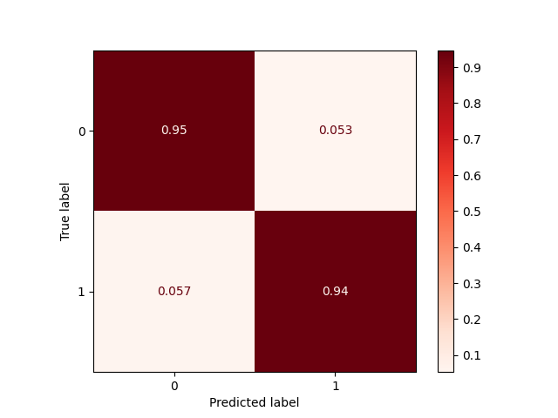

Figure 13 – Logistic Regression Confusion Matrix

| Precision-Recall Curve | AUC-ROC Curve |
| --- | --- |
|  |  |

Figure 14 – Logistic Regression: Precision-Recall and AUC-ROC Curves

|  |  |
| --- | --- |
| Hyper-parameter | Value |
| max_iter | 10000 |
| random_state | 88 |

Table 12 – Logistic Regression Hyper-parameters

## Gaussian Naive-Bayes

The experimental results after running the ‘Gaussian Naïve-Bayes’ are shown in Table 13. The confusion matrix and the precision recall curves are shown in Figure 15 and Figure 16 respectively.

The default hyper-parameters were used for Gaussian Naïve-Bayes.

precision recall f1-score support

0 1.00 0.57 0.73 1270881

1 0.00 0.99 0.01 1643

accuracy 0.57 1272524

macro avg 0.50 0.78 0.37 1272524

weighted avg 1.00 0.57 0.73 1272524

| Score Type | Value |
| --- | --- |
| Precision Score | 0.003 |
| Recall Score | 0.993 |
| F1 Score | 0.006 |
| Balanced Accuracy | 0.783 |
| AUC ROC Score | 0.783 |

Table 13 – Gaussian Naïve-Bayes Performance Scores

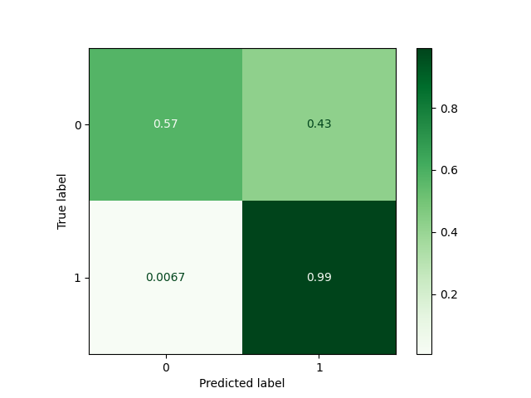

Figure 15 – Gaussian Naïve-Bayes Confusion Matrix

| Precision-Recall Curve | AUC-ROC Curve |
| --- | --- |
|  |  |

Figure 16 - Gaussian Naïve-Bayes: Precision-Recall and AUC-ROC Curves

## XGBoost

The experimental results after running the ‘XGBoost’ are shown in Table 16. The confusion matrix and the precision recall curves are shown in Figure 17 and Figure 18 respectively. Table 15 shows the default parameters used for XGBoost.

precision recall f1-score support

0 1.00 1.00 1.00 1270881

1 0.83 1.00 0.90 1643

accuracy 1.00 1272524

macro avg 0.91 1.00 0.95 1272524

weighted avg 1.00 1.00 1.00 1272524

| Score Type | Value |
| --- | --- |
| Precision Score | 0.826 |
| Recall Score | 0.996 |
| F1 Score | 0.903 |
| Balanced Accuracy | 0.998 |
| AUC ROC Score | 0.998 |

Table 14 – XGBoost Performance Scores

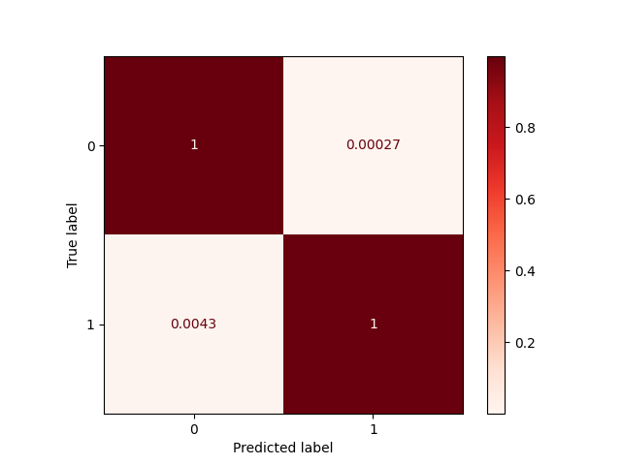

Figure 17 – XGBoost Confusion Matrix

| Precision-Recall Curve | AUC-ROC Curve |
| --- | --- |
|  |  |

Figure 18 – XGBoost: Precision-Recall and AUC-ROC Curves

| Hyper-parameter | Value |
| --- | --- |
| tree_method | exact |
| max_depth | 3 |
| n_estimators | 50 |
| random_state | 88 |

Table 15 – XGBoost Hyper-parameters

## Decision Tree Classifier

The experimental results after running the ‘Decision Tree Classifier’ are shown in Table 16. The confusion matrix and the precision recall curves are shown in Figure 19 and Figure 20 respectively. Table 17 shows the default hyper-parameters used for the Decision Tree Classifier.

precision recall f1-score support

0 1.00 1.00 1.00 1270881

1 0.97 0.99 0.98 1643

accuracy 1.00 1272524

macro avg 0.99 1.00 0.99 1272524

weighted avg 1.00 1.00 1.00 1272524

| Score Type | Value |
| --- | --- |
| Precision Score | 0.975 |
| Recall Score | 0.995 |
| F1 Score | 0.985 |
| Balanced Accuracy | 0.997 |
| AUC ROC Score | 0.997 |

Table 16 – Decision Tree Classifier Performance Scores

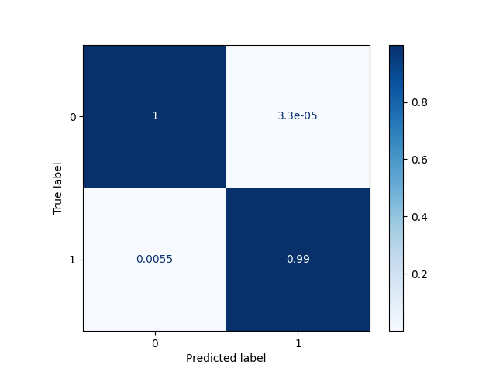

Figure 19 – Decision Tree Classifier Confusion Matrix

| Precision-Recall Curve | AUC-ROC Curve |
| --- | --- |
|  |  |

Figure 20 – Decision Tree Classifier: Precision-Recall and AUC-ROC Curves

|  |  |
| --- | --- |
| Hyper-parameter | Value |
| max_depth | 3 |
| random_state | 88 |

Table 17 – Decision Tree Classifier Hyper-parameters

## Random Forest Classifier

The experimental results after running the ‘Random Forest Classifier’ are shown in Table 18. The confusion matrix and the precision recall curves are shown in Figure 21 and Figure 22Figure 24 respectively. Table 19 shows the default hyper-parameters used for training the random forest classifier.

| Score Type | Value |
| --- | --- |
| Precision Score | 0.867 |
| Recall Score | 0.995 |
| F1 Score | 0.927 |
| Balanced Accuracy | 0.997 |
| AUC ROC Score | 0.997 |

Table 18 – Random Forest Classifier Performance Scores

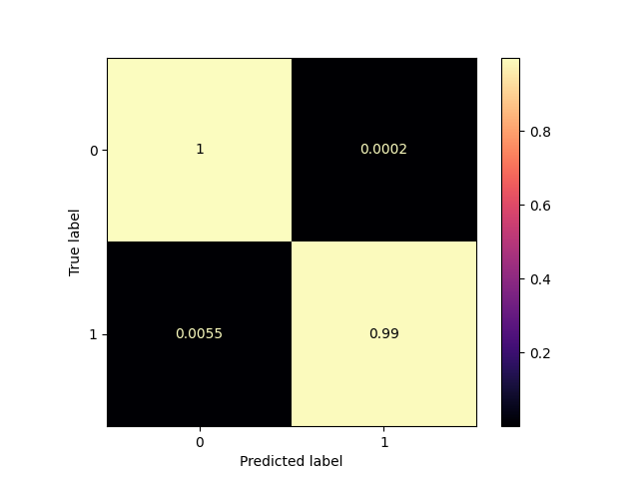

Figure 21 – Random Forest Classifier Confusion Matrix

| Precision-Recall Curve | AUC-ROC Curve |
| --- | --- |
|  |  |

Figure 22 – Random Forest Classifier Precision-Recall and AUC-ROC Curve

|  |  |
| --- | --- |
| Hyper-parameter | Value |
| n_estimators | 50 |
| n_jobs | -1 |
| oob_score | True |
| random_state | 88 |

Table 19 – Random Forest Classifier Hyper-parameters

## CatBoost

The experimental results after running the ‘CatBoost’ are shown in Table 20. The confusion matrix and the precision recall curves are shown in Figure 23 and Figure 24 respectively. Table 21 shows the hyper-parameters for training the CatBoost model.

precision recall f1-score support

0 1.00 1.00 1.00 1270881

1 0.98 1.00 0.99 1643

accuracy 1.00 1272524

macro avg 0.99 1.00 1.00 1272524

weighted avg 1.00 1.00 1.00 1272524

| Score Type | Value |
| --- | --- |
| Precision Score | 0.984 |
| Recall Score | 0.996 |
| F1 Score | 0.99 |
| Balanced Accuracy | 0.998 |
| AUC ROC Score | 0.998 |

Table 20 – CatBoost Classifier Performance Scores

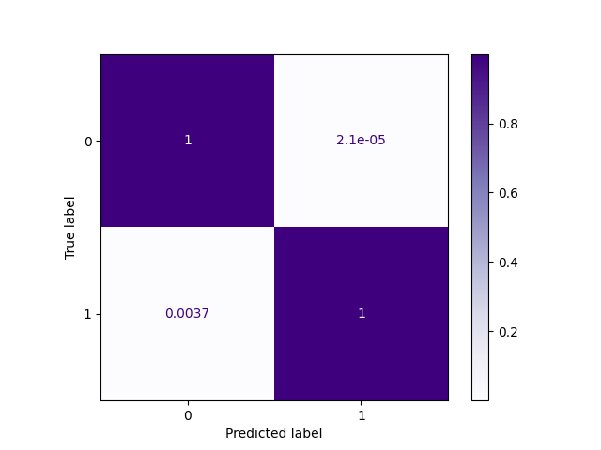

Figure 23 – CatBoost Confusion Matrix

| Precision-Recall Curve | AUC-ROC Curve |
| --- | --- |
|  |  |

Figure 24 – CatBoost: Precision-Recall and AUC-ROC Curves

|  |  |
| --- | --- |
| Hyper-parameter | Value |
| iterations | 5 |
| learning_rate | 0.1 |
| random_state | 88 |

Table 21 – CatBoost Hyper-parameters

## LightGBM

The experimental results after running the ‘LightGBM’ are shown in Table 22. The confusion matrix and the precision recall curves are shown in Figure 25 and Figure 26 respectively. Table 23 shows the hyper-parameters used for training the LightGBM model.

precision recall f1-score support

0 1.00 1.00 1.00 1270881

1 0.81 1.00 0.89 1643

accuracy 1.00 1272524

macro avg 0.90 1.00 0.95 1272524

weighted avg 1.00 1.00 1.00 1272524

| Score Type | Value |
| --- | --- |
| Precision Score | 0.808 |
| Recall Score | 0.998 |
| F1 Score | 0.893 |
| Balanced Accuracy | 0.999 |
| AUC ROC Score | 0.999 |

Table 22 – LightGBM Performance Scores

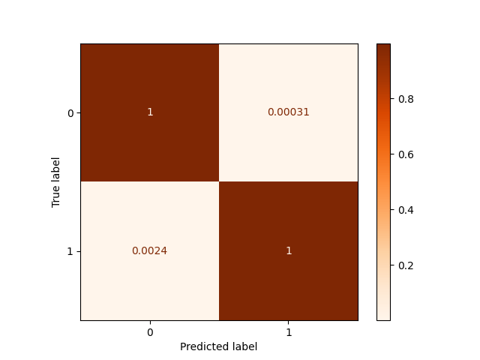

Figure 25 – LightGBM Confusion Matrix

| Precision-Recall Curve | AUC-ROC Curve |
| --- | --- |
|  |  |

Figure 26 – LightGBM: Precision-Recall and AUC-ROC Curves

|  |  |
| --- | --- |
| Hyper-parameter | Value |
| boosting_type | gbdt |
| learning_rate | 0.1 |
| random_state | 88 |

Table 23 – LightGBM Hyper-parameters

## Bagging Classifier

The experimental results after running the ‘Bagging Classifier’ are shown in Table 24. The confusion matrix and the precision recall curves are shown in Figure 27 and Figure 28 respectively. Table 25 shows the default parameters used training the bagging classifier model.

precision recall f1-score support

0 1.00 1.00 1.00 1270881

1 0.86 0.99 0.92 1643

accuracy 1.00 1272524

macro avg 0.93 1.00 0.96 1272524

weighted avg 1.00 1.00 1.00 1272524

| Score Type | Value |
| --- | --- |
| Precision Score | 0.858 |
| Recall Score | 0.995 |
| F1 Score | 0.921 |
| Balanced Accuracy | 0.997 |
| AUC ROC Score | 0.997 |

Table 24 – Bagging Classifier Performance Scores

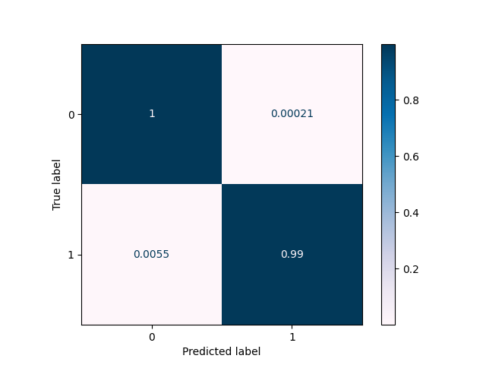

Figure 27 – Bagging Classifier Confusion Matrix

| Precision-Recall Curve | AUC-ROC Curve |
| --- | --- |
|  |  |

Figure 28 – Bagging Classifier: Precision-Recall and AUC-ROC Curves

|  |  |
| --- | --- |
| Hyper-parameter | Value |
| base_estimtator | DecisionTreeClassifier(random_state=88) |
| random_state | 88 |

Table 25 – Bagging Classifier Hyper-parameters

# Results Summary

Table 26 shows the summary scores for all the experiments we carried out on this dataset.

|  | Recall | Precision | F1 Score | Balanced Accuracy |
| --- | --- | --- | --- | --- |
| Logistic Regression | 0.943 | 0.023 | 0.044 | 0.945 |
| Gaussian Naïve-Bayes | 0.993 | 0.003 | 0.006 | 0.783 |
| XGBoost | 0.996 | 0.826 | 0.903 | 0.998 |
| Decision Tree Classifier | 0.995 | 0.975 | 0.985 | 0.997 |
| Random Forest Classifier | 0.995 | 0.867 | 0.927 | 0.997 |
| CatBoost | 0.996 | 0.984 | 0.99 | 0.998 |
| LightGBM | 0.998 | 0.808 | 0.893 | 0.999 |
| Bagging Classifier | 0.995 | 0.858 | 0.921 | 0.997 |

Table 26 – Summary Scores

The results show a close race between *CatBoost* and *LightGBM*.

Recall is a better measure to use compared to precision or accuracy in cases when there is a high cost associated with false negatives (e.g., fraud detection or sick patient detection).

Accuracy does not work in in imbalanced datasets (as in this case). Here we have 99% more non-fraudulent data and less than 1% fraud data. If we predict all data points as a normal class, we will at least get 99% correct. This is called accuracy paradox.

Precision is a good measure to determine when the cost of false positives is high e.g., a movie recommender system which drives value by consistently delivering suggestions the user will enjoy. Precision is the priority in this scenario because every suggestion must be a correct prediction to maintain usability. For fraud detection, precision will not be a good measure.

The F1-score can be used primarily to compare the performance of two classifiers. LightGBM has a recall of **0.998** compared to CatBoost, whose recall is **0.996**. CatBoost has a higher precision **0.984** compared to LightGBM **0.808**. In this case, the F1-scores for both the classifiers can be used to determine which one produces better results. The F1-score for CatBoost is **0.99** whilst that of LightGBM is **0.893**. We can conclude that **CatBoost is the better classifier**.

| Precision-Recall Curves for the different classifiers | |
| --- | --- |
| Logistic Regression PR-Curve | **Gaussian Naïve-Bayes PR-Curve** |
| XBGoost PR-Curve | **Decision Tree Classifier PR-Curve** |
| Random Forest Classifier PR-Curve | **CatBoost PR-Curve** |
| LightGBM PR-Curve | **Bagging Classifier PR-Curve** |

Table – Precision- Recall (PR) Curves for the different classifiers

Table 27 shows the PR curves for the different classifiers used in our experiments. We observe that all the ensemble methods (random forest, CatBoost, LightGBM and Bagging Classifiers) exhibit near perfect precision recall curves. The Decision Tree Classifier also exhibits a near perfect precision recall curve. The PR-curves for Logistic Regression and Naïve-Bayes Classifier display fairly poor results when compared to the ensemble and decision tree classifiers.

# Grid Searching to find best parameters

Given the close race between the CatBoost and LightGBM classifiers, the next steps would be to apply GridSearch to determine if we can narrow down and find the best parameters to use. Once the best parameters have been found, we will need to run the experiments to evaluate the resulting metrics from the experimental runs to determine the final model we will use in our deployment.

The parameters that we selected to apply grid searching on are the important parameters that control overfitting [2].

The maximum number of iterations used for both was 25.

For CatBoost, the parameters we used to tune were:

* Learning rate
* Depth
* L2 leaf regularization

Likewise, for LightGBM, the following parameters were chosen for tuning:

* Learning rate
* Maximum depth
* Minimum data in leaf

Table 28 show the parameter values that we use as a basis to start the parameter search and the results of grid search are displayed under the ‘best parameters’ column (highlighted in yellow).

| CatBoost | Values | Best  Parameters | LightGBM | Values | Best  Parameters |
| --- | --- | --- | --- | --- | --- |
| Learning Rate (This determines how fast or slow the model will learn. The default is usually 0.03) | 0.001, 0.01, 0.5 | 0.01 | Learning Rate (Default: 0.1) | 0.001, 0.01, 0.5 | 0.01 |
| Depth (up to 16) (tree depth) | 4, 6, 10 | 10 | Max depth (Controls the max depth of each trained tree; If you use a large value of **max_depth**, your model will likely be **over fit** to the train set) | 10, 50 | 10 |
| L2-leaf-reg (Coefficient at the L2 regularization term of the cost function. The default is 3.0) | 10, 15, 25 | 10 | Min Data in Leaf: the minimum number of data/sample/count per leaf (default is 20; lower min_data_in_leaf means less conservative/control, potentially overfitting). | 500, 1000 | 1000 |

Table 28 – Best Parameters after GridSearch applied

Using the best parameters that were returned by GridSearch, we use these to retrain our model. Table 29 shows the improvement in the precision and F1 scores for both CatBoost and LightGBM when using the new parameter set (items highlighted in yellow).

| Score Type | CatBoost  (Old Hyper Parameters) | CatBoost | Light GBM  (Old Hyper Parameters) | Light GBM |
| --- | --- | --- | --- | --- |
| **Precision Score** | 0.984 | 0.993 | 0.808 | 0.888 |
| **Recall Score** | 0.996 | 0.996 | 0.998 | 0.997 |
| **F1 Score** | 0.99 | 0.995 | 0.893 | 0.939 |
| **Balanced Accuracy** | 0.998 | 0.998 | 0.999 | 0.998 |
| **AUC ROC Score** | 0.998 | 0.998 | 0.999 | 0.998 |

Table 29 – Performance Scores using best parameters found by GridSearch

We again use the F1-score to compare the performance of two classifiers. LightGBM has a recall of **0.997** compared to CatBoost, whose recall is **0.996**. CatBoost has a new higher precision **0.993** compared to LightGBM’s new precision score of **0.888**. In this case, the F1-scores for both the classifiers can be used to determine which one produces better results. The new F1-score for CatBoost is **0.995** whilst the new F1-score for LightGBM is **0.939**. From this, we again conclude that **CatBoost is the better classifier**.

| CatBoost | LightGBM |
| --- | --- |
|  |  |

Figure 29 – Confusion Matrix CatBoost and LightGBM using best hyper-parameters found by GridSearch

| CatBoost | LightGBM |
| --- | --- |
|  |  |
| Precision-Recall Curves | |
|  |  |
| AUC-ROC Curves | |

Figure 30 – CatBoost and LightGBM Precision-Recall and AUC-ROC Curves using best hyper-parameters found by GridSearch

Again, the PR-curves for CatBoost and LightGBM show similar characteristics – near perfect precision-recall curves (Figure 30), even after applying Grid Search to determine the best parameters.

# Deployment

We have created a simple Flask-based web application where users are able to input a set of features, (Amount, Initial Sender Balance, New Sender Balance, Initial Recipient Balance, New Recipient Balance, Sender Amount Difference, Recipient Amount Difference & Transfer type), as parameters to query our model and it will generate an output on whether the transaction is a fraudulent or not (1 for fraudulent, 0 for genuine).

The screen shots for our web-based flask application are shown Figure 31.

|  |
| --- |
|  |

Figure 31 – Fraud Detector Web Front End

|  |
| --- |
|  |

Figure 32 – Results Returned – OK

|  |
| --- |
|  |

Figure 33 – Results Returned – FRAUD

# Conclusion and Future Work

This project investigated the problem of detecting fraud in financial transactions. As financial transactional data is hard to come by, we used the dataset from Kaggle. This has been generated by the PaySim mobile generator [1]. It simulates mobile money transactions based on a sample of real transactions extracted from one month of financial logs from a mobile money service implemented in an African country.

The work is broken down into several parts and they are listed as follows:

* Exploratory Data Analysis
* Feature Engineering
* Experiments and analysis of results
* Applying Grid Search to narrow down the best parameters on the top 2 models
* Deploying the solution as a Web Application

A number of different algorithms were tried. These ranged from the simple like Logistic Regression to more complex models (ensemble techniques).

Results from the experimental runs have demonstrated that “LightGBM” gave the highest recall score of **0.997** followed closely by “CatBoost”, with a recall score of **0.996**. The difference between the 2 scores is only 0.001 (very small). Only the precision and F1 scores showed an improvement. Precision scores are not as useful compared to recall in the case of fraud detection. The F1 score for “CatBoost” is higher (**0.995**) compared to “LightGBM” (**0.939**) – a difference of 0.056. This means that CatBoost is more accurate compared to LightGBM on the basis of the F1 score values.

On the basis of these values, we can conclude that CatBoost is the better classifier compared to LightGBM.

Finally, as next steps, we should consider using Bayesian Optimization **Error! Reference source not found.** for hyper-parameter tuning. Given that hyper-parameter tuning is a very time-consuming task, we have only tried a small subset of hyper-parameters. Bayesian optimization promises to be faster way to tune hyper-parameters. It is an approach that uses Bayes Theorem to direct the search in order to find the minimum or maximum of an objective function. This is most useful for objective functions that are complex, noisy, and/or expensive to evaluate and can be potentially used to help in hyper-parameter tuning.

We can also study how we can apply deep learning and neural networks to this problem set.

# Reference

1. Edgar Lopez-Rojas, [Synthetic Financial Datasets For Fraud Detection](https://www.kaggle.com/ealaxi/paysim1)
2. Alvira Swalin, [CatBoost vs. Light GBM vs. XGBoost](https://www.kdnuggets.com/2018/03/catboost-vs-light-gbm-vs-xgboost.html)
3. Somang Han, Tuning Hyperparameters Under 10 Minutes (LGBM)