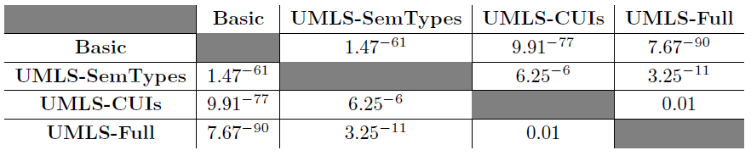

**Table 4.** Paired T-Test p-values comparing RandomForest classification runs

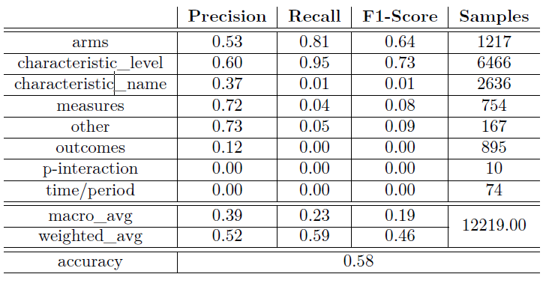

**Table 5.** RandomForest classifier results, basic features (No UMLS)

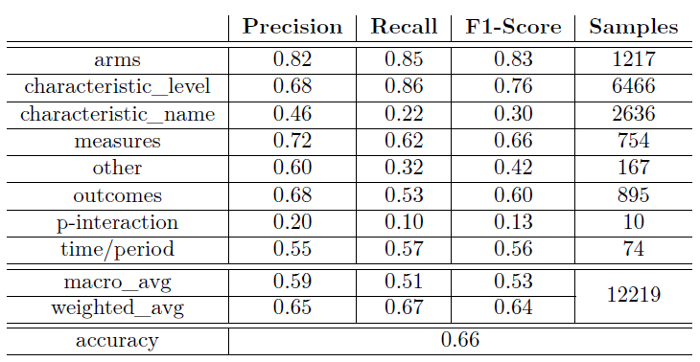

**Table 6.** RandomForest classifier results with Full UMLS features enabled