Table Tidier: RM version something

One1, Two2

1 affiliation 1

2 affiliation 2

## Corresponding Author:

Dr Jesus Alberto Rodriguez Perez, Room 207, 1 Lilybank Gardens, University of Glasgow, G12 8QQ, [jesus.RodriguezPerez@glasgow.ac.uk](mailto:jesus.RodriguezPerez@glasgow.ac.uk), 0751688104.

## Keywords

Up to five keywords or phrases suitable for use in an index (it is recommended to use MeSH terms).

## Word count

excluding title page, abstract, references, figures and tables.

##### _

# Abstract

## Objective

## Background and Significance

## Materials and Methods

## Results

## Discussion

## Conclusion

##### _

# Objective

cite [1], cite [2]

## Subsection: level 2 title ##

### Subsubsection: level 3 title ###

#### Subsubsubsection: level 4 title ####

one can create page breaks using the level 5 titles: #####

# Background and Significance

# Materials and Methods

# Results

to reference a table number in text use table.ref('tab_1') see results in Table 1.

|  |  |  |
| --- | --- | --- |
| Fruit | Price | Advantages |
| Bananas | $1.34 | - built-in wrapper |
|  |  | - bright color |
| ————— | ————— | ——————– |
| Oranges | $2.10 | - cures scurvy |
|  |  | - tasty |

Table 1: This is table tab_1 caption

to print the table caption with the table number use: table_nums('tab_1')

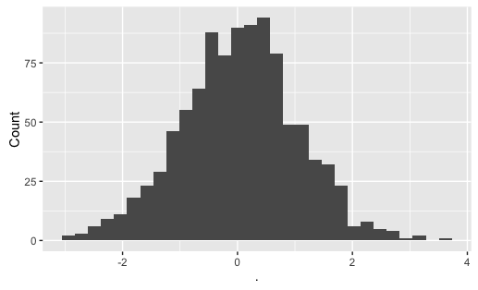

Figure 1: This is figure fig_1 caption

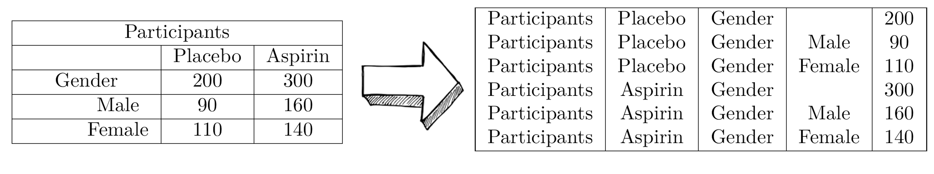

Figure 3: This is the task

|  |  |
| --- | --- |
| col1 | col2 |
| 1 | 1 |
| 2 | 2 |
| 3 | 3 |
| 4 | 4 |
| 5 | 5 |

Table 2: This is table tab_2 caption

# Discussion

# Conclusion

# Acknowledgments

# Competing Interests

# Funding

# Figure legends

Figure 1: This is figure fig_1 caption

Figure 2: This is figure fig_2 caption

# References

1 Miotto R, Li L, Kidd BA *et al.* Deep patient: An unsupervised representation to predict the future of patients from the electronic health records. *Scientific Reports* 2016;**6**:26094. doi:[10.1038/srep26094](https://doi.org/10.1038/srep26094)

2 Ye Z, Mayer J, Ivacic L *et al.* Phenome-wide association studies (phewass) for functional variants. *Eur J Hum Genet* 2015;**23**:523–9. doi:[10.1038/ejhg.2014.123](https://doi.org/10.1038/ejhg.2014.123)