**2018 CSE5CI**

**Computational Intelligence Assignment**

**Latrobe University**

Submitted by:

Ravi Rathore 19539061

Lakshmi Deepak Laveti 19542554

**Index**

1. Problem Description 3

1.1 System Inputs and Outputs 3

2. Outliers Removal 3

2.1 Approach taken for outliers’ removal 3

3. Selecting fuzzy subsets and membership functions 4

3.1 Selecting input variables 4

3.2 Defining fuzzy subsets and membership functions 5

4. Fuzzy rules from the training data 6

5. Creating Fuzzy inference system 7

6. System performance 7

6.1 Effects of membership function and defuzzification method Error! Bookmark not defined.

Code for the assignment 8

References 18

# Problem Description

Develop a fuzzy forecasting system for data analysis using Python. The system performs a forecasting task for power marketing price.

## 1.1 System Inputs and Outputs

Let the temperature and total demand of electricity at time instant ‘t’ be T(t) and D(t), respectively. The goal of the fuzzy forecasting system is to predict the RRP price by using some historical data as system inputs. The historical data set used for building the fuzzy system at time instant t is composed of a subset of the set M={T(t-2), T(t-1), T(t), D(t-2), D(t-1), D(t)}. The output of your system at time instant t is a forecasting value of the Recommended Retail Price (RRP) of electricity at the next time instant t+1, denoted by P(t+1)

# Outliers Removal

We started by analyzing any presence of the outliers in the training and testing data. An outlier is an input data to an inference system which is at abnormal distance from other input variables in a given population of the data.

## 2.1 Approach taken for outliers’ removal

We eliminated outliers using **interquartile range**. The interquartile range is a measure of variability based on dividing the input set into sets called quartiles. The idea is to divide ordered data set into four equal parts. Thus we have three values between four partitions namely Q1, Q2, and Q3 respectively.

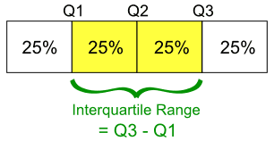

* Q2 is the median of the given input set.
* Q1 and Q3 are the middle values in the first and second half of the input set respectively.
* And, Interquartile range = Q3 - Q1

Then we removed the points which were 1.5*IQR away from the mean and saved the final training and testing data.

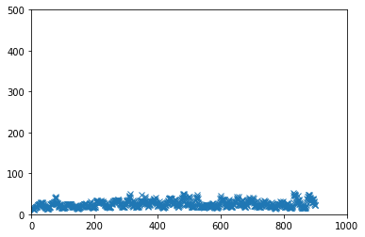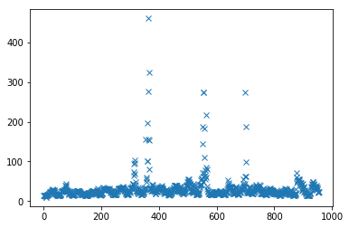

Figure 1Training data with outliers

Figure 2Training data without outliers

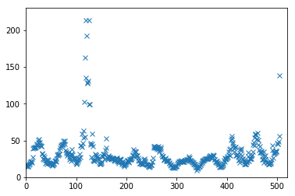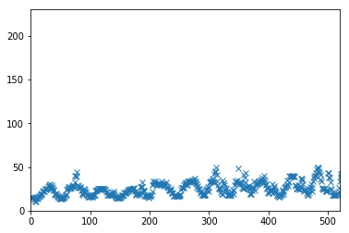

Figure 3Testing data with outliers

Figure 4Testing data after outlier removal

# Selecting fuzzy subsets and membership functions

## Selecting input variables

The training data had multiple input data for each of temperature and demand. It is better to find relation between input variables and take only one of strongly related inputs. This helps to remove unwanted variable and at the same time makes system more efficient.

We performed correlation analysis between input and the output variable to see how strongly they are attached to each other. Using correlation, we got following correlation matrix.

**P(t+1)**

[[1.000 0.977 0.941 0.435 0.493 0.540 **0.493**]**T(t-2)**

[0.977 1.000 0.977 0.371 0.439 0.497 0.462]

[0.941 0.977 1.000 0.297 0.374 0.441 0.418]

[0.435 0.371 0.297 1.000 0.986 0.950 0.530]

[0.493 0.439 0.374 0.986 1.000 0.986 0.565]

[0.540 0.497 0.441 0.950 0.986 1.000 **0.588**]**D(t)**

[0.493 0.462 0.418 0.530 0.565 0.588 1.000]]

The order of columns is T(t-2), T(t-1), T, d(t-2), d(t-1), d(t). A value close to 1 shows a strong

relation between the two variables. Clearly, all the temperatures have very strong relationship and similarly all the demand inputs have very strong relation. So, we can take any one of each.

However, we have to consider relation between inputs and output as well. By looking at correlation table, we found out that T(t-2) and D(t) are strongly related to P(t+1) compared to other temperature and demands. Hence, we take T(t-2) as temperature input and D(t) as demand input for our fuzzy inference system.

## Defining fuzzy subsets and membership functions

Linguistic Variables: temperature and demand.

Now, we have to decide linguistic terms for each of linguistic variable.

For this fuzzy system we have used triangular membership functions . Calculations with triangular and trapezoidal membership are easy. We can not easily calculate the arithmetic operations in case of Bell, Sigmoidal, Asymmetric , LR, Guassian.

Starting with temperature data,

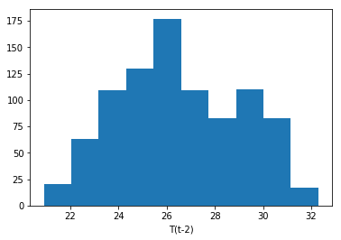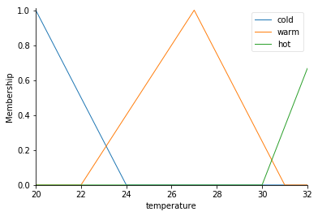

We calculated 25th and 75th percentiles of the data. Below 25th percentile the temperature would be cold and above 75th percentile it would be high. Thereby , between 25th percentile

And 75th percentile it would be warm(average).

25th percentile for temperature = 24.6

75th percentile = 28.6. So we tried to adjust membership functions accordingly and at the same time a decent overlap between the sets have been used.

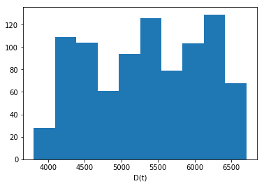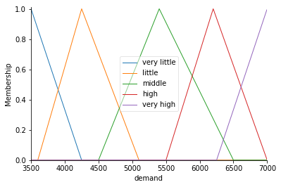

The same was done for demand by calculating 20th, 40th, 60th and 80th percentile from the data.

And creating 5 membership subsets with enough overlap to provide better result.

For price, we created 3 subsets that is , low , medium and high by calculating 25th and 75th percentile from the input data.

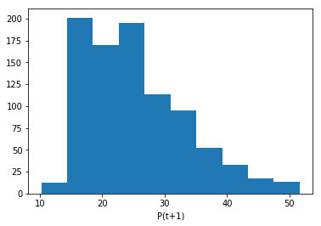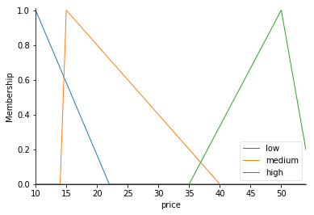

# Fuzzy rules from the training data

The next step is to generate fuzzy rules from the training data so that the inference system can reflect better results based on the training data. We reviewed couple of papers to find a better way to get fuzzy rules and selected the way described in

**“Generating fuzzy rules by leaning from examples” by Li-Xin Wang, Jerry M. Mendel**

Li-Xin and Jerry have suggested following approach to get rules from the input data.

1. Diving input and output variables into fuzzy subsets. This has been done in step3.
2. Generating rules from the training data by assigning degree to each rule.

For a given temperature t, and demand d, and price p; we have to find membership value for each subset then take membership value of the maximum.

For instance, t has degree 0.8 in cold, 0.2 degree in warm and 0.0 degree in hot.

d has 0.9 in very little, 0.6 in little and 0.0 in medium, high and very high.

Price, p, has degree 0.6 in low, 0.3 degree in medium and 0.0 degree in high.

We take maximum degree for each variable, so, t has 0.8 max in cold, d has 0.9 max in very little and p has 0.6 degree max in low.

This defines rule as,

**IF t is *cold* AND d is *very little***

**THEN p is *low***

1. Now we have to assign degree to each rule because there could be conflicting rules for the same input membership classes.

So, the degree of a rule is defined as

D(rule) = mA(t)mB(d)mC(p)

And if we already have such existing rule, then we update the degree of that rule as

D_updated(rule) = mA(t)mB(d)mC(p)*D(rule)

1. Now we have a rule based and we have to choose rule among conflicting ones with the maximum degree of rule and that would give us final rule base.

{'00': (0, 1.0), '11': ('0', 5e-06), '01': ('0', 3.2e-05), '12': ('1', 0.0), '13': ('1', 0.0), '23': ('1', 0.0), '24': ('1', 0.037957), '14': ('1', 0.094978), '22': ('2', 0.005958), '03': ('2', 0.060499), '02': ('2', 0.06468), '21': ('1', 0.000503), '10': ('0', 0.227959)}

This is the rule base generated by us.

**'00': (0, 1.0),** It is stored in a dictionary form. The key ‘00’ represents membership function for temperature and demand.

For t, 0 is low,

1 is medium and

2 is high.

Similarly for d,

0 is very little

1 is little

2 is medium

3 is high

4 is very high

For Price p,

0 is low

1 is medium

2 is high

From the rule base using above notations we made following rules,

rule1 = temperature is cold and demand is very little then price is low

rule2 = temperature is cold and demand is little then price is low

rule3 = temperature is cold and demand is middle then price is high

rule4 = temperature is cold and demand is high then price is high

rule5 = temperature is cold and demand is very high then price is high

rule6 = temperature is warm and demand is very little then price is low

rule7 = temperature is warm and demand is little then price is low

rule8 = temperature is warm and demand is middle then price is medium

rule9 = temperature is warm and demand is high then price is medium

rule10 = temperature is warm and demand is very high then price is medium

rule11 = temperature is hot and demand is very little then price is low

rule12 = temperature is hot and demand is little then price is low

rule13 = temperature is hot and demand is middle then price is medium

rule14 = temperature is hot and demand is high then price is medium

rule15 = temperature is hot and demand is very high then price is medium

# Creating Fuzzy inference system

To build fuzzy inference system, we have used control sub package of skfuzzy library. This is a collection of fuzzy logic algorithms and control is used to design fuzzy system.

Using control package, we feed all the rules to the control system simulation.

This is based on fuzzy logic and takes crisp values for temperature and demand to generate crisp value for price. **compute()** method of the simulation system computes the sugeno style inference.

Although, we have a method called **compute_rule()** to use Mamdani style inference but that would be more heavy on computation and is not efficient in terms of computation.

# System performance

To calculate the efficiency of the fuzzy inference system, we have used Average relative error

Defined as

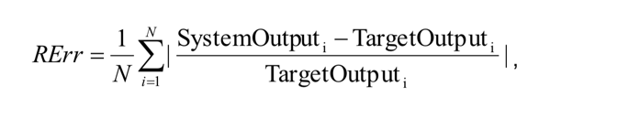

For testing data , we got average relative error : 19.66%

For training data, we got average relative error : 16.23%

## Tuning the system

**Rule update:** The algorithm we used to generate the rules did not generate few rules. So, to improve the system we added 2 rules based on our intuition . And it did reduce the average relative error using updated rules.

**Changing parameters of membership function shape:**

We have used triangular membership function in our system. To better reflect the input data we did multiple trials on input data and continuously updating the shape with very positive feedback from the trails test.

**Overlap between subsets:** By checking different overlaps between the subsets we were able to improve the accuracy and found that a good overlap between fuzzy subsets actually helps to predict better result.

# Code for the assignment

======================

In [1]:

#import libararies here

import numpy as np

import pandas as pd

import matplotlib.pyplot as plt

import skfuzzy as fuzz

from skfuzzy import control as ctrl

In [2]:

fileName = 'Training_Data.csv'

rawTrainingData = pd.read_csv(fileName).values

f = rawTrainingData[:,[6]]

f = f.flatten()

print(f.shape)

plt.plot(f, 'x')

(956,)

Out[2]:

[<matplotlib.lines.Line2D at 0x15181e4e10>]



In [3]:

Q1=np.percentile(f, 25) ; # the value 25 is fixed for every problem;

Q3=np.percentile(f, 75) ; # the value 25 is fixed for every problem;

r=[Q1-1.5*(Q3-Q1),Q3+1.5*(Q3-Q1)];

pos = np.concatenate((np.where(f>r[1]),np.where(f<r[0])),axis=1)

newData = np.delete(rawTrainingData, pos, axis=0)

g = newData[:,[6]]

g = g.flatten()

print(g.shape)

plt.xlim(0, 1000) # use the same axes setting as the above figure (with three outliers)

plt.ylim(0, 500)

plt.plot(g, 'x')

np.savetxt('ProcessedTrainingData.csv', newData, fmt='%.2f', delimiter=',', header=" T(t-2),T(t-1),T(t),D(t-2),D(t-1),D(t),P(t+1)")

(901,)



In [4]:

#remove outliers from the testing data

fileName = 'Testing_Data.csv'

rawTestingData = pd.read_csv(fileName).values

f = rawTestingData[:,[6]]

f = f.flatten()

plt.xlim(0, 520) # use the same axes setting as the above figure (with three outliers) to better reflect the difference

plt.ylim(0, 230)

plt.plot(f, 'x')

Q1=np.percentile(f, 25) ; # the value 25 is fixed for every problem;

Q3=np.percentile(f, 75) ; # the value 75 is fixed for every problem;

r=[Q1-1.5*(Q3-Q1),Q3+1.5*(Q3-Q1)];

pos = np.concatenate((np.where(f>r[1]),np.where(f<r[0])),axis=1)

newTestingData = np.delete(rawTestingData, pos, axis=0)

g = newTestingData[:,[6]]

g = g.flatten()



In [5]:

plt.xlim(0, 520) # use the same axes setting as the above figure (with three outliers) to better reflect the difference

plt.ylim(0, 230)

plt.plot(g, 'x')

Out[5]:

[<matplotlib.lines.Line2D at 0x15214d0fd0>]

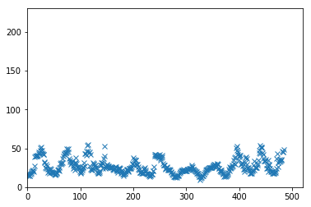

In [6]:

#save processed testing data

np.savetxt('ProcessedTestingData.csv', newTestingData, fmt='%.2f', delimiter=',', header=" T(t-2),T(t-1),T(t),D(t-2),D(t-1),D(t),P(t+1)")

In [7]:

a = newData[:,[0]] # T(t-2)

a = a.flatten()

b = newData[:,[1]] # T(t-1)

b = b.flatten()

c = newData[:,[2]] #T(t)

c = c.flatten()

d1 = newData[:,[3]] #D(t-2)

d1 = d1.flatten()

d2 = newData[:,[4]] #D(t-1)

d2 = d2.flatten()

d3 = newData[:,[5]] #D(t)

d3 = d3.flatten()

p = newData[:,[6]] # price

p = p.flatten()

v = np.array([a,b,c,d1,d2,d3,p])

CCM=np.corrcoef(v)

plt.matshow(CCM)

groups= ['t-2','t-1','t','d-2','d-1', 'd', 'p']

x_pos = np.arange(len(groups))

plt.xticks(x_pos,groups)

y_pos = np.arange(len(groups))

plt.yticks(y_pos,groups)

plt.show()

[[1.000 0.977 0.941 0.435 0.493 0.540 0.493]

[0.977 1.000 0.977 0.371 0.439 0.497 0.462]

[0.941 0.977 1.000 0.297 0.374 0.441 0.418]

[0.435 0.371 0.297 1.000 0.986 0.950 0.530]

[0.493 0.439 0.374 0.986 1.000 0.986 0.565]

[0.540 0.497 0.441 0.950 0.986 1.000 0.588]

[0.493 0.462 0.418 0.530 0.565 0.588 1.000]]

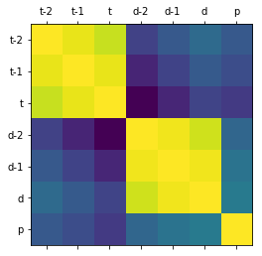

In [8]:

temperature = a

plt.hist(temperature)

plt.xlabel('T(t-2)');



In [9]:

temperature = ctrl.Antecedent(np.arange(20,33,1), 'temperature')

t_cold = fuzz.trimf(temperature.universe, [20, 20, 24])

temperature['cold'] = t_cold

t_warm = fuzz.trimf(temperature.universe, [22, 27, 31])

temperature['warm'] = t_warm

t_hot = fuzz.trimf(temperature.universe, [30, 33, 33])

temperature['hot'] = t_hot

temperature.view()

/Users/rpsr15/anaconda3/lib/python3.6/site-packages/matplotlib/figure.py:418: UserWarning: matplotlib is currently using a non-GUI backend, so cannot show the figure

"matplotlib is currently using a non-GUI backend, "



In [10]:

demand = d3

plt.hist(demand)

plt.xlabel('D(t)');



In [11]:

demand = ctrl.Antecedent(np.arange(3500,7000,5), 'demand')

d_verylittle = fuzz.trimf(demand.universe, [3500, 3500, 4250])

demand['very little'] = d_verylittle

d_little = fuzz.trimf(demand.universe, [3600, 4250, 5100])

demand['little'] = d_little

d_middle = fuzz.trimf(demand.universe, [4500, 5400, 6500])

demand['middle'] = d_middle

d_high = fuzz.trimf(demand.universe, [5500, 6200, 7000])

demand['high'] = d_high

d_veryhigh = fuzz.trimf(demand.universe, [6250, 7000, 7000])

demand['very high'] = d_veryhigh

demand.view()

/Users/rpsr15/anaconda3/lib/python3.6/site-packages/matplotlib/figure.py:418: UserWarning: matplotlib is currently using a non-GUI backend, so cannot show the figure

"matplotlib is currently using a non-GUI backend, "



In [12]:

prices = p

plt.hist(prices)

plt.xlabel('P(t+1)');

prices = ctrl.Consequent(np.arange(10,55,1), 'price')

p_low= fuzz.trimf(prices.universe, [10,10, 22])

prices['low'] = p_low

p_medium = fuzz.trimf(prices.universe, [14, 15,40])

prices['medium'] = p_medium

p_high = fuzz.trimf(prices.universe, [35, 50, 55])

prices['high'] = p_high

prices.view()

/Users/rpsr15/anaconda3/lib/python3.6/site-packages/matplotlib/figure.py:418: UserWarning: matplotlib is currently using a non-GUI backend, so cannot show the figure

"matplotlib is currently using a non-GUI backend, "



In [13]:

#method to generate rule and the degree

def getRule(temp, dmd, prc):

#calculate membeship for temperature

m_t_cold = fuzz.interp_membership(temperature.universe,t_cold, temp)

m_t_warm = fuzz.interp_membership(temperature.universe,t_warm, temp)

m_t_hot = fuzz.interp_membership(temperature.universe,t_hot, temp)

temp_t = [m_t_cold, m_t_warm, m_t_hot]

max_t = max(temp_t)

temp_t = temp_t.index(max_t)

#calculate membership for demand

m_d_vl = fuzz.interp_membership(demand.universe,d_verylittle, dmd)

m_d_l = fuzz.interp_membership(demand.universe,d_little, dmd)

m_d_m = fuzz.interp_membership(demand.universe,d_middle, dmd)

m_d_h = fuzz.interp_membership(demand.universe,d_high, dmd)

m_d_vh = fuzz.interp_membership(demand.universe,d_veryhigh, dmd)

temp_d = [m_d_vl, m_d_l, m_d_m, m_d_h, m_d_vh]

max_d = max(temp_d)

temp_d = temp_d.index(max_d)

#calculate for price

m_p_l = fuzz.interp_membership(prices.universe,p_low, prc)

m_p_m = fuzz.interp_membership(prices.universe,p_medium, prc)

m_p_h = fuzz.interp_membership(prices.universe,p_high, prc)

temp_p = [m_p_l, m_p_m, m_p_h]

max_p = max(temp_p)

temp_p = temp_p.index(max_p)

degreeRule = max_t * max_d * max_p

rule_string = "{}{}{}".format(temp_t, temp_d, temp_p)

tup1 = (rule_string, degreeRule)

return tup1

In [14]:

rulebase = {"000":1.0}

for i in range(a.size):

rule_result = getRule(a[i], d3[i], p[i])

if rule_result[0] in rulebase:

if rule_result[1] > rulebase[rule_result[0]]:

rulebase[rule_result[0]] = rule_result[1] * rulebase[rule_result[0]]

#print("upgrading",(rule_result[1] * rulebase[rule_result[0]]))

else:

rulebase[rule_result[0]] = rule_result[1]

In [15]:

#creating rule base using algorithm based on paper published by lin wang, mentioned in references

final_rules = {"00":(0, 1.0)}

for rule_s, rule_de in rulebase.items():

in_val = rule_s[:2]

out_val = rule_s[2]

dd = round(rule_de,6)

print(in_val, out_val, dd)

#if alrready there check for degree of rule

if in_val in final_rules:

if dd > final_rules[in_val][1]:

final_rules[in_val] = (out_val, dd)

#else add to final rules

else:

#temp_st =

final_rules[in_val] = (out_val, dd)

1

In [16]:

print(final_rules)

{'00': (0, 1.0), '11': ('0', 5e-06), '01': ('0', 3.2e-05), '12': ('1', 0.0), '13': ('1', 0.0), '23': ('1', 0.0), '24': ('1', 0.037957), '14': ('1', 0.094978), '22': ('2', 0.005958), '03': ('2', 0.060499), '02': ('2', 0.06468), '21': ('1', 0.000503), '10': ('0', 0.227959)}

In [17]:

#3 linguistic variables for temperature and 5 liguistic variables for demand

#so it can be represented on a 2d matrix with 5*3 = 15 rules

#rules generated from algorithm above based on research paper(mentioned in references)

rule1 = ctrl.Rule(temperature['cold'] & demand['very little'], prices['low'])

rule2 = ctrl.Rule(temperature['cold'] & demand['little'], prices['low'])

rule3 = ctrl.Rule(temperature['cold'] & demand['middle'], prices['high'])

rule4 = ctrl.Rule(temperature['cold'] & demand['high'], prices['high'])

rule5 = ctrl.Rule(temperature['cold'] & demand['very high'], prices['high'])

rule6 = ctrl.Rule(temperature['warm'] & demand['very little'], prices['low'])

rule7 = ctrl.Rule(temperature['warm'] & demand['little'], prices['low'])

rule8 = ctrl.Rule(temperature['warm'] & demand['middle'], prices['medium'])

rule9 = ctrl.Rule(temperature['warm'] & demand['high'], prices['medium'])

rule10 = ctrl.Rule(temperature['warm'] & demand['very high'], prices['medium'])

rule11 = ctrl.Rule(temperature['hot'] & demand['very little'], prices['low'])

rule12 = ctrl.Rule(temperature['hot'] & demand['little'], prices['low'])

rule13 = ctrl.Rule(temperature['hot'] & demand['middle'], prices['medium'])

rule14 = ctrl.Rule(temperature['hot'] & demand['high'], prices['medium'])

rule15 = ctrl.Rule(temperature['hot'] & demand['very high'], prices['medium'])

prices_ctrl = ctrl.ControlSystem([rule1, rule2, rule3, rule4, rule5, rule6, rule7, rule8, rule9, rule10, rule11, rule12, rule13, rule14, rule15])

price_simulation = ctrl.ControlSystemSimulation(prices_ctrl)

In [18]:

#read processed training and testing data

finalTrainingData = pd.read_csv("ProcessedTrainingData.csv").values

finalTrainingData = finalTrainingData[:,(0,5,6)]

finalTestingData = pd.read_csv("ProcessedTestingData.csv").values

finalTestingData = finalTestingData[:,(0,5,6)]

In [21]:

System_outputs=np.zeros(finalTrainingData.shape[0],dtype=np.float64)

i = 0

sum = 0

for t_val in finalTrainingData:

price_simulation.input['temperature'] = t_val[0]

price_simulation.input['demand'] = t_val[1]

price_simulation.compute()

sim_out = price_simulation.output['price']

diff = abs(t_val[2] - (sim_out))

div = diff/t_val[2]

sum += div

System_outputs[i]=sim_out

i += 1

print("Average Relative Error for Training Data: %.2f%%" %((sum/finalTrainingData.shape[0])*100))

**Average Relative Error for Training Data: 16.23%**

In [22]:

System_outputs=np.zeros(finalTestingData.shape[0],dtype=np.float64)

i = 0

sum = 0

for t_val in finalTestingData:

price_simulation.input['temperature'] = t_val[0]

price_simulation.input['demand'] = t_val[1]

price_simulation.compute()

sim_out = price_simulation.output['price']

diff = abs(t_val[2] - (sim_out))

div = diff/t_val[2]

sum += div

System_outputs[i]=sim_out

i += 1

print("Average Relative Error for Testing Data: %.2f%%" %((sum/finalTestingData.shape[0])*100))

**Average Relative Error for Testing Data: 19.96%**

# References

* Generating Fuzzy rules by learning from examples by li-xin wang, Jerry M. Mendel
* <https://www.khanacademy.org/math/statistics-probability/summarizing-quantitative-data/interquartile-range-iqr/a/interquartile-range-review>
* Fuzzy expert systems - Artificial Intelligence a guide by M. Negnevitsky
* Introduction to fuzzy systems by G. chen
* http://www.dma.fi.upm.es/recursos/aplicaciones/logica_borrosa/web/fuzzy_inferencia/funpert_en.htm