To,  Mr. D.G BHALKE  AISSMS, PUNE,  MAHARASHTRA.  Phone: +91-9028299230  Email: - dgbhalke@aissmscoe.com |  | Our Ref: | Infiiot/Quote/EDA/2020-21/111
 |  | Date: | 02-02-2021
 |  | Your Ref: | -
 |  | Your Ref. Date: | -
Subject: | Quotation for InfiIoT an IoT Platform with InfiSense and InfiCare.
Kind Attn.: | Mrs. Kirti Chaudhari, Associate Professor (Electronics & Telecommunication)

Dear Sir,
With reference to your inquiry for InfiIoT cloud software with Infi-Sense kit, please below the prices for the package.

Sr. No | Description | Qty | Unit Price  (in Rs.)
1. | InfiIoT an Industrial IoT cloud Platform  - Includes 5 perpetual tokens (10 yrs.)  Annexure A attached is feature list, please check brochure for details | 1 pc | 2,30,000/-
2. | InfiSense kit (IoT based agricultural monitoring system)  Annexure B attached is feature list, please check brochure for details. | 1 pc | 40,000/-
3. | InfiCare kit (IoT based Health Care monitoring system)  Annexure C attached is feature list, please check brochure for details. | 1 pc | 42,000/-
4. | Training  A 1-day software& hardware usage training | 1 day | 10,000/-
 |  | Total | 3,22,000/-

We look forward to our relationship growing and flourishing.


For InfiIoT Technologies Pvt Ltd


Mr. Bhupesh Purohit
(Authorized Signatory)
Authorization:
Infiiot Technologies is the exclusive Authorized Distributor of InfiIoT in Asia Pacific Region including India.

Terms of Payment:
- GST of 18 % as applicable on above quoted prices.
- 50% advance along with purchase order, remaining 50% after successful delivery and installation.
- The Payment should be made in advance by wire transfer, cheque, DD, or TT in the name of InfiIoT Technologies Pvt. Ltd., India payable at Pune.

Warranty and Maintenance:
Software is warranted for any defects for 10 years. All upgrades within period of 1 year will be provided to customer.
- Per year account retention& maintenance 10,000/-
- Per year feature updates 10,000/-

Validity:
Our offer will remain valid up to 1 Month from the date mentioned above

Delivery:
For software, Within 2-3 weeks from receipt of purchase order and advance payment.
For Hardware, Within 4-6 weeks from receipt of purchase order and advance payment.

Training:
The offer includes a 1 day of onsite comprehensive training on usage of product. For additional number of days, the prices are mentioned in the above quotation.

For InfiIoT Technologies Pvt Ltd


Mr. Bhupesh Purohit
(Authorized Signatory)

ANNXURE – A

InfiIoT an Industrial IoT cloud Platform

The IoT Platform integration with hardware is one of the most popular experiments/projects electronics and IoT domain. It is ideal to introduce intermediate IoT concepts and theories relevant to challenges automation and electronics engineers face in real life.
This InfiIoT is an Advance IoT development platform for connecting devices to the cloud and to remotely monitor and manage these devices in lower costs and simpler ways.
InfiIoT along with other latest domains gives its users the most advanced tools to getting internet connected products and solutions in least possible. Teachers can make use of InfiIoT Token Management Console to manage and distribute tokens between students for research projects and for conducting IoT Labs.

Topics which can be covered:
- Various concepts, terminologies and architecture of IoT Cloud systems
- Understand and apply protocols for design of IoT systems
- Use various techniques of data storage and analytics in IoT
- Discover the fundamentals of Cloud Computing
- Analyze potential applications of IoT and the cloud
- Develop IoT solutions and implement cloud services through case studies
- Use visualization techniques to show data generated from the IoT devices
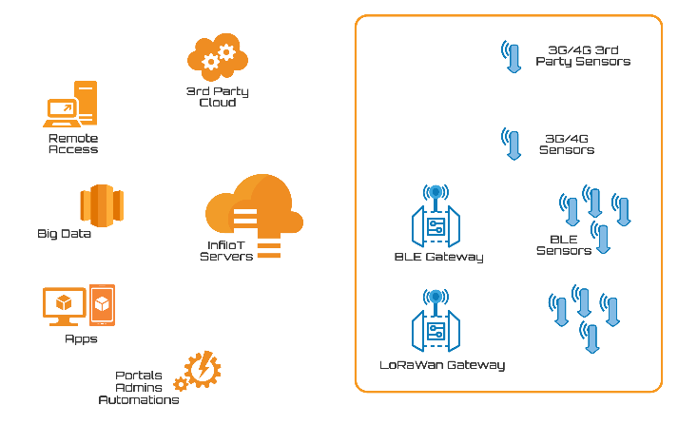
- Implement and secure your own cloud service
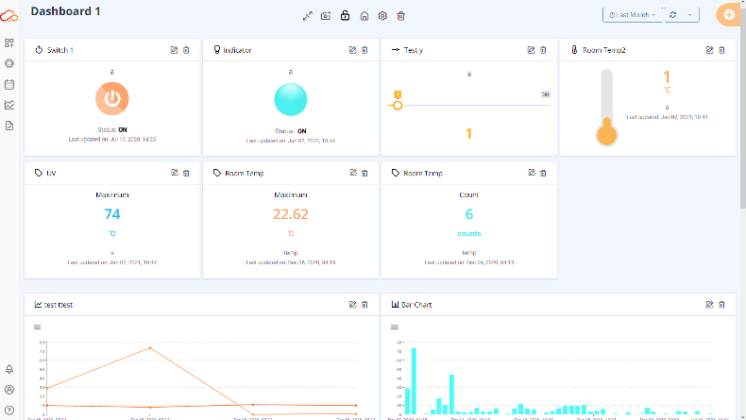
Highlighted Features
- Manage your devices, variables and historical data with most advanced tools
- Multiple Visuals for project specific controls
- Automated Device and Variable onboarding
- Ingest data from third party platforms
- API’s and SDK’s to support various hardware’s and software development.
- Trigger notifications and alerts using complex logic
- Create backup in the form of csv, pdf, reports containing tables, charts, widgets and send over email.
- Multi-Threaded interface for faster and responsive behavior
- Oauth2, SSL, AES and Latest TLS for the best class security
- Token Management interface for token distribution between users

ANNXURE – B

Infi-Sense kit (IoT based agricultural monitoring system)

The Sensors and Actuators Integration with Microcontroller is one of the most basic and important experiment electronics and IoT domain. It is ideal to introduce intermediate IoT concepts and theories relevant to challenges automation and electronics engineers face in real life.
The purpose of the InfiSense Agriculture Kit is to enable students to build a complete IoT solution from sensors and actuators, through a gateway up to different clouds and apps just in a matter of a couple of hours and use your solutions for proof-of-concept for your projects.
InfiSense Kit is to teach in-depth interfacing of various important sensors and actuators with Controller, connecting to network using various protocols, plotting and analyzing of the collected data thus using IOT for monitoring and control things.
InfiSense uses a fleet of in-house developed precision sensors and InfiIoT Platform solutions to achieve maximum yields, ensure safety and save dollars.

Topics which can be covered:
- Interfacing devices with sensors and actuators to IoT Cloud Platform
- Evaluate and analyze IoT system using an industrial use case
- Identify the Components that forms part of IoT Architecture

Highlighted Features
- Configure and control via built-in API’s and controller SDKs.
- Easy Plug and Play Phoenix connection for sensors and actuators
- Comprehensive working and principle of all sensors
- Easy to use API’s with elaborative example codes
- Portable Kit – capable of testing real field parameters
- Interfacing of many important sensors and actuators for agricultural IoT
- Easy Programmable/Replaceable microcontroller
- Interface Indications and controls using Indication LEDs, button and LCD.
- On-board I2C based LCD module for real-time display of important data
- Provision for Deep Sleep modes for real on-field testing of your project
- On board 16-bit Analog-to-Digital Converter for precise measurements
Collected Data Includes:
Soil Moisture, Soil Temperature, Leaf Moisture, Rain, UV, Light, Air (Humidity, temperature & Pressure), & Altitude.

ANNXURE – C

Infi-Care kit (IoT based HealthCare monitoring system)

Internet of Things (IoT)-enabled devices have made remote monitoring in the healthcare sector possible, unleashing the potential to keep patients safe and healthy, and empowering physicians to deliver superlative care.
The purpose of the InfiCare Healthcare Case Study is to enable students/researchers to build a complete IoT solution from sensors, through a gateway up to different clouds and app’s just in a matter of a couple of hours and use your solutions for proof-of-concept for your projects.
InfiCare Kit is to teach in-depth interfacing of various important sensors and actuators with Controller, connecting to network using various protocols, plotting and analyzing of the collected data thus using IOT for monitoring and control things.
InfiCare uses a fleet of in-house developed precision sensors and InfiIoT Platform solutions to achieve quality, efficiency, acceptability, and equity.

Topics which can be covered:
- Interfacing devices with sensors and actuators to IoT Cloud Platform
- Evaluate and analyze IoT system using healthcare use case
- Identify the Components that forms part of Health Care IoT

Highlighted Features
- Microcontroller Board with Bluetooth and Wi-Fi capabilities.
- For more technical features refer Annexure B (Highlighted Features)

Collected Data Includes:
Body Temperature (Non-Contact), SpO2, Heart Rate, Electrocardiography, Galvanic skin response, Muscle Flex Sensor, Blood Glucose Level.
Deliverables
ANNXURE – A contains:
5 perpetual token licenses for a tenure of 10 years. Each token avail following features:
- 20 devices
- 200 variables
- 0.6 million data points ingestions and extractions per month
- 40 Events per month
- 40 Emails per month
- 10 SMS per month
- 10 WhatsApp message per month
ANNXURE – B contains:
- Motherboard with Wi-Fi Enabled Controller and Relay Control Module
- InfiSoil Sensor (Capacitive Technology Based)
- UV Sensor
- Light Sensor
- InfiLeaf Sensor (Mimics Real Leaf – useful for monitoring dew conditions)
- Soil Temperature Probe
- Resistive Rain Sensor
- Air Sensor
- 16*2 LCD panel
- Water Submersible pump with small tank
- Plant with pot
- 12v 2A Power Adapter
ANNXURE – C contains:
- Motherboard with Wi-Fi and Bluetooth Enabled Controller.
- Non-Contact Temperature Sensor
- Oxygen and Pulse Sensor
- ECG Sensor
- GSR Sensor
- Muscle Flex Sensor
- Blood Glucose Sensor
- 16*2 LCD Panel
- Wrist watch with Sensor unit
- 12v 2A Power Adapter

