**ABSTRACT**

**Mankind has always struggled to find alternatives for himself to work in hostile zones and carry out his orders. The popular concept for this is robot which is machine that performs specific task according to orders given to it.**

**The modern industry is moving from automation towards “Robotization” to maintain product quality and increase productivity. Today’s robots do not look like human being but research is going on to provide more and more anthropomorohic structure and human capabilities in these.**

**Here how a pick and place robot can be designed for industries where store rooms are to be managed or loading and packing is to be done. Various problems and obstructions are taken into consideration and analysed taken into consideration while designing the robot.**

**Table of contents**

1. **Introduction**
2. **Literature survey**
3. **Hardware description**
4. **System analysis**
5. **System design**
6. **Coding and testing**
7. **Conclusion**
8. **Future enhancement**

**Chapter 1**

**INTRODUCTION**

**The main objective of pick and place robot is pick the object form source location and place it to desired destination.The mechanical arm is arrangement made for picking and placing the object. For detection purpose proximity sensors are used.**

**The robot is made of three sections. The top gripper unit is to pick and place any object. The bottom driving unit is to move the object to location specified by user. And control unit which will control the operation of whole system.**

**1.1 AIM AND OBJECTIVE**

**The aim of this project is to design an autonomous robot with complete system that allow the robot to identify predefined locations and interact with desired object.**

**To achieve this aim ,certain objectives are needed to be complete.**

**1.2 IMPORTANCE**

**In today’s scenario, the industry having a problem by human life in some hazardous duty service. Robots can work in hazardous environments where unprotected human would quickly die.**

**Chapter 2**

**LITERATURE SURVEY**

**2.1 Introduction**

**For our project we decided to make a pick and place robot. Through the literature survey we found basic principles of pick and place robots and many associated problems that are needed to be solved.**

**Optimization of these robots is still very important field . main specifications of pick and place robors are speed of operation , precision, maximum load,range of motion and cost.**

**2.2 Internet Search**

**Our internet search found out the wide range of applications for pick and place robots. There are too many websites as well as YouTube videos that guide about the actual robot build,full instructions for how to build a simple robot.**

**It features parts lists including type of motors, battery,modules ,specifications and more.**

**The usefull part of this search include power supply, motor ,and micontroller details .By looking how the build is made , we can modify and expand the project.**

**Chapter 3**

**Hardware description**

**3.1 Chasis**

**Chasis is internal vehicle frame that provides base and supports an artificial object in its construction and use ,it also provides protection for some internal parts.**

**????/////////**

**3.2 Motor driver**

**L293D is dual H-bridge motor driver. Motor drivers act as current amplifiers since they take low current control signal and provide a higher current signal. This high current is used to drive the motors.**

**We designed our motor driver PCB by referring the L293D internal structure.**

**///////////????**

**3.3 Actuation**

**Actuators are like muscles of the robot ,the parts that will convert stored energy into movement. Most used actuators are electric motors that spin a wheel or gear.**

**We are using DC motors and servo motors in our project**

**3.3.1 DC motor**

**DC motors for the movement of the robot. DC motors are connected to the wheels of the robot. The speed and load shifting capacity of robot will depend**

**upon the RPM and Torque generated by the motors.**

**3.3.2 Servo motor**

**It is a motor which can rotate with great precision. If application needs to move some object at some specific angle, then servo motor can be used.**

**We require this kind of rotation for our “Robotic Arm”. We are using servo motor to ope and close the arm grip.**

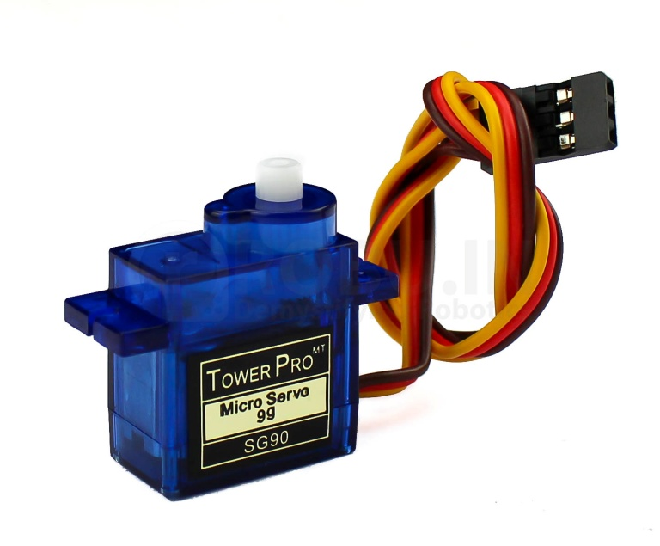

**3.3.3 Power Source**

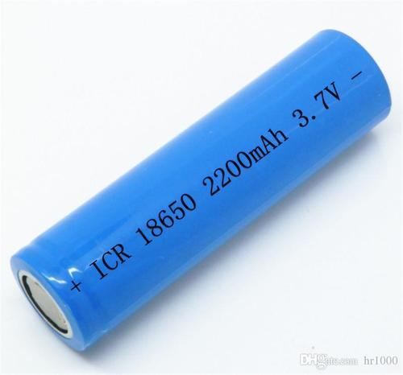

**We are using lithium-ion battery to power the robot. Lithium-ion batteries are rechargeable batteries used for**[**portable electronics**](https://en.wikipedia.org/wiki/Portable_electronics)**, with a high**[**energy density**](https://en.wikipedia.org/wiki/Energy_density)**.**

**One cell will provide nearly 6Amperes of current. We are using 3 cells.**

**3.4 Robotic Arm**

**A robotic arm is a type of mechanical arm. Which can perform near similar to human arm. Our robotic arm is specially designed by us for pick and place type task.**

**It is designed by online 3D design software**

**(tinkercad). And made using 3D printing technology.**

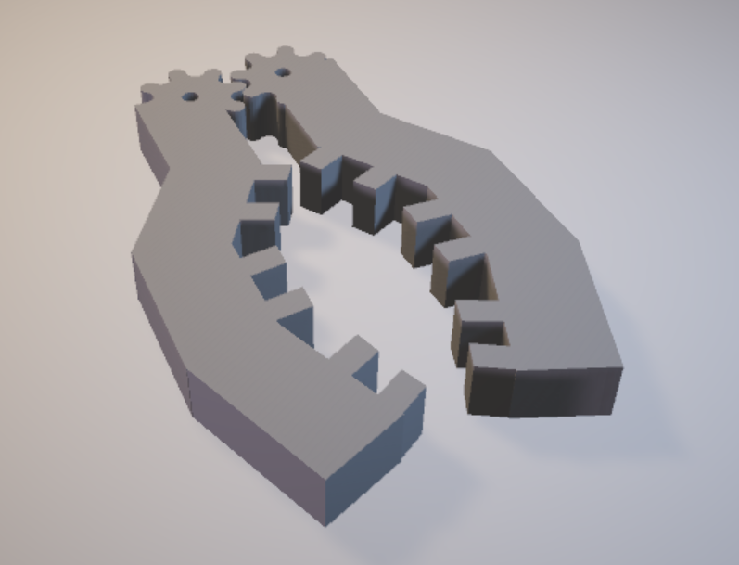

**Provided with multiple teeth structure for maximum grip. And angular structure for holding flat as well as round objects.**

**3.5 Bluetooth module (BM-10)**

**A communication interface is necessary for the robot to convey location information. We are using Bluetooth module BM-10 (having Bluetooth 4.1 technology) .**

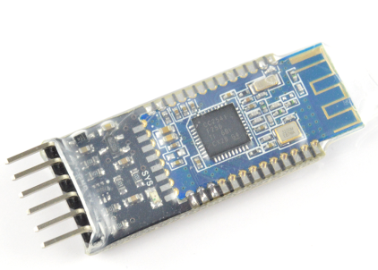

**3.6 MicroController**

**Micro controller is necessary to govern all the tasks of the robot. It will receive the data through Bluetooth module and perform the tsaks accordingly.**

**We are using ATMEGA328P-PU for this application.**

**It can be programmed using Arduino IDE which is open source software. The programmer for ATMEGA328P-PU is also cheap. It can be programmed by using arduino uno board as well.**