A

Mini Project

Synopsis on

“Smart Wireless Controlled Pick-N-Place Line

Following Robot”

Submitted By:

Arpit Shrivastava (312059)

Durgesh Vitore (312070)

Tejas Shinde (312058)



DEPARTMENT OF

ELECTRONICS AND TELECOMMUNICATION ENGINEERING,

VISHWAKARMA INSTITUTE OF INFORMATION TECHNOLOGY,

PUNE– 411048

YEAR 2018-2019

Smart WiFi Controlled Pick-N-Place Line Following Robot

Brief Description of Project:

* Robot will be used to Pick-N-Place object from different locations.
* There can be N number of destination locations.
* The locations for picking or placing objects are given over WIFI to the Robot.
* Robot follows the path using Line (White over Black line) as the guideline and reach to the destined location.
* The arm over the bot picks the object once it is detected in front.
* After picking up it makes a 180* turn and then return back to the starting position/position according to the command from user.
* In future, camera module will be implemented along with Raspberry Pi and the user will also get to choose what object the bot have to pick.
* Use: This Robot can have application in autonomous garbage collection, items or goods management in warehouses of delivery companies, or to do any autonomous work on any specified location.

Block Diagram/Circuit Diagram:

**Battery Source**

**3S-1P**

(O/P: 4.2V [max], 2.2A)/cell

**IR Receiver**

(I/P: 5V, 20mA)

**IR Receiver Array**

(I/P: 5V, 100mA)

**ATMEGA 328P**

(I/P: 7-12V, 250mA)

**Motor Driver**

(I/P: 12V, )

**Wireless Module (HC09)**

(I/P: 5V, 250mA)

**Motor ( 2 )**

(I/P: 0-12V, 150-650mA)

**Mobile**

**Servo Motor**

(I/P: 5V,550mA)

Controller Schematics:

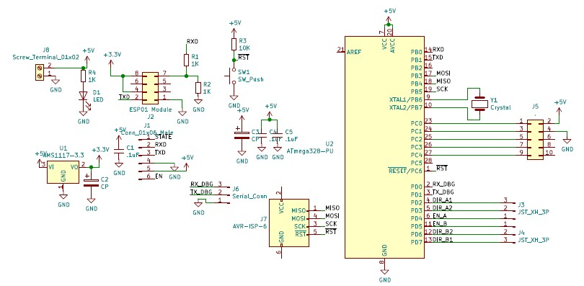

Driver Schematics:

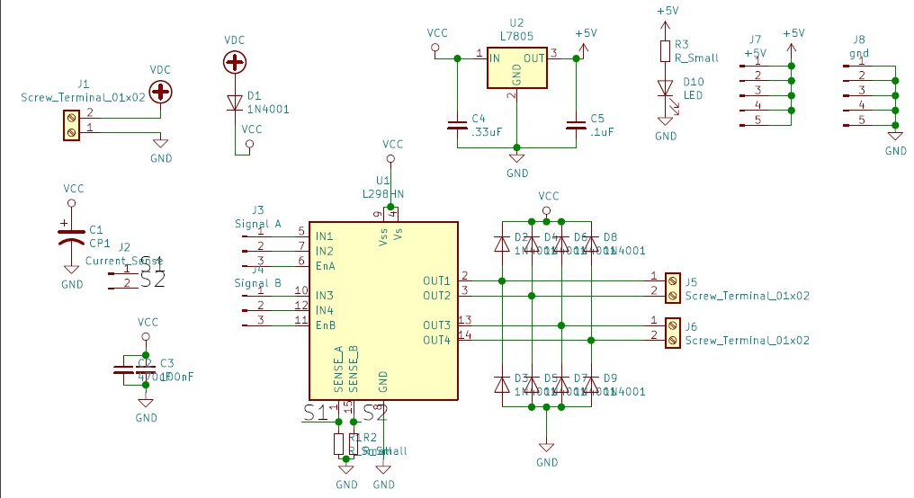

Component List:

|  |  |
| --- | --- |
| Robot chassis | 400₹ |
| Motors | 500₹ |
| Tyres | 50₹ |
| Battery | 400₹ |
| Switch | 10₹ |
| Microcontroller (ATMEGA328p-Pu) | 110₹ |
| Wifi (Esp8266-12E) | 150₹ |
| Motor Driver(L293D) | 200₹ |
| Servo Motors [2] | 300₹ |
| Arm mechanism | 150₹ |
| IR Line Sensor | 150₹ |
|  | 2420₹ |

Approximate Budget: approximately 2420₹

References:-

Arduino and Wireless module : <https://create.arduino.cc/projecthub/mayooghgirish/arduino-bluetooth-basic-tutorial-d8b737>

L298N Motor Driver:

<https://howtomechatronics.com/tutorials/arduino/arduino-dc-motor-control-tutorial-l298n-pwm-h-bridge/>

Servo motor and Arduino:

[http://www.electronics-lab.com/project/using-sg90-servo- motor-arduino/](http://www.electronics-lab.com/project/using-sg90-servo-%20%20motor-arduino/)

3d modelling:

<https://robo3d.com/blogs/news/how-to-basic-3d-design-using-tinkercad> ;

<https://www.youtube.com/watch?v=60xfIu-lqAs>

3d printing :

<https://all3dp.com/3d-printing-3d-printer-guide-101-questions/>

Chassis Selection:

<https://embedjournal.com/how-to-make-chassis/>

Battery calculations:

<https://secondlifestorage.com/t-18650-Battery-Pack-Calculator>