Zava Retail Analysis Report
This document captures the SQL, sample outputs, and chart summaries for the consolidated analysis workflow in the Zava retail database.
Database: zava | Host: db | Schema: retail

1. Seasonal Demand Pattern
SQL used:
WITH monthly_category_sales AS (
SELECT c.category_name,
EXTRACT(MONTH FROM o.order_date)::int AS month_num,
SUM(oi.quantity) AS units_sold,
SUM(oi.total_amount) AS revenue
FROM retail.orders o
JOIN retail.order_items oi ON oi.order_id = o.order_id
JOIN retail.products p ON p.product_id = oi.product_id
JOIN retail.categories c ON c.category_id = p.category_id
GROUP BY c.category_name, EXTRACT(MONTH FROM o.order_date)::int
),
month_names AS (
SELECT 1 AS month_num, 'Jan' AS month_name
UNION ALL SELECT 2, 'Feb' UNION ALL SELECT 3, 'Mar' UNION ALL SELECT 4, 'Apr'
UNION ALL SELECT 5, 'May' UNION ALL SELECT 6, 'Jun' UNION ALL SELECT 7, 'Jul'
UNION ALL SELECT 8, 'Aug' UNION ALL SELECT 9, 'Sep' UNION ALL SELECT 10, 'Oct'
UNION ALL SELECT 11, 'Nov' UNION ALL SELECT 12, 'Dec'
),
category_months AS (
SELECT s.category_name, m.month_num, m.month_name,
COALESCE(s.units_sold, 0) AS units_sold,
COALESCE(s.revenue, 0) AS revenue
FROM (SELECT DISTINCT category_name FROM retail.categories) cat
CROSS JOIN month_names m
LEFT JOIN monthly_category_sales s
ON s.category_name = cat.category_name AND s.month_num = m.month_num
),
normalized AS (
SELECT category_name, month_num, month_name, units_sold,
AVG(units_sold) OVER (PARTITION BY category_name) AS avg_units,
units_sold / NULLIF(AVG(units_sold) OVER (PARTITION BY category_name), 0) AS seasonal_index
FROM category_months
),
ranked AS (
SELECT *,
MAX(seasonal_index) OVER (PARTITION BY category_name) AS peak_index,
MIN(seasonal_index) OVER (PARTITION BY category_name) AS low_index,
ROW_NUMBER() OVER (PARTITION BY category_name ORDER BY seasonal_index DESC) AS peak_rank,
ROW_NUMBER() OVER (PARTITION BY category_name ORDER BY seasonal_index ASC) AS low_rank
FROM normalized
),
summary AS (
SELECT DISTINCT category_name,
peak_index - low_index AS seasonal_swing,
peak_index,
low_index
FROM ranked
)
SELECT category_name,
seasonal_swing,
(SELECT month_name FROM ranked r WHERE r.category_name = s.category_name AND r.peak_rank = 1) AS peak_month,
(SELECT month_name FROM ranked r WHERE r.category_name = s.category_name AND r.low_rank = 1) AS low_month
FROM summary s
ORDER BY seasonal_swing DESC;
Sample output:
category_name | seasonal_swing | peak_month | low_month
GARDEN & OUTDOOR | 0.93496373056994814093 | Apr | Dec
STORAGE & ORGANIZATION | 0.88575149064491805881 | Feb | Jul
HARDWARE | 0.60889256512129302777 | Oct | Jun
LUMBER & BUILDING MATERIALS | 0.56945045434876680732 | Jul | Dec
ELECTRICAL | 0.56540984480827690266 | Dec | Apr
PAINT & FINISHES | 0.48135274776890556839 | Mar | Nov
POWER TOOLS | 0.47718865598027131134 | Aug | Dec
PLUMBING | 0.42590246138085354863 | Oct | Aug

Chart:
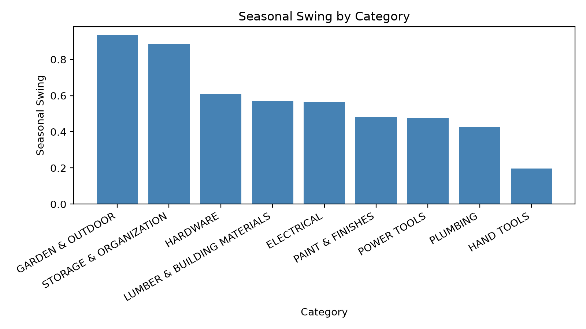

2. Store Alignment to National Seasonality
SQL used:
WITH store_weights AS (
SELECT * FROM (VALUES
('Zava Retail Seattle', 30, 3.0),
('Zava Retail Bellevue', 25, 2.6),
('Zava Retail Tacoma', 20, 2.4),
('Zava Retail Spokane', 8, 2.0),
('Zava Retail Everett', 7, 1.8),
('Zava Retail Redmond', 6, 1.6),
('Zava Retail Kirkland', 4, 1.4),
('Zava Retail Online', 30, 3.0)
) AS t(store_name, customer_distribution_weight, order_frequency_multiplier)
)
SELECT s.store_name,
sw.customer_distribution_weight AS customer_weight,
sw.order_frequency_multiplier AS frequency_multiplier,
sw.customer_distribution_weight * sw.order_frequency_multiplier AS alignment_index
FROM retail.stores s
JOIN store_weights sw ON sw.store_name = s.store_name
ORDER BY alignment_index DESC;
Sample output:
store_name | customer_weight | frequency_multiplier | alignment_index
Zava Retail Seattle | 30 | 3.0 | 90.0
Zava Retail Online | 30 | 3.0 | 90.0
Zava Retail Bellevue | 25 | 2.6 | 65.0
Zava Retail Tacoma | 20 | 2.4 | 48.0
Zava Retail Spokane | 8 | 2.0 | 16.0
Zava Retail Everett | 7 | 1.8 | 12.6
Zava Retail Redmond | 6 | 1.6 | 9.6
Zava Retail Kirkland | 4 | 1.4 | 5.6

Chart:
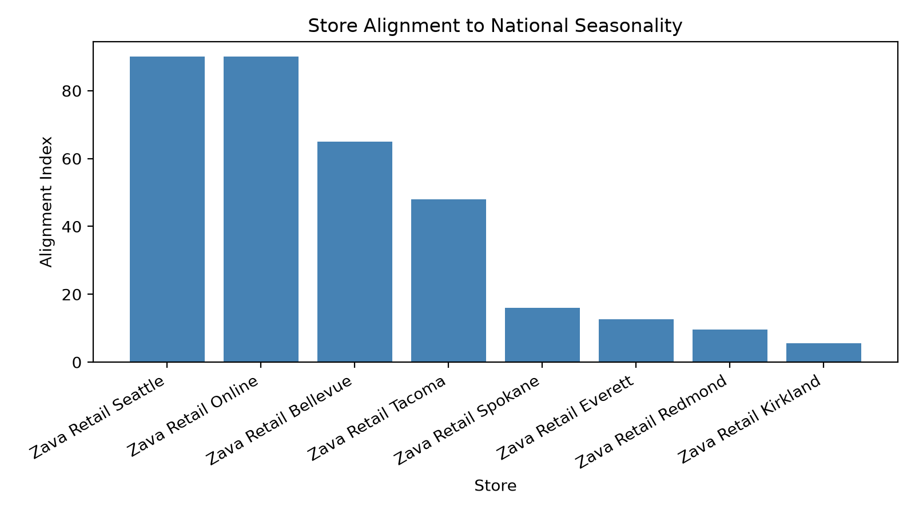

3. 2023 Sales Snapshot
SQL used:
SELECT EXTRACT(MONTH FROM o.order_date)::int AS month_num,
TO_CHAR(o.order_date, 'Mon') AS month_name,
c.category_name,
SUM(oi.quantity) AS units_sold,
SUM(oi.total_amount) AS revenue
FROM retail.orders o
JOIN retail.order_items oi ON oi.order_id = o.order_id
JOIN retail.products p ON p.product_id = oi.product_id
JOIN retail.categories c ON c.category_id = p.category_id
WHERE EXTRACT(YEAR FROM o.order_date) = 2023
GROUP BY EXTRACT(MONTH FROM o.order_date)::int, TO_CHAR(o.order_date, 'Mon'), c.category_name
ORDER BY month_num, category_name;
Sample output:
month_num | month_name | category_name | units_sold | revenue
1 | Jan | ELECTRICAL | 1072 | 40627.08
1 | Jan | GARDEN & OUTDOOR | 569 | 20680.20
1 | Jan | HAND TOOLS | 888 | 35526.97
1 | Jan | HARDWARE | 795 | 19324.47
1 | Jan | LUMBER & BUILDING MATERIALS | 768 | 28886.82
1 | Jan | PAINT & FINISHES | 964 | 38532.94
1 | Jan | PLUMBING | 1009 | 34706.49
1 | Jan | POWER TOOLS | 824 | 177666.18

Chart:
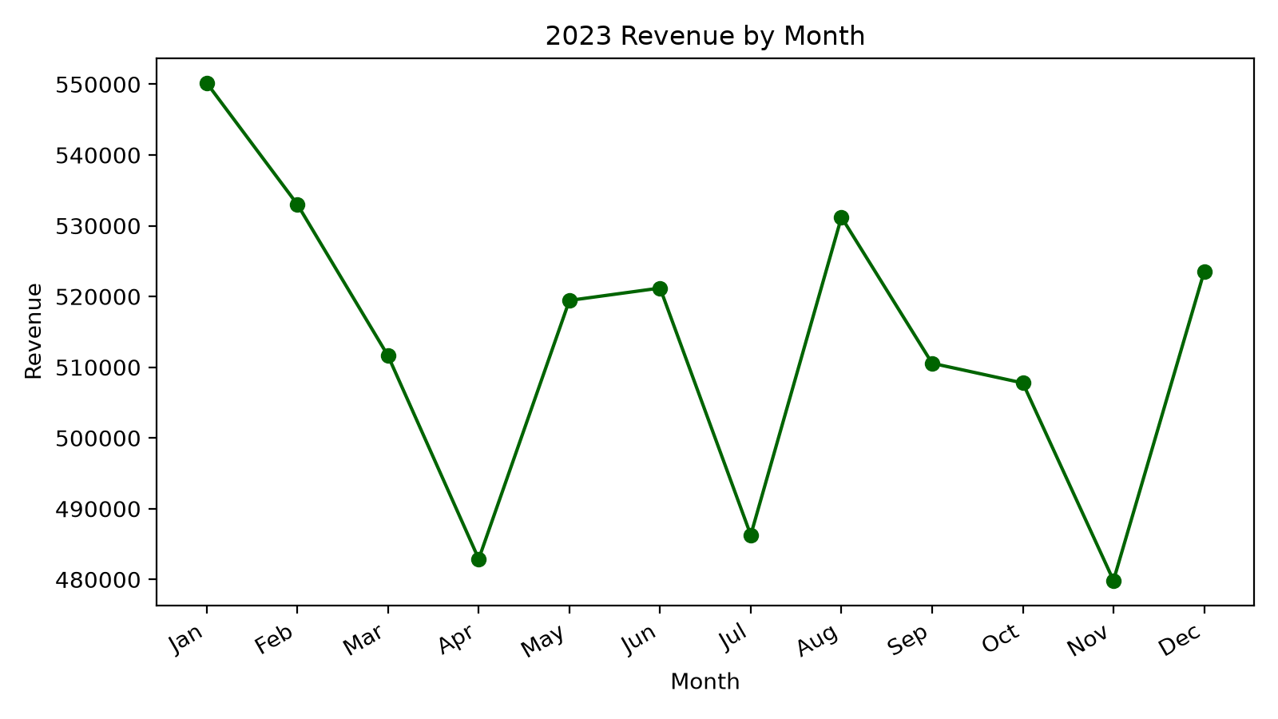

4. Product Affinity and Cross-Sell Signals
SQL used:
WITH order_pairs AS (
SELECT oi1.order_id,
oi1.store_id,
CASE WHEN oi1.product_id < oi2.product_id THEN oi1.product_id ELSE oi2.product_id END AS product_a,
CASE WHEN oi1.product_id < oi2.product_id THEN oi2.product_id ELSE oi1.product_id END AS product_b
FROM retail.order_items oi1
JOIN retail.order_items oi2
ON oi1.order_id = oi2.order_id
AND oi1.product_id < oi2.product_id
),
pair_summary AS (
SELECT op.product_a,
op.product_b,
p1.product_name AS product_a_name,
p2.product_name AS product_b_name,
COUNT(*) AS pair_count
FROM order_pairs op
JOIN retail.products p1 ON p1.product_id = op.product_a
JOIN retail.products p2 ON p2.product_id = op.product_b
GROUP BY op.product_a, op.product_b, p1.product_name, p2.product_name
)
SELECT *
FROM pair_summary
ORDER BY pair_count DESC, product_a_name
LIMIT 20;
Sample output:
product_a | product_b | product_a_name | product_b_name | pair_count
11 | 31 | Metric Wrench Set | Long Arm Hex Set | 95
2 | 5 | Ball Peen Hammer 12oz | Phillips Screwdriver Set | 90
10 | 25 | Combination Wrench Set SAE | Folding Rule 6-foot | 88
7 | 23 | Precision Screwdriver Kit | Speed Square 7-inch | 88
7 | 22 | Precision Screwdriver Kit | Tape Measure 25-foot | 87
1 | 13 | Professional Claw Hammer 16oz | Pipe Wrench Set | 87
1 | 18 | Professional Claw Hammer 16oz | Wire Stripping Pliers | 87
3 | 9 | Finishing Hammer 13oz | Ratcheting Screwdriver | 86

Chart:
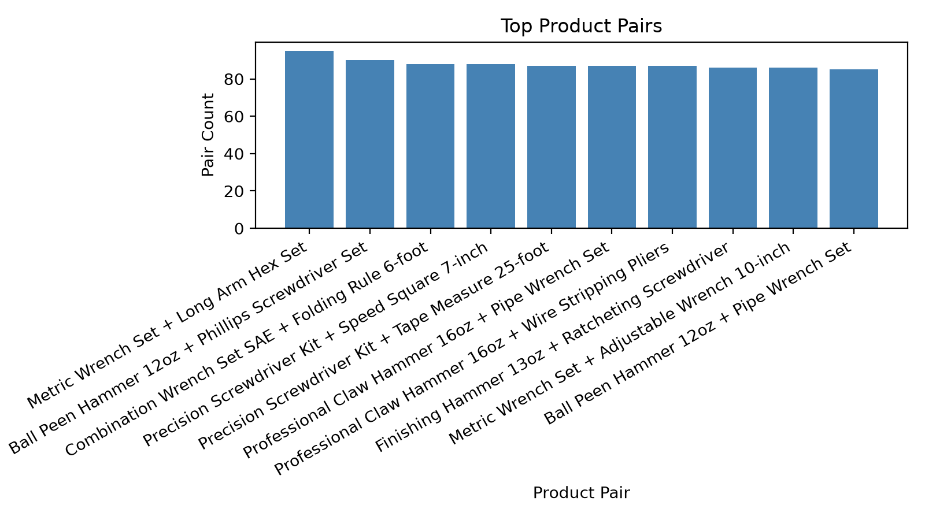

5. Product Pair Summary
SQL used:
WITH order_pairs AS (
SELECT CASE WHEN oi1.product_id < oi2.product_id THEN oi1.product_id ELSE oi2.product_id END AS product_a,
CASE WHEN oi1.product_id < oi2.product_id THEN oi2.product_id ELSE oi1.product_id END AS product_b
FROM retail.order_items oi1
JOIN retail.order_items oi2
ON oi1.order_id = oi2.order_id
AND oi1.product_id < oi2.product_id
)
SELECT p1.product_name AS product_a_name,
p2.product_name AS product_b_name,
COUNT(*) AS pair_count
FROM order_pairs op
JOIN retail.products p1 ON p1.product_id = op.product_a
JOIN retail.products p2 ON p2.product_id = op.product_b
GROUP BY p1.product_name, p2.product_name
ORDER BY pair_count DESC
LIMIT 20;
Sample output:
product_a_name | product_b_name | pair_count
Metric Wrench Set | Long Arm Hex Set | 95
Ball Peen Hammer 12oz | Phillips Screwdriver Set | 90
Precision Screwdriver Kit | Speed Square 7-inch | 88
Combination Wrench Set SAE | Folding Rule 6-foot | 88
Professional Claw Hammer 16oz | Wire Stripping Pliers | 87
Precision Screwdriver Kit | Tape Measure 25-foot | 87
Professional Claw Hammer 16oz | Pipe Wrench Set | 87
Metric Wrench Set | Adjustable Wrench 10-inch | 86

Chart:
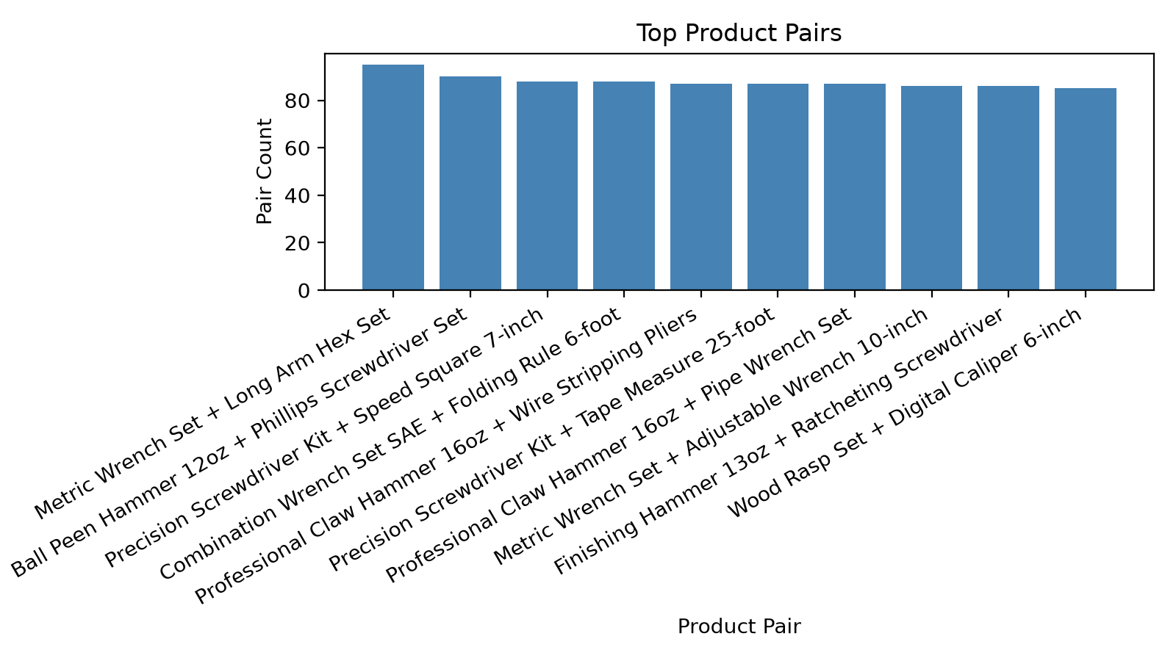

6. Inventory Risk by Store
SQL used:
WITH store_weights AS (
SELECT * FROM (VALUES
('Zava Retail Seattle', 30, 3.0),
('Zava Retail Bellevue', 25, 2.6),
('Zava Retail Tacoma', 20, 2.4),
('Zava Retail Spokane', 8, 2.0),
('Zava Retail Everett', 7, 1.8),
('Zava Retail Redmond', 6, 1.6),
('Zava Retail Kirkland', 4, 1.4),
('Zava Retail Online', 30, 3.0)
) AS t(store_name, customer_distribution_weight, order_frequency_multiplier)
),
store_demand AS (
SELECT s.store_name,
c.category_name,
SUM(oi.quantity) AS units_sold,
SUM(oi.total_amount) AS demand_revenue,
SUM(oi.quantity) * sw.customer_distribution_weight * sw.order_frequency_multiplier AS weighted_demand_index
FROM retail.orders o
JOIN retail.order_items oi ON oi.order_id = o.order_id
JOIN retail.products p ON p.product_id = oi.product_id
JOIN retail.categories c ON c.category_id = p.category_id
JOIN retail.stores s ON s.store_id = o.store_id
JOIN store_weights sw ON sw.store_name = s.store_name
GROUP BY s.store_name, c.category_name, sw.customer_distribution_weight, sw.order_frequency_multiplier
),
store_inventory AS (
SELECT s.store_name,
c.category_name,
SUM(i.stock_level) AS inventory_units
FROM retail.inventory i
JOIN retail.products p ON p.product_id = i.product_id
JOIN retail.categories c ON c.category_id = p.category_id
JOIN retail.stores s ON s.store_id = i.store_id
GROUP BY s.store_name, c.category_name
),
inventory_vs_demand AS (
SELECT d.store_name AS demand_store,
d.category_name,
d.weighted_demand_index,
inv.inventory_units,
inv.inventory_units / NULLIF(d.weighted_demand_index, 0) AS inventory_to_demand_ratio
FROM store_demand d
JOIN store_inventory inv
ON inv.store_name = d.store_name AND inv.category_name = d.category_name
)
SELECT a.demand_store AS surplus_store,
a.category_name,
a.inventory_units AS surplus_inventory,
a.inventory_to_demand_ratio AS surplus_ratio,
b.demand_store AS deficit_store,
b.inventory_units AS deficit_inventory,
b.inventory_to_demand_ratio AS deficit_ratio,
a.inventory_units / NULLIF(b.inventory_units, 0) AS surplus_to_deficit_ratio
FROM inventory_vs_demand a
JOIN inventory_vs_demand b
ON a.category_name = b.category_name AND a.demand_store <> b.demand_store
WHERE a.inventory_to_demand_ratio >= 1.5
AND b.inventory_to_demand_ratio <= 0.7
ORDER BY a.category_name, a.inventory_to_demand_ratio DESC, surplus_to_deficit_ratio DESC
LIMIT 20;
Sample output:
surplus_store | category_name | surplus_inventory | surplus_ratio | deficit_store | deficit_inventory | deficit_ratio | surplus_to_deficit_ratio
Zava Retail Kirkland | ELECTRICAL | 12326 | 2.0494147379622240 | Zava Retail Seattle | 98553 | 0.05334340088334632372 | 0
Zava Retail Kirkland | ELECTRICAL | 12326 | 2.0494147379622240 | Zava Retail Everett | 19043 | 0.60696755275068528081 | 0
Zava Retail Kirkland | ELECTRICAL | 12326 | 2.0494147379622240 | Zava Retail Tacoma | 70406 | 0.14826560867953772027 | 0
Zava Retail Kirkland | ELECTRICAL | 12326 | 2.0494147379622240 | Zava Retail Bellevue | 84343 | 0.09294352950251524852 | 0
Zava Retail Kirkland | ELECTRICAL | 12326 | 2.0494147379622240 | Zava Retail Spokane | 30121 | 0.51718750000000000000 | 0
Zava Retail Kirkland | ELECTRICAL | 12326 | 2.0494147379622240 | Zava Retail Online | 114480 | 0.05948929005705733795 | 0
Zava Retail Kirkland | GARDEN & OUTDOOR | 11418 | 1.9002130209026761 | Zava Retail Everett | 20777 | 0.68251997266897929150 | 0
Zava Retail Kirkland | GARDEN & OUTDOOR | 11418 | 1.9002130209026761 | Zava Retail Spokane | 26477 | 0.47552083333333333333 | 0

Chart:
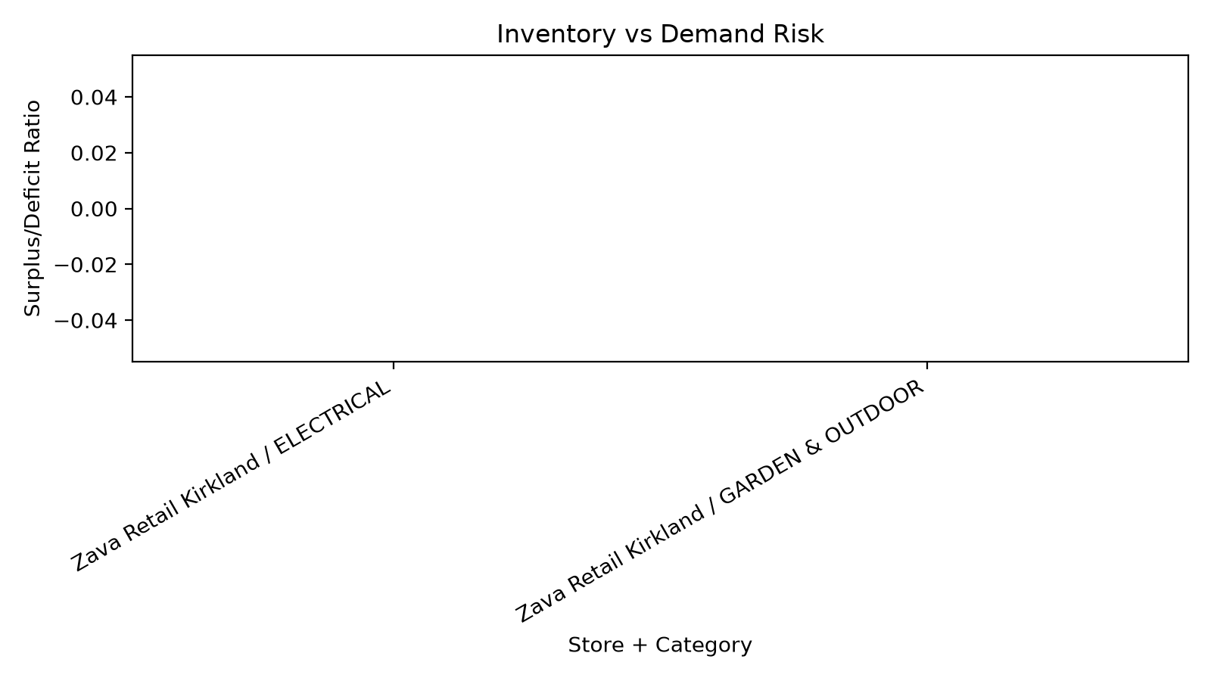

7. Inventory Gap vs. Sales Velocity
SQL used:
WITH product_sales AS (
SELECT p.product_id,
p.product_name,
SUM(oi.quantity) AS units_sold,
SUM(oi.total_amount) AS sales_revenue
FROM retail.order_items oi
JOIN retail.products p ON p.product_id = oi.product_id
GROUP BY p.product_id, p.product_name
),
product_inventory AS (
SELECT i.product_id,
SUM(i.stock_level) AS total_stock
FROM retail.inventory i
GROUP BY i.product_id
)
SELECT ps.product_name,
ps.units_sold,
COALESCE(pi.total_stock, 0) AS total_stock,
COALESCE(pi.total_stock, 0) - ps.units_sold AS inventory_gap,
CASE WHEN ps.units_sold = 0 THEN 0
ELSE (COALESCE(pi.total_stock, 0) / ps.units_sold)::numeric(12,2)
END AS stock_to_sales_ratio
FROM product_sales ps
LEFT JOIN product_inventory pi ON pi.product_id = ps.product_id
ORDER BY ABS(COALESCE(pi.total_stock, 0) - ps.units_sold) DESC, ps.units_sold DESC
LIMIT 20;
Sample output:
product_name | units_sold | total_stock | inventory_gap | stock_to_sales_ratio
Angled Brush Set | 1560 | 17251 | 15691 | 11.00
Gloss Spray Paint | 1551 | 16413 | 14862 | 10.00
Rigid Conduit 1-inch | 1537 | 15171 | 13634 | 9.00
Floor Polyurethane | 1688 | 15204 | 13516 | 9.00
Douglas Fir 2x6x10 | 1608 | 15107 | 13499 | 9.00
Cedar 2x4x8 | 1510 | 14801 | 13291 | 9.00
Fire Resistant Drywall | 1516 | 14750 | 13234 | 9.00
Compression Fittings | 1446 | 14621 | 13175 | 10.00

Chart:
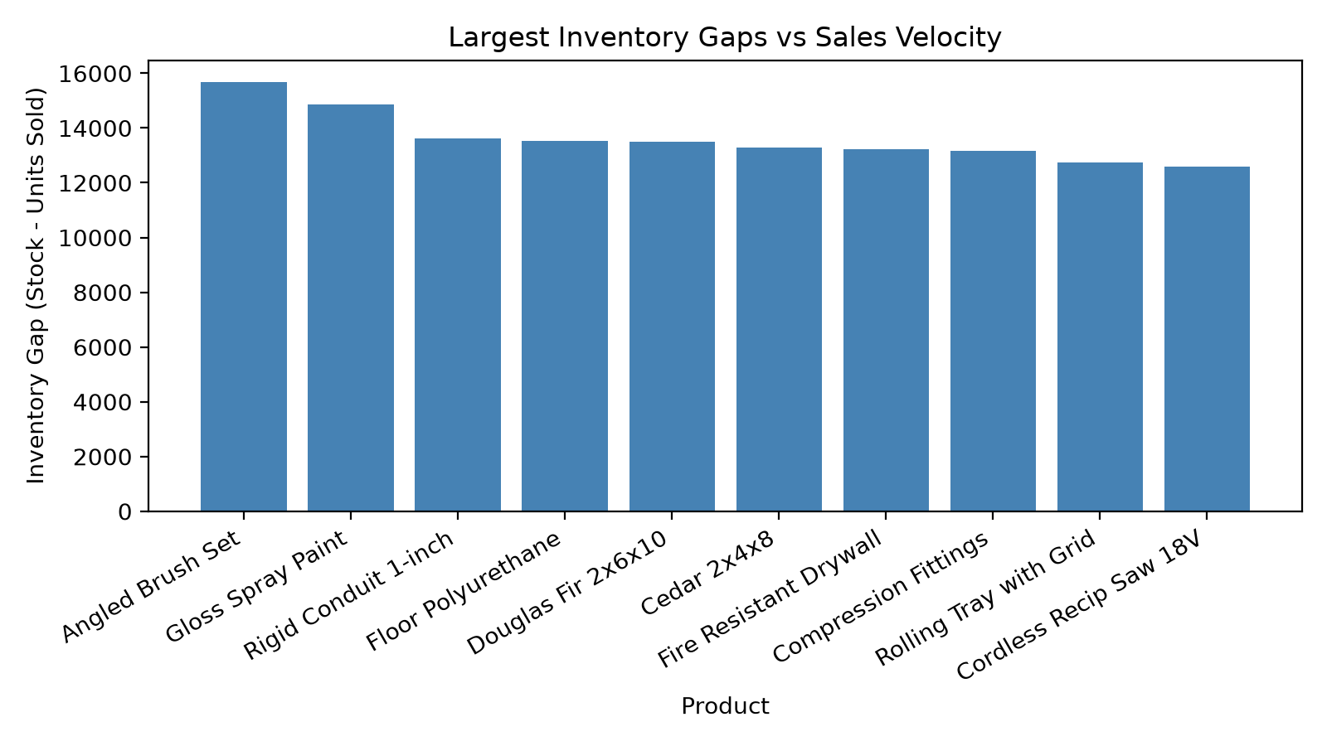

8. Super Manager vs Store Manager RLS Comparison
SQL used:
SELECT store_id, store_name, rls_user_id::text AS rls_user_id
FROM retail.stores
ORDER BY store_name;
Sample output:
store_id | store_name | rls_user_id
2 | Zava Retail Bellevue | 6ba7b810-9dad-11d1-80b4-00c04fd430c8
5 | Zava Retail Everett | 3b9ac9fa-cd5e-4b92-a7f2-b8c1d0e9f2a3
7 | Zava Retail Kirkland | 9c8b7a65-4321-fed0-9876-543210fedcba
8 | Zava Retail Online | 2f4e6d8c-1a3b-5c7e-9f0a-b2d4f6e8c0a2
6 | Zava Retail Redmond | e7f8a9b0-c1d2-3e4f-5678-90abcdef1234
1 | Zava Retail Seattle | f47ac10b-58cc-4372-a567-0e02b2c3d479
4 | Zava Retail Spokane | d8e9f0a1-b2c3-4567-8901-234567890abc
3 | Zava Retail Tacoma | a1b2c3d4-e5f6-7890-abcd-ef1234567890

Chart:
