Hi

I decided to use pandas for getting and processing this information. (about half way thru, I should have used Jason formats and a SQL database instead). (I will take a look of doing that today and hopefully can get something together by the end of tomorrow, since I know what needs to be done.)

I stated this project reading the exact input_sample in python and tried several ways and couldn’t figure out how to put the input into a list, so I ended up putting the data in a text file and renamed it to be: fd.py. That way I could just import fd.py and use the various inputs as lists as I needed.

I will place fd.py in both input and the src directories.

The name of my source program is MyProject.py

Two variables can be changed:

debug (default is False, if changed to True, will list out debugging and tracing information

path (default is ‘’, will be prefixed to location of ‘df_ingest_pandas.csv’ (be care of word’s quote, if you copy and paste from here)

I ran into two problems both with trying to run: UPDATES

I’m getting the following screen image when trying to update SITE_VISITS and ORDERS (I’ve haven’t been able to figure it out yet and may look later today)

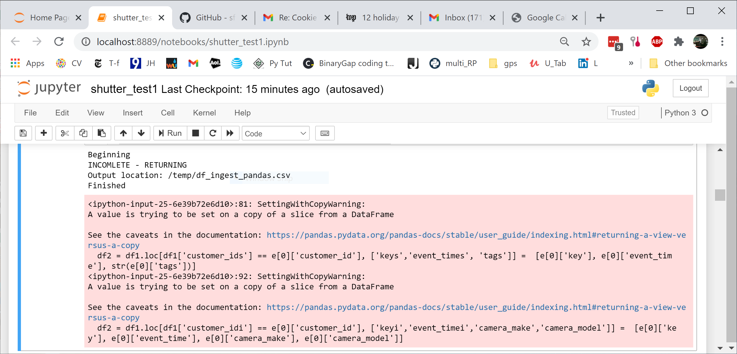

Since I ran into the above problems, I have deferred trying to do NEW Orders by themselves since I’m sure I would eventually encounter the same error

I ran and debug my program using Jupyter Notebooks.

I put a few comments scattered in the program and hope they are enough to basically see and understand what I did. I created a single panda for retaining all of the information. It was a real pain, so I might enjoy trying a different way.

If you have any questions, please email me or set up a conference call and we can discuss them.

Thank You,

Bob Wenzel

[Wenzel.robert.p@gmail.com](mailto:Wenzel.robert.p@gmail.com) or 650.233.1903