Market Efficiency as a State Across Global Equity Markets
A Threshold-Autoregressive Panel Extension of Ahmed and Satchell (2018)
RongQuan
Undergraduate Research Opportunities Programme (UROP), Department of Economics
Imperial College London · Supervisor: Dr Muhammad Farid Ahmed
June 2026

Abstract
Ahmed and Satchell (2018) treat weak-form efficiency not as a binary property but as one of several states a price process occupies over time, identified through a three-regime threshold autoregression (TAR) driven by an exogenous sentiment trigger. We replicate their S&P 500 and FTSE 100 results in Python as a validated baseline and extend the framework in three directions. First, we scale the method from two indices to a panel of 23 globally-admissible equity index series, using the amplitude-adjusted Global OECD Consumer Confidence Indicator (CCI) as a common trigger; the estimated regime thresholds cluster tightly across markets (c₁ ≈ 96.8–98.2, c₂ ≈ 100.8–102.5), establishing cross-market comparability. Second, we characterise the framework’s appropriate domain: the global trigger classifies globally-integrated markets coherently but systematically misses regional and domestic crises (the eurozone debt crisis in Greece and Spain; Turkey’s domestic boom-bust cycles), and a first-difference correlation diagnostic predicts ex ante which markets need a country-specific trigger instead. Third, a pooled forward-return test validates the framework’s economic content: twelve months after a market enters the mean-reverting (MR) state it earns +14.3% on average, versus −3.3% for the explosive (EXP) state and +7.9% for the efficient (RW) baseline, all significant at the 0.1% level. We further document a novel within-regime result: the early phase of an explosive episode still earns positive forward returns (+4.5%) while the late phase is sharply negative (−11.5%).

1. Introduction
The efficient market hypothesis is among the most influential and most contested ideas in financial economics. Since Fama (1965) characterised efficient prices as following a random walk, the literature has largely treated efficiency as a property that either holds or fails on average over a sample. Yet asset prices visibly pass through extended episodes of explosive exuberance and subsequent mean-reverting correction. Treating efficiency as a single sample-wide verdict discards exactly this time variation.
Ahmed and Satchell (2018) reframe efficiency as a state rather than a condition. They model log prices as a three-regime threshold autoregression in which an exogenous trigger variable governs which regime is active in each period. The middle regime is restricted to a unit root and is therefore the efficient, random-walk (RW) state; the outer regimes are free and capture mean reversion (MR, the autoregressive slope below unity, associated with correction) and local explosiveness (EXP, the slope above unity, associated with bubble dynamics). The proportion of time a market spends in each state then becomes a continuous, comparable metric of efficiency. Their illustration used the Michigan Consumer Sentiment Index (MCSI) and the VIX as triggers for the S&P 500 and FTSE 100.
The original study is explicitly illustrative and leaves three questions open, each of which this project takes up. The authors note that the method is “applicable to other assets” but demonstrate it on only two; that “finding an appropriate trigger variable … is non-trivial in practice”; and that combining triggers and applying the method across many markets is left for future research. We first reproduced Tables 7 and 8 of the original paper in Python (the original used MATLAB), recovering the headline finding that both indices appear largely efficient under the switching-drift specification, with inefficiency concentrated in the dot-com run-up and the post-crisis correction. With that baseline validated, we extend the framework along three axes:
- Panel breadth — from two indices to a screened panel of 23 admissible index series spanning developed, emerging and frontier markets, under a single common trigger.
- Trigger methodology and appropriate domain — a principled procedure for choosing the trigger, and a demonstration of where the global trigger succeeds, where it fails, and how to predict failure in advance.
- Economic validation — an out-of-sample forward-return test showing that the regime labels carry genuine predictive content, which the original study did not assess.
Sections 2 sets out the methodology and sample construction. Section 3 reports the cross-market regime classifications. Section 4 — the central methodological contribution — maps the framework’s appropriate domain. Sections 5 and 6 present the forward-return validation and a novel within-regime result. Sections 7 and 8 discuss implications and conclude.

2. Methodology

2.1 The three-regime TAR and the efficiency metric
Following the empirical specification of the original paper, we estimate, for each market, the threshold model Δpₜ = ψₜ₋₁ + (ϕₜ₋₁ − 1)·pₜ₋₁ + ηₜ, where the drift ψ and slope ϕ switch according to the value of the lagged trigger Zₜ₋₁ relative to two thresholds c₁ < c₂. The central regime (c₁ ≤ Z < c₂) is constrained to a random walk (slope of unity in levels, i.e. the reported coefficient is zero) and is labelled efficient. The two outer regimes are left free. We locate c₁ and c₂ by a double grid search that minimises the residual sum of squares across the three sub-samples, then classify each month by its active regime: RW where the slope is statistically indistinguishable from a random walk, MR where the significant slope implies reversion, and EXP where it implies explosiveness. The share of months in each state is the efficiency metric, and — because the same trigger and specification are applied everywhere — it is comparable across markets.

2.2 From MCSI to the Global OECD CCI: threshold stationarity
The original trigger, MCSI, is US-specific and, more importantly, its distribution drifts over time. We found that the optimal c₁ estimated on rolling sub-samples moved across a range of roughly 46 index units, so the very definition of a regime shifts with the sample window. A trigger whose thresholds are not stable cannot anchor a cross-market comparison, because the same numerical threshold no longer means the same thing in two windows or two markets.
We therefore adopt the OECD amplitude-adjusted Composite Consumer Confidence Indicator, normalised to a long-run mean of 100, in its GDP-weighted global aggregate. Amplitude adjustment renders the distribution stationary: the same rolling exercise yields a c₁ range of about 4.8 units, an order of magnitude tighter. Threshold stationarity, not merely exogeneity, is the property that makes out-of-sample comparison valid, and it is the decisive reason for preferring the OECD CCI over MCSI. We also assessed credit- and valuation-based triggers and rejected them on principled grounds: a cyclically-adjusted price-earnings ratio is endogenous to price by construction, and the BIS credit-to-GDP gap fails as a global trigger because credit cycles are governed by domestic mortgage markets, banking systems and regulation rather than by shared information. Consumer sentiment, by contrast, responds to globally-common news — sentiment globalises in a way credit does not.

2.3 Exogeneity, sample length and the admissible panel
Two screens define the panel. The first is exogeneity: the framework requires that the trigger not be Granger-caused by the index’s own returns. Of 48 markets with adequate data, 27 pass this test against the global CCI. The markets that fail are precisely the large economies — the US indices, the UK, Germany’s DAX, France’s CAC 40, Australia’s ASX 200 — whose own equity performance is large enough to move the GDP-weighted aggregate; including them would violate the exogeneity assumption that underpins the estimator. The second screen is sample length: we require at least 340 monthly observations (roughly January 1998 onward) so that every market is exposed to the dot-com, global-financial-crisis (GFC) and COVID episodes. This removes five further markets (Portugal, New Zealand, the TOPIX, Chile and the KOSDAQ). The result is a panel of 23 admissible index series, listed in Appendix B. The panel contains paired indices for several markets (two Israeli, two Hong Kong, two Indonesian and two Chinese indices), which we retain but treat with care when pooling.

2.4 Estimation and inference
Parameters are estimated by non-linear least squares over a grid on the trigger, with the central slope restricted to zero. For the forward-return tests of Sections 5 and 6 we compute cumulative forward log-returns at 1, 3, 6 and 12 months, pool observations within each regime across the panel, and compare regimes using Welch two-sample t-tests with Newey–West (HAC) standard errors whose bandwidth is matched to the return horizon to account for the mechanical overlap in multi-month returns.

3. Cross-Market Regime Classification

3.1 Threshold consistency
Figure 1 plots the estimated thresholds for all 23 markets, ordered by their time-in-RW share. The lower thresholds c₁ cluster between roughly 96.8 and 98.2, and the upper thresholds c₂ between 100.8 and 102.5, straddling the indicator’s long-run mean of 100. This clustering is the key internal validation of the amplitude-adjusted CCI as a common trigger: the same trigger value demarcates the same regime almost everywhere, which is what makes the cross-market metric meaningful. The handful of upward outliers in c₁ — the two Chinese indices, the Philippines and Brazil, which sit near or above 100 — foreshadow markets whose dynamics align only loosely with global sentiment.
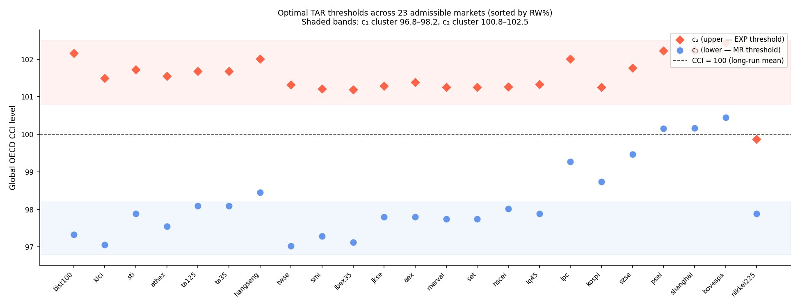
Figure 1. Optimal TAR thresholds across the 23 admissible markets, ordered by time-in-RW share. Shaded bands mark the c₁ and c₂ clusters; the dashed line is the long-run CCI mean of 100.

3.2 A cross-market ranking and a verdict taxonomy
Figure 2 ranks the panel by the proportion of time spent in the efficient RW state, from Turkey (94%) down to Japan (34%). The ranking must be read carefully: “efficiency” here is defined internally as time in the random-walk regime under this particular trigger, not as a universal property. As Section 4 shows, the market at the top of the ranking earns that position because the global trigger cannot see its domestic stress — a caution, not an endorsement.
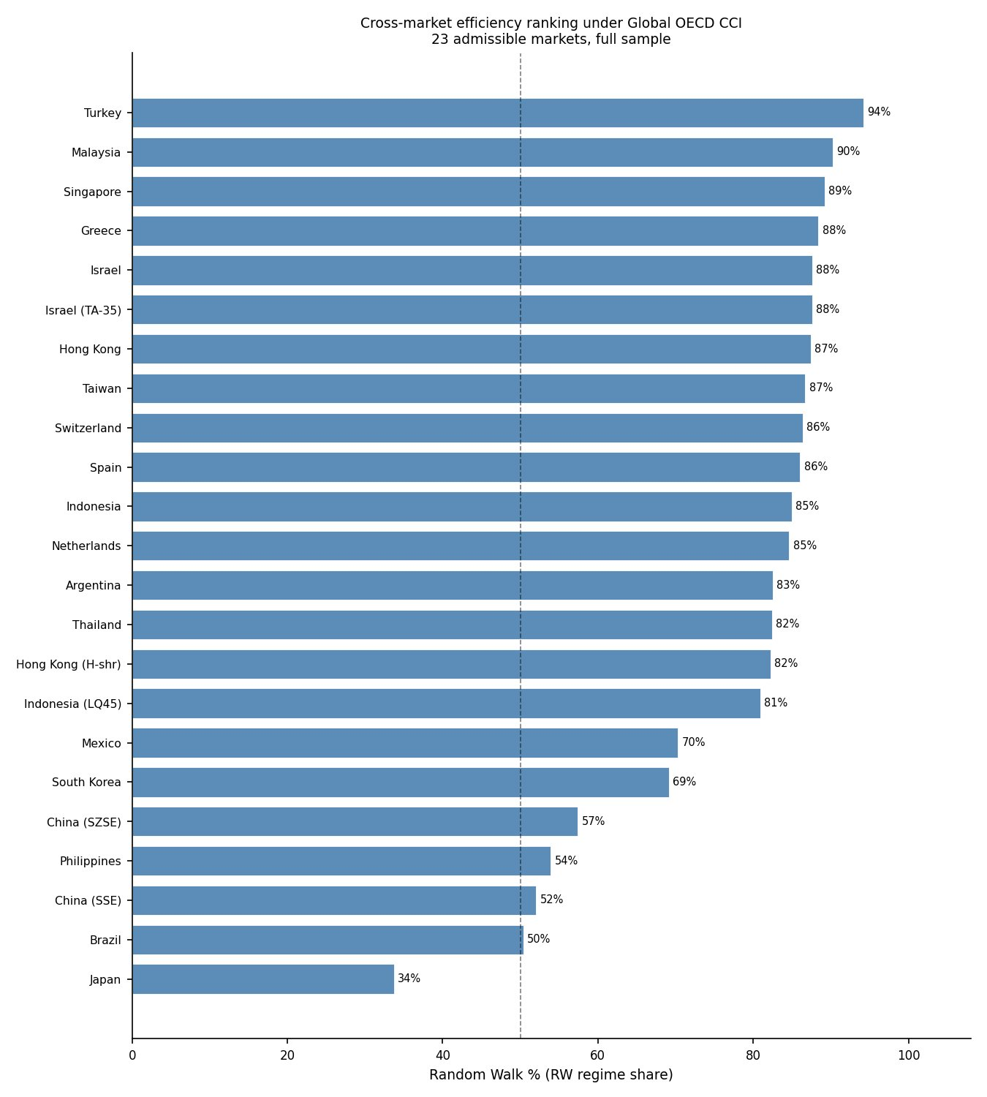
Figure 2. Cross-market efficiency ranking: share of months in the efficient (random-walk) regime under the Global OECD CCI, full sample.
Comparing each market’s behaviour at the dot-com peak (an expected EXP episode) and the GFC trough (an expected MR episode) yields a three-way taxonomy of what the global trigger can detect. Most markets are both-tails cases in which the trigger flags explosiveness at the 2000 peak and mean reversion at the 2008 trough. A few are one-tailed: Malaysia and Taiwan are euphoria gauges — the trigger captures the dot-com explosive tail but not the GFC correction — while Brazil is a fear gauge, flagging downside mean reversion at the GFC and COVID troughs but never flagging an explosive episode. The taxonomy tells us, market by market, which tail of the efficiency spectrum the global trigger is able to resolve.

3.3 A four-category reading of the panel
Stepping back from the ranking, the panel sorts into four broad behavioural groups, distinguished by how each market’s regime structure relates to globally-shared stress. Table 2 summarises the grouping, which also organises the case studies that follow. The categories are read off the regime shares of Appendix B together with the episode-coverage diagnostic of Appendix A (“dot-com” denotes the share of the dot-com peak classified explosive; “GFC” the share of the 2008 trough classified mean-reverting).
Table 2. A four-category synthesis of the admissible panel.
Category | Representative markets | What the regime mix reflects
1. Global-stress aligned | Hong Kong, Singapore, Switzerland, Spain, Netherlands, Israel, Indonesia, Malaysia, Taiwan | High RW with brief, correctly-flagged stress. The dot-com explosive episode and/or the GFC correction are captured in line with each market’s history (e.g. Indonesia dot-com 92%, GFC 100%).
2. Structural divergence | Japan (Nikkei 225), China (SSE, SZSE) | A distinctive regime mix reflecting genuine economic difference: Japan’s post-1990 sentiment–equity divergence (61% EXP); China’s domestic boom-bust cycles (heavy MR), only partly aligned with global sentiment.
3. High mean-reversion (Latin America) | Mexico, Brazil, Argentina | Extended MR driven by commodity and crisis cycles, with little explosiveness. Brazil is the degenerate limit — 0% EXP, effectively a two-regime market (a pure “fear gauge”).
4. Recent-stress capture | South Korea (KOSPI), Philippines (PSEI) | Multiple episodes captured across dot-com, GFC and — unusually, for the Philippines — COVID, with sizeable MR shares (18% and 45%).

Two observations stand out. First, the majority of the panel (Category 1) tracks globally-shared stress closely: these markets are financial centres or open economies whose participation in the global tech bubble and the GFC the trigger identifies cleanly. Two South-East Asian markets are informative exceptions — Malaysia and Taiwan capture the dot-com episode strongly (74% and 90%) yet show zero GFC coverage, having decoupled from the global 2008 drawdown; these are the “euphoria-gauge” cases of Section 3.2. Capturing the global episodes, however, does not guarantee capturing regional ones: Spain sits in Category 1 for the tech bubble yet misses the eurozone debt crisis entirely — the boundary that Section 4 takes up.
Second, the most informative departures are structural rather than failures. Japan is classified explosive for 61% of the sample because consumer sentiment stayed elevated relative to deflation-era equity returns, a genuine feature of the post-1990 economy rather than an artefact. China’s two indices spend 47% (SSE) and 37% (SZSE) in mean reversion, tracing domestic boom-bust cycles around 2008 and 2015 that align only partly with global sentiment; the Shenzhen index’s heavier technology weighting gives it stronger dot-com coverage (46%) than Shanghai (10%). Latin America forms a third cluster of high mean-reversion with little explosiveness, of which Brazil is the limiting case: the framework finds no explosive months at all, so Brazil collapses to an effectively two-regime, downside-only process — a degenerate outcome worth flagging methodologically and a reminder that commodity-driven markets can experience deep corrections without globally-registered euphoria.

3.4 Representative case studies
Three markets illustrate the range of behaviour. Hong Kong (Figure 3) is the canonical globally-integrated, both-tails case: 87% RW, with a brief explosive episode at the 2000 peak and mean reversion at the 2008 and 2020 troughs.
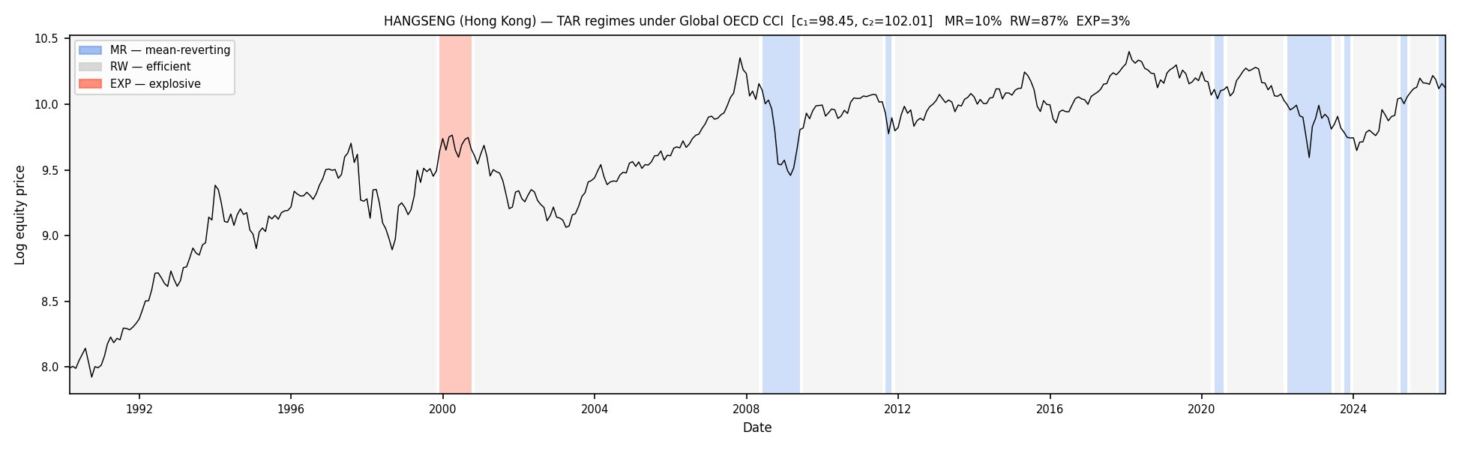
Figure 3. Hang Seng (Hong Kong) under the Global OECD CCI: RW 87%, MR 10%, EXP 3%. Explosive shading at the dot-com peak; mean-reverting shading at the GFC and COVID troughs.
Japan (Figure 4) is the structural outlier, spending 61% of the sample in the EXP regime. This is not a malfunction but a real feature: through the post-1990 deflationary decades Japanese equities de-rated while global confidence rose, so the high-sentiment regime maps onto sustained Japanese weakness. It is a reminder that the regime labels are relative to the trigger’s information set.
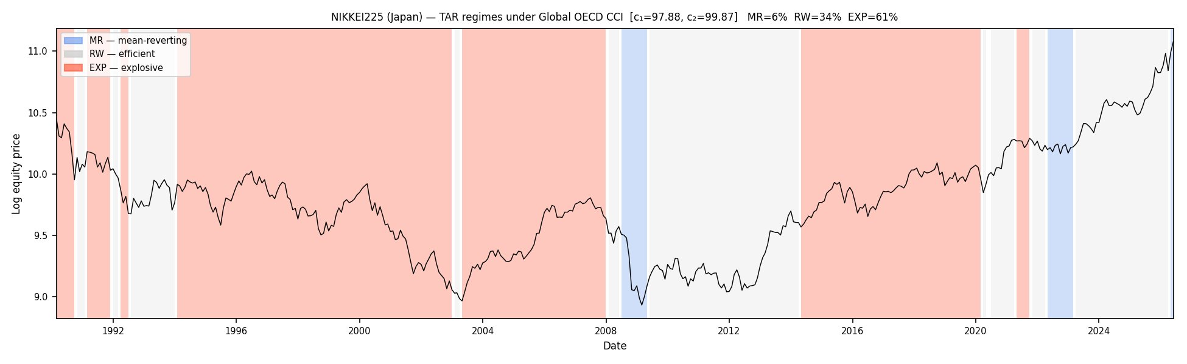
Figure 4. Nikkei 225 (Japan) under the Global OECD CCI: RW 34%, MR 6%, EXP 61% — the structural outlier reflecting Japan’s post-1990 divergence from global sentiment.
Mainland China (Figure 5) sits at the other extreme of the ranking, with the Shanghai composite in the MR regime 47% of the time. Chinese A-shares exhibit pronounced domestic boom-bust cycles — most visibly around 2007–08 and 2015 — which the global trigger reads largely as extended mean reversion.
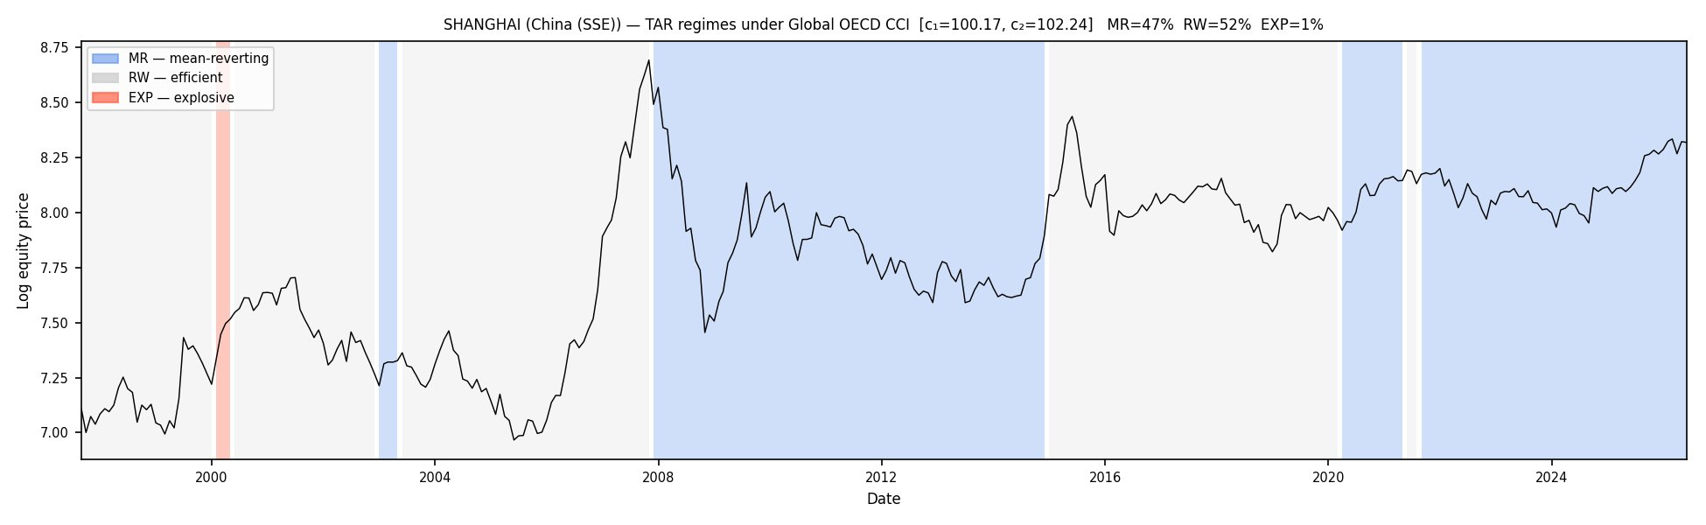
Figure 5. Shanghai (China, SSE) under the Global OECD CCI: RW 52%, MR 47%, EXP 1%.

4. The Framework’s Appropriate Domain
A global sentiment trigger can only resolve sentiment swings that are globally shared. Regional and domestic crises that do not register in the OECD aggregate are therefore invisible to it, and the affected market is mislabelled as efficient. This section makes that boundary precise, provides a diagnostic that predicts it, and proposes a workflow for choosing the trigger. We regard this as the project’s central contribution.

4.1 Motivation: a crisis hidden inside the efficient band
Spain (Figure 6) makes the problem concrete. Under the global CCI the IBEX 35 is classified RW 86% of the time, with explosive shading only at the dot-com peak and a bare 2% in MR. The entire 2010–2012 eurozone sovereign-debt collapse falls inside the “efficient” band, because Spanish sentiment diverged sharply from the OECD aggregate during the crisis. The framework records no inefficiency precisely when Spain was most stressed.
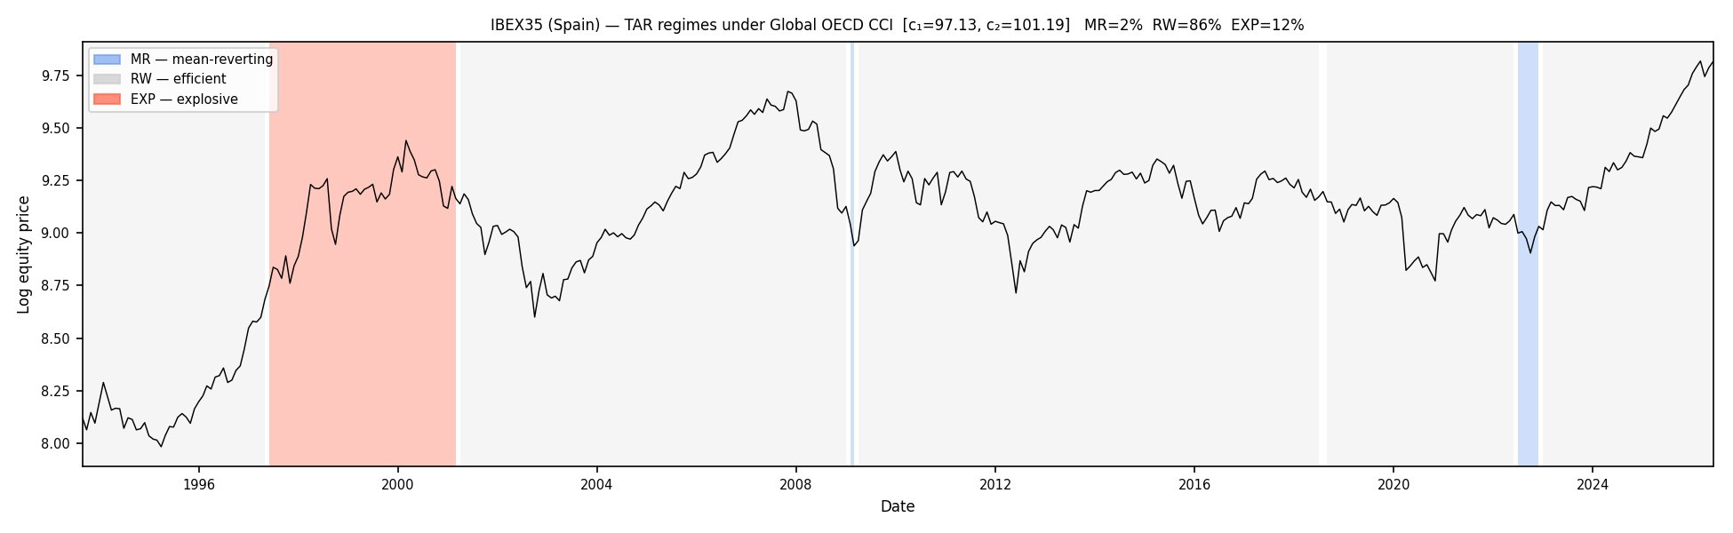
Figure 6. IBEX 35 (Spain) under the Global OECD CCI: RW 86%, EXP 12%, MR 2%. The eurozone debt crisis (2010–2012) is absorbed into the efficient band.

4.2 A diagnostic: first-difference correlations
Which markets are at risk can be anticipated. We correlate the month-on-month changes in each economy’s own OECD CCI with the changes in the global aggregate. First differences are more informative than levels here, because level correlations are inflated by common long-run trends; differencing isolates genuine contemporaneous co-movement. Table 1 reports representative values. The United States sits at 0.81 — mechanically high, since it carries roughly 40% of the GDP-weighted aggregate — and most OECD economies fall between 0.50 and 0.70. Greece (0.37), Turkey (0.38) and New Zealand (0.29) lie far below, marking markets whose domestic sentiment moves largely independently of the global signal.
Table 1. Selected first-difference correlations between national and global OECD CCI.
Economy | Δ-correlation | Economy | Δ-correlation
United States | 0.81 | Germany | 0.52
Spain | 0.71 | Mexico | 0.51
Japan | 0.67 | Italy | 0.49
United Kingdom | 0.62 | Turkey | 0.38
South Korea | 0.60 | Greece | 0.37
Netherlands | 0.56 | New Zealand | 0.29

4.3 Greece: recovering the crisis with a domestic trigger
Under the global CCI the Athens index is 88% RW and just 4% MR (Figure 7, top), missing the entire 2010–2018 debt crisis. Replacing the trigger with the Greek-specific OECD CCI transforms the classification (Figure 7, bottom): the market is now 44% MR, 25% EXP and 31% RW, with the long crisis appearing as a sustained mean-reverting collapse and the late-1990s run-up as explosive. The economic content was always in the price series; only a trigger aligned with Greek conditions could expose it.
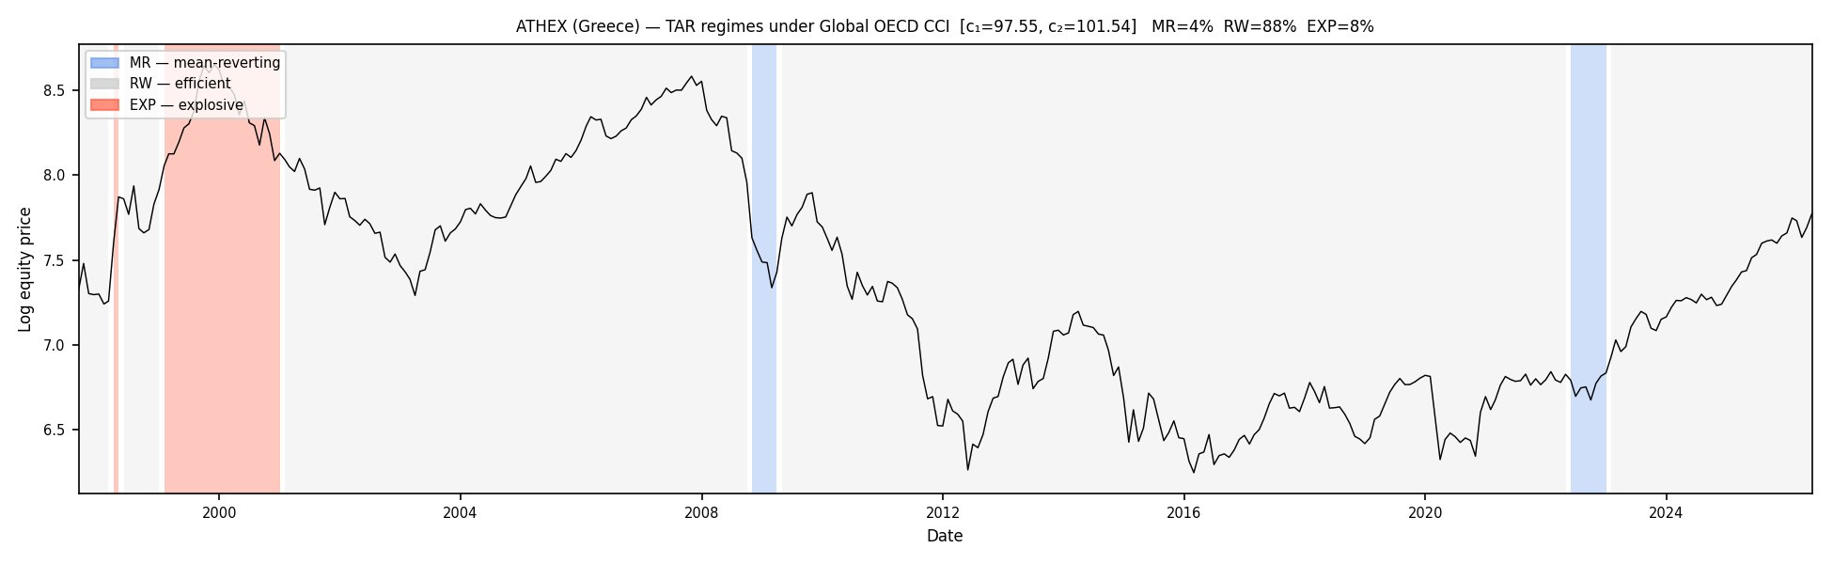
Figure 7 (top). ATHEX (Greece) under the Global OECD CCI: RW 88%, MR 4%, EXP 8% — the debt crisis is missed.
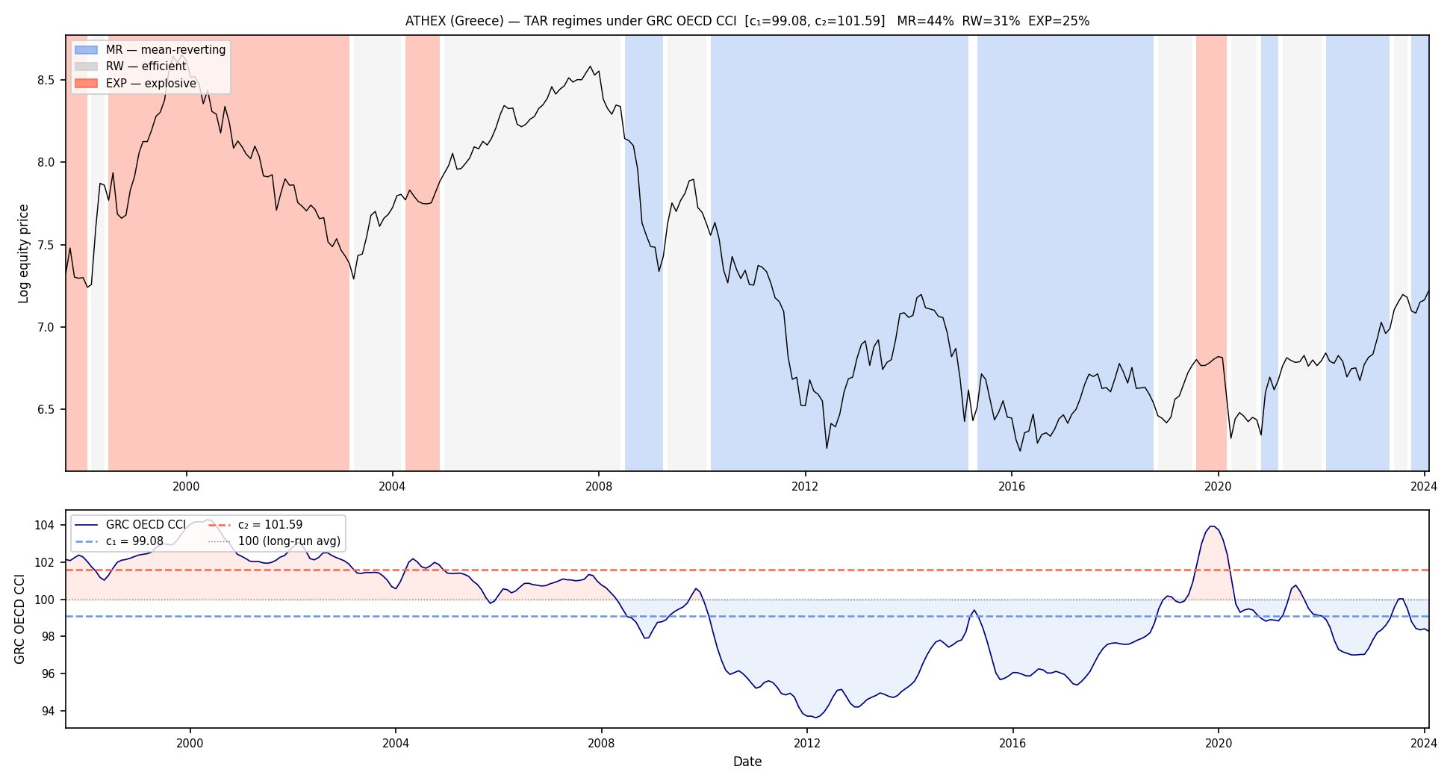
Figure 7 (bottom). ATHEX (Greece) under the Greek-specific OECD CCI: RW 31%, MR 44%, EXP 25% — the 2010–2018 crisis is recovered as a mean-reverting collapse.

4.4 Turkey: the “most efficient” market reconsidered
Turkey tops the efficiency ranking at 94% RW under the global trigger (Figure 8, top) — but only because its recurrent currency, banking and inflation crises are domestic and leave no trace in global sentiment. Under the Turkish-specific CCI (Figure 8, bottom) the picture inverts: 48% EXP, 45% RW and 7% MR, with the lira-driven nominal boom-bust pattern emerging clearly. The market that looked most efficient is in fact the one whose stress the global trigger is least able to see.
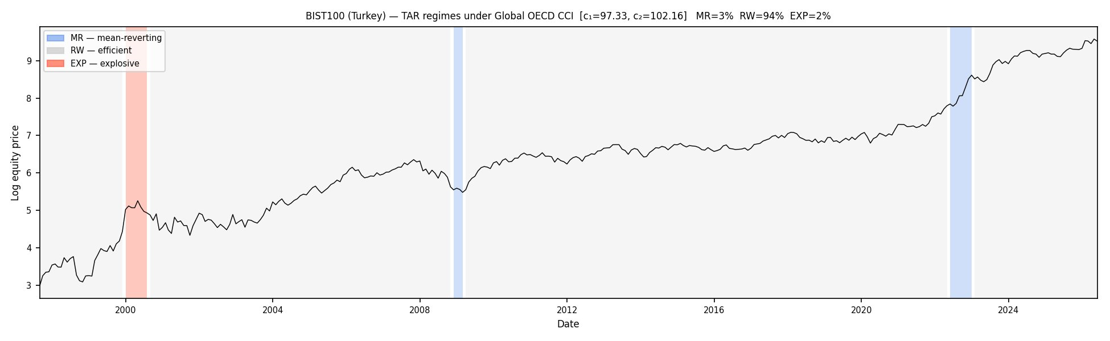
Figure 8 (top). BIST 100 (Turkey) under the Global OECD CCI: RW 94%, MR 3%, EXP 2% — domestic crises are invisible.
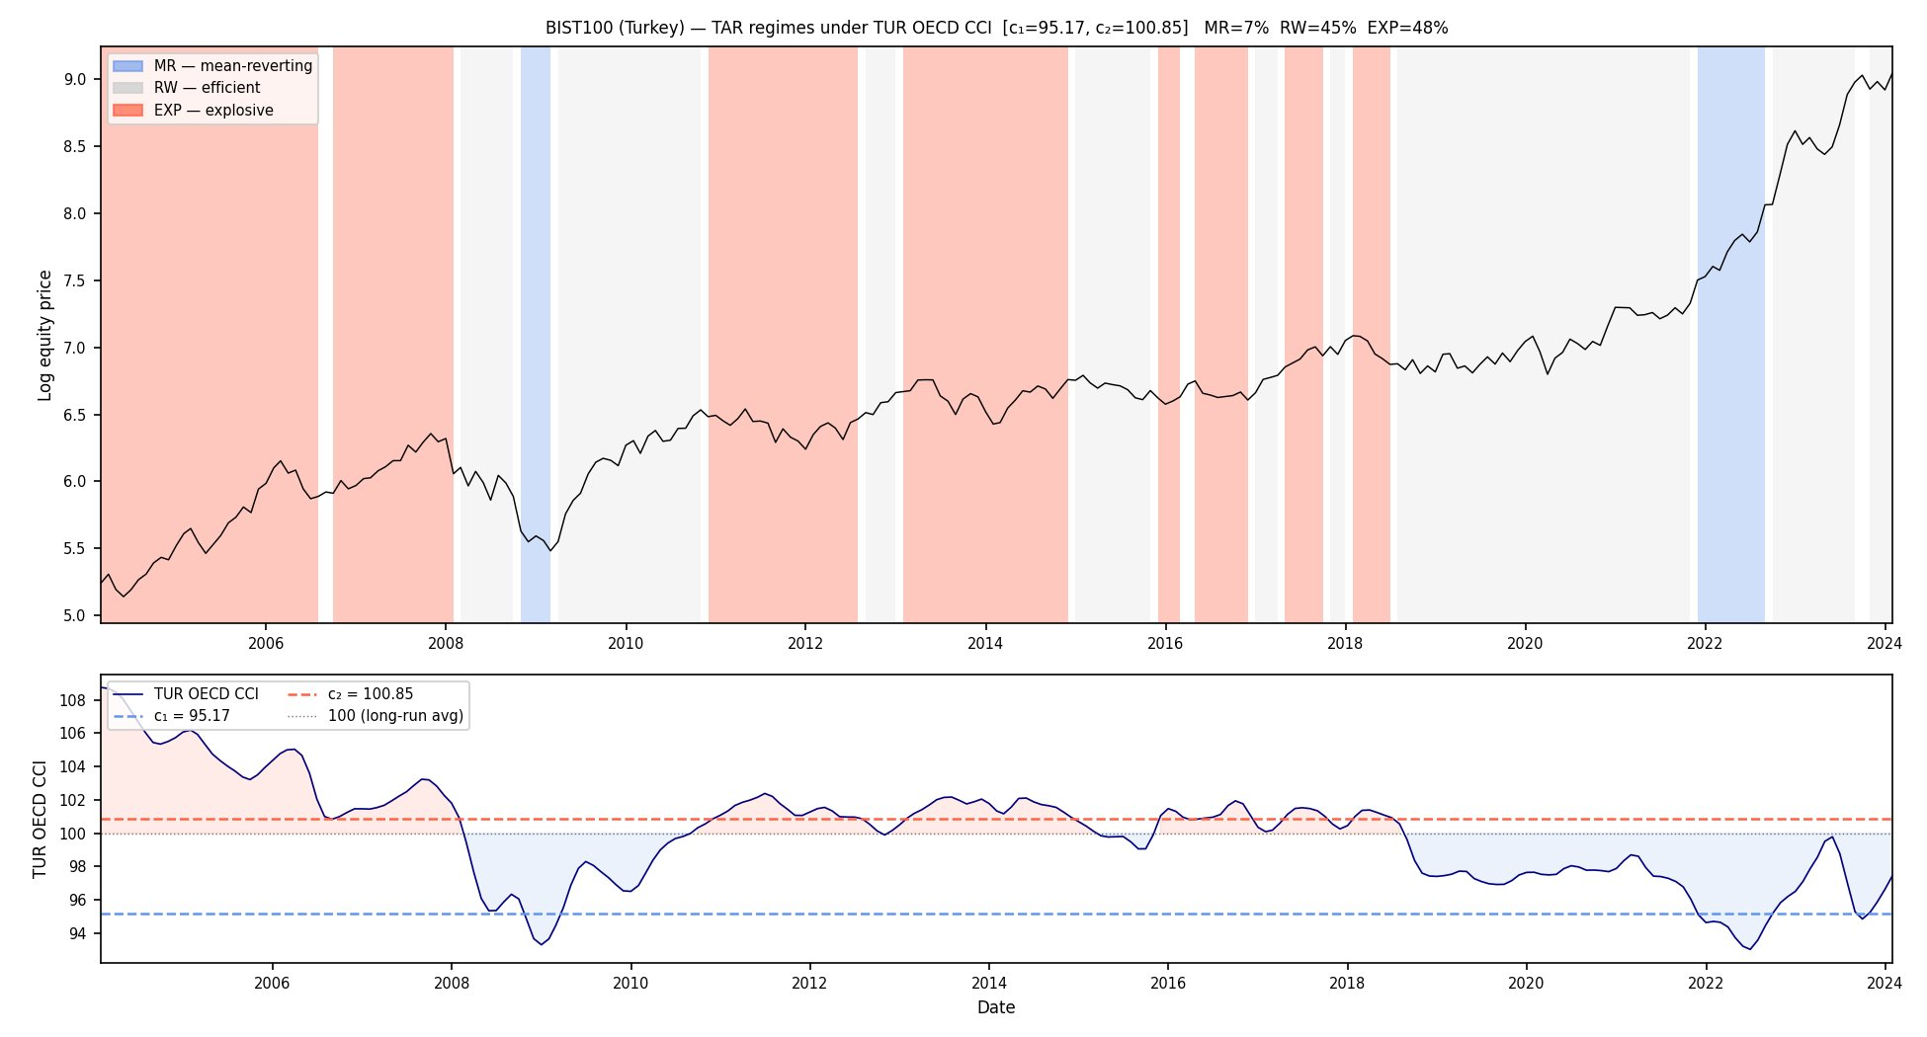
Figure 8 (bottom). BIST 100 (Turkey) under the Turkish-specific OECD CCI: RW 45%, MR 7%, EXP 48% — the domestic boom-bust pattern emerges.

4.5 A structural explanation and a trigger-selection workflow
The mechanism is the GDP weighting itself. The global aggregate is dominated by large economies, so a small or peripheral economy contributes little weight and its domestic sentiment can move opposite to the aggregate without disturbing it. The diagnostic of Section 4.2 is simply a direct measure of that misalignment. These observations suggest a four-stage workflow for choosing a trigger in any application of the framework: (i) test exogeneity by Granger causality and discard markets that move the aggregate; (ii) screen the first-difference correlation, treating values below about 0.5 as candidates for a country-specific trigger; (iii) validate against documented crisis sub-periods, since correlation is necessary but not sufficient — Spain’s 0.71 overall correlation masks acute crisis-period divergence; and (iv) implement the framework with the global or country-specific trigger accordingly. Documenting which candidate triggers fail, and why, is itself a methodological output that future applications can reuse.

5. Out-of-Sample Economic Content
The original study assessed only how often each market was inefficient, not whether the regime labels predict anything. We close that gap with a pooled forward-return test. For every month we record the active regime and the subsequent cumulative log-return at 1, 3, 6 and 12 months, then pool within regime across the panel. Figure 9 reports the 12-month results. Entering the mean-reverting state precedes an average gain of +14.3%; entering the explosive state precedes −3.3%; the efficient baseline returns +7.9%. Both differences from the RW baseline are significant at the 0.1% level, and the MR–EXP spread exceeds 17 percentage points.
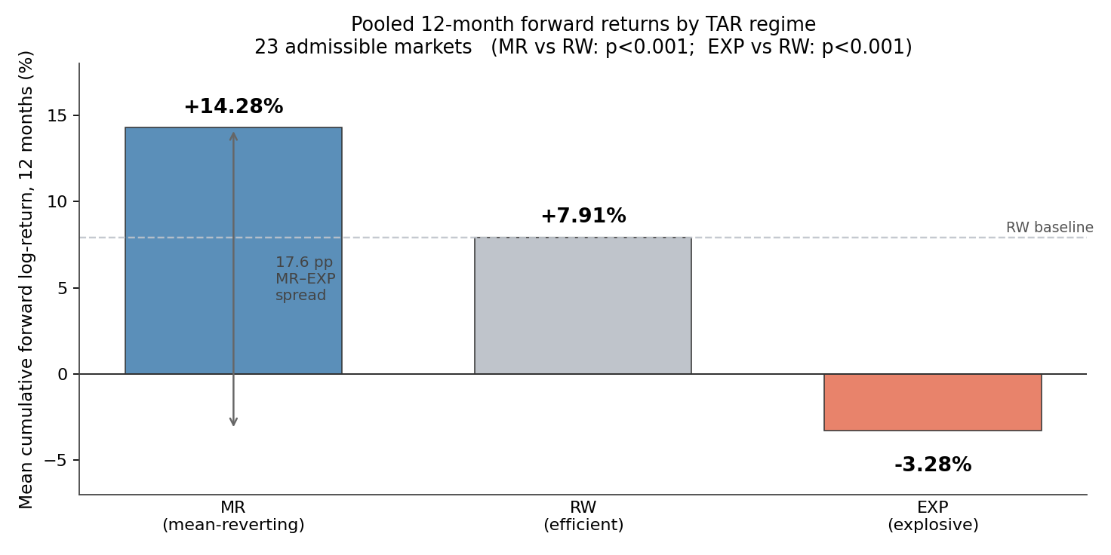
Figure 9. Pooled 12-month forward log-returns by regime across the 23 markets. MR vs RW and EXP vs RW differences both significant at p < 0.001.
The economic reading is intuitive. The MR state is entered when sentiment is depressed and prices have corrected, conditions that historically precede recovery; the EXP state is entered amid euphoric sentiment that historically precedes underperformance. The regime labels, derived purely from the trigger and the price dynamics, thus carry genuine forward-looking information — the validation the framework needed to move from a descriptive metric toward a usable one.

6. Within-Regime Dynamics: Early versus Late Explosiveness
A finer cut of the explosive state yields a result not present in the original paper. We split each continuous EXP episode at its midpoint (excluding episodes of three months or fewer, and taking the floor of the midpoint for odd lengths) into an early and a late phase, and recompute 12-month forward returns. The two phases behave very differently (Figure 10): the early phase still earns +4.5%, while the late phase loses −11.5%, a spread of about 16 percentage points, again significant at the 0.1% level.
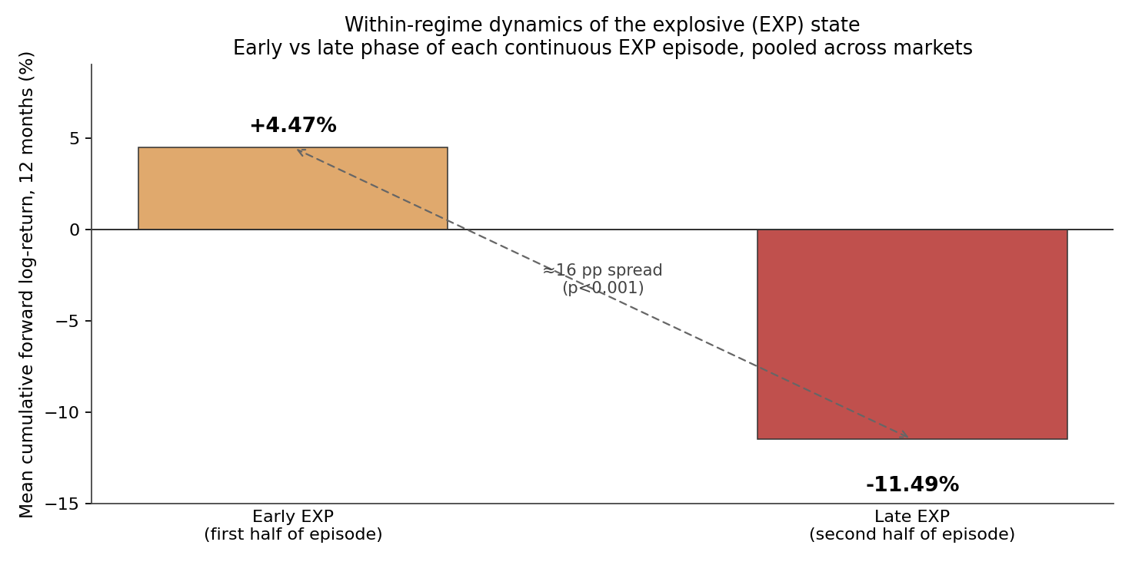
Figure 10. Early versus late phase of explosive episodes: 12-month forward log-returns pooled across markets. The damage concentrates in the late phase (p < 0.001).
Explosiveness, in other words, is not uniformly costly: the build-up phase of a bubble still pays, and the losses concentrate as the episode matures. This characterises the anatomy of explosive episodes rather than offering a real-time signal — the early/late split is an ex-post classification of completed episodes and should be read as descriptive. Even so, it sharpens the framework’s account of how inefficiency resolves.

7. Discussion
The project makes three contributions. It scales the efficiency-as-a-state framework from two indices to a screened global panel and shows that the regime thresholds are stable across markets, establishing comparability. It maps the framework’s appropriate domain, demonstrating that a global sentiment trigger is valid for globally-integrated markets, that its failures coincide with domestically-driven crises, and that those failures can be predicted in advance and repaired with a country-specific trigger. And it validates the regime labels out of sample, showing they carry substantial and significant forward-return content, including a novel early-versus-late asymmetry within explosive episodes.
As a current reading — offered with caution, as a regime classification at one trigger value rather than a forecast — the latest Global OECD CCI of about 97.55 sits below the typical lower threshold of 97–98, which places most admissible markets in the mean-reverting regime as of early 2026 and leaves no market carrying an explosive classification under the global trigger. This points to a correction-and-recovery reading rather than a bubble signal, consistent with the sentiment drawdown that followed the April 2025 shock.
Several limitations qualify the results. The early/late split is ex-post; the regime labels are relative to the trigger’s information set; COVID coverage is weak across markets, reflecting the lag between sentiment and equity prices; the paired indices are not independent observations in the pooled tests; and grid-search inference is approximate. The natural next steps are to extend the country-specific trigger to further low-correlation markets (Mexico, Spain, Italy), to add robustness checks (bootstrap confidence intervals, alternative drift specifications, a COVID-excluded sub-sample), and — following a question raised in supervision — to examine individual equities, given the absence of an index-level bubble signal in the United States.

8. Conclusion
Treating market efficiency as a state, not a verdict, scales cleanly to a global panel of equity markets. A single amplitude-adjusted global sentiment trigger classifies globally-integrated markets coherently and comparably; where it fails, it fails for an identifiable structural reason and in a way that a simple diagnostic anticipates and a country-specific trigger corrects. Most importantly, the regime labels are not merely descriptive: they predict forward returns with economically large and statistically significant gaps between mean-reverting, efficient and explosive states. Building on a validated replication of Ahmed and Satchell (2018), the three extensions — panel breadth, an appropriate-domain methodology, and out-of-sample validation — together move the framework from an illustrative metric toward a comparative, predictive tool.

Appendix A. Historical Episode Coverage
Figure A1 reports, for each market, the share of episode months classified in the expected regime: the dot-com peak as explosive, and the GFC and COVID troughs as mean-reverting. We present this for transparency rather than as primary evidence. Coverage percentages are sensitive to the exact window definitions, and the near-zero COVID coverage across most markets reflects the lag between consumer sentiment and equity prices rather than a classification error. The case-study comparisons of Section 4 provide stronger evidence on the framework’s domain than these aggregate coverage figures.
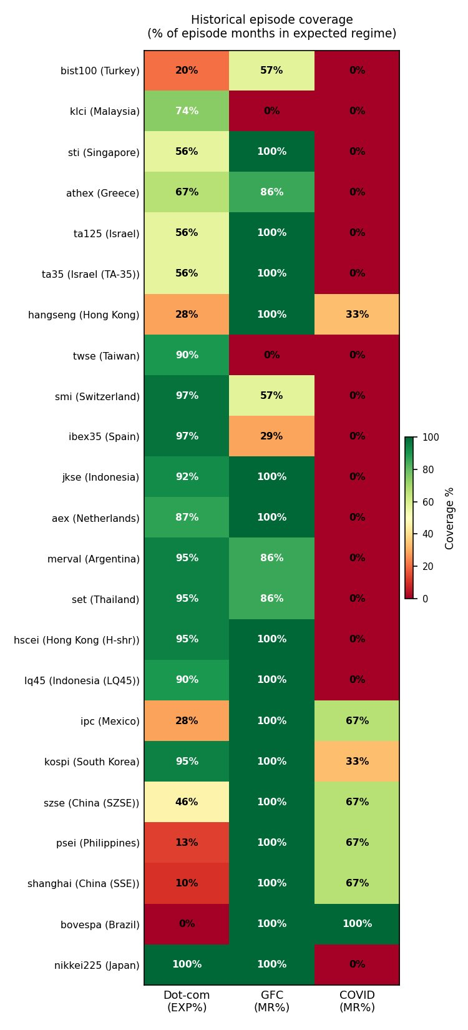
Figure A1. Historical episode coverage: percentage of episode months classified in the expected regime, by market and episode.

Appendix B. The Admissible Panel
Table B1 lists the 23 admissible index series, ordered by time in the efficient regime, with regime shares, estimated thresholds and the verdict taxonomy of Section 3.2. Regime shares are rounded and may not sum to 100.
Table B1. Admissible panel under the Global OECD CCI (full sample).
Index | Country / market | RW % | MR % | EXP % | c₁ | c₂ | Verdict
bist100 | Turkey | 94 | 3 | 2 | 97.33 | 102.16 | Both tails
klci | Malaysia | 90 | 2 | 8 | 97.06 | 101.50 | Euphoria gauge
sti | Singapore | 89 | 6 | 5 | 97.88 | 101.72 | Both tails
athex | Greece | 88 | 4 | 8 | 97.55 | 101.54 | Both tails
ta125 | Israel | 88 | 7 | 5 | 98.09 | 101.68 | Both tails
ta35 | Israel (TA-35) | 88 | 7 | 5 | 98.09 | 101.68 | Both tails
hangseng | Hong Kong | 87 | 10 | 3 | 98.45 | 102.01 | Both tails
twse | Taiwan | 87 | 2 | 12 | 97.02 | 101.32 | Euphoria gauge
smi | Switzerland | 86 | 3 | 11 | 97.28 | 101.21 | Both tails
ibex35 | Spain | 86 | 2 | 12 | 97.13 | 101.19 | Both tails
jkse | Indonesia | 85 | 5 | 10 | 97.80 | 101.28 | Both tails
aex | Netherlands | 85 | 5 | 10 | 97.80 | 101.38 | Both tails
merval | Argentina | 83 | 5 | 12 | 97.75 | 101.25 | Both tails
set | Thailand | 82 | 5 | 12 | 97.74 | 101.26 | Both tails
hscei | Hong Kong (H-shr) | 82 | 7 | 11 | 98.01 | 101.26 | Both tails
lq45 | Indonesia (LQ45) | 81 | 7 | 12 | 97.88 | 101.33 | Both tails
ipc | Mexico | 70 | 27 | 3 | 99.27 | 102.01 | Both tails
kospi | South Korea | 69 | 18 | 12 | 98.73 | 101.26 | Both tails
szse | China (SZSE) | 57 | 37 | 5 | 99.47 | 101.77 | Both tails
psei | Philippines | 54 | 45 | 1 | 100.16 | 102.22 | Both tails
shanghai | China (SSE) | 52 | 47 | 1 | 100.17 | 102.24 | Both tails
bovespa | Brazil | 50 | 50 | 0 | 100.44 | 102.43 | Fear gauge
nikkei225 | Japan | 34 | 6 | 61 | 97.88 | 99.87 | Both tails
Selected references
Ahmed, M. F., and S. E. Satchell. 2018. “What Proportion of Time is a Particular Market Inefficient?” Journal of Time Series Econometrics 20160021.
Fama, E. F. 1965. “The Behaviour of Stock-Market Prices.” Journal of Business 38 (1): 34–105.
Knight, J., and S. E. Satchell. 2011. “Some New Results for Threshold AR(1) Models.” Journal of Time Series Econometrics 3: 1–42.
Phillips, P. C. B., S. Shi, and J. Yu. 2013. “Testing for Multiple Bubbles.” Cowles Foundation Discussion Paper 1914.
Evans, G. W. 1991. “Pitfalls in Testing for Explosive Bubbles in Asset Prices.” American Economic Review 81: 1189–1214.
OECD. Composite Consumer Confidence Indicator (amplitude-adjusted), global and country series.

