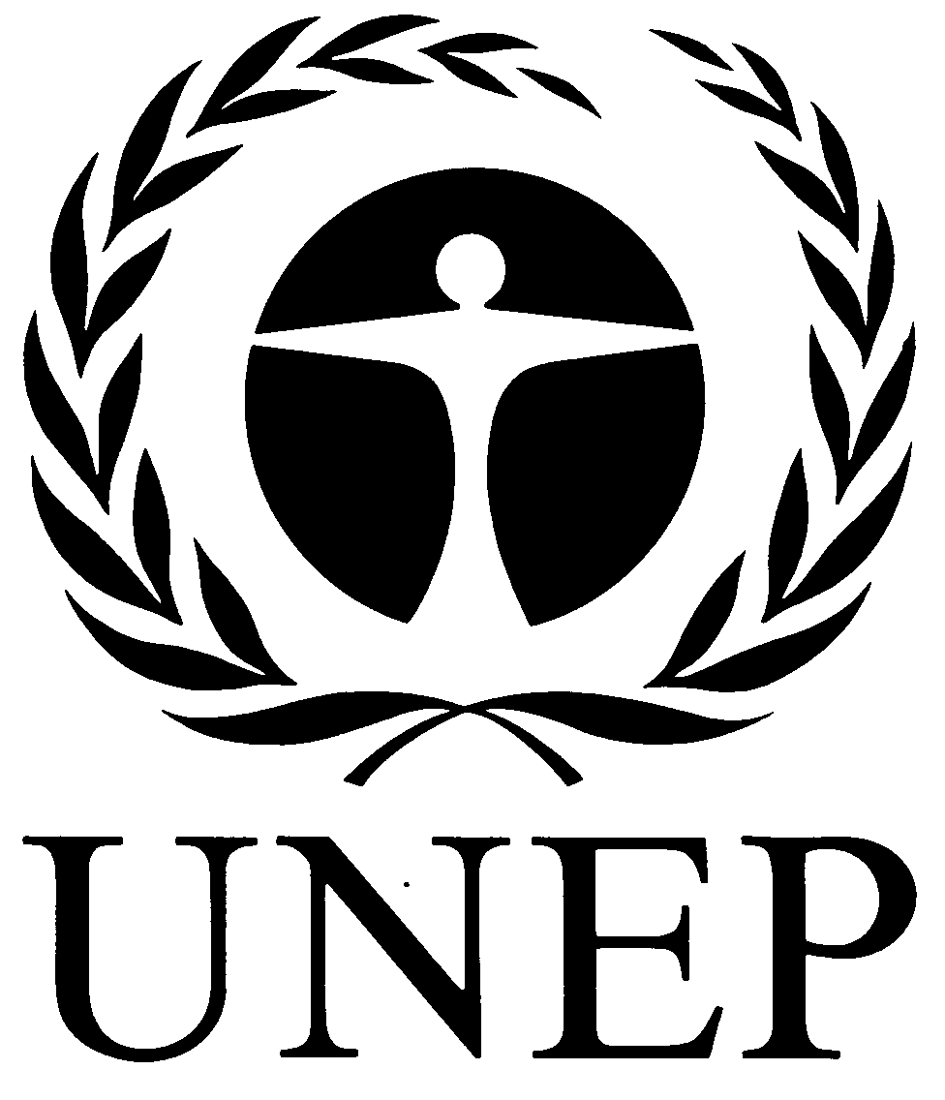 |  | CBD
 |  |  |  | Distr.  GENERAL  UNEP/CBD/COP/DEC/XII/16  17 October 2014  ORIGINAL: ENGLISH
CONFERENCE OF THE PARTIES TO THE CONVENTION ON BIOLOGICAL DIVERSITY
Twelfth meeting
Pyeongchang, Republic of Korea, 6-17 October 2014
Agenda item 22

DECISION ADOPTED BY THE CONFERENCE OF THE PARTIES TO THE CONVENTION ON BIOLOGICAL DIVERSITY

XII/16. Invasive alien species: management of risks associated with introduction of alien species as pets, aquarium and terrarium species, and as live bait and live food, and related issues
The Conference of the Parties,
Recognizing the negative impacts of invasive alien species introduced as pets, aquarium and terrarium species, and as live bait and live food, on biodiversity, and the risk of escape and release,
Reaffirming that the Guiding Principles for the Prevention, Introduction and Mitigation of Impacts of Alien Species that Threaten Ecosystems, Habitats or Species contained in the annex to decision VI/23* continue to provide guidance to Parties, other Governments, relevant organizations and all biodiversity stakeholders,
Recalling its encouragement to Parties, in decision IX/4, to make use of the risk assessment guidance and other procedures and standards developed by the International Plant Protection Convention, the World Organisation for Animal Health and other relevant organizations,

Also recalling the request to the Executive Secretary, in decision XI/28, to continue to pursue the tasks set out in paragraphs 11, 12 and 13 of decision IX/4 A and paragraph 13 of decision X/38, especially regarding progress in its relationship with standard-setting bodies recognized by the World Trade Organization (the International Plant Protection Convention, the World Organisation for Animal Health and the Codex Alimentarius Commission), and other relevant organizations,
1. Adopts the voluntary guidance on devising and implementing measures to address the risks associated with the introduction of alien species as pets, aquarium and terrarium species, and as live bait and live food, as contained in the annex to this decision, noting that measures taken under this guidance are to be consistent with applicable national and international obligations;
2. Urges Parties, other Governments, and relevant organizations to disseminate this guidance widely and to promote its use for the development of regulations, codes of conduct and/or other guidance, as appropriate, by States, industry and relevant organizations at all levels, and to facilitate the harmonization of measures;
3. Invites Parties, Governments and other relevant bodies to make available relevant information, including the results of risk assessments on invasive alien species and lists of species, as well as National Invasive Species Strategies and Action Plans, through clearing-house mechanisms and/or the Global Invasive Alien Species Information Partnership;
4. Requests the Executive Secretary, in collaboration with the Convention on International Trade in Endangered Species of Wild Fauna and Flora and relevant organizations, to explore ways and means to address the risks associated with trade in wildlife introduced as pets, aquarium and terrarium species, and as live bait and live food, noting that some trade is unregulated, unreported or illegal, including by enhancing cooperation with authorities responsible for the control of wildlife trade and to report to the Subsidiary Body on Scientific, Technical and Technological Advice at a meeting prior to thirteenth meeting of the Conference of the Parties.
Annex
GUIDANCE ON DEVISING AND IMPLEMENTING MEASURES TO ADDRESS THE RISKS
ASSOCIATED WITH THE INTRODUCTION OF ALIEN SPECIES AS PETS, AQUARIUM
AND TERRARIUM SPECIES, AND AS LIVE BAIT AND LIVE FOOD
Objectives and nature of this guidance
- This guidance is intended to assist countries and relevant organizations in devising and implementing measures, at national, regional, subregional and other levels, to address the risks associated with the introduction of alien species as pets, aquarium and terrarium species, and as live bait and live food. It provides elements that relevant authorities may use for the development of regulations or codes of conduct, or that international organizations, industry and civil society organizations may use in voluntary codes of conduct and other guidance.
- The introduction of invasive alien species as pets, aquarium and terrarium species, and as live bait and live food, is a subcategory of “escape” as a pathway. Escape is the movement of organisms from captivity or confined conditions into the natural environment. Through this pathway the organisms are initially intentionally imported or transported into the confined conditions, then escape. This may include intentional, accidental or careless release of live organisms into the environment, including cases such as the disposal of live food into the environment or the use of live bait in non-confined water systems.
- For the purpose of this guidance, pets, aquarium and terrarium species, live bait and live food are understood to include lower taxa and hybrids (including hybrids between native organisms and organisms that are alien in the region to which they are intended to be imported or transported).
- This guidance is intended to apply to the import or transport to a country or distinct biogeographical area within the country, of pets, aquarium and terrarium species, live bait and live food, including trade via the Internet. This guidance is relevant to States, relevant organizations, the industry and consumers, including all actors along the value chain (such as importers, breeders, wholesalers, retailers and customers). For the case of live food, this also includes restaurants and markets.
- This guidance is voluntary and is not intended to affect any existing national and international obligations. It is intended to be used in conjunction and mutually supportive with other relevant guidance, for example the Guiding Principles for the Prevention, Introduction and Mitigation of Impacts of Alien Species that Threaten Ecosystems, Habitats and Species; standards, guidelines and recommendations developed under the International Plant Protection Convention or under the World Organisation for Animal Health and Codex Alimentarius Commission and other relevant organizations; and relevant voluntary codes.
Prevention and responsible conduct
- Industry and all actors should be aware of the risk of alien organisms becoming invasive and their potential negative impacts on biodiversity at ecosystem, habitat, species and gene levels, and related impacts on human health, livelihoods and economies. States, industry and relevant organizations should undertake public awareness campaigns to this effect.
- Generally, and as a priority, States, relevant organizations and the industry should promote the use of species that have been shown to be non-invasive in the case of species used as pets and aquarium and terrarium species.
- States, relevant organizations and the industry should discourage or prohibit the use of live bait that may pose a risk of invasion and/or spread of pathogens or parasites.
- States, relevant organizations and the industry should raise awareness of buyers, potential buyers, suppliers, sellers consumers, and potential consumers on the importance of safe handling of, and appropriate care for, live organisms as pets, aquarium and terrarium species and of the safe handling and disposal of invasive species used as live bait or live food.
- States, relevant organizations, the industry and consumers should handle any potentially invasive pet, aquarium and terrarium species, or species used as live bait and live food, responsibly and with utmost care. They should undertake, where possible and appropriate, the measures listed in paragraph 18 below.
Risk assessment and management
- When planning to import or transport pets, aquarium and terrarium species, live bait and live food to a country, or distinct biogeographical area within a country, where they are non-native, States, relevant organizations or the industry, should undertake a risk assessment. The risk assessment may draw on previously conducted assessments and other available information. The risk assessment should consider, inter alia:
(a) The probability of escape of organisms, at any stage of their life cycle, from confined conditions (including through accidental or careless release);
(b) The probability of establishment and spread of the species;
(c) The impacts of establishment and spread of the species on biodiversity, including hybridization with native species leading to loss of genetic diversity, and related impacts on productive activities and human health and the significance of these impacts;
(d) Risk regarding spread of pathogens and parasites.
- The assessment of the probability of escape should take into account the specific characteristics of the species as well as existing measures in place to retain it within confined conditions.
- Where the risk assessment indicates that the risk associated with the pet, aquarium and terrarium species, live bait or live food is acceptable, the species may be imported or transported to a country or distinct biogeographical area within a country. States, relevant organizations and the industry may need to repeat the risk assessment if new information becomes available that may change the outcome of the assessment.
- Where the risk assessment indicates that the risk associated with the pet, aquarium and terrarium species, live bait or live food is not acceptable, measures to manage the risk should be taken. They could include the requirement to undertake one or more of the actions listed in paragraph 18 below.
- Where the risk assessment indicates that the risk associated with the pet, aquarium and terrarium species, live bait or live food is not acceptable and risk management measures are not sufficient to lower the risk, the import or transport of the species as pets, aquarium and terrarium species, live bait or live food should not be permitted.
- Alien species of pet, aquarium and terrarium species, live bait or live food that have not been subjected to a risk assessment should be treated as having the potential to become invasive.
- The standards, guidelines and recommendations developed by the standard-setting organizations recognized by the Agreement on the Application of Sanitary and Phytosanitary Measures of the World Trade Organization may be relevant in the conduct of risk assessments.
Measures
- A number of measures are available to address the risks associated with alien species introduced as pets, aquarium and terrarium species, live bait and live food. Examples of such measures include, inter alia:
(a) To ensure that efficient measures to prevent escape (for example, methods of secure confinement, handling, and transport) are in place;
(b) To raise awareness and develop capacity among all persons involved in transporting, handling, selling, using or keeping a species of its risk and appropriate measures to prevent escape (for example, methods of secure confinement, handling, and transport);
(c) To discourage or prohibit users, consumers, owners, traders, and keepers of live organisms from releasing the organisms into the natural environment and, in the event of an escape, to urge or require them to take immediate measures to recapture the organisms and, if appropriate, report the escape to the relevant authorities in order to facilitate a rapid response;
(d) To provide secure and humane services for the return, resale, rehoming or disposal of undesired species;
(e) To ensure that appropriate response measures, including eradication and control, are in place to address potential introduction, establishment and spread;
(f) To ensure that appropriate and safe methods of disposal for live bait and live food are used by buyers and sellers;
(g) To ensure that appropriate control measures are taken to prevent illegal import, transit and export or re-export;
(h) To encourage the use, where appropriate, of sterile organisms as pets, aquarium and terrarium species, as live bait and live food;
- All consignments of pet, aquarium and terrarium species, live bait or live food should clearly indicate the taxon (at the lowest known taxonomic rank and if available, the genotype, using the scientific name and the Taxonomic Serial Number or alternatives to such numbers), as well as any relevant requirements on confinement, handling and transport.
- Consignments may be labelled as a potential hazard to biodiversity unless the species has been shown to be safe for import to the particular country or biogeographical region within the country in question.
Information sharing
- The results of risk assessments should be made publicly available and shared among Parties through the clearing-house mechanism or other appropriate means.
- States could maintain lists of species shown to be safe for import into their territory or into particular biogeographical regions within their territory, and for specific sectors, including detailed information on their native range and a clear definition of the countries or biogeographical regions for which they are shown to be safe.
- States should maintain lists of species with the assessed potential to become invasive and associated with unacceptable risks for biodiversity and make it available through the clearing-house mechanism or other appropriate means.
Consistency with other international obligations
- Measures under this guidance should be undertaken in a manner that is consistent with applicable international obligations, for example, the Agreement on the Application of Sanitary and Phytosanitary Measures of the World Trade Organization, and the standard-setting organizations recognized by this agreement, as well as the Convention on International Trade in Endangered Species of Wild Fauna and Flora.
__________

* One representative entered a formal objection during the process leading to the adoption of this decision and underlined that he did not believe that the Conference of the Parties could legitimately adopt a motion or a text with a formal objection in place. A few representatives expressed reservations regarding the procedure leading to the adoption of this decision (see UNEP/CBD/COP/6/20, paras. 294-324).

