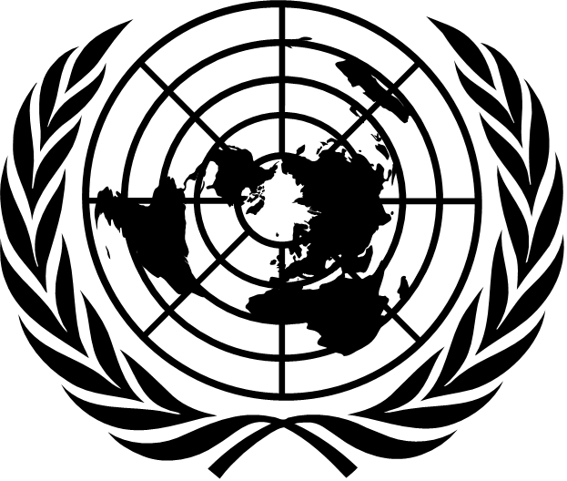 | 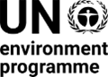 | CBD/COP/DEC/16/1

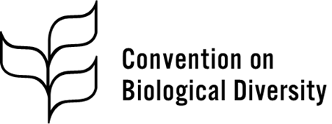 | Distr.: General  1 November 2024  Original: English

Conference of the Parties to the
Convention on Biological Diversity
Sixteenth meeting
Cali, Colombia, 21 October–1 November 2024
Agenda item 8
Progress on the preparation of targets and updating
of national biodiversity strategies and action plans by
Parties in line with the Kunming-Montreal Global
Biodiversity Framework
Decision adopted by the Conference of the Parties to the Convention on Biological Diversity on 1 November 2024
16/1. Review of implementation: progress in national target setting and updating of national biodiversity strategies and action plans
The Conference of the Parties,
Recalling the adoption of mechanisms for planning, monitoring, reporting and review in decision 15/6 of 19 December 2022,
Noting the outcomes of and the information and experiences shared during the regional and subregional dialogues on national biodiversity strategies and action plans, and expressing its appreciation to the Parties that hosted the dialogues and the Parties and organizations that provided financial and logistical support for them,
Noting with appreciation the support provided to many Parties by the Global Environment Facility and its implementing agencies for facilitating the revision or updating of national biodiversity strategies and action plans, while noting with concern that not all eligible Parties were provided with support or timely support,
Recognizing that the revision or updating of national biodiversity strategies and action plans in line with the Kunming-Montreal Global Biodiversity Framework depends on the provision of adequate, sufficient, predictable and accessible means of implementation, including financial resources, capacity-building and capacity development, technical and scientific cooperation and technology transfer, in particular for developing country Parties,
1. Congratulates the Parties that have submitted their revised and updated national biodiversity strategies and action plans in the light of the Kunming-Montreal Global Biodiversity Framework, as listed in annex I;
2. Notes with satisfaction that a number of Parties, as listed in annex II, have communicated national targets aligned with the global targets of the Framework, either as a stand-alone submission or as part of the submission of their national biodiversity strategies and action plans, and submitted those following the template provided in annex I to decision 15/6 and using the online reporting tool of the clearing-house mechanism;
3. Urges Parties that have not yet done so to revise or update their national biodiversity strategies and action plans, as requested in decision 15/6, as soon as possible;
4. Encourages Parties to enable the full and effective participation and engagement of women, indigenous peoples and local communities, youth, civil society organizations, academia, the private sector, all levels of government and stakeholders from all other relevant sectors in all levels of the revision or updating of the national biodiversity strategies and action plans, through inclusive and transparent modalities;
5. Requests the Global Environment Facility and its implementing agencies to provide timely support to all eligible Parties, aligned with national circumstances and needs, upon request, to enable them to revise or update their national biodiversity strategies and action plans;
6. Urges all Parties to implement their national biodiversity strategies and action plans, in accordance with Article 20 of the Convention on Biological Diversity, according to national circumstances, priorities and capabilities, recognizing the need for enhanced support, especially for developing countries, in particular the least developed countries and small island developing States, and countries with economies in transition, through adequate, timely, predictable and easily accessible means of implementation from all sources, on a needs basis, and taking the considerations for the implementation, as set out in section C of the Framework, into account.
Annex I
List of Parties having submitted a national biodiversity strategy and action plan to the Secretariat aligned with the Kunming-Montreal Global Biodiversity Framework since December 2022, as at 31 October 2024
 | Party | Date of receipt by the Secretariat
1 | Afghanistan | 28 July 2024
2 | Argentina | 30 October 2024
3 | Australia | 27 September 2024
4 | Austriaª | 3 May 2024
5 | Burkina Faso | 15 August 2024
6 | Canada | 21 June 2024
7 | China | 25 January 2024
8 | Colombia | 21 October 2024
9 | Cuba | 31 July 2024
10 | Denmark | 21 October 2024
11 | European Union | 14 November 2023
12 | France | 11 December 2023
13 | Germanyª | 27 October 2024
14 | Hungary | 28 August 2023
15 | India | 31 October 2024
16 | Indonesia | 12 September 2024
17 | Iran (Islamic Republic of) | 29 October 2024
18 | Ireland | 8 February 2024
19 | Italy^{b} | 9 July 2024
20 | Japan | 11 July 2023
21 | Jordan | 11 August 2024
22 | Libya | 17 October 2024
23 | Luxembourg | 7 November 2023
24 | Malaysia | 31 July 2024
25 | Malta | 23 September 2024
26 | Mauritania | 20 October 2024
27 | Mexico | 22 August 2024
28 | Netherlands (Kingdom of the)^{c} | 18 October 2024
29 | Norway | 7 October 2024
30 | Peru | 30 October 2024
31 | Republic of Korea | 2 August 2024
32 | Republic of Moldova | 16 October 2024
33 | Slovenia | 10 September 2024
34 | Spain | 30 January 2023
35 | State of Palestine | 16 October 2024
36 | Suriname | 16 July 2024
37 | Thailand^{b} | 31 October 2024
38 | Tonga | 27 September 2024
39 | Tunisia | 15 October 2024
40 | Uganda | 15 October 2024
41 | United Arab Emirates | 9 October 2024
42 | United Republic of Tanzania | 31 October 2024
43 | Venezuela (Bolivarian Republic of) | 30 October 2024
44 | Viet Nam | 21 October 2024
ª Not submitted in an official United Nations language.
^{b} Only the summary was submitted in an official United Nations language.
^{c} Only the national biodiversity strategies and action plans for Aruba and Curaçao, as countries of the Kingdom of the Netherlands, are currently available.
Annex II
List of Parties having submitted national targets aligned with the Kunming-Montreal Global Biodiversity Framework through the online reporting tool, as at 31 October 2024
 | Party | Date of publication
1 | Algeria | 1 August 2024
2 | Angola | 13 September 2024
3 | Australia | 18 October 2024
4 | Austria | 1 August 2024
5 | Azerbaijan | 20 July 2024
6 | Bangladesh | 29 September 2024
7 | Benin | 30 September 2024
8 | Bhutan | 25 July 2024
9 | Bolivia (Plurinational State of) | 31 October 2024
10 | Bosnia and Herzegovina | 2 August 2024
11 | Botswana | 14 October 2024
12 | Burkina Faso | 16 August 2024
13 | Burundi | 25 July 2024
14 | Cabo Verde | 18 October 2024
15 | Cambodia | 29 July 2024
16 | Cameroon | 23 August 2024
17 | Canada | 20 September 2024
18 | Central African Republic | 15 September 2024
19 | Chad | 12 September 2024
20 | Chile | 21 October 2024
21 | China | 6 September 2024
22 | Colombia | 17 September 2024
23 | Comoros | 1 August 2024
24 | Cook Islands | 16 October 2024
25 | Costa Rica | 2 August 2024
26 | Côte d’Ivoire | 15 October 2024
27 | Croatia | 2 August 2024
28 | Cuba | 25 July 2024
29 | Cyprus | 18 October 2024
30 | Czechia | 31 July 2024
31 | Democratic Republic of the Congo | 2 August 2024
32 | Djibouti | 15 August 2024
33 | Dominican Republic | 20 September 2024
34 | Ecuador | 31 August 2024
35 | El Salvador | 16 October 2024
36 | Equatorial Guinea | 13 September 2024
37 | Eritrea | 16 October 2024
38 | Eswatini | 31 July 2024
39 | Ethiopia | 5 July 2024
40 | European Union | 1 August 2024
41 | Fiji | 8 October 2024
42 | Finland | 19 August 2024
43 | France | 31 July 2024
44 | Gabon | 9 September 2024
45 | Ghana | 1 August 2024
46 | Guatemala | 13 August 2024
47 | Guinea | 8 October 2024
48 | Honduras | 31 July 2024
49 | Hungary | 2 July 2024
50 | India | 10 September 2024
51 | Indonesia | 12 September 2024
52 | Iraq | 21 October 2024
53 | Ireland | 20 August 2024
54 | Iran (Islamic Republic of) | 29 October 2024
55 | Israel | 9 August 2024
56 | Japan | 31 July 2024
57 | Jordan | 3 August 2024
58 | Kazakhstan | 24 October 2024
59 | Kenya | 31 July 2024
60 | Lao People’s Democratic Republic | 9 October 2024
61 | Lebanon | 2 August 2024
62 | Lesotho | 27 September 2024
63 | Liberia | 3 August 2024
64 | Libya | 17 October 2024
65 | Luxembourg | 30 July 2024
66 | Madagascar | 29 July 2024
67 | Malawi | 31 July 2024
68 | Malaysia | 1 July 2024
69 | Mali | 17 October 2024
70 | Malta | 31 July 2024
71 | Marshall Islands | 22 October 2024
72 | Mexico | 31 July 2024
73 | Mongolia | 4 August 2024
74 | Morocco | 2 August 2024
75 | Mozambique | 31 July 2024
76 | Namibia | 25 October 2024
77 | Nepal | 1 August 2024
78 | New Zealand | 7 October 2024
79 | Niger | 31 July 2024
80 | Nigeria | 31 July 2024
81 | Pakistan | 15 August 2024
82 | Panama | 31 July 2024
83 | Papua New Guinea | 14 October 2024
84 | Paraguay | 31 July 2024
85 | Peru | 18 October 2024
86 | Qatar | 23 October 2024
87 | Republic of Korea | 1 August 2024
88 | Republic of Moldova | 30 July 2024
89 | Russian Federation | 21 October 2024
90 | Rwanda | 1 August 2024
91 | Samoa | 31 October 2024
92 | Saudi Arabia | 15 October 2024
93 | Senegal | 24 August 2024
94 | Sierra Leone | 15 October 2024
95 | Singapore | 20 October 2024
96 | Slovenia | 17 October 2024
97 | Somalia | 19 August 2024
98 | South Africa | 18 October 2024
99 | South Sudan | 16 October 2024
100 | Spain | 22 July 2024
101 | Sudan | 26 July 2024
102 | Suriname | 20 October 2024
103 | Sweden | 3 July 2024
104 | Thailand | 30 October 2024
105 | Togo | 25 July 2024
106 | Tonga | 16 October 2024
107 | Tunisia | 15 October 2024
108 | Türkiye | 17 October 2024
109 | Uganda | 4 October 2024
110 | United Arab Emirates | 1 August 2024
111 | United Kingdom of Great Britain and Northern Ireland | 1 August 2024
112 | United Republic of Tanzania | 20 October 2024
113 | Uruguay | 25 October 2024
114 | Uzbekistan | 7 August 2024
115 | Vanuatu | 1 August 2024
116 | Venezuela (Bolivarian Republic of) | 2 August 2024
117 | Yemen | 1 August 2024
118 | Zambia | 23 October 2024
119 | Zimbabwe | 9 October 2024
__________

Decision 15/4, annex.
United Nations, Treaty Series, vol. 1760, No. 30619.

