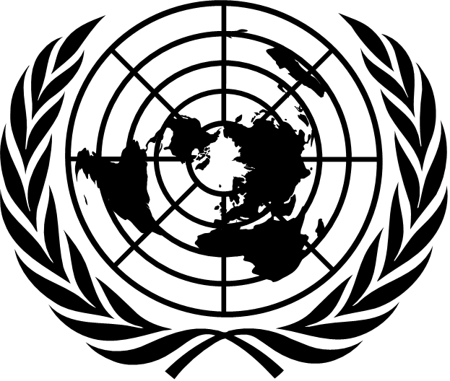 | 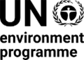 | CBD/COP/DEC/16/8

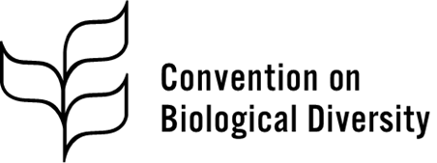 | Distr.: General  1 November 2024  Original: English

Conference of the Parties to the
Convention on Biological Diversity
Sixteenth meeting
Cali, Colombia, 21 October–1 November 2024
Agenda item 14
Implementation of Article 8(j) and related provisions
Decision adopted by the Conference of the Parties to the Convention on Biological Diversity on 1 November 2024
16/8. Recommendations from the Permanent Forum on Indigenous Issues pertaining to the Convention on Biological Diversity*
The Conference of the Parties,
Recalling that the Kunming-Montreal Global Biodiversity Framework is to be understood, acted upon, implemented, reported and evaluated consistent with the contribution and rights of indigenous peoples and local communities and that the important roles and contributions of indigenous peoples and local communities as custodians of biodiversity and as partners in its conservation, restoration and sustainable use are acknowledged in the Framework,
Recalling also that the Framework is to be implemented in accordance with international instruments, including the United Nations Declaration on the Rights of Indigenous Peoples, and human rights law, and in this regard that nothing in the Framework may be construed as diminishing or extinguishing the rights that indigenous peoples currently have or may acquire in the future,
Having considered the note by the Secretariat on the recommendations from the Permanent Forum on Indigenous Issues pertaining to the Convention on Biological Diversity,
1. Takes note of the observations and recommendations emanating from the twentieth, twenty-first and twenty-second sessions of the Permanent Forum on Indigenous Issues;
2. Requests the Executive Secretary to continue to exchange information with the Permanent Forum on Indigenous Issues on issues of mutual interest and to provide information to the Forum on activities undertaken in the context of the Convention on Biological Diversity in relation to the rights of indigenous peoples and local communities.
__________

* Nothing in the present decision should be interpreted as implying a separation between indigenous peoples and local communities.
Decision 15/4, annex.
General Assembly resolution 61/295, annex.
CBD/WG8J/12/7.
United Nations, Treaty Series, vol. 1760, No. 30619.

