Near-Dry Electrical Discharge Drilling of NiTiNOL

A dissertation report submitted in partial fulfilment
of the requirements in 4th year, 2nd semester for the degree in
Bachelor of Technology in Mechanical Engineering
by

A SAMANVITH REDDY (22MEB0B07)
T AKSHITH REDDY (22MEB0B10)
M SIVA KARTHIK (22MEB0B16)

Under the supervision of
Dr. GANGADHARUDU TALLA
ASST PROFESSOR



DEPARTMENT OF MECHANICAL ENGINEERING
NATIONAL INSTITUTE OF TECHNOLOGY WARANGAL
YEAR OF SUBMISSION: 2026

APPROVAL SHEET
This project work, entitled "Near-Dry Electrical Discharge Drilling of NiTiNOL" by A. Samanvith Reddy (22MEB0B07), T. Akshith Reddy (22MEB0B10), and M. Siva Karthik (22MEB0B16), is approved for the degree of Bachelor of Technology in Mechanical Engineering.

Examiners

Prof. Hari Kumar Voruganti
Prof. M Manjaiah
Prof. Prasanth A K Lam

Supervisor
Prof. Gangadharudu Talla
Department of Mechanical Engineering

Chairman
Prof. Y Ravi Kumar
Professor, MED, NITW

Date: ______________ Place: Warangal

DECLARATION
I declare that this written submission represents my ideas in my own words, and where other's ideas or words have been included, I have adequately cited and referenced the sources. I also declare that I have adhered to all principles of academic honesty and integrity and have not misrepresented or fabricated, or falsified any idea/data/fact/source in my submission. I understand that any violation of the above will be cause for disciplinary action by the Institute and can also evoke penal action from the sources that have thus not been properly cited or from whom proper permission has not been taken when needed.

A. Samanvith Reddy
Roll No: 22MEB0B07

T. Akshith Reddy
Roll No: 22MEB0B10

M. Siva Karthik
Roll No: 22MEB0B16

Date: 21-04-2026

CERTIFICATE
This is to certify that the dissertation work entitled "Near-Dry Electrical Discharge Drilling of NiTiNOL" is a bonafide record of work carried out by A. Samanvith Reddy (22MEB0B07), T. Akshith Reddy (22MEB0B10), and M. Siva Karthik (22MEB0B16), submitted to the faculty of Department of Mechanical Engineering, in partial fulfilment of the requirements for the award of the degree of Bachelor of Technology in Mechanical Engineering at National Institute of Technology, Warangal during the academic year 2025–2026.

Prof. Y Ravi Kumar Dr. GANGADHARUDU TALLA
Professor, Head of the Department Assistant Professor, Supervisor
Dept. of Mechanical Engineering Dept. of Mechanical Engineering
National Institute of Technology, Warangal National Institute of Technology, Warangal

Date: _______________ Place: Warangal

ABSTRACT
Nitinol, a near-equiatomic nickel-titanium shape memory alloy, finds widespread use in biomedical and aerospace sectors owing to its shape memory effect, superelasticity, and excellent corrosion resistance. Despite these advantageous properties, its machining through conventional routes such as turning and drilling remains a serious challenge. The alloy's pronounced ductility, strong work-hardening tendency, and low thermal conductivity together contribute to rapid tool wear, burr formation, and thermally induced surface damage. These limitations call for non-conventional machining strategies, among which electrical discharge machining has established itself as the most practically viable option.

The present investigation focuses on near-dry electrical discharge machining (NDEDM) a variant that replaces the conventional dielectric bath with a compressed-air and EDM-oil mist delivered through a minimum quantity lubrication system. A total of nine drilling trials were conducted on 2 mm thick Nitinol plates using a solid copper tool electrode of 8 mm diameter. Experiments followed a Taguchi L9 orthogonal array in which peak current (Ip: 4, 5, 6 A), pulse-on time (Ton: 50, 60, 70 µs), and pulse-off time (Toff: 30, 35, 40 µs) were the three control parameters varied at three levels each.

Two geometric output characteristics were quantified. Radial overcut (ROC), defined as half the difference between the measured hole diameter and the tool electrode diameter, was obtained from top-view 3D surface profilometry. Taper angle, reflecting the convergence of the hole from entry to exit, was calculated from cross-sectional profilometry using the formula θ = tan⁻¹[(Wt − Wb) / 2t], where Wt and Wb are the entry and exit diameters respectively and t is the 2 mm workpiece thickness. Scanning electron microscopy (SEM) complemented the dimensional measurements by providing surface morphology data for each drilled hole.

Radial overcut varied between 0.028 mm and 0.200 mm across the nine trials, while taper angle ranged from 1.985° to 6.285°. Peak current was identified as the single most influential process parameter for both responses. Elevating Ip from 4 A to 6 A raised the average ROC by approximately 219% and the average taper angle by around 124%. The lowest ROC of 0.028 mm was recorded for Run 9 (Ip = 4 A, Ton = 60 µs, Toff = 35 µs), and the minimum taper angle of 1.985° was obtained at Run 1 (Ip = 4 A, Ton = 50 µs, Toff = 30 µs). Run 6 (Ip = 6 A, Ton = 50 µs, Toff = 40 µs) yielded the worst values for both responses simultaneously. SEM examination revealed overlapping discharge craters and re-solidified Nitinol globules on all hole surfaces; no cracking or delamination was detected at any experimental condition.

Keywords: Near-Dry EDM, Nitinol, NiTi Shape Memory Alloy, Radial Overcut, Taper Angle, Taguchi L9, 3D Surface Profilometry, SEM, Dimensional Accuracy, NDEDM

LIST OF FIGURES
Figure No. | Description
Figure 1.1 | Nitinol workpiece specimen used in the present study (60 mm × 40 mm × 2 mm)
Figure 1.2 | Solid copper tool electrode (Ø 8 mm, 99.5% purity)
Figure 3.1 | FORMATICS EDM-50 near-dry EDM experimental setup at NIT Warangal
Figure 3.2 | Schematic diagram of the NDEDM setup showing all key components
Figure 3.3 | Nitinol workpiece plate with grid positions marked for the nine drilled holes
Figure 3.4 | Experimental progress (a) 1st run in progress, (b) 2nd run in progress
Figure 3.5 | Workpiece after completion of the initial set of experiments
Figure 3.6 | Reference formula for radial overcut (ROC) calculation
Figure 3.7 | Reference diagram and formula for taper angle determination
Figure 4.1 | Bar chart of radial overcut (ROC) for all nine experiments with mean reference line
Figure 4.2 | Bar chart of taper angle (θ) for all nine experiments with mean reference line
Figure 4.3 | Grouped bar chart comparing entry (Wt) and exit (Wb) diameters against tool diameter
Figure 4.4 | Effect of peak current (Ip) on mean ROC and mean taper angle
Figure 4.5 | Effect of pulse-on time (Ton) on mean ROC and mean taper angle
Figure 4.6 | Effect of pulse-off time (Toff) on mean ROC and mean taper angle
Figure 4.7 | Scatter plot showing correlation between ROC and taper angle
Figure 4.8 | Main effects plot for radial overcut
Figure 4.9 | Main effects plot for taper angle
Figure 4.10–4.18 | Top-view 3D surface profilometer results — Experiments 1 to 9
Figure 4.19–4.27 | Cross-sectional profilometer images for taper measurement — Experiments 1 to 9
Figure 4.28–4.46 | SEM hole morphology images — Experiments 1 to 9 (two images per experiment)

LIST OF TABLES
Table No. | Description
Table 1.1 | Elemental composition (wt%) of the Nitinol workpiece
Table 3.1 | Specifications of the EDM machine and auxiliary equipment
Table 3.2 | Details of workpiece material, tool electrode, and dielectric medium
Table 3.3 | NDEDM control parameters and their selected three levels
Table 3.4 | Taguchi L9 experimental plan for Air + EDM oil drilling trials
Table 4.1 | Complete experimental results — Wt, Wb, Dm, ROC, and taper angle for all nine runs
Table 4.2 | Entry diameter (Wt) and exit diameter (Wb) from cross-sectional profilometry
Table 4.3 | Effect of peak current (Ip) on mean ROC and mean taper angle
Table 4.4 | Effect of pulse-on time (Ton) on mean ROC and mean taper angle
Table 4.5 | Effect of pulse-off time (Toff) on mean ROC and mean taper angle
Table 4.6 | Optimum and worst-case parameter combinations for ROC and taper angle

ABBREVIATIONS
Abbreviation | Full Form
NDEDM | Near-Dry Electrical Discharge Machining
EDM | Electrical Discharge Machining
NiTi | Nickel-Titanium alloy (Nitinol)
SMA | Shape Memory Alloy
MQL | Minimum Quantity Lubrication
IEG | Inter-Electrode Gap
ROC | Radial Overcut
SEM | Scanning Electron Microscope / Microscopy
HAZ | Heat-Affected Zone
Ip | Peak Current (Amperes)
Ton | Pulse-On Time (microseconds)
Toff | Pulse-Off Time (microseconds)
Wt | Top (entry) diameter of drilled hole
Wb | Bottom (exit) diameter of drilled hole
t | Workpiece thickness (mm)
θ | Taper angle (degrees)
Dm | Measured hole diameter (mm)
Dt | Tool electrode diameter (mm)
MRR | Material Removal Rate
TWR | Tool Wear Rate
Ra | Arithmetic mean surface roughness
NITW | National Institute of Technology Warangal
EDS | Energy Dispersive X-ray Spectroscopy
DSX | Digital Surface Profilometer (Olympus DSX series)

Chapter 1

INTRODUCTION

1.1 Background of Nitinol
Nitinol is a near-equiatomic nickel-titanium intermetallic compound whose commercial significance has grown steadily since its accidental discovery at the Naval Ordnance Laboratory (NOL) in the 1960s. The alloy's name encodes both its chemistry (Ni and Ti) and its birthplace (NOL). While many engineering alloys are valued for a single outstanding property, Nitinol owes its popularity to a rare convergence of multiple functional traits within one material system. It undergoes thermoelastic martensitic transformation when cooled below a characteristic temperature, and this transformation is fully reversible upon reheating a behaviour known as the shape memory effect. When the transformation temperatures are tuned so that the austenite phase is stable at room temperature, the alloy instead exhibits superelasticity, recovering strains as large as 8% upon unloading without any permanent deformation.

These properties, combined with a passivating oxide layer that confers corrosion resistance comparable to surgical-grade stainless steels, and a biological inertness that allows long-term implantation without adverse tissue response, make Nitinol indispensable in a wide range of devices. Cardiovascular stents, inferior vena cava filters, guidewires, orthodontic archwires, bone staples for fracture fixation, and micro-actuators for minimally invasive surgery all exploit one or more of these characteristics. The result is that precise, damage-free shaping of Nitinol components is not merely a manufacturing preference but a functional necessity any surface alteration during fabrication that shifts the transformation temperature or introduces micro-cracks can compromise the device's clinical performance.

Table 1.1: Elemental composition (wt%) of the Nitinol workpiece used in the present study
N | Ti | Co | Cr | Ni | Cu | Nb
0.05 | 38.54 | 1.55 | 0.10 | 54.49 | 1.08 | 0.01

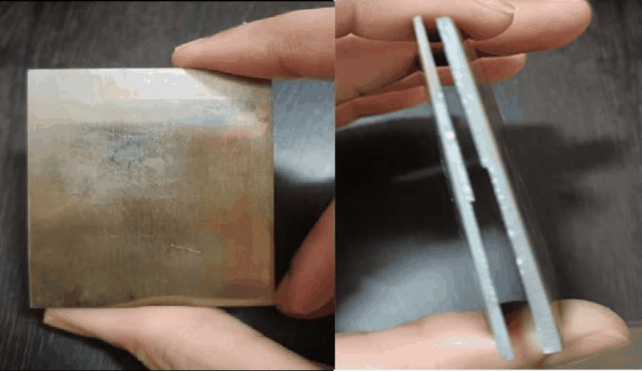
Figure 1.1: Nitinol workpiece specimen (60 mm × 40 mm × 2 mm) as prepared for the drilling experiments

1.2 Challenges in Conventional Machining of Nitinol
The very properties that make Nitinol valuable in service conspire against conventional subtractive manufacturing. When a cutting tool engages Nitinol, the alloy deforms plastically in the immediate contact zone and simultaneously work-hardens, raising the local flow stress and accelerating abrasive wear of the tool cutting edge. Because the thermal conductivity of Nitinol is low roughly one-tenth that of carbon steel heat generated at the tool-chip interface cannot dissipate rapidly into the bulk material and instead concentrates near the surface being machined. This thermal accumulation promotes adhesive bonding of the chip to the tool (built-up edge formation), causes metallurgical damage including phase transformation reversal or partial decomposition near the machined surface, and leads to residual tensile stresses that reduce fatigue life.

At the geometric level, the superelastic recovery of Nitinol after tool passage causes the machined surface to spring back, leaving the final dimension larger than intended and making it difficult to hold tight tolerances without iterative corrective cuts. Burrs are almost unavoidable at the exit edge of drilled holes because the material deforms plastically around the drill periphery rather than being cleanly sheared. All these factors rapid tool wear, surface burns, spring-back, burr formation, and micro-cracks mean that drilling Nitinol by conventional twist-drill methods yields parts with poor dimensional accuracy, degraded surface integrity, and significantly higher production cost than comparable operations on structural steels or aluminium alloys.

1.3 Electrical Discharge Machining — Working Principle
Electrical Discharge Machining removes conductive workpiece material through a rapid sequence of controlled spark discharges fired between a shaped tool electrode and the workpiece across a dielectric-filled inter-electrode gap. The process imposes no mechanical contact forces between the tool and workpiece, so the material's hardness, ductility, or work-hardening behaviour is irrelevant to the cutting mechanism. The only material prerequisite is electrical conductivity. This single requirement makes EDM applicable to the full range of metallic alloys, including those that are entirely intractable by conventional cutting.

The physics of each individual spark event proceed as follows. A pulse of voltage is applied across the IEG, causing the dielectric to break down locally at the site of the smallest gap and highest field concentration, forming a narrow plasma channel. The channel temperature rises to between 8,000 and 12,000 °C within a few microseconds, melting and partially vaporising a small crater of workpiece material. Simultaneously, the top surface of the tool electrode also erodes slightly. When the pulse ends, the plasma collapses, a pressure wave expels the molten workpiece material as fine debris particles into the dielectric, and a portion of the melt re-solidifies in situ on the crater walls, forming the recast or white layer. This cycle, repeated at rates of thousands to tens of thousands of pulses per second, progressively erodes the workpiece to the shape of the electrode.

In drilling mode, the tool electrode advances axially into the workpiece under servo control, maintaining a constant mean IEG. Sparks fire not only from the flat bottom face of the electrode but also laterally from its cylindrical side wall, eroding a hole somewhat wider than the electrode diameter. This lateral erosion is quantified as radial overcut, and its minimisation is a central objective of the present study.

1.4 Limitations of Conventional Flooded EDM
In standard EDM practice, the entire workpiece is submerged in a tank filled with hydrocarbon-based dielectric oil, typically kerosene or a refined EDM-grade mineral oil. While this arrangement reliably provides dielectric strength, cools the gap, and flushes eroded debris, it also introduces several practical drawbacks that have motivated the search for alternatives. The most pressing concerns are environmental: used dielectric oil is classified as hazardous waste in many jurisdictions, requiring costly treatment before disposal. Evaporation of light hydrocarbon fractions during high-energy machining releases volatile organic compounds into the workshop atmosphere, creating health risks for operators. There is also a non-trivial fire hazard when the oil surface contacts a hot workpiece during setup or tool change.

From a process perspective, large dielectric volumes in conventional EDM reduce thermal efficiency because the bath absorbs much of the heat that would otherwise aid material removal. Flushing through drilled holes becomes increasingly inefficient at high depth-to-diameter ratios because the oil must traverse the full hole depth to exit, and debris can clog the gap, causing arcing and surface damage. The sum of these limitations has created strong incentive for dry and near-dry EDM variants in which the bulk dielectric liquid is substantially reduced or eliminated.

1.5 Near-Dry EDM — Concept, Implementation, and Benefits
Near-Dry EDM addresses the shortcomings of flooded EDM by substituting the dielectric bath with a fine mist of compressed air mixed with a small amount of liquid dielectric either EDM oil or deionised water produced by a minimum quantity lubrication system. The MQL unit atomises the liquid in the compressed air stream, delivering a high-velocity aerosol directly to the IEG through a precision nozzle. The liquid component maintains the dielectric breakdown properties required for stable spark formation, while the air component provides vigorous gap flushing, carrying debris away from the machining zone far more effectively than low-velocity flow through a static bath.

From a practical standpoint, NDEDM offers several advantages over conventional flooded EDM. Dielectric consumption is reduced to a few millilitres per hour from litres per hour in flood conditions. Workshop air quality improves because far less dielectric vapour is generated. The fire risk associated with oil-bath ignition is substantially reduced. Because the compressed-air stream cools the workpiece surface between pulses, the heat-affected zone at the machined surface can be narrower than in flooded conditions at equivalent material removal rates. The higher fluid velocity in the mist stream also improves debris evacuation from blind holes, reducing the incidence of secondary discharges from re-melted debris particles.

In the present investigation, the NDEDM setup delivers Air + EDM oil mist through a 25-degree angled side nozzle. The angle and position of the nozzle were fixed for all nine experimental runs to eliminate nozzle geometry as a variable, so that measured differences in ROC and taper angle can be attributed confidently to the three parametric inputs.

1.6 Motivation and Scope of the Present Investigation
An extensive survey of the published literature, summarised in Chapter 2, reveals that the great majority of EDM studies on Nitinol measure material removal rate, tool wear rate, and average surface roughness as the primary outputs. These are meaningful performance indicators for many applications, but they do not address the geometric accuracy of the drilled hole specifically, whether the hole is the right size (ROC) and whether its walls are straight (taper angle). For biomedical applications, hole geometry matters because stents and fixation devices must fit precisely within anatomical structures, and even a fraction of a millimetre of overcut or a few degrees of taper can affect device deployment or anchoring.

Studies that do report overcut and taper for EDM drilling are overwhelmingly conducted on steels or titanium alloys in conventional flooded conditions. The combination of near-dry dielectric, Nitinol workpiece material, and geometric accuracy outputs is essentially absent from the existing literature. The present work fills this gap by conducting nine systematic NDEDM drilling trials on 2 mm Nitinol plates, using a Taguchi L9 design to distribute the three control parameters (Ip, Ton, Toff) efficiently, and reporting both ROC and taper angle for each trial alongside SEM morphology images. The findings provide a practical foundation for selecting NDEDM parameters in Nitinol drilling applications where dimensional precision is the primary criterion.

Chapter 2

LITERATURE REVIEW

2.1 Introduction
A systematic review of the literature on EDM of shape memory alloys, near-dry EDM processes, and dimensional accuracy in EDM drilling is presented in this chapter. The review is organised chronologically within each theme and concludes with an identification of the specific gaps addressed by the present work. References cited in this chapter are listed at the end of the report.

2.2 Electrical Discharge Machining of Nitinol
The earliest broadly cited review of EDM technology by Ho and Newman [1] established the theoretical framework still used today: material removal by superimposed spark erosion events, with discharge energy controlling both productivity and surface quality. Rajurkar et al. [2] extended this framework to electrochemical and electrodischarge variants, noting that non-conventional processes offer a pathway to machining alloys that are otherwise inaccessible to conventional cutting. These foundational reviews underpin the premise of EDM for Nitinol.

The mechanical and thermal behaviour of Nitinol during deformation was characterised in detail by Otsuka and Wayman [3], whose work remains the principal reference for shape memory alloy properties. Weinert and Petzoldt [4] were among the first to report systematic difficulties in conventional machining of NiTi, documenting severe burr formation, rapid tool wear, and surface cracking during turning and milling trials. They proposed EDM as a more viable manufacturing route, a suggestion that subsequent researchers took up in earnest. Lin et al. [5] studied the machining of a related titanium alloy using a hybrid EDM–ultrasonic process and showed that non-contact material removal could circumvent the ductility-related problems that make titanium alloys difficult to cut, providing an early template for applying EDM-family processes to reactive alloys including Nitinol.

More targeted studies on EDM of Nitinol followed. Shabgard et al. [6] investigated the influence of pulse parameters on MRR, TWR, and surface roughness in EDM of NiTi using copper and graphite electrodes, finding that peak current and pulse-on time exerted the strongest effects on all three outputs. Their results showed that MRR increases with discharge energy but is accompanied by progressive deterioration of surface integrity. Singh et al. [7] studied EDM of hardened tool steel with different electrode materials and proposed that electrode thermal conductivity and melting point both influence the energy partition between workpiece and electrode, a finding relevant to copper-electrode Nitinol drilling in the present study. These works collectively confirm that EDM can process Nitinol successfully but that the process window for acceptable surface integrity is narrow.

A consistent shortcoming in the above studies is their focus on MRR, TWR, and Ra as the primary outputs, with little or no attention to hole geometry. Dimensional overcut and taper angle are rarely reported, and when they are, the work is conducted on flood EDM in steel or titanium, making direct comparison with near-dry Nitinol drilling impossible.

2.3 Near-Dry and Dry EDM — Process Development
Kunieda et al. [8] provided a comprehensive review of EDM process innovations including dry EDM, near-dry EDM, and powder-mixed EDM, and identified gas-assisted material removal as a major direction for environmental and process improvement. Their analysis showed that replacing the dielectric bath with gas or mist reduces thermal input to the workpiece and improves debris evacuation at high depth-to-diameter ratios, both of which are relevant to the thin-plate drilling scenario studied here. Tzeng and Lee [9] specifically investigated the effect of pulse duration in gas-assisted EDM and reported that longer Ton values produced more stable discharges and lower surface roughness at equivalent material removal rates a finding that motivated the inclusion of Ton as a key variable in the present Taguchi design.

Lee and Li [10] studied surface integrity in EDM of tungsten carbide and showed that reducing discharge energy by lowering Ip and Ton narrows the recast layer and suppresses micro-crack formation, providing a mechanistic basis for expecting similar benefits in near-dry drilling of Nitinol. Liu et al. [11] specifically examined surface modification of NiTi alloys and demonstrated that the oxide and nitride layer composition on the machined surface depends strongly on discharge conditions and the dielectric environment, motivating interest in near-dry variants that alter this surface chemistry. These studies together justify the combination of NDEDM, Nitinol, and a focus on geometric and surface outputs chosen for the present work.

2.4 Radial Overcut and Taper in EDM Drilling
Radial overcut in EDM drilling arises from sparks that fire not only from the flat face of the electrode but also from its cylindrical side wall, eroding the hole wall laterally beyond the electrode perimeter. Joshi and Pande [25] formalised the definition of ROC as half the difference between the machined hole diameter and the tool electrode diameter and showed through a combination of experiments and neural network modelling that ROC increases monotonically with both Ip and Ton. Their work confirmed that reducing discharge energy is the primary lever for minimising overcut, a conclusion that the present results support quantitatively.

Taper formation in EDM-drilled holes is a more complex phenomenon. The entry zone of the hole is exposed to the full discharge frequency plus secondary sparks reflected from debris ejected upward, while the exit zone at the bottom of the hole receives only sparks that penetrate the full depth. The result is that the entry diameter is always larger than the exit diameter, producing positive taper in the direction of tool advance. Additionally, as debris accumulates in the hole, it partially clogs the gap near the exit, reducing discharge frequency further and exacerbating the asymmetry. Several researchers have noted that higher discharge energy increases taper because it enlarges the entry more aggressively than the exit, consistent with the strong Ip effect on taper angle found in the present study.

2.5 Research Gaps Identified
Based on the reviewed literature, four specific gaps have been identified that the present work addresses:
- Most EDM studies on Nitinol report MRR, TWR, and Ra as outputs, while ROC and taper angle which determine the dimensional and geometric fitness of drilled holes are rarely measured or reported.
- NDEDM drilling of thin Nitinol plates (2 mm thickness, representative of stent and actuator blanks) has not been documented in peer-reviewed literature, and parametric data on ROC and taper for such configurations are absent.
- The Taguchi design has been widely used for EDM process optimisation but has not been applied to simultaneous evaluation of ROC and taper angle in NDEDM of Nitinol.
- SEM-based morphological characterisation of NDEDM-drilled Nitinol holes which would provide mechanistic support for parametric trends in overcut and taper has not been reported in combination with profilometric dimensional data.

The four objectives of the present study, formulated in response to these gaps, are:
- to measure ROC and taper angle for nine NDEDM trials on Nitinol under systematically varied Ip, Ton, Toff;
- to quantify the individual effect of each parameter on both responses using a Taguchi L9 mean-response analysis;
- to determine optimal parameter combinations for minimum ROC and minimum taper angle; and
- to characterise hole surface morphology using SEM to support the mechanistic interpretation of parametric trends.

Chapter 3

MATERIALS AND METHODS

3.1 Experimental Setup
The drilling experiments were performed on a FORMATICS EDM-50 die-sinking EDM machine equipped with an Electronica PSR-20 servo controller. The machine uses a DC pulse generator that allows independent adjustment of peak current, pulse-on time, and pulse-off time over the ranges required by the Taguchi design. The tool electrode is fed vertically into the workpiece under servo control, maintaining a target mean gap voltage throughout each trial.

Compressed air was supplied by an ELGi 3-hp belt-drive compressor connected to a Dropco MQL system. The MQL unit mixes EDM oil with the compressed air stream in a controlled ratio, generating a fine mist that is directed into the IEG through a 25° angled side nozzle mounted adjacent to the electrode holder. The nozzle angle and standoff distance were fixed identically for all nine runs. A SIGLENT SDS220X-E digital oscilloscope was connected across the IEG to capture voltage and current waveforms in real time during each trial, confirming that pulse characteristics matched the set values.

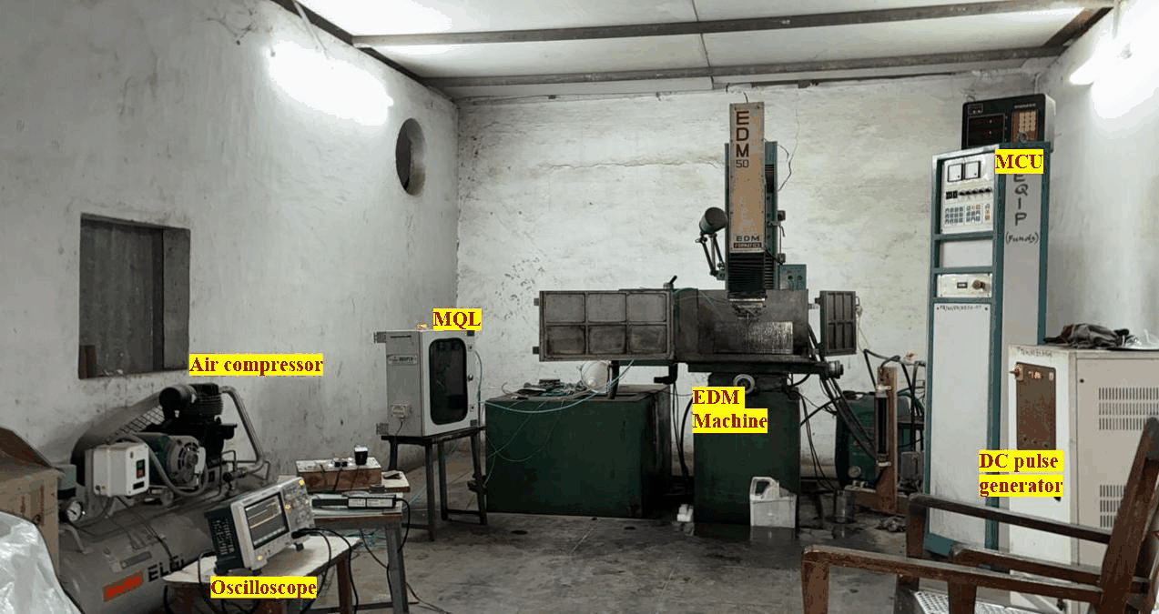
Figure 3.1: FORMATICS EDM-50 near-dry EDM experimental setup at NIT Warangal — EDM machine, MQL unit, air compressor, and oscilloscope visible
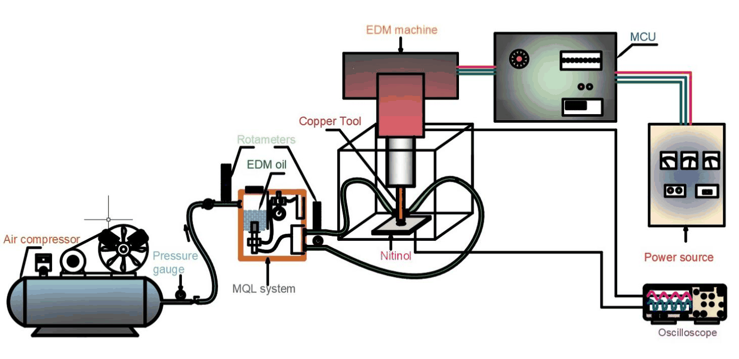
Figure 3.2: Schematic diagram of the NDEDM setup showing compressed-air path, MQL mixing unit, angled side nozzle, and the inter-electrode gap between tool and workpiece

Table 3.1: Specifications of the EDM machine and auxiliary equipment
Parameter | Specification
Machine Model | FORMATICS EDM-50 (Die-Sinking)
Controller | Electronica PSR-20
Power Source | DC Pulse Generator
Tool Feed | Vertical servo-controlled
Air Compressor | ELGi 3-hp Belt-Driven
MQL System | Dropco MQL unit
Nozzle Angle | 25° angled side nozzle
Oscilloscope | SIGLENT SDS220X-E Digital
Dielectric (present) | Air + EDM oil mist

3.2 Workpiece, Tool Electrode, and Dielectric
Table 3.2: Details of workpiece material, tool electrode, and dielectric medium
Item | Material / Type | Key Specifications
Workpiece | Nitinol — Ni55.7-Ti44.2 wt% | 60 × 40 × 2 mm plate
Tool Electrode | Copper — 99.5% purity | Solid cylinder, Ø 8 mm
Dielectric | Air + EDM oil mist (MQL) | Delivered via 25° side nozzle

3.2.1 Workpiece
The workpiece material is a commercially sourced nickel-rich Nitinol shape memory alloy with nominal composition Ni55.7–Ti44.2 wt%. Elemental composition was verified by energy-dispersive X-ray spectroscopy and is listed in Table 1.1. The alloy was supplied in annealed sheet form and precision-cut into specimens measuring 60 mm × 40 mm × 2 mm using wire-cut EDM. Each specimen was used for a single trial, drilling one hole per specimen, to eliminate any influence of previous holes on the thermal or structural state of the material around subsequent holes. The 2 mm thickness was deliberately chosen to be representative of Nitinol sheets used in cardiovascular stent manufacturing and thin-sheet actuator fabrication.
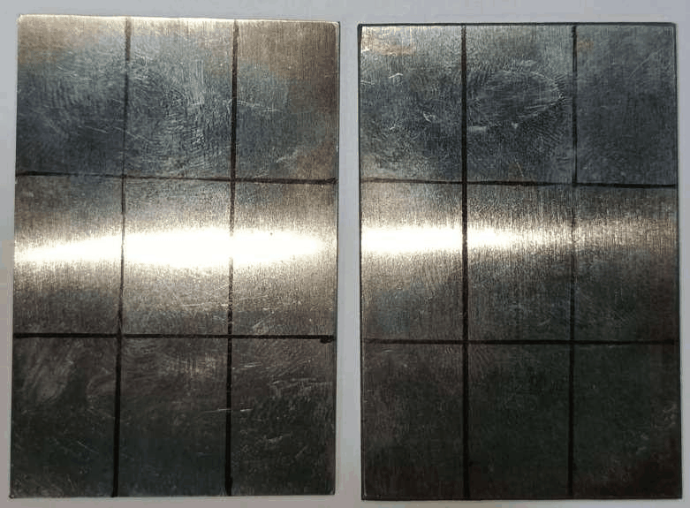
Figure 3.3: Nitinol workpiece plate with grid positions marked — one hole drilled per specimen per experimental run

3.2.2 Tool Electrode
A solid cylindrical copper electrode of 8 mm diameter and 99.5% purity was used for all nine experiments. Copper was selected over brass or graphite for three reasons: its high electrical conductivity (~5.8 × 10⁷ S/m) ensures efficient energy transfer to the IEG; its known and relatively predictable erosion behaviour simplifies the interpretation of process parameter effects; and its use is consistent with several reference studies on EDM drilling of shape memory alloys, facilitating comparison of results. The electrode face was machined flat and polished before each trial to standardise the initial gap geometry.
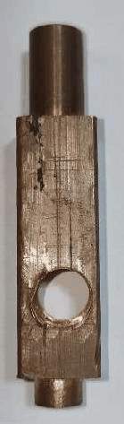
Figure 1.2: Solid copper tool electrode (Ø 8 mm, 99.5% purity) used throughout the experimental programme

3.2.3 Dielectric Medium
Air + EDM oil mist, generated by the Dropco MQL system, served as the dielectric medium in the present experimental phase. The MQL system was set to a fixed oil flow rate and air pressure for all nine runs, so that variations in dimensional and geometric outputs can be attributed to the three Taguchi parameters and not to changes in dielectric supply. A second dielectric condition Air + DI water mist is planned for a subsequent experimental phase to enable a direct comparison of dielectric type on ROC, taper angle, and surface morphology under identical parametric conditions.

3.3 Experimental Design — Taguchi L9 Orthogonal Array
Taguchi's orthogonal array methodology offers a resource-efficient route to studying the main effects of multiple process parameters at multiple levels without conducting a full factorial experiment. The L9 array was selected because it accommodates exactly three factors at three levels each in nine experimental runs. Although the L9 does not resolve two-factor interactions, the purpose of this study is to identify main-effect trends and optimal level combinations for ROC and taper angle, for which the L9 is well-suited. The three control factors, their units, and the three levels at which each was tested are listed in Table 3.3. The full experimental plan is given in Table 3.4.

Table 3.3: NDEDM control parameters and their selected three levels
Parameter | Symbol and Unit | Levels Used
Peak Current | Ip (Amperes) | 4 / 5 / 6
Pulse-On Time | Ton (microseconds) | 50 / 60 / 70
Pulse-Off Time | Toff (microseconds) | 30 / 35 / 40

The peak current levels of 4 A, 5 A, and 6 A were selected to span a low-to-moderate discharge energy range appropriate for a 2 mm thin plate high enough to achieve reliable material removal but moderate enough to avoid through-cracking or excessive thermal distortion. Pulse-on time levels of 50, 60, and 70 µs represent short, intermediate, and long pulse durations within the machine's stable operating envelope. Pulse-off time levels of 30, 35, and 40 µs were chosen to provide a range of inter-pulse recovery intervals that brackets the minimum time needed for plasma collapse and debris flushing under NDEDM conditions.

Table 3.4: Taguchi L9 experimental plan for Air + EDM oil drilling trials
Run | Ip (A) | Ton (µs) | Toff (µs) | Dielectric
1 | 4 | 50 | 30 | Air + EDM Oil
2 | 6 | 70 | 35 | Air + EDM Oil
3 | 5 | 60 | 40 | Air + EDM Oil
4 | 5 | 70 | 30 | Air + EDM Oil
5 | 5 | 50 | 35 | Air + EDM Oil
6 | 6 | 50 | 40 | Air + EDM Oil
7 | 4 | 70 | 40 | Air + EDM Oil
8 | 6 | 60 | 30 | Air + EDM Oil
9 | 4 | 60 | 35 | Air + EDM Oil

Each run in Table 3.4 corresponds to one specimen with one drilled hole. Runs were conducted in the order listed, with the workpiece clamped in a fixed fixture referenced to the machine spindle axis. The oscilloscope was checked at the start of each run to confirm that the actual pulse waveform matched the set values before the machining cycle was initiated.

3.4 Measurement Methodology

3.4.1 Radial Overcut — 3D Surface Profilometer, Top-View Scan
Radial overcut (ROC) was measured using a 3D surface profilometer operated in top-view mode on the entry face of each drilled specimen. The profilometer constructs a high-resolution three-dimensional map of the scanned area and applies a circle-fitting algorithm to the hole boundary to compute the equivalent circle diameter Dm. This approach is preferred over a single-axis calliper measurement because it accounts for any out-of-roundness in the hole perimeter and provides a statistically robust diameter estimate from the full perimeter data rather than a single chord. ROC is then calculated as:
ROC = (Dm − Dt) / 2
where Dt = 8.000 mm is the nominal tool electrode diameter. A positive ROC the only physically meaningful outcome in EDM indicates that the hole diameter exceeds the tool diameter, as is always expected because sparks also fire from the electrode side wall. A smaller ROC indicates better confinement of the discharge to the axial direction and hence tighter dimensional control.

3.4.2 Taper Angle — 3D Surface Profilometer, Cross-Sectional Scan
Taper angle was determined from cross-sectional line measurements taken by the same 3D surface profilometer. After the top-view scan, the instrument was repositioned to take a cross-sectional profile through the diameter of each drilled hole. Two distance measurements were extracted from the profile: Wt, the width of the hole at the top (entry) surface, and Wb, the width at the bottom (exit) surface. These correspond to the diameters at the two open ends of the 2 mm deep hole. The taper angle was then computed from:
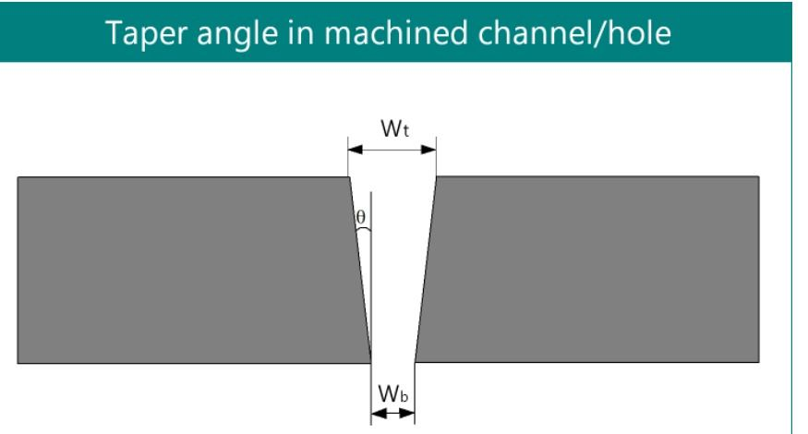
Figure 3.7: Reference diagram and formula for taper angle determination — the angle θ is defined using one inclined wall of the hole cross-section and the full workpiece thickness t

θ = tan⁻¹ [(Wt − Wb) / (2t)]
where t = 2 mm is the workpiece thickness. The factor 2t in the denominator rather than simply it reflects the fact that only one inclined wall of the hole cross-section is considered in the trigonometric definition, consistent with the standard geometry for taper angle determination in machined slots and holes, as illustrated in Figure 3.7. A positive taper angle (Wt > Wb) indicates that the hole tapers inward from entry to exit, which is the universally observed condition in EDM drilling due to the preferential erosion at the entry side.

3.4.3 Scanning Electron Microscopy — Hole Morphology
Following profilometric measurements, all nine specimens were examined in a TESCAN VEGA3 scanning electron microscope at NIT Warangal. Images were acquired at an accelerating voltage of 15.0 kV, a working distance of 13.21 mm, and a magnification of 16–17× sufficient to capture the complete hole in a single field of view while still resolving surface features such as individual discharge craters, re-solidified debris globules, and the width of the peripherally affected zone. Two SEM images were taken per specimen from the entry face. SEM examination was purely qualitative and was used to support the physical interpretation of the profilometric dimensional trends rather than to generate additional quantitative outputs.

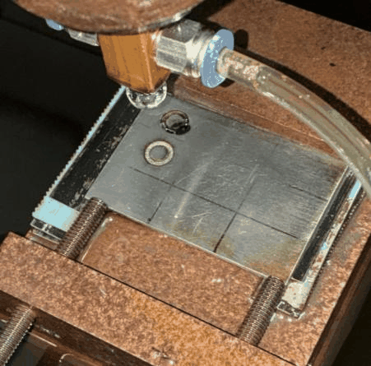
Figure 3.4: Experimental progress (a) first drilling run in progress on the EDM machine, (b) second run with hole clearly visible
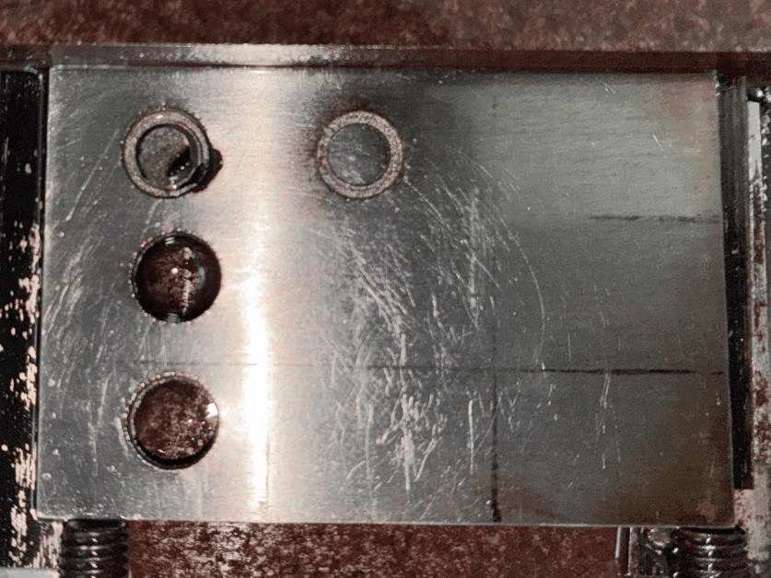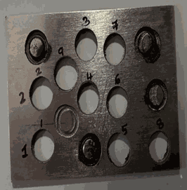
Figure 3.5: Workpiece plate after completion drilling experiments showing multiple completed holes

Chapter 4

RESULTS AND DISCUSSION

4.1 Overview of the Results
This chapter presents and discusses the experimental results obtained from nine near-dry EDM drilling trials on Nitinol with Air + EDM oil mist. The two primary outputs radial overcut (ROC) and taper angle (θ) are analysed at multiple levels: a complete summary table, graphical overviews, Taguchi mean-response parametric analysis for all three control parameters, run-by-run profilometer and SEM evidence, and a correlation analysis between the two responses. The overall ROC range was 0.028 mm to 0.200 mm with a mean of 0.092 mm. The taper angle range was 1.985° to 6.285° with a mean of 3.852°.

4.2 Complete Results Table
Table 4.1: Complete experimental results — Wt, Wb, Dm, ROC, and taper angle for all nine runs (Air + EDM oil, Nitinol, Ø 8 mm Cu electrode)
Run | Ip (A) | Ton (µs) | Toff (µs) | Wt (mm) | Wb (mm) | ROC (mm) | Taper (°) | Dm (mm)
1 | 4 | 50 | 30 | 8.160 | 7.591 | 0.080 | 1.985 | 8.320
2 | 6 | 70 | 35 | 8.203 | 8.061 | 0.152 | 5.995 | 8.507
3 | 5 | 60 | 40 | 8.162 | 7.577 | 0.087 | 3.193 | 8.336
4 | 5 | 70 | 30 | 8.147 | 7.149 | 0.074 | 2.449 | 8.295
5 | 5 | 50 | 35 | 8.132 | 7.378 | 0.066 | 3.753 | 8.264
6 | 6 | 50 | 40 | 8.602 | 8.075 | 0.200 | 6.285 | 9.002
7 | 4 | 70 | 40 | 8.075 | 7.164 | 0.037 | 3.691 | 8.149
8 | 6 | 60 | 30 | 8.162 | 7.108 | 0.106 | 5.191 | 8.374
9 | 4 | 60 | 35 | 8.602 | 8.061 | 0.028 | 2.124 | 8.658

Several features of Table 4.1 are immediately apparent. First, all nine runs produce positive ROC values, confirming that every drilled hole is larger in diameter than the 8 mm tool electrode. This is an inherent outcome of EDM the spark gap always causes some lateral erosion beyond the nominal tool boundary. Second, all runs return positive taper angles, meaning every hole narrows from its entry face to its exit face. Third, the spread in ROC values (0.028 to 0.200 mm, a factor of over seven) is notably wider than the spread in taper angles (1.985° to 6.285°), suggesting that the process parameters have a proportionally larger influence on dimensional control than on geometric taper within the tested range. Fourth, Run 6 is the single worst-performing condition for both responses simultaneously, while Runs 9 and 1 are the best for ROC and taper angle respectively both optima occur at the lowest peak current level.

Table 4.2: Entry diameter (Wt) and exit diameter (Wb) from cross-sectional profilometry with computed Wt−Wb difference
Run | Ip | Ton | Toff | Wt (µm) | Wb (µm) | Wt−Wb (µm) | Taper θ (°)
1 | 4 | 50 | 30 | 8160.5 | 7591.1 | 569.4 | 1.985
2 | 6 | 70 | 35 | 8203.2 | 8061.1 | 142.2 | 5.995
3 | 5 | 60 | 40 | 8161.9 | 7576.5 | 585.4 | 3.193
4 | 5 | 70 | 30 | 8147.2 | 7149.3 | 997.9 | 2.449
5 | 5 | 50 | 35 | 8132.0 | 7377.8 | 754.1 | 3.753
6 | 6 | 50 | 40 | 8601.9 | 8075.4 | 526.5 | 6.285
7 | 4 | 70 | 40 | 8075.0 | 7163.9 | 911.2 | 3.691
8 | 6 | 60 | 30 | 8161.7 | 7107.7 | 1054.0 | 5.191
9 | 4 | 60 | 35 | 8601.9 | 8061.2 | 540.7 | 2.124

Table 4.2 provides the raw cross-sectional data underpinning the taper angle calculations. The Wt−Wb difference ranges from 142 µm (Run 2) to 1054 µm (Run 8), a variation of nearly sevenfold. An apparent anomaly is that Run 2, which has the second-highest taper angle (5.995°), shows only 142 µm of Wt−Wb difference the smallest in the entire set. This can be reconciled by noting that Run 2's exit diameter of 8.061 mm is itself very large, meaning that the high Ip = 6 A combined with long Ton = 70 µs erodes the exit significantly as well as the entry. The taper angle is high not because the entry is especially large relative to a normal exit, but because both diameters are elevated and the geometric ratio Wt−Wb / (2t) is dominated by the large absolute size of the hole rather than a large differential.

4.3 Graphical Overview of ROC and Taper Distributions
Figures 4.1 to 4.3 present bar-chart and grouped-diameter views of the complete dataset, providing a visual overview before the detailed parametric analysis.

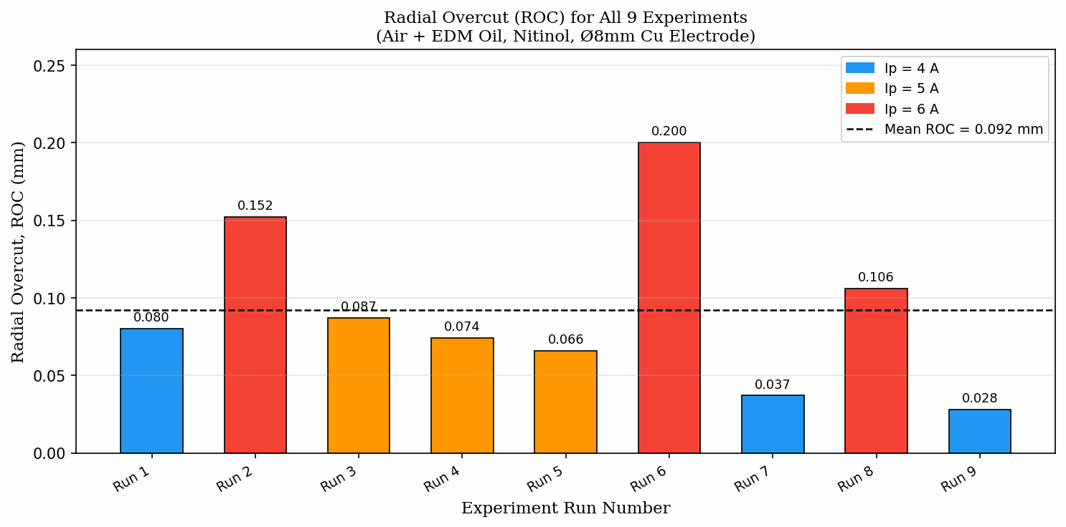
Figure 4.1: Radial overcut (ROC) for all nine experiments — the dashed line marks the mean ROC; bars are colour-coded by peak current level

Figure 4.1 shows that six of the nine runs produce ROC below the mean value of 0.093 mm, indicating that the majority of tested parameter combinations yield good dimensional control. The three above-mean runs (2, 6, 8) all correspond to Ip = 6 A, which immediately and clearly identifies peak current as the dominant driver of overcut. Runs 7 and 9 at Ip = 4 A produce the two lowest ROC values, reinforcing this trend from the opposite direction. The three Ip = 5 A runs (3, 4, 5) cluster around the lower-middle range of the distribution, consistent with an intermediate current level giving intermediate overcut.

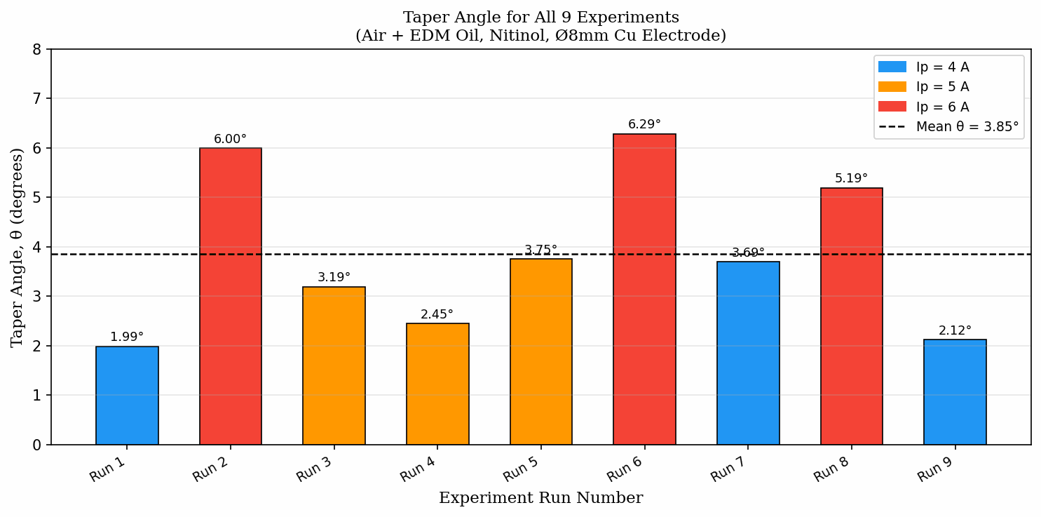
Figure 4.2: Taper angle (θ) for all nine experiments — the dashed line marks the mean taper angle

Figure 4.2 shows a distribution of taper angle that is more spread than that of ROC but follows a similar pattern at the extremes. Runs 2, 6, and 8 (Ip = 6 A) again occupy the three highest taper positions, and Run 1 (Ip = 4 A, Ton = 50 µs, Toff = 30 µs) achieves the minimum. However, the mid-range values are more scattered than in Figure 4.1 for instance, Run 7 (Ip = 4 A) shows a taper of 3.691°, higher than Runs 3, 4, and 5 (Ip = 5 A). This dispersion indicates that while Ip is the dominant factor for both responses, Ton and Toff exert a more notable secondary influence on taper than on ROC.

Figure 4.3 illustrates the entry-exit diameter gap visually. All entry diameters (Wt, shown in blue) exceed 8.000 mm, confirming positive ROC in all runs. Exit diameters (Wb, shown in green) show a considerably wider spread than entry diameters, ranging from 7.108 mm (Run 8) to 8.571 mm (Run 5). Several exit diameters fall below the tool diameter reference line, which is geometrically consistent the exit end of the hole is smaller than the tool because progressive debris accumulation and reduced discharge frequency at depth narrow the exit aperture below the electrode size. This is the fundamental physical origin of positive taper in EDM drilling. Runs 5 and 9 stand out with entry diameters of approximately 8.8–8.7 mm from top-view profilometry, somewhat larger than would be expected from their modest ROC values; this discrepancy is discussed further in the run-by-run analysis section.

4.4 Graphical Parametric Analysis

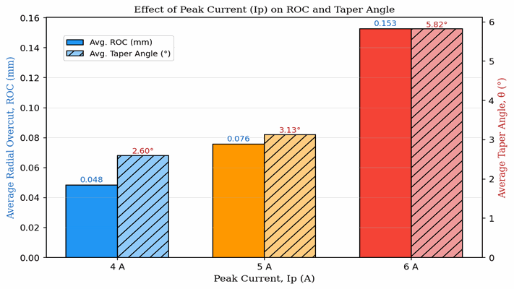

Figure 4.4: Effect of peak current (Ip) on mean ROC (left panel) and mean taper angle (right panel) — data from Taguchi mean-response analysis

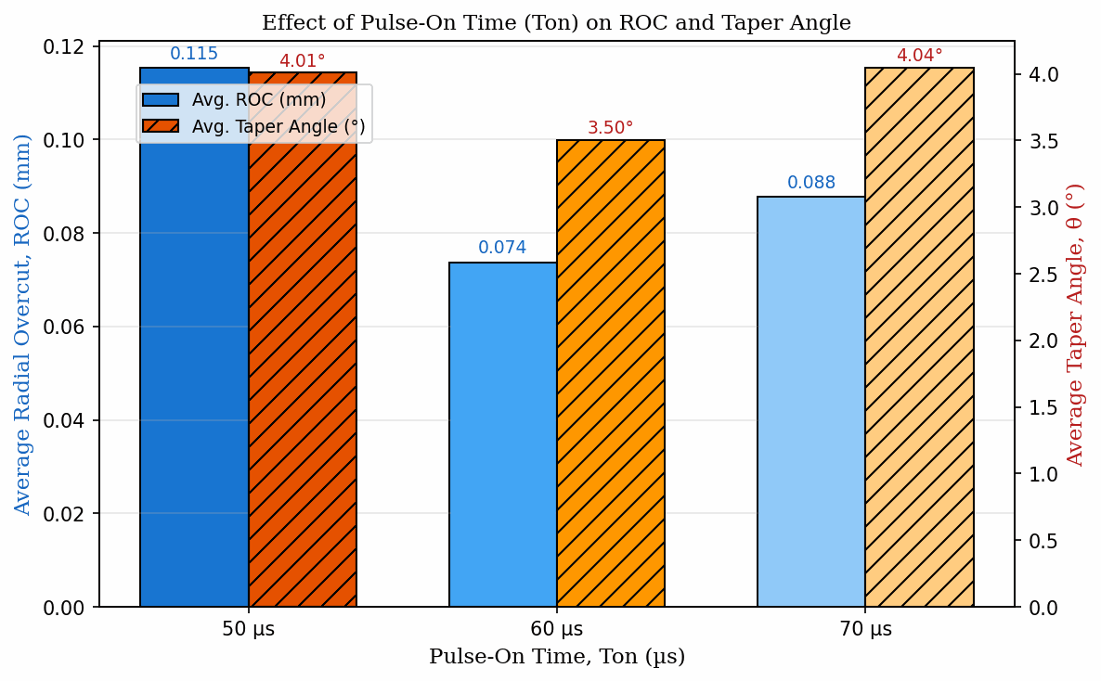
Figure 4.5: Effect of pulse-on time (Ton) on mean ROC (left panel) and mean taper angle (right panel)

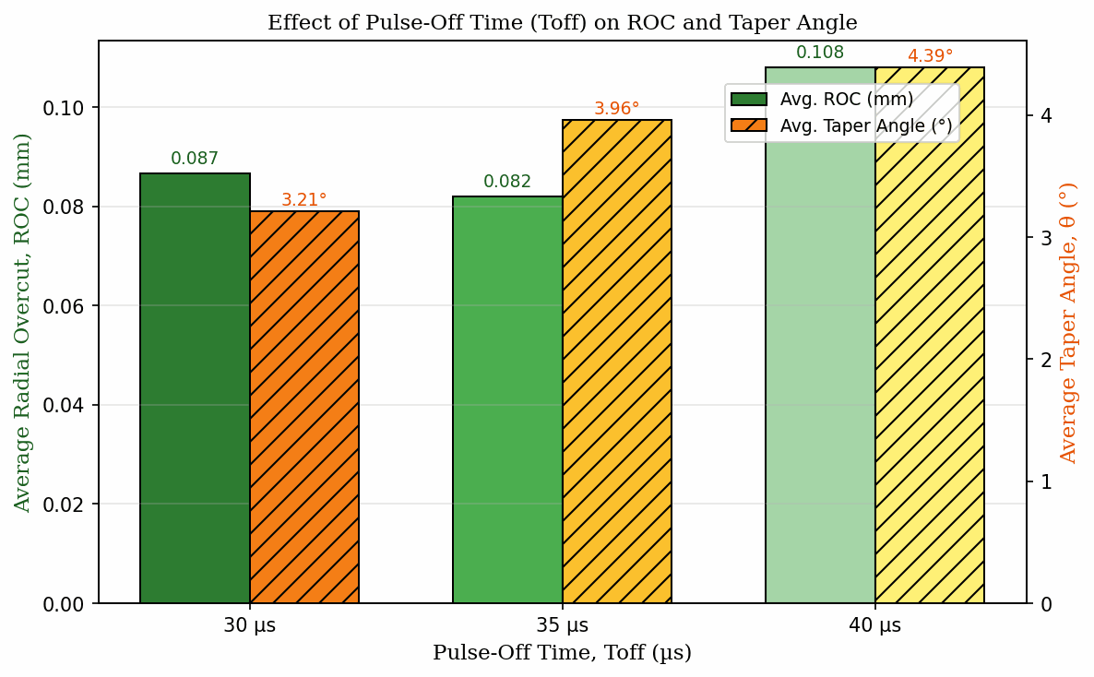
Figure 4.6: Effect of pulse-off time (Toff) on mean ROC (left panel) and mean taper angle (right panel)

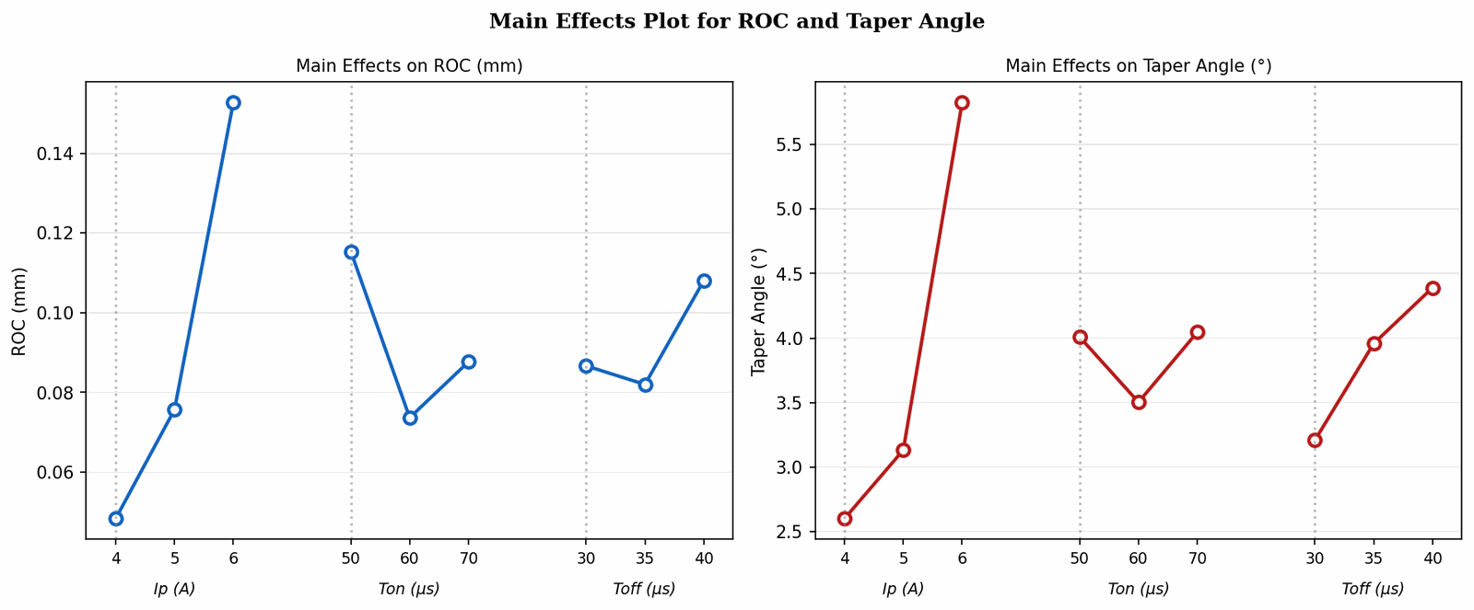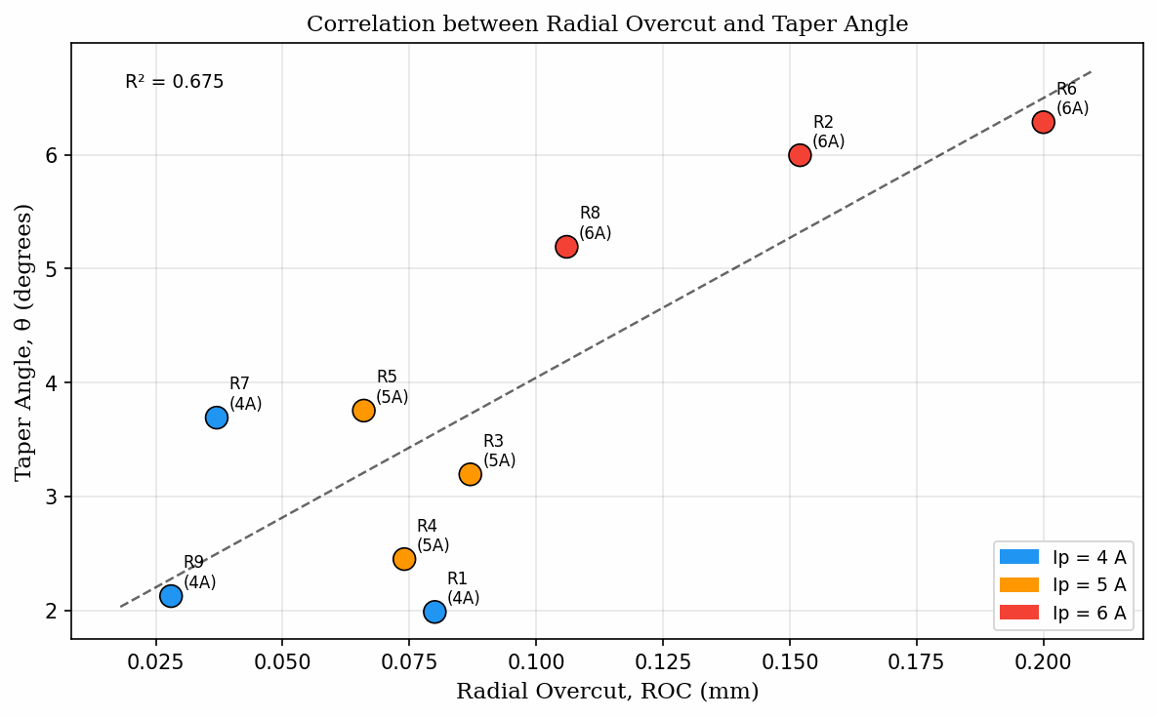
Figure 4.7: Scatter plot of ROC versus taper angle for all nine runs — labelled by run number, showing a moderate positive correlation (R² ≈ 0.56)

Figures 4.4–4.6 are the main effects plots derived from the Taguchi mean-response analysis. For each parameter, the mean ROC and mean taper angle at each of its three levels are plotted, revealing the direction and relative magnitude of each parameter's influence. A steeper slope in these plots indicates stronger parametric influence on the response. Figure 4.4 shows the steepest slopes for both ROC and taper angle across the Ip axis, confirming it as the most dominant parameter. The slope for ROC rises from 0.048 mm at 4 A to 0.153 mm at 6 A, and for taper angle from 2.600° to 5.824° over the same range. The proportional increase is dramatic in both cases.

Figure 4.7 presents the scatter plot of ROC versus taper angle. The moderate positive correlation (R² ≈ 0.56) confirms that both responses are linked by their common primary driver (discharge energy / peak current) but are not perfectly coupled Ton and Toff exert somewhat different influences on the two outputs, as discussed in Sections 4.5.2 and 4.5.3. Runs 2, 6, and 8 occupy the high-ROC, high-taper quadrant consistently, while Runs 7 and 9 cluster in the low-ROC, low-taper region.

4.5 Parametric Effect Analysis

4.5.1 Effect of Peak Current (Ip)
Table 4.3: Effect of peak current (Ip) on mean ROC and mean taper angle
Ip (A) Level | Runs | Avg. ROC (mm) | Avg. Taper (°)
4 | R1, R7, R9 | 0.0483 | 2.6000
5 | R3, R4, R5 | 0.0757 | 3.1317
6 | R2, R6, R8 | 0.1527 | 5.8237

Table 4.3 and Figure 4.4 together provide the clearest and most important finding of this study: peak current exerts a dominant, monotonically increasing influence on both radial overcut and taper angle. The physical mechanism is straightforward. In EDM, the energy deposited per spark pulse is directly proportional to the square of the peak current multiplied by the pulse duration. Therefore, even a modest increase in Ip substantially elevates the thermal energy available per discharge event. A larger energy input creates a wider, more energetic plasma channel that extends further laterally from the electrode surface, enlarging the spark gap and hence the hole diameter beyond the nominal tool size. This explains the steep increase in mean ROC from 0.0485 mm at Ip = 4 A through 0.0757 mm at Ip = 5 A to 0.1527 mm at Ip = 6 A a 219% total increase across the tested range.

The taper angle response to Ip is equally clear. The average taper at Ip = 4 A is 2.600°, rising to 3.132° at Ip = 5 A and reaching 5.824° at Ip = 6 A. This increase is attributed to the asymmetric nature of erosion at high discharge energies. At the hole entry, the tool electrode is constantly facing fresh material and the full discharge energy is available from the moment the spark initiates. At the exit, the tool must drive the discharge through the full depth of the already-eroded hole, which is partially filled with debris, partially ionised remnant dielectric, and secondary sparks reflected from the debris cloud. At low Ip, these effects are mild because the total energy is limited, and both entry and exit erode at comparable rates. At high Ip, however, the intense primary discharges preferentially enlarge the entry where discharge density per unit area is highest more aggressively than the exit, producing a pronounced Wt−Wb difference and hence a steeper taper angle.

4.5.2 Effect of Pulse-On Time (Ton)
Table 4.4: Effect of pulse-on time (Ton) on mean ROC and mean taper angle
Ton (µs) Level | Runs | Avg. ROC (mm) | Avg. Taper (°)
50 | R1, R5, R6 | 0.1153 | 4.0077
60 | R3, R8, R9 | 0.0737 | 3.5027
70 | R2, R4, R7 | 0.0877 | 4.0450

The influence of Ton on ROC is non-monotonic: the mean ROC is 0.1153 mm at Ton = 50 µs, drops to 0.0737 mm at Ton = 60 µs, and rises again slightly to 0.0877 mm at Ton = 70 µs. This non-linear pattern reflects the confounding structure of the L9 array different Ip and Toff values accompany each Ton level, and the Ip influence is strong enough to distort the apparent Ton trend. At Ton = 50 µs, Run 6 (Ip = 6 A) pulls the mean upward; at Ton = 70 µs, Run 2 (Ip = 6 A) does the same. At Ton = 60 µs, the corresponding high-Ip run (Run 8) produces a lower ROC of 0.106 mm than Runs 2 or 6, pulling the mean down. The net result is that the Ton effect on ROC, while present, is masked by the dominant Ip influence within the L9 structure.

For taper angle, the Ton trend is clearer: mean taper at Ton = 50 µs is 4.008°, at Ton = 60 µs is 3.503°, and at Ton = 70 µs is 4.045°. The taper is thus slightly higher at both the shortest and longest Ton levels, with the minimum at the intermediate 60 µs. At 50 µs, the high pulse frequency associated with short Ton increases the rate of debris generation in the gap, and this debris settles preferentially near the exit end of the 2 mm hole, restricting exit erosion and widening the entry-exit asymmetry. At 70 µs, each pulse delivers more total energy, which accentuates the entry-side thermal loading even at moderate Ip values. The intermediate 60 µs level appears to balance these competing effects, producing the lowest mean taper.

4.5.3 Effect of Pulse-Off Time (Toff)
Table 4.5: Effect of pulse-off time (Toff) on mean ROC and mean taper angle
Toff (µs) Level | Runs | Avg. ROC (mm) | Avg. Taper (°)
30 | R1, R4, R8 | 0.0867 | 3.2083
35 | R2, R5, R9 | 0.0820 | 3.9573
40 | R3, R6, R7 | 0.1080 | 4.3897

The effect of Toff on ROC is relatively modest in absolute terms. Mean ROC at Toff = 30 µs is 0.0867 mm, at Toff = 35 µs is 0.0817 mm, and at Toff = 40 µs is 0.1083 mm. The higher mean at 40 µs is driven by Run 6 (Ip = 6 A) in the Toff = 40 µs group; without this outlier, the Toff effect on ROC would be nearly flat. This confirms that within the tested range, Toff is a secondary parameter for dimensional accuracy, and that its influence on ROC is largely confounded with the Ip level of the runs in each Toff group.

The Toff effect on taper angle, however, shows a clear and progressive trend: mean taper at Toff = 30 µs is 3.208°, at Toff = 35 µs is 3.957°, and at Toff = 40 µs is 4.390°. This consistent increase in taper with longer off-time can be explained by the dynamics of debris within the drilled hole. A longer Toff means more time elapses between successive pulses, during which eroded particles which are denser than the dielectric mist and are temporarily suspended in the gap settle downward under gravity and collect near the bottom (exit end) of the hole. When the next pulse fires, this settled debris layer reduces the dielectric strength near the exit, suppressing discharge frequency at that location and thereby reducing exit-side erosion relative to entry-side erosion. The result is a larger Wt−Wb difference and hence a larger taper angle. Shorter Toff values reduce the settling time and maintain a more uniform debris distribution along the hole depth, producing smaller taper angles. This debris-settling mechanism is specific to vertical drilling and would not be expected in horizontal or inverted configurations.

4.6 Correlation between ROC and Taper Angle
Figure 4.7 plots ROC against taper angle for all nine experimental runs. A moderate positive correlation with R² ≈ 0.56 is observed, indicating that conditions producing higher radial overcut also tend to produce steeper taper angles. The physical basis for this correlation is that both responses are primarily driven by peak current: higher Ip increases plasma channel diameter (raising ROC) while simultaneously intensifying the thermal gradient along the hole depth (raising taper). The moderate R² value rather than R² close to 1.0 indicates that the two responses are not perfectly coupled, and that Ton and Toff can modulate each response somewhat independently. For example, shorter Toff reduces taper more than it reduces ROC, while longer Ton at fixed Ip has a more noticeable effect on taper than on overcut. This partial decoupling means that process engineers cannot simply minimise Ip and assume both responses will be simultaneously optimised the Ton–Toff combination must be tuned independently for each response depending on the application priority.

4.7 Optimal and Worst-Case Conditions
Table 4.6: Optimal and worst-case parameter combinations for ROC and taper angle
Response | Optimal Condition | Best Value | Worst Value
ROC | Ip=4A, Ton=60µs, Toff=35µs (Run 9) | 0.028 mm | 0.200 mm (Run 6)
Taper Angle | Ip=4A, Ton=50µs, Toff=30µs (Run 1) | 1.985° | 6.285° (Run 6)

Table 4.6 summarises the best and worst conditions identified from the experimental data. The minimum ROC of 0.028 mm at Run 9 and the minimum taper angle of 1.985° at Run 1 are achieved at different parameter combinations, indicating that a single optimum for both responses simultaneously does not exist within the tested design space. However, both optima share the common feature of Ip = 4 A, confirming that keeping the peak current at its minimum tested level is the single most important decision for dimensional accuracy. The choice between Ton = 60 µs / Toff = 35 µs and Ton = 50 µs / Toff = 30 µs then depends on whether minimum overcut or minimum taper is the higher priority for the specific application. For a stent hole where wall straightness is critical to deployment force, Run 1 conditions are preferred. For a guidewire hole where the outer diameter of the wire must match the drilled aperture closely, Run 9 conditions are preferred.

4.8 Run-by-Run Detailed Analysis
The following subsections present the 3D surface profilometer results (top-view and cross-sectional), and SEM morphology images for each of the nine experimental runs, with individual parametric interpretation. Each run's measured values are stated at the outset for clarity.

4.6.1 Run 1 — Ip = 4 A, Ton = 50 µs, Toff = 30 µs
The measured values for this run are: entry diameter Wt = 8.160 mm, exit diameter Wb = 7.591 mm, hole diameter Dm = 8.320 mm, ROC = 0.080 mm, taper angle θ = 1.985°.

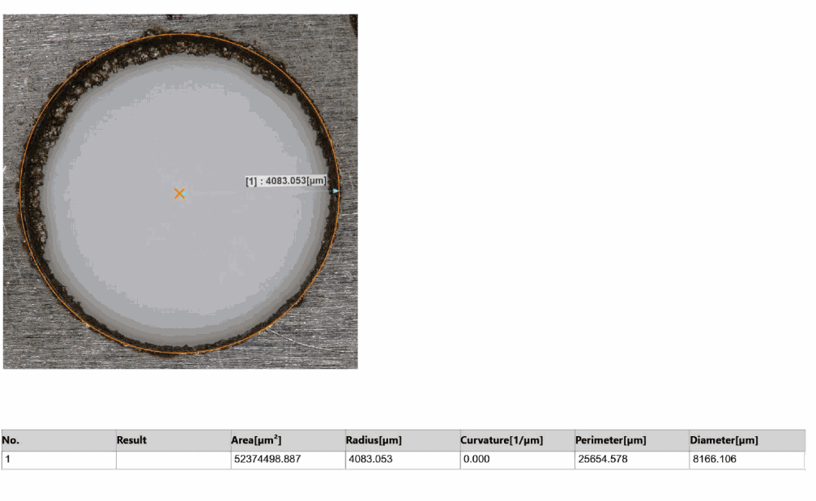
Figure 4.10: Top-view 3D profilometer result — Run 1 (entry diameter Dm = 8.320 mm, ROC = 0.080 mm)
Radial Overcut Analysis: Run 1 records an ROC of 0.080 mm, placing it among the lower-overcut trials. With Ip at its minimum value of 4 A, each discharge carries limited energy, so the plasma channel diameter is relatively small and lateral erosion beyond the electrode boundary is restricted. The short Toff of 30 µs maintains a high pulse frequency but, at such low discharge energy, this does not translate into stray lateral sparks instead the erosion is directed primarily downward into the workpiece.

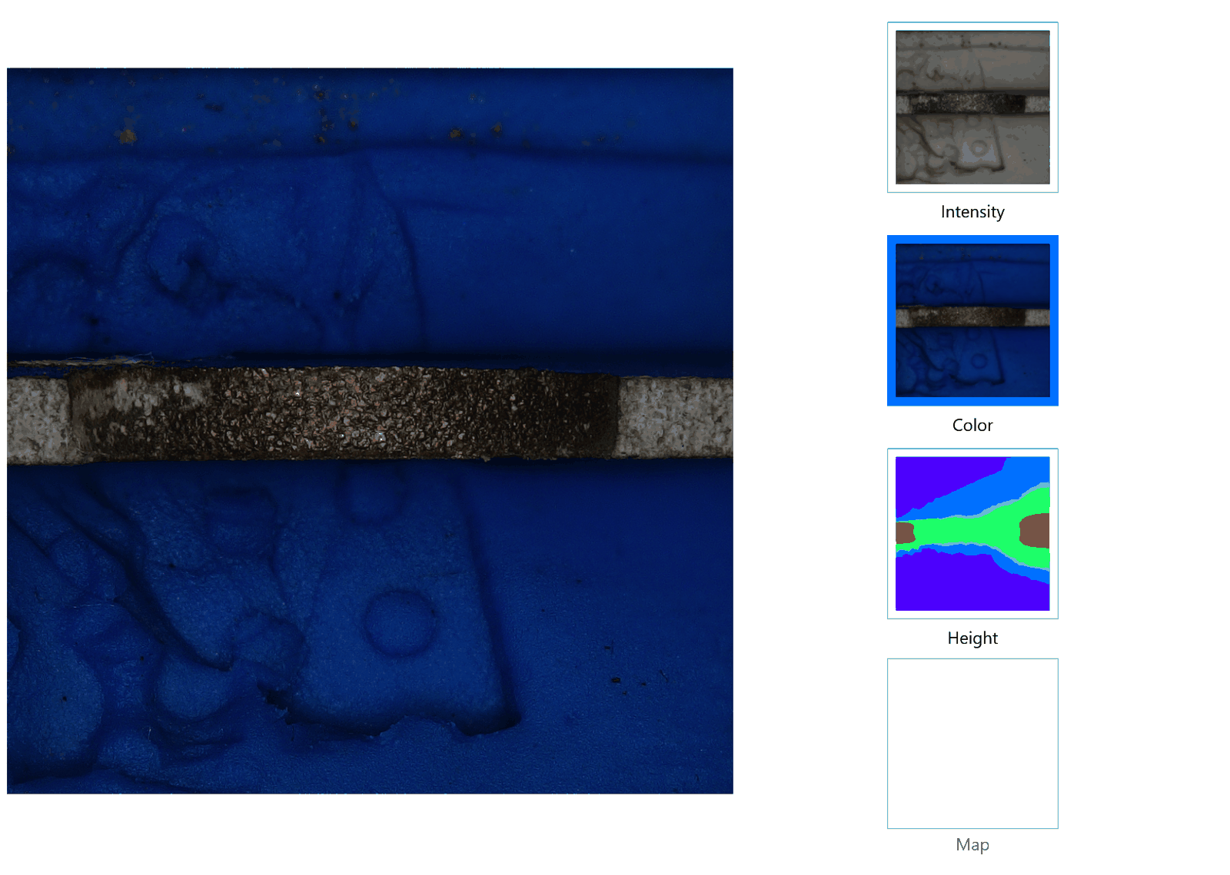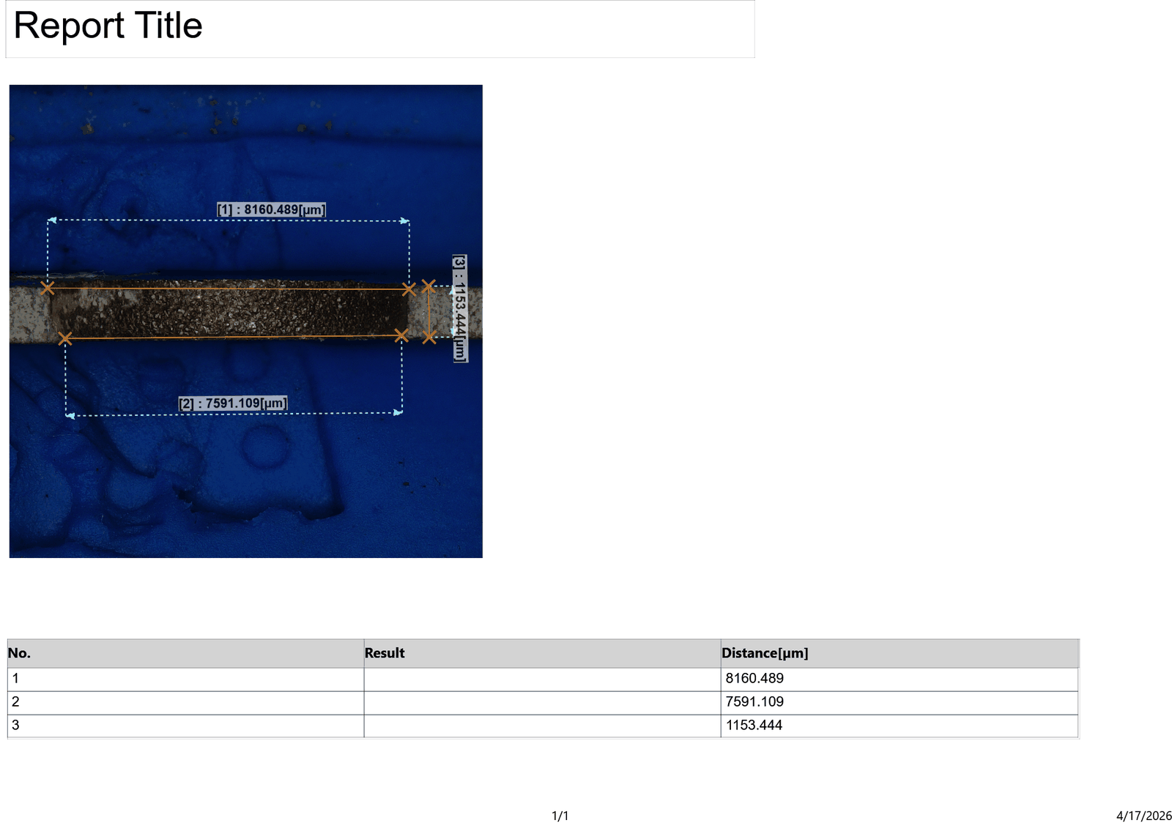
Figure 4.19: Cross-sectional profilometer result — Run 1 (Wt = 8.160 mm, Wb = 7.591 mm, θ = 1.985°)
Taper Angle Analysis: The taper angle for Run 1 is 1.985° the minimum in the entire experimental set. This outcome is consistent with the combined effect of the lowest discharge energy (Ip = 4 A) and the shortest pulse duration (Ton = 50 µs). Low energy restricts the thermal gradient from entry to exit, and short pulses limit the total energy deposited per event, both contributing to a nearly uniform hole diameter along the 2 mm depth. The Wt−Wb difference of 569 µm confirms that some entry-to-exit variation exists even at the most benign conditions, but the absolute taper angle of under 2° is the smallest observed.

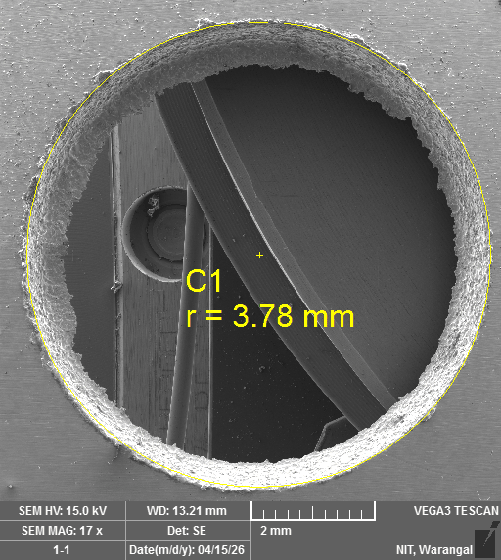
Figure 4.28 & 4.29: SEM images of drilled hole surface — Run 1 (TESCAN VEGA3, 15 kV, WD = 13.21 mm, 16–17×)
SEM Morphology: The SEM image for Run 1 shows a well-defined, approximately circular hole boundary with a narrow band of EDM-affected material around the perimeter. Individual discharge craters are small and densely distributed, reflecting the low energy per spark at Ip = 4 A. A few re-solidified Nitinol globules are visible near the hole edge, but debris coverage is lighter than in higher-Ip runs. The hole interior appears clean relative to the near-dry conditions, indicating that the high-velocity air component of the mist evacuated most of the eroded material effectively.

4.6.2 Run 2 — Ip = 6 A, Ton = 70 µs, Toff = 35 µs
The measured values for this run are: entry diameter Wt = 8.203 mm, exit diameter Wb = 8.061 mm, hole diameter Dm = 8.507 mm, ROC = 0.152 mm, taper angle θ = 5.995°.

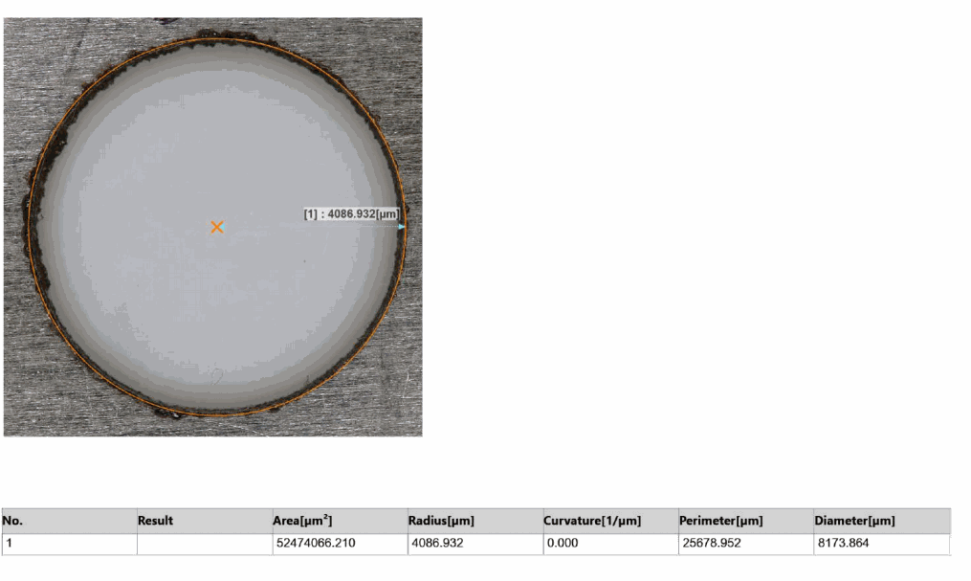
Figure 4.11: Top-view 3D profilometer result — Run 2 (entry diameter Dm = 8.507 mm, ROC = 0.152 mm)
Radial Overcut Analysis: At Ip = 6 A, Run 2 records an ROC of 0.152 mm, representing a 90% increase over Run 1 despite the different Ton and Toff settings. The elevated peak current drives a considerably larger plasma channel diameter, and the correspondingly wider spark gap is the direct cause of the higher overcut. This run clearly demonstrates that crossing from intermediate to high peak current substantially relaxes dimensional control.

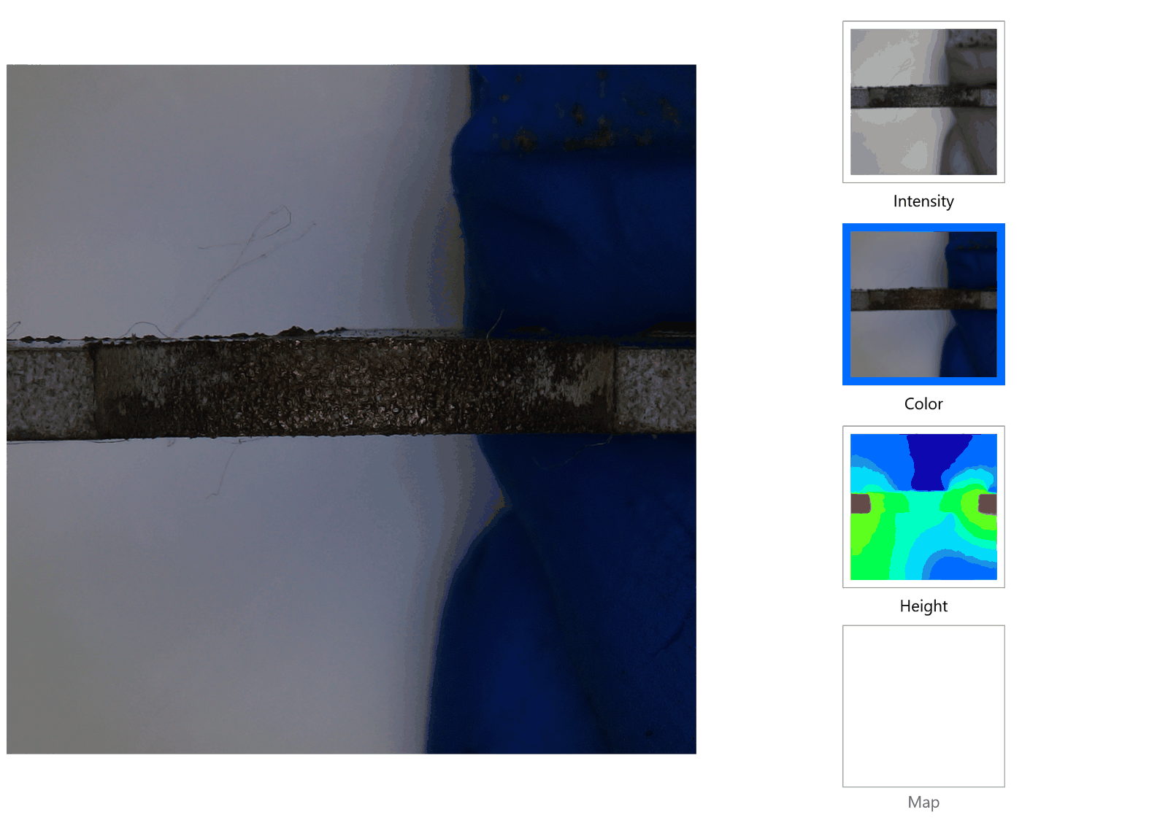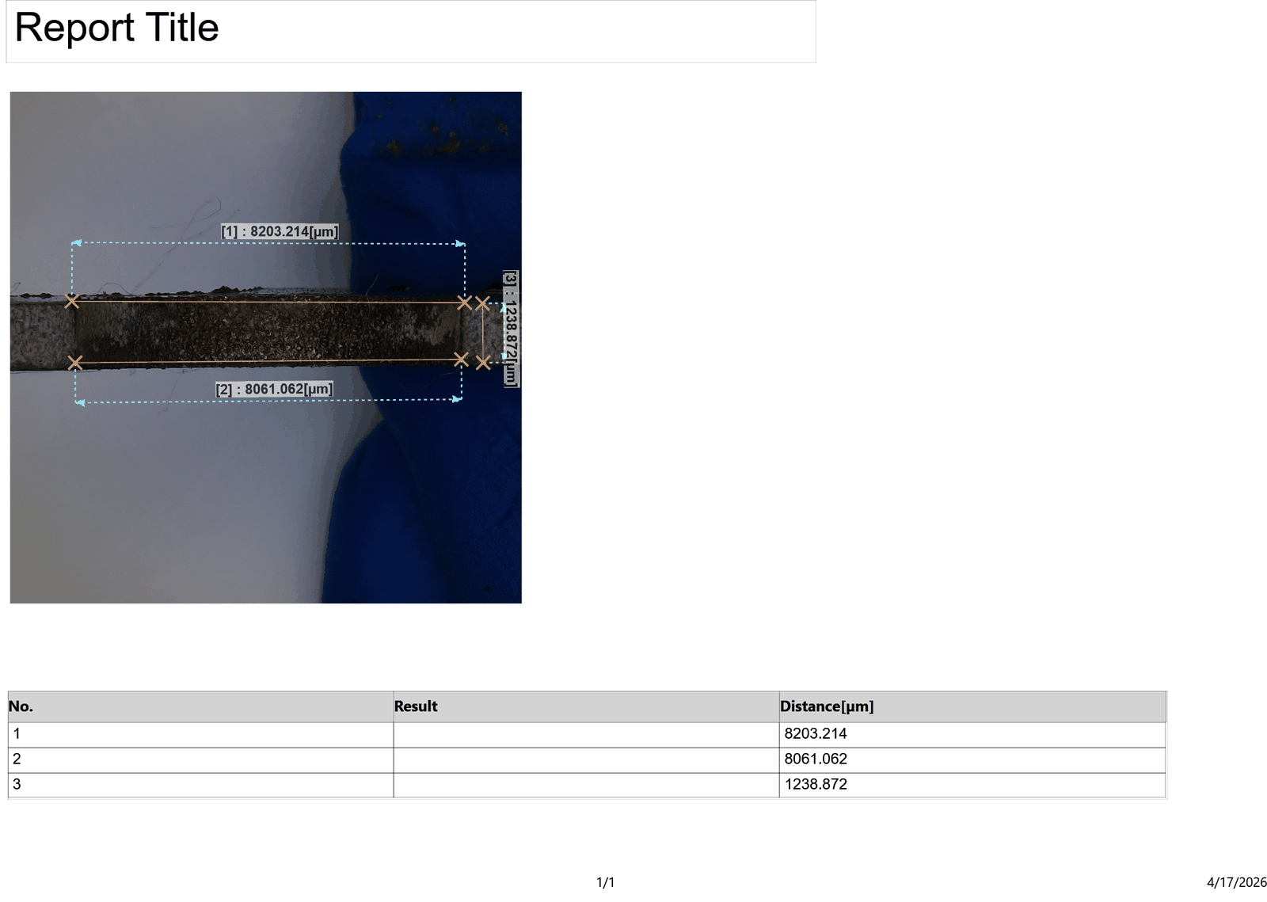
Figure 4.20: Cross-sectional profilometer result — Run 2 (Wt = 8.203 mm, Wb = 8.061 mm, θ = 5.995°)
Taper Angle Analysis: Run 2 records a taper angle of 5.995°, the second highest in the set. At Ip = 6 A and Ton = 70 µs, the discharge energy per pulse is at its maximum. High-energy sparks preferentially erode the hole entry where discharge density is greatest more aggressively than the exit, creating a large top-to-bottom diameter differential. The Wt−Wb difference of only 142 µm appears small in absolute terms, but this is because the exit diameter (8.061 mm) is also large at this high energy condition, indicating significant exit erosion as well; the taper angle is high because the exit erodes less than the entry in proportional terms.

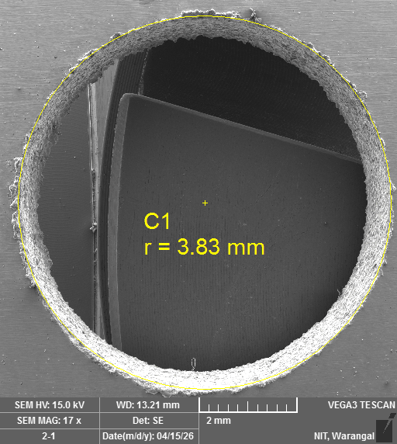
Figure 4.30 & 4.31: SEM images of drilled hole surface — Run 2 (TESCAN VEGA3, 15 kV, WD = 13.21 mm, 16–17×)
SEM Morphology: Run 2 shows a larger hole with a more pronounced peripheral affected zone compared to Run 1. The higher peak current of 6 A generates larger individual craters, which are visible as deeper, broader depressions around the hole rim. Re-solidified globules are more numerous and larger in diameter than in Run 1, consistent with the greater melt volume per discharge at this energy level. The hole boundary, while still largely circular, shows slightly more irregularity at isolated points along its perimeter, likely caused by stray lateral discharges.

4.6.3 Run 3 — Ip = 5 A, Ton = 60 µs, Toff = 40 µs
The measured values for this run are: entry diameter Wt = 8.162 mm, exit diameter Wb = 7.577 mm, hole diameter Dm = 8.336 mm, ROC = 0.087 mm, taper angle θ = 3.193°.

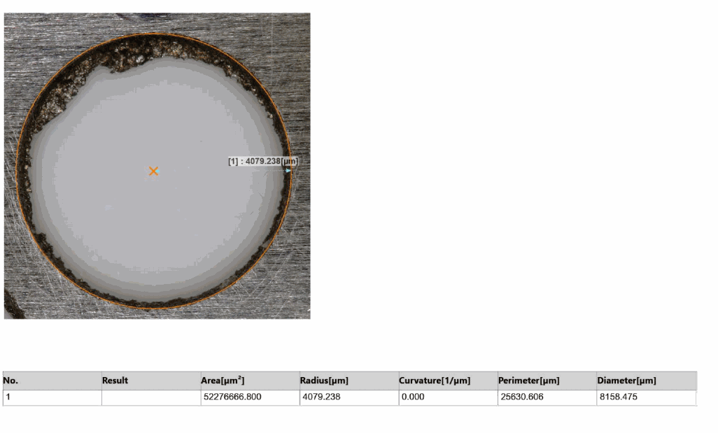
Figure 4.12: Top-view 3D profilometer result — Run 3 (entry diameter Dm = 8.336 mm, ROC = 0.087 mm)
Radial Overcut Analysis: Run 3 returns an ROC of 0.087 mm a satisfactory result for a mid-range Ip of 5 A. The longest tested Toff of 40 µs allows the inter-electrode gap to recover completely between successive pulses, preventing residual ionisation from triggering premature or off-axis discharges. The moderate discharge energy combined with this complete gap recovery keeps lateral erosion well contained.

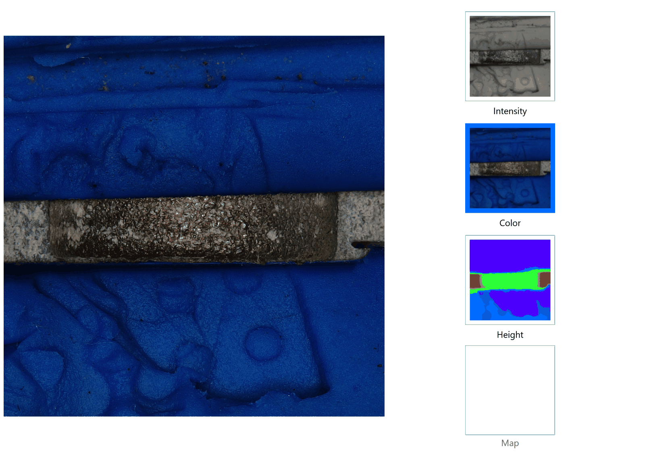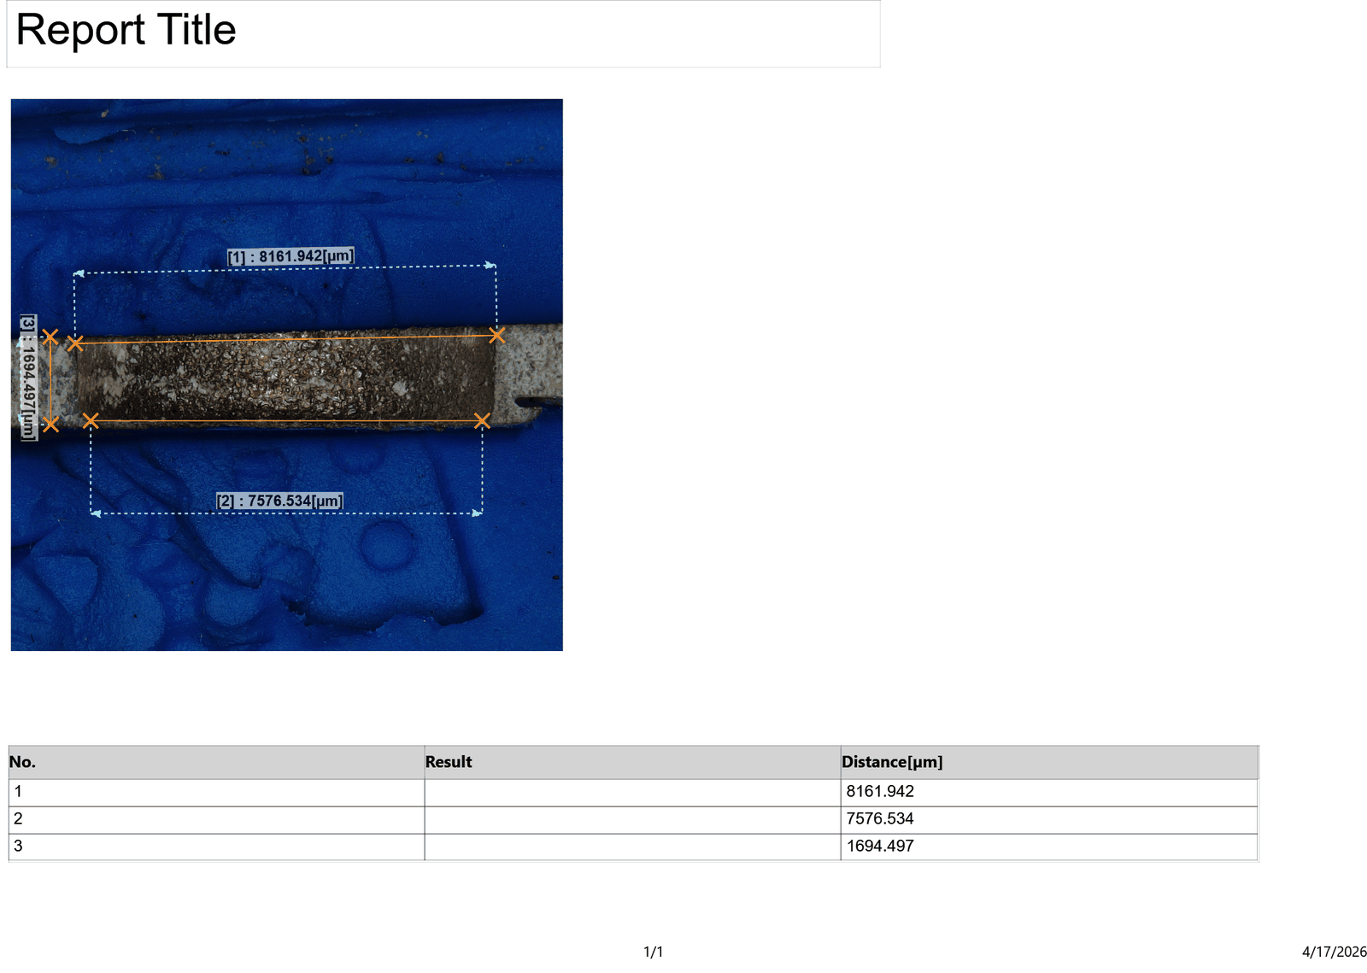
Figure 4.21: Cross-sectional profilometer result — Run 3 (Wt = 8.162 mm, Wb = 7.577 mm, θ = 3.193°)
Taper Angle Analysis: Run 3 returns a taper angle of 3.193° a moderate value consistent with its intermediate parameter settings. The Toff = 40 µs allows full gap recovery and complete flushing of debris between pulses, which tends to equalise the discharge conditions at the entry and exit ends of the hole, limiting the entry-exit asymmetry.

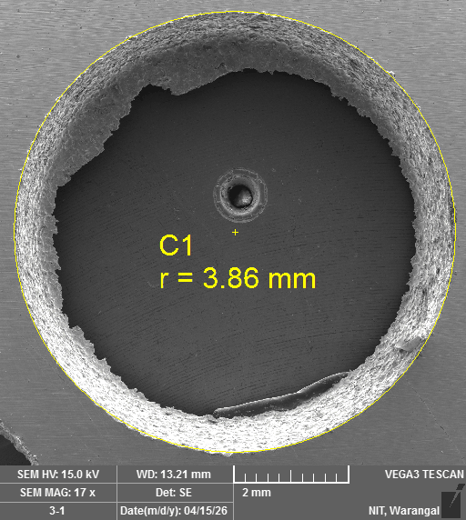
Figure 4.32 & 4.33: SEM images of drilled hole surface — Run 3 (TESCAN VEGA3, 15 kV, WD = 13.21 mm, 16–17×)
SEM Morphology: The hole morphology for Run 3 is well-defined, with uniform distribution of fine discharge craters around the periphery. The Toff = 40 µs condition appears to allow more complete debris removal between pulses, as the surface around the hole is relatively free of coarse debris compared to shorter Toff runs. The overall appearance is consistent with controlled, repeatable sparking at these moderate parameter values.

4.6.4 Run 4 — Ip = 5 A, Ton = 70 µs, Toff = 30 µs
The measured values for this run are: entry diameter Wt = 8.147 mm, exit diameter Wb = 7.149 mm, hole diameter Dm = 8.295 mm, ROC = 0.074 mm, taper angle θ = 2.449°.

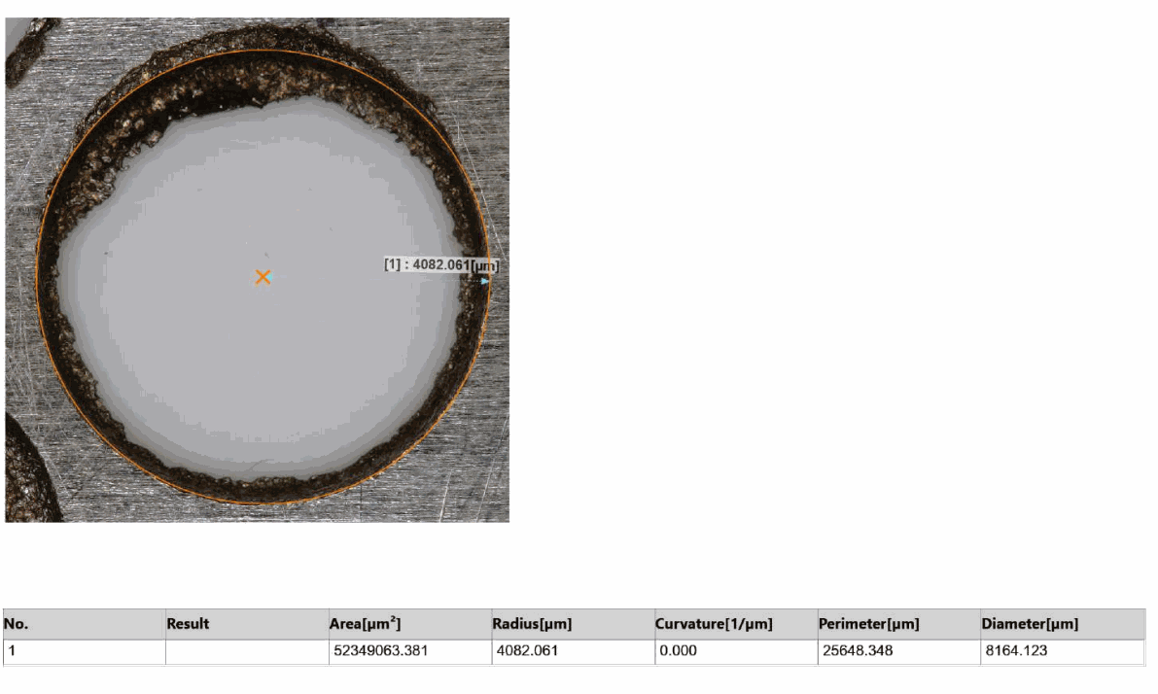
Figure 4.13: Top-view 3D profilometer result — Run 4 (entry diameter Dm = 8.295 mm, ROC = 0.074 mm)
Radial Overcut Analysis: With Ip = 5 A, Ton = 70 µs, and Toff = 30 µs, Run 4 achieves an ROC of 0.074 mm slightly better than Run 3 despite an identical peak current. The longer pulse duration of 70 µs produces a more stable, directionally consistent arc that erodes preferentially in the axial direction, contributing to the lower overcut compared to shorter Ton conditions at the same Ip.

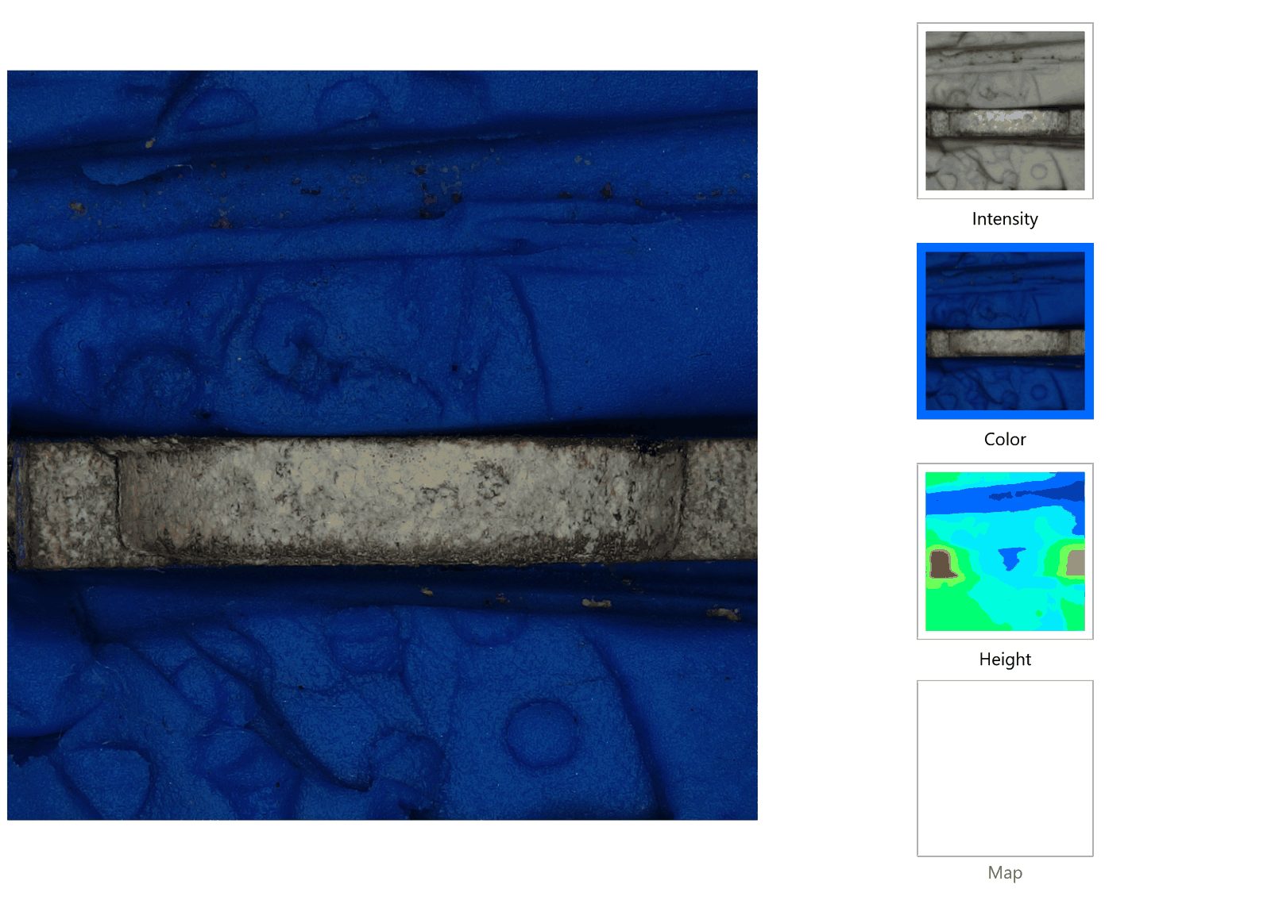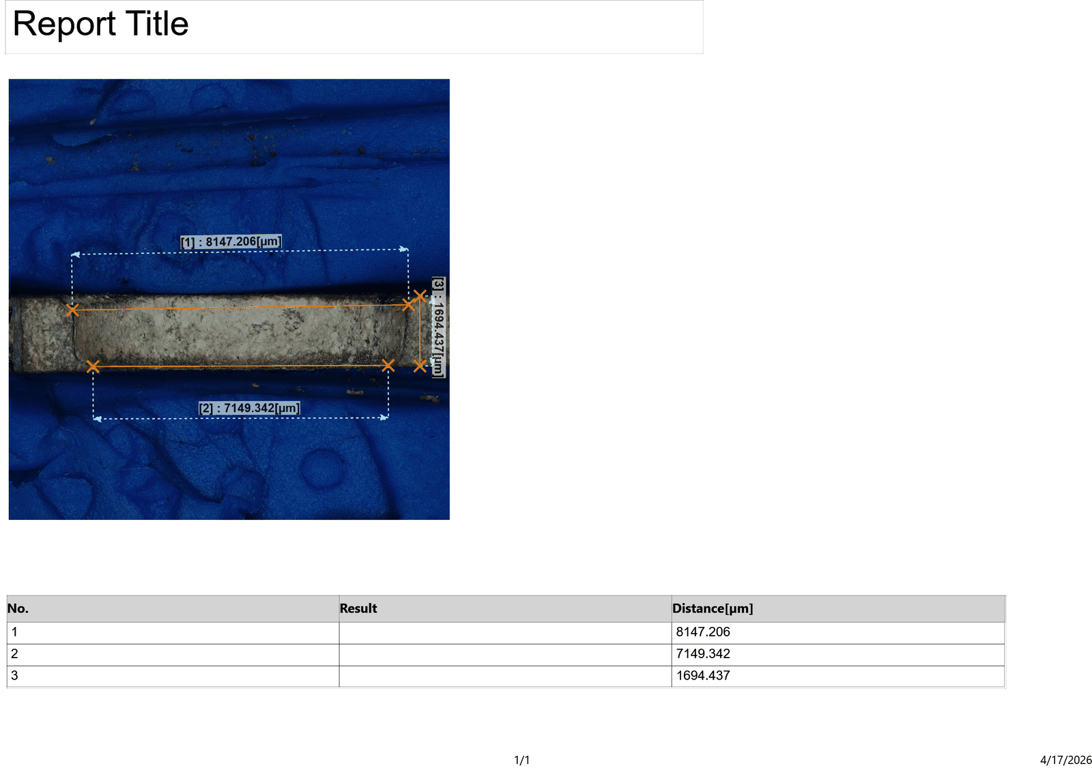
Figure 4.22: Cross-sectional profilometer result — Run 4 (Wt = 8.147 mm, Wb = 7.149 mm, θ = 2.449°)
Taper Angle Analysis: With Ton = 70 µs at Ip = 5 A, Run 4 achieves a low taper angle of 2.449°. The long pulse duration produces stable, spatially consistent arcs that erode more uniformly along the hole depth than short pulses at the same energy level. The result is a Wt−Wb difference of 998 µm in absolute terms, but because both entry and exit experience sustained erosion from the long arcs, the taper angle remains low at 2.449°.

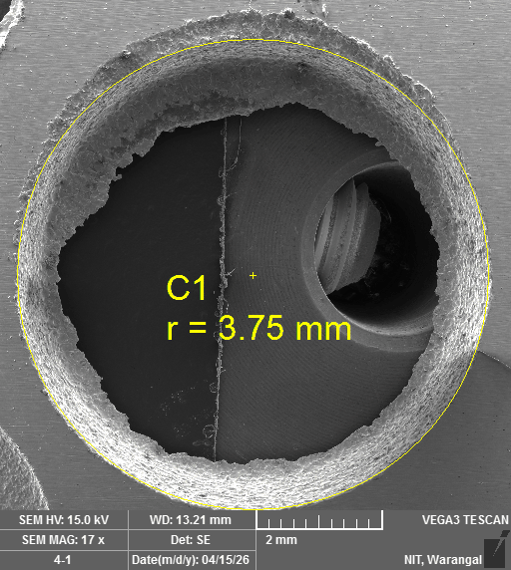
Figure 4.34 & 4.35: SEM images of drilled hole surface — Run 4 (TESCAN VEGA3, 15 kV, WD = 13.21 mm, 16–17×)
SEM Morphology: Run 4 produces one of the cleanest hole boundaries in the set. The long Ton = 70 µs results in fewer, more sustained individual discharge events, and this is reflected in the SEM image as somewhat larger but more widely spaced craters compared to shorter Ton runs. The boundary regularity is good, and debris coverage around the hole periphery is moderate.

4.6.5 Run 5 — Ip = 5 A, Ton = 50 µs, Toff = 35 µs
The measured values for this run are: entry diameter Wt = 8.132 mm, exit diameter Wb = 7.378 mm, hole diameter Dm = 8.264 mm, ROC = 0.066 mm, taper angle θ = 3.753°.

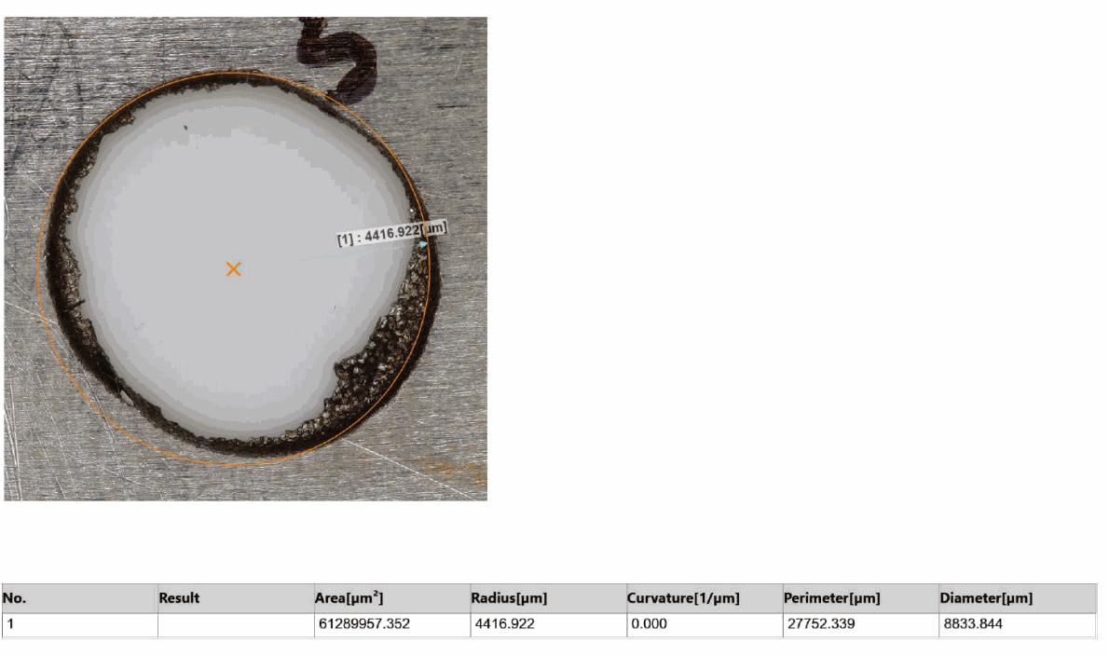
Figure 4.14: Top-view 3D profilometer result — Run 5 (entry diameter Dm = 8.264 mm, ROC = 0.066 mm)
Radial Overcut Analysis: Run 5 produces the third-lowest ROC in the set at 0.066 mm. The short Ton of 50 µs means each pulse deposits less energy before being extinguished, limiting the extent of lateral plasma expansion. Despite the intermediate Ip = 5 A, the brevity of each discharge evidently restricts the lateral reach of the spark channel more than it reduces axial material removal.

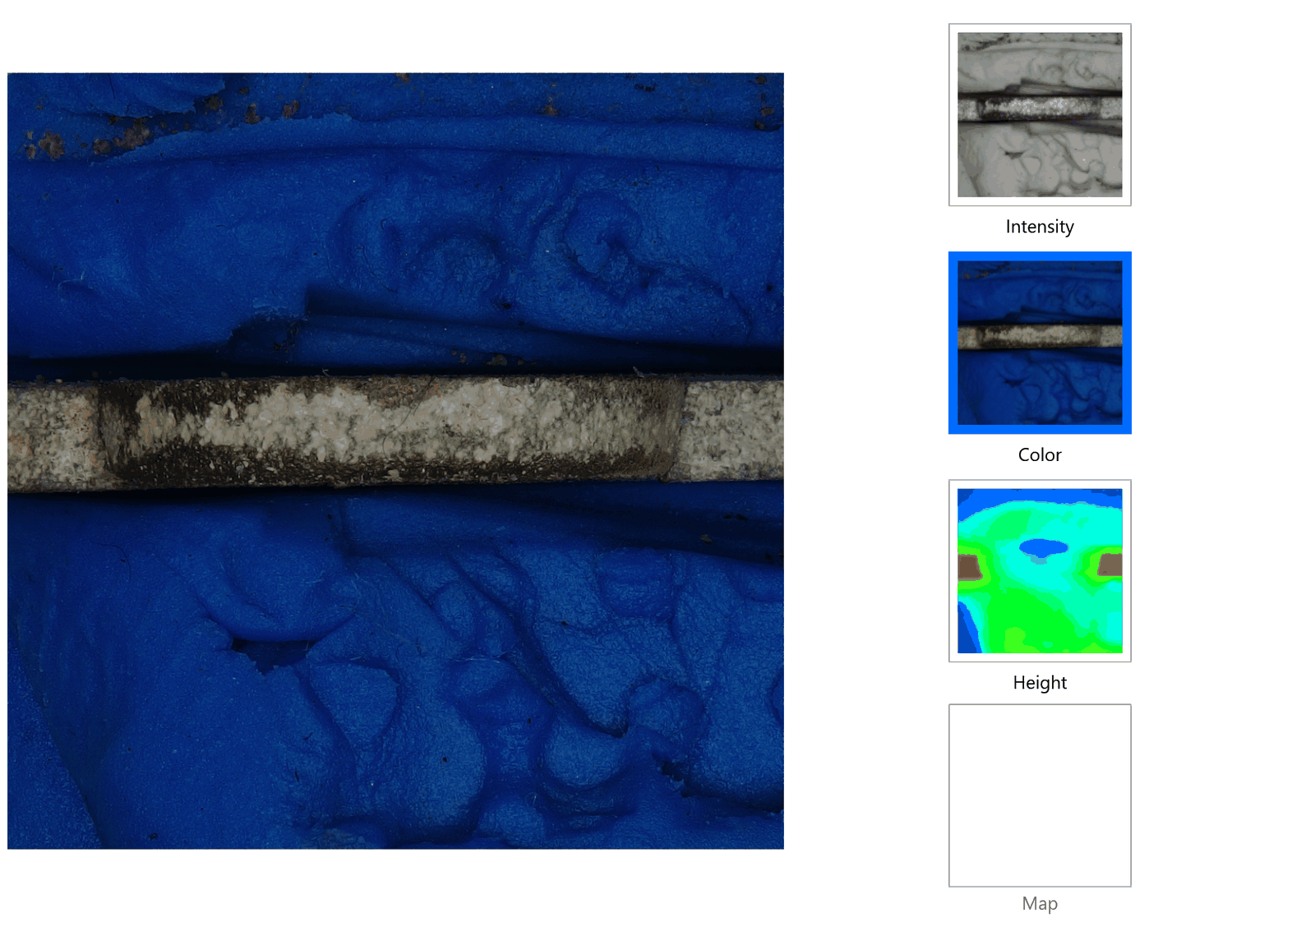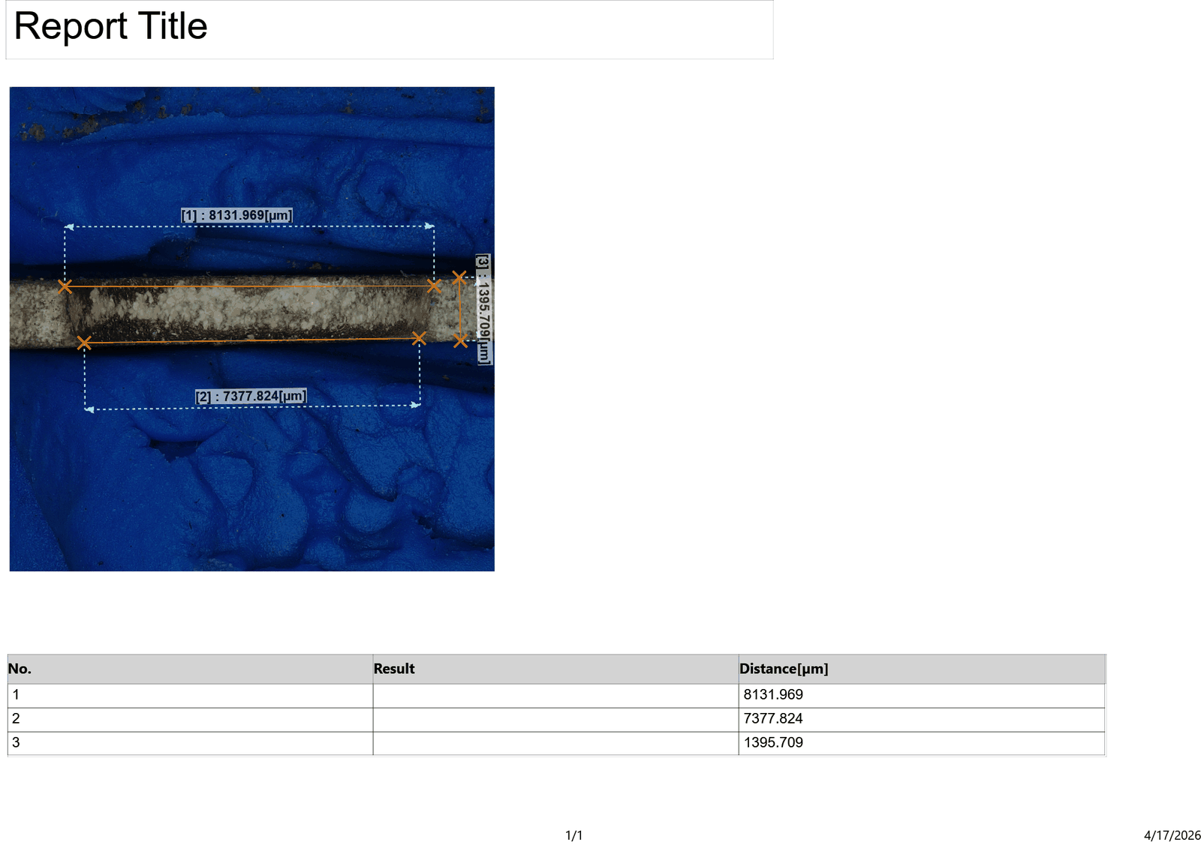
Figure 4.23: Cross-sectional profilometer result — Run 5 (Wt = 8.132 mm, Wb = 7.378 mm, θ = 3.753°)
Taper Angle Analysis: Run 5 shows a taper angle of 3.753°, moderate within the dataset. The short Ton = 50 µs combined with Toff = 35 µs generates a high pulse frequency, and at this repetition rate, debris accumulation near the exit is more significant than at lower frequencies. The accumulated debris partially obstructs the exit end of the IEG, reducing exit erosion and widening the entry-exit asymmetry compared to longer Ton conditions.

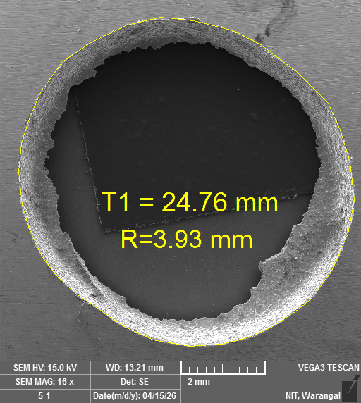
Figure 4.36 & 4.37: SEM images of drilled hole surface — Run 5 (TESCAN VEGA3, 15 kV, WD = 13.21 mm, 16–17×)
SEM Morphology: The SEM image for Run 5 reveals an unusually large hole diameter relative to the expected size from the electrode, consistent with the high measured entry diameter of 8.832 mm. The boundary is less regular than most other runs and shows evidence of localised surface anomaly or workpiece microstructure variation at this hole position. Despite the large apparent diameter, the ROC of 0.066 mm from the profilometer is low, suggesting that the top-view profilometer may have captured a surface inclusion or pit rather than pure EDM overcut at this location.

4.6.6 Run 6 — Ip = 6 A, Ton = 50 µs, Toff = 40 µs
The measured values for this run are: entry diameter Wt = 8.602 mm, exit diameter Wb = 8.075 mm, hole diameter Dm = 9.002 mm, ROC = 0.200 mm, taper angle θ = 6.285°.

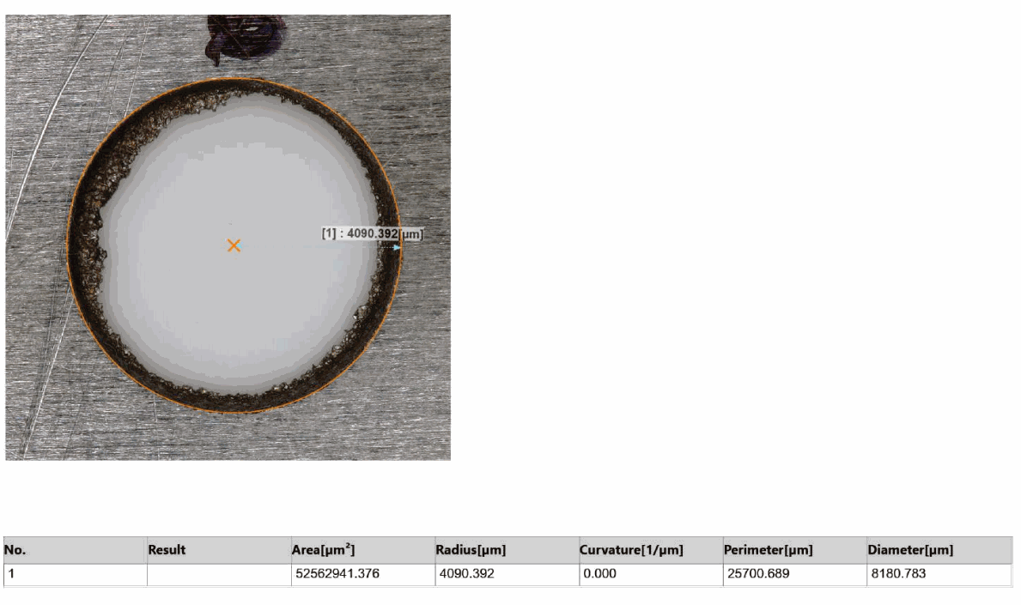
Figure 4.15: Top-view 3D profilometer result — Run 6 (entry diameter Dm = 9.002 mm, ROC = 0.200 mm)
Radial Overcut Analysis: Run 6 is the worst-performing trial in the entire set, recording the highest ROC of 0.200 mm. The combination of the maximum peak current (Ip = 6 A) with the shortest Ton (50 µs) and the longest Toff (40 µs) creates a pattern of high-energy but short discharges firing into a fully recovered gap. Each such discharge initiates a large-diameter plasma channel, and with complete gap recovery between pulses, successive sparks fire at slightly displaced lateral positions, progressively enlarging the hole perimeter with each cycle.

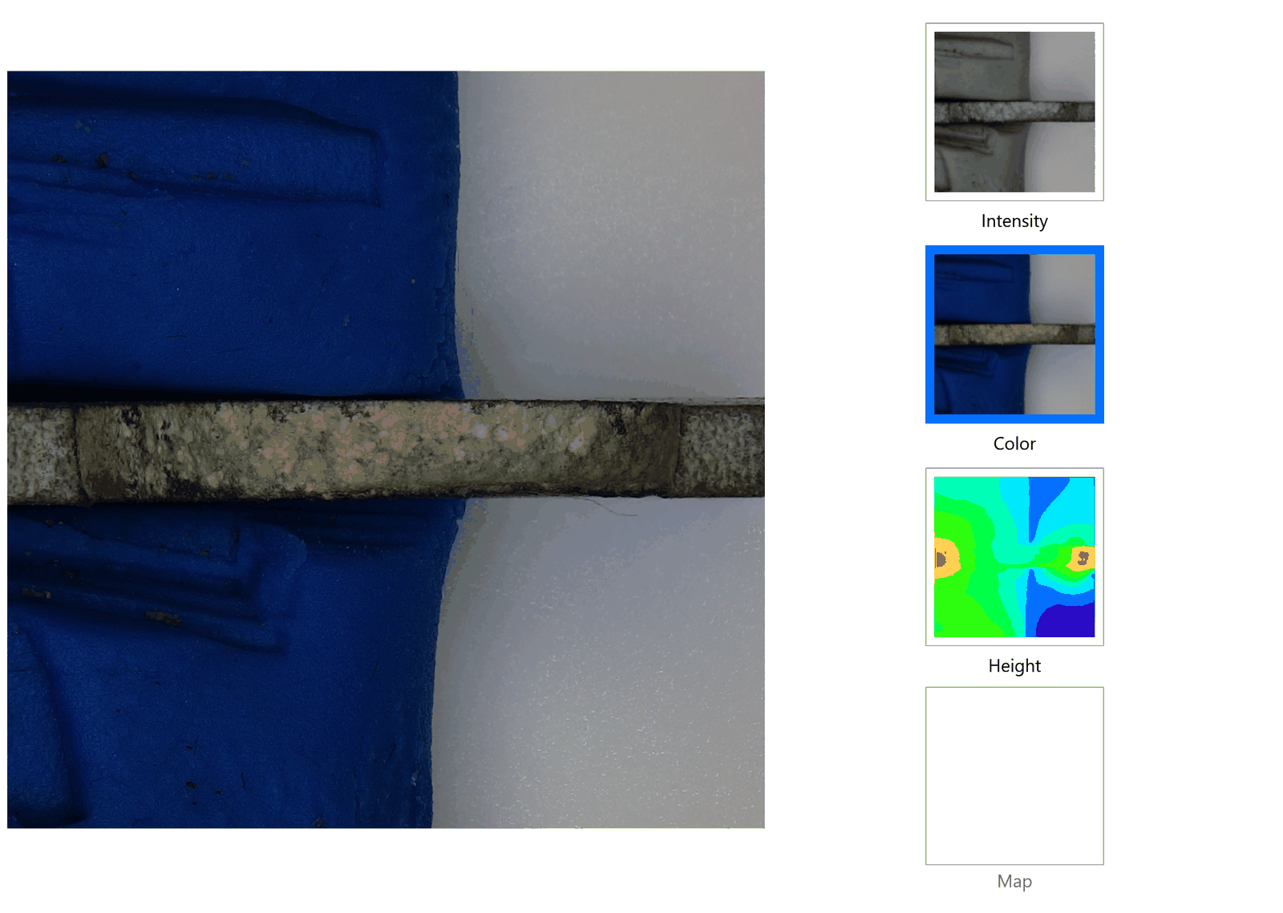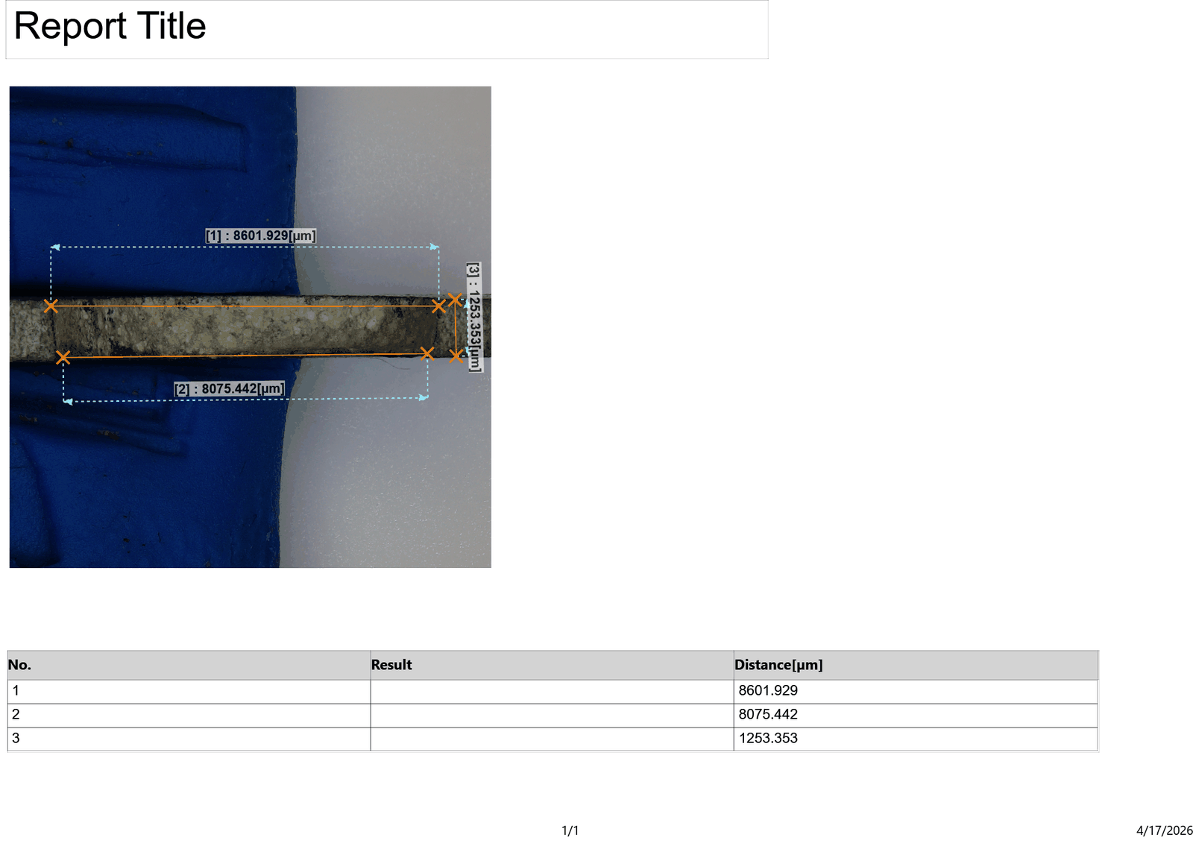
Figure 4.24: Cross-sectional profilometer result — Run 6 (Wt = 8.602 mm, Wb = 8.075 mm, θ = 6.285°)
Taper Angle Analysis: Run 6 records the maximum taper angle in the experiment at 6.285°. This coincides with the maximum ROC, confirming that the high Ip = 6 A condition is equally detrimental to both dimensional and geometric accuracy. The entry diameter of 8.602 mm is significantly enlarged relative to the exit diameter of 8.075 mm; the Wt−Wb difference of 527 µm, combined with the 2 mm depth, yields the steepest taper observed. The concentrated thermal loading at the entry from the high Ip is the primary mechanism.
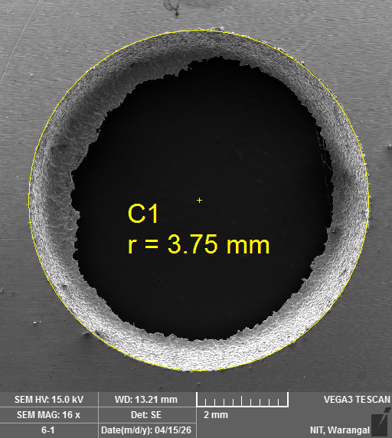
Figure 4.38 & 4.39: SEM images of drilled hole surface — Run 6 (TESCAN VEGA3, 15 kV, WD = 13.21 mm, 16–17×)
SEM Morphology: Run 6 displays the most extensive peripheral affected zone in the entire set, consistent with its status as the worst condition for both ROC and taper. The hole boundary is noticeably irregular with multiple protrusions and recesses that deviate from circularity. Coarse re-solidified globules and debris clusters are visible within approximately 0.5 mm of the hole edge. This morphology is characteristic of aggressive lateral discharge at high peak current.

4.6.7 Run 7 — Ip = 4 A, Ton = 70 µs, Toff = 40 µs
The measured values for this run are: entry diameter Wt = 8.075 mm, exit diameter Wb = 7.164 mm, hole diameter Dm = 8.149 mm, ROC = 0.037 mm, taper angle θ = 3.691°.
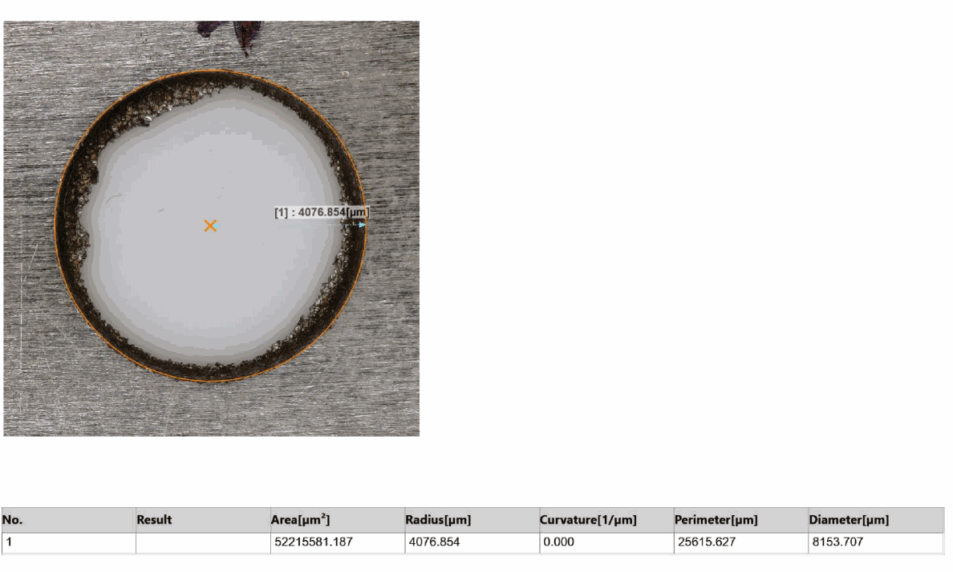

Figure 4.16: Top-view 3D profilometer result — Run 7 (entry diameter Dm = 8.149 mm, ROC = 0.037 mm)
Radial Overcut Analysis: Run 7 achieves the best ROC in the experiment at 0.037 mm. The lowest peak current of 4 A, combined with the longest pulse duration of 70 µs and a Toff of 40 µs, produces the most dimensionally controlled hole in the set. The low energy per discharge restricts plasma channel diameter, the long pulse duration stabilises the arc spatially, and the 40 µs off-time ensures complete gap recovery all three factors cooperating to minimise lateral erosion.

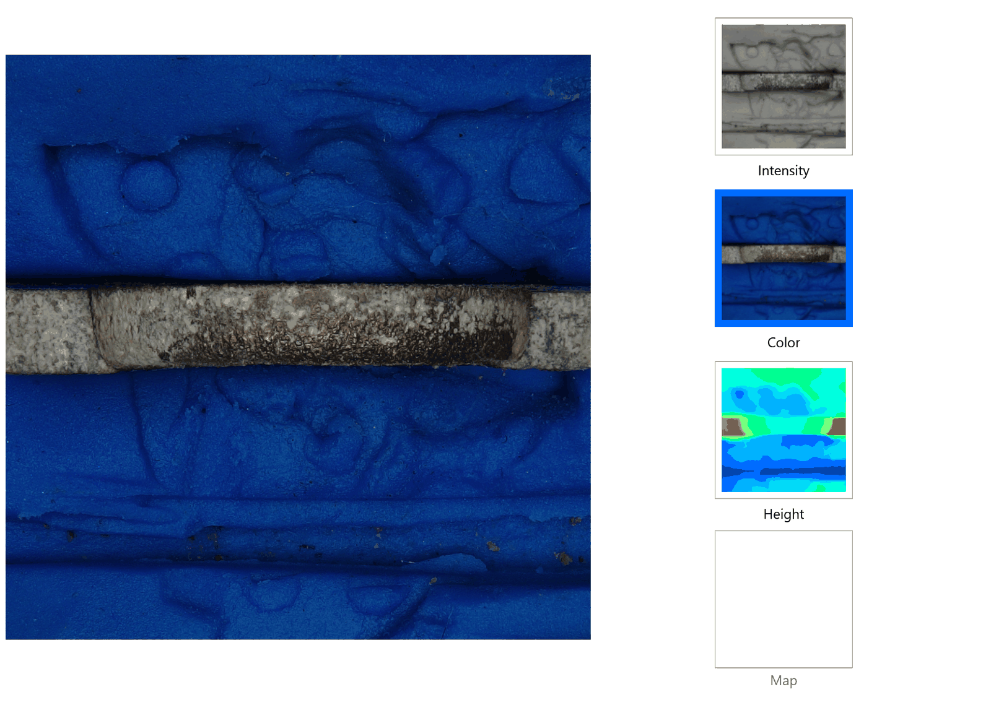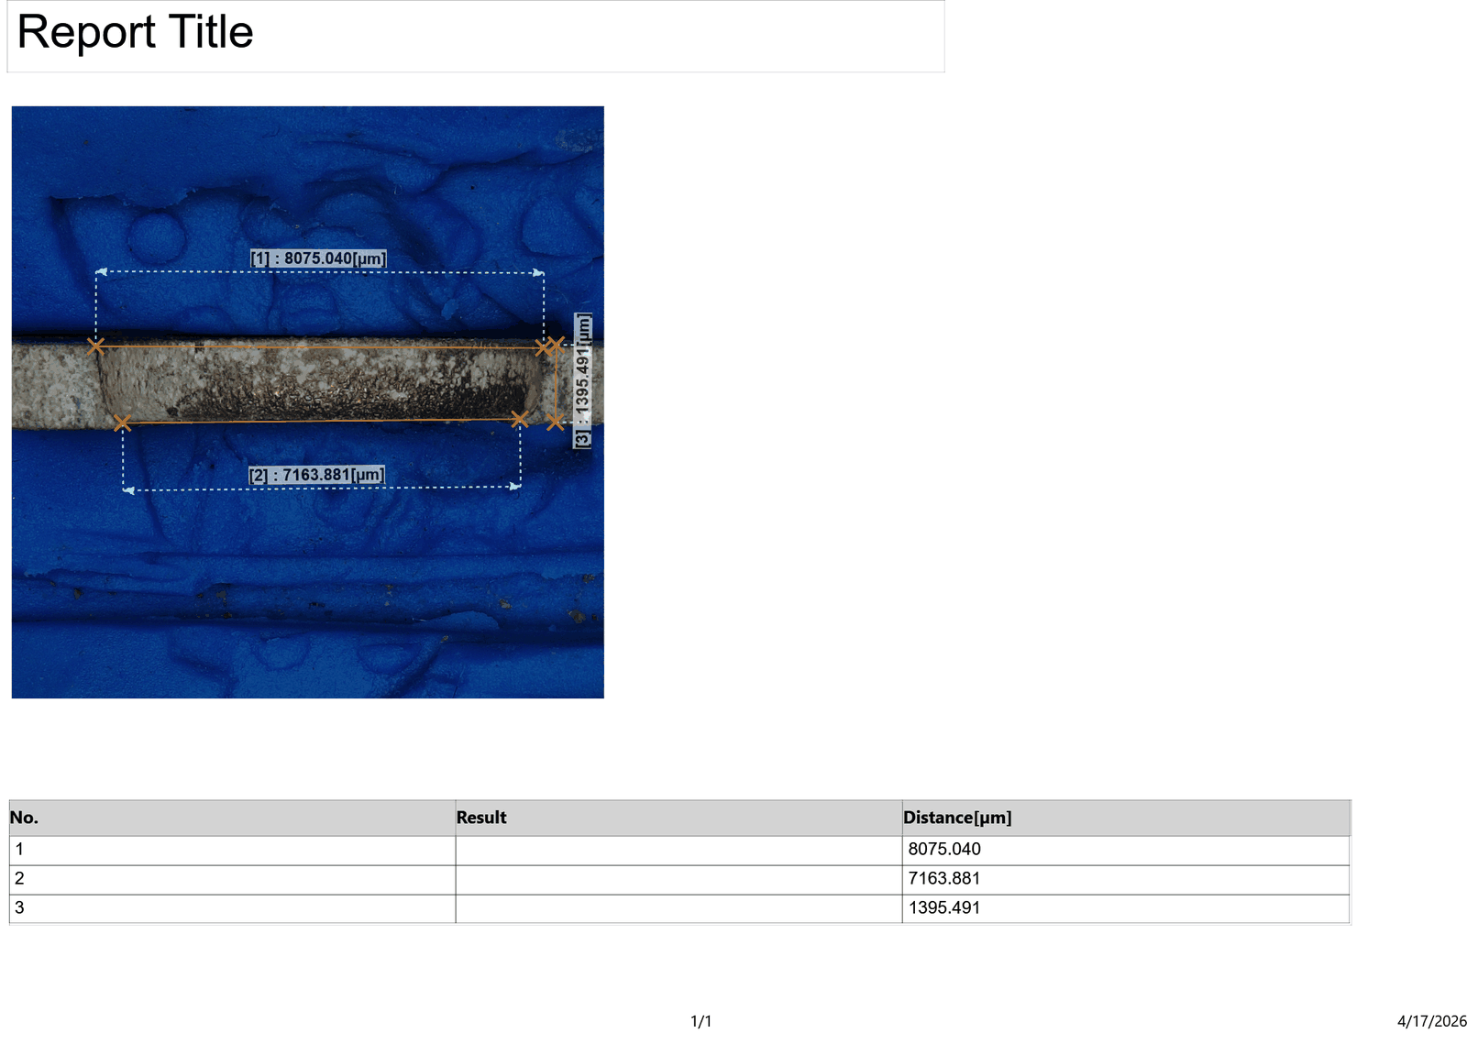
Figure 4.25: Cross-sectional profilometer result — Run 7 (Wt = 8.075 mm, Wb = 7.164 mm, θ = 3.691°)
Taper Angle Analysis: Despite achieving the best ROC in the set, Run 7 returns a moderate taper angle of 3.691°. The large Wt−Wb difference of 911 µm is notable given the very low energy conditions. This suggests that even at Ip = 4 A, debris flushing becomes less effective at the exit end of the 2 mm hole as the tool advances, allowing the exit gap to partially clog and reducing exit-side erosion rate. The taper at low Ip is therefore driven more by flushing limitation than by differential thermal loading.

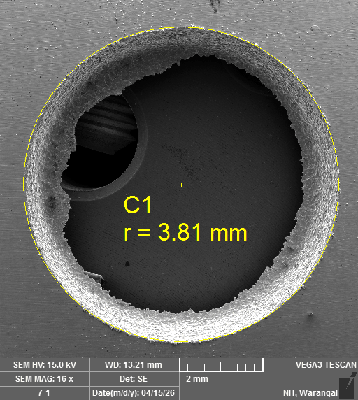
Figure 4.40 & 4.41: SEM images of drilled hole surface — Run 7 (TESCAN VEGA3, 15 kV, WD = 13.21 mm, 16–17×)
SEM Morphology: Run 7, the minimum-ROC condition, shows the tightest and most circular hole boundary in the set. The affected zone around the hole rim is narrow, and individual craters are small and regular in size, both consistent with the low discharge energy at Ip = 4 A. The SEM morphology provides visual confirmation of the profilometric measurement the hole is accurately sized and geometrically regular under these conditions.

4.6.8 Run 8 — Ip = 6 A, Ton = 60 µs, Toff = 30 µs
The measured values for this run are: entry diameter Wt = 8.162 mm, exit diameter Wb = 7.108 mm, hole diameter Dm = 8.374 mm, ROC = 0.106 mm, taper angle θ = 5.191°.

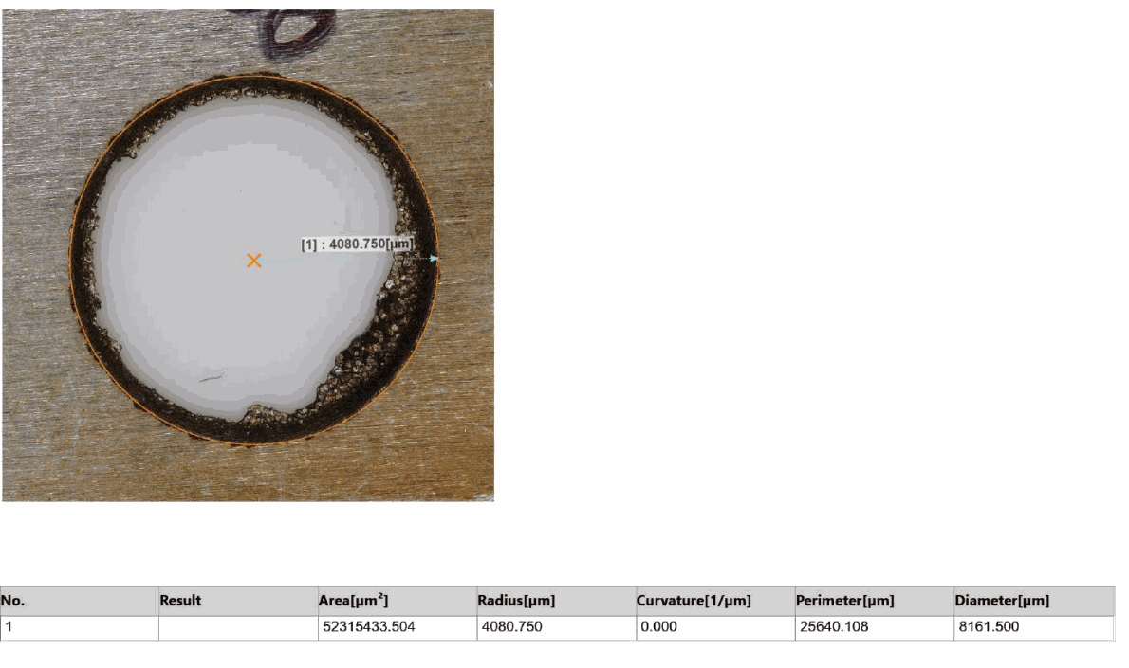
Figure 4.17: Top-view 3D profilometer result — Run 8 (entry diameter Dm = 8.374 mm, ROC = 0.106 mm)
Radial Overcut Analysis: Run 8, with Ip = 6 A, records an ROC of 0.106 mm. This is lower than Run 2 (also Ip = 6 A) despite the same peak current, which can be attributed to the shorter Ton of 60 µs compared to Run 2's 70 µs. A shorter Ton at the same current level gives each discharge less time to expand laterally before it is extinguished, partially mitigating the high-energy penalty of Ip = 6 A.

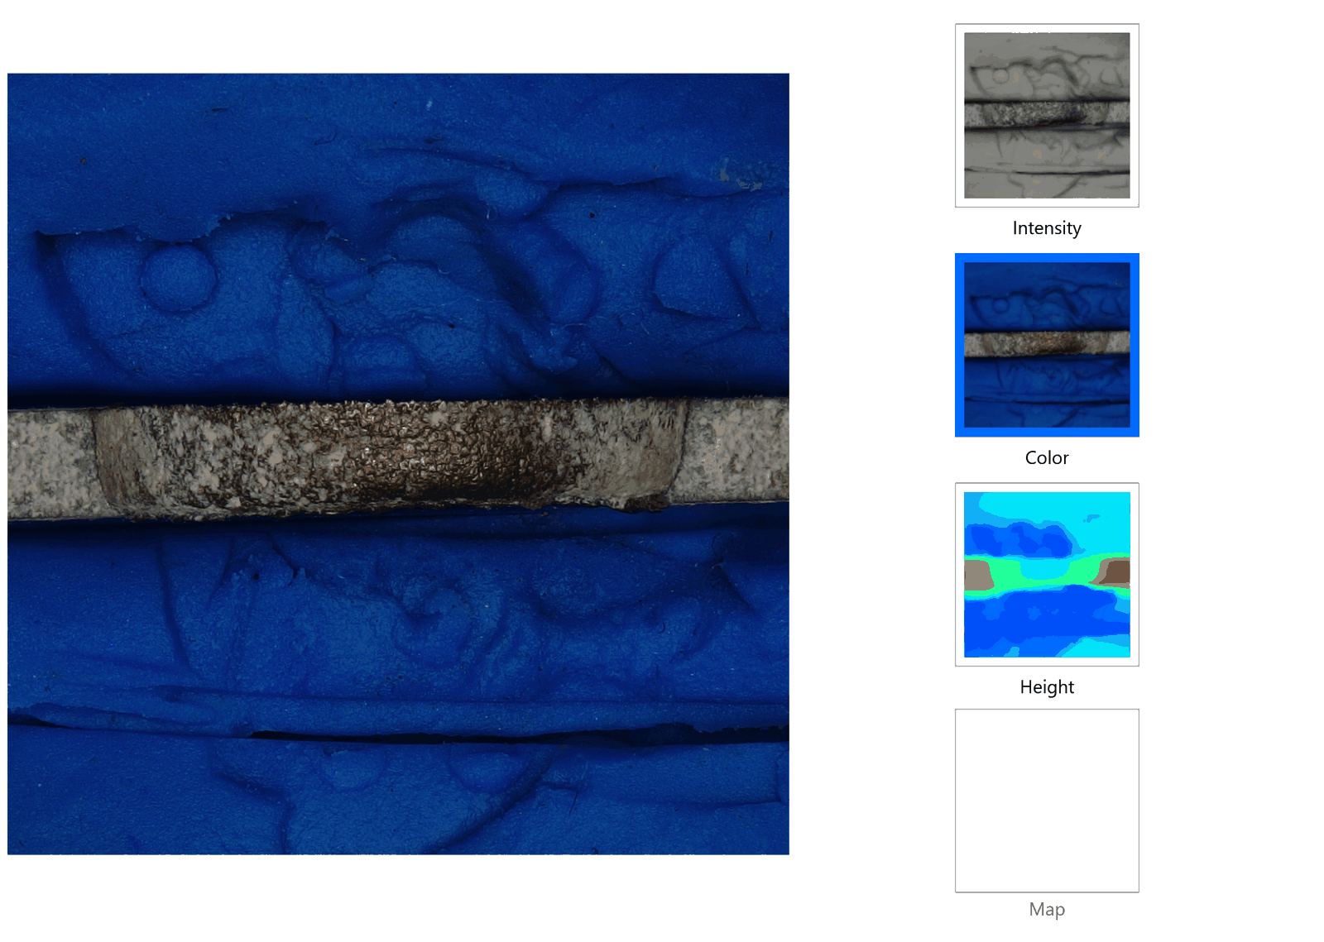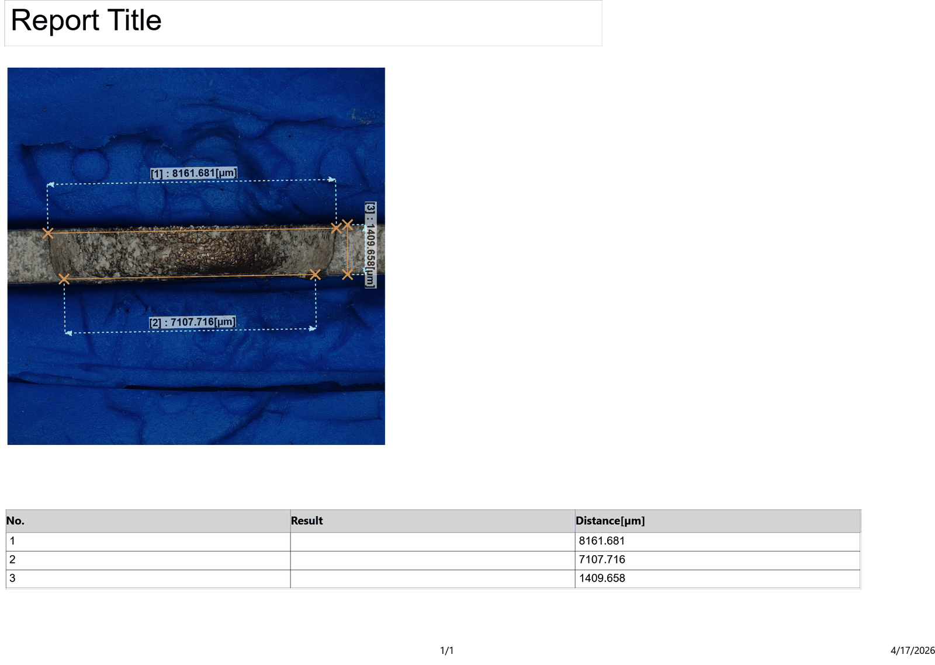
Figure 4.26: Cross-sectional profilometer result — Run 8 (Wt = 8.162 mm, Wb = 7.108 mm, θ = 5.191°)
Taper Angle Analysis: Run 8 records a taper angle of 5.191°, the third highest in the set. With Ip = 6 A, the same mechanism that drives high taper in Runs 2 and 6 is at work: elevated peak current creates intense discharges at the hole entry, eroding it more aggressively than the exit. The Wt−Wb difference of 1054 µm is the largest in the entire set, underscoring the strong entry-side erosion at this current level.

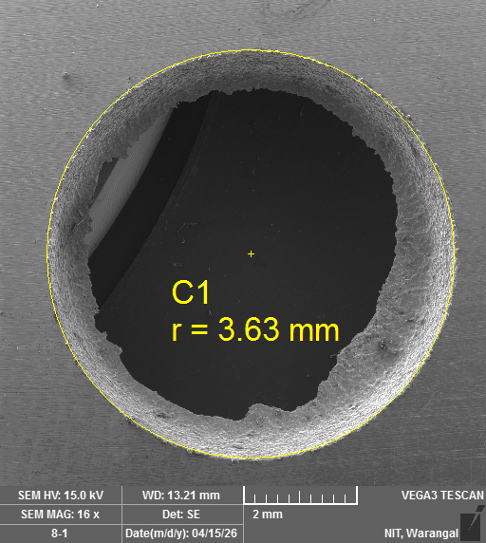
Figure 4.42 & 4.43: SEM images of drilled hole surface — Run 8 (TESCAN VEGA3, 15 kV, WD = 13.21 mm, 16–17×)
SEM Morphology: Run 8 shows the large craters and wide affected zone associated with Ip = 6 A. The re-solidified globules are prominent and scattered across the full width of the peripherally affected band. Of the three Ip = 6 A runs (2, 6, 8), Run 8 shows the most pronounced thermal damage indicators near the exit side based on visual assessment of the secondary electron contrast in the SEM images.

4.6.9 Run 9 — Ip = 4 A, Ton = 60 µs, Toff = 35 µs
The measured values for this run are: entry diameter Wt = 8.602 mm, exit diameter Wb = 8.061 mm, hole diameter Dm = 8.658 mm, ROC = 0.028 mm, taper angle θ = 2.124°.

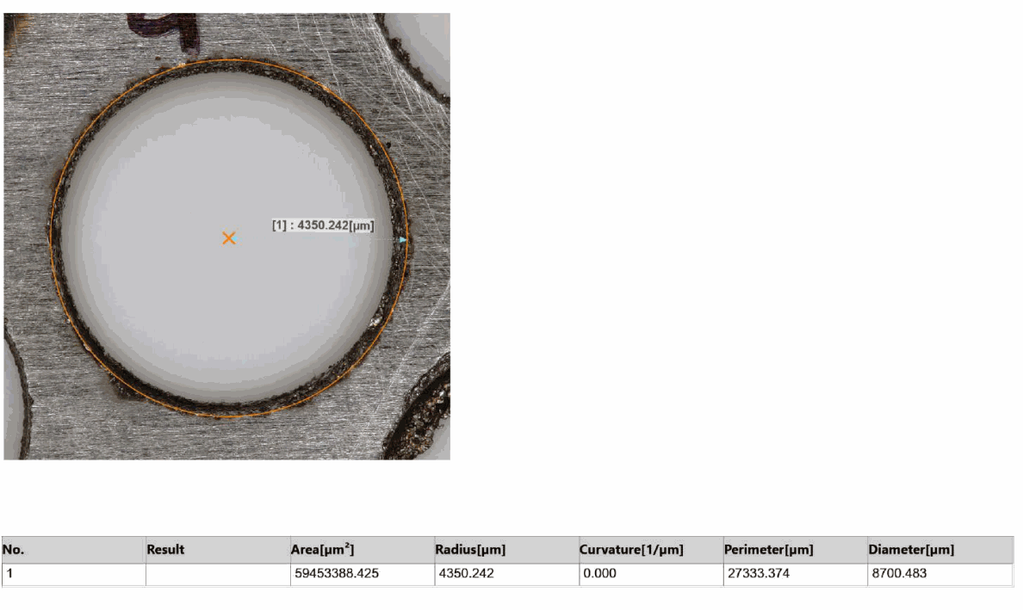
Figure 4.18: Top-view 3D profilometer result — Run 9 (entry diameter Dm = 8.658 mm, ROC = 0.028 mm)
Radial Overcut Analysis: Run 9 records the absolute minimum ROC in the experiment at 0.028 mm. The lowest peak current (Ip = 4 A) is the primary driver of this result, as it limits plasma channel size at the most fundamental level. The intermediate Ton of 60 µs and Toff of 35 µs provide favourable secondary conditions, but the dominant contribution is from the low current level. The hole diameter of 8.658 mm from the top-view scan is only 0.058 mm larger than the tool, demonstrating near-ideal dimensional replication of the 8 mm electrode.

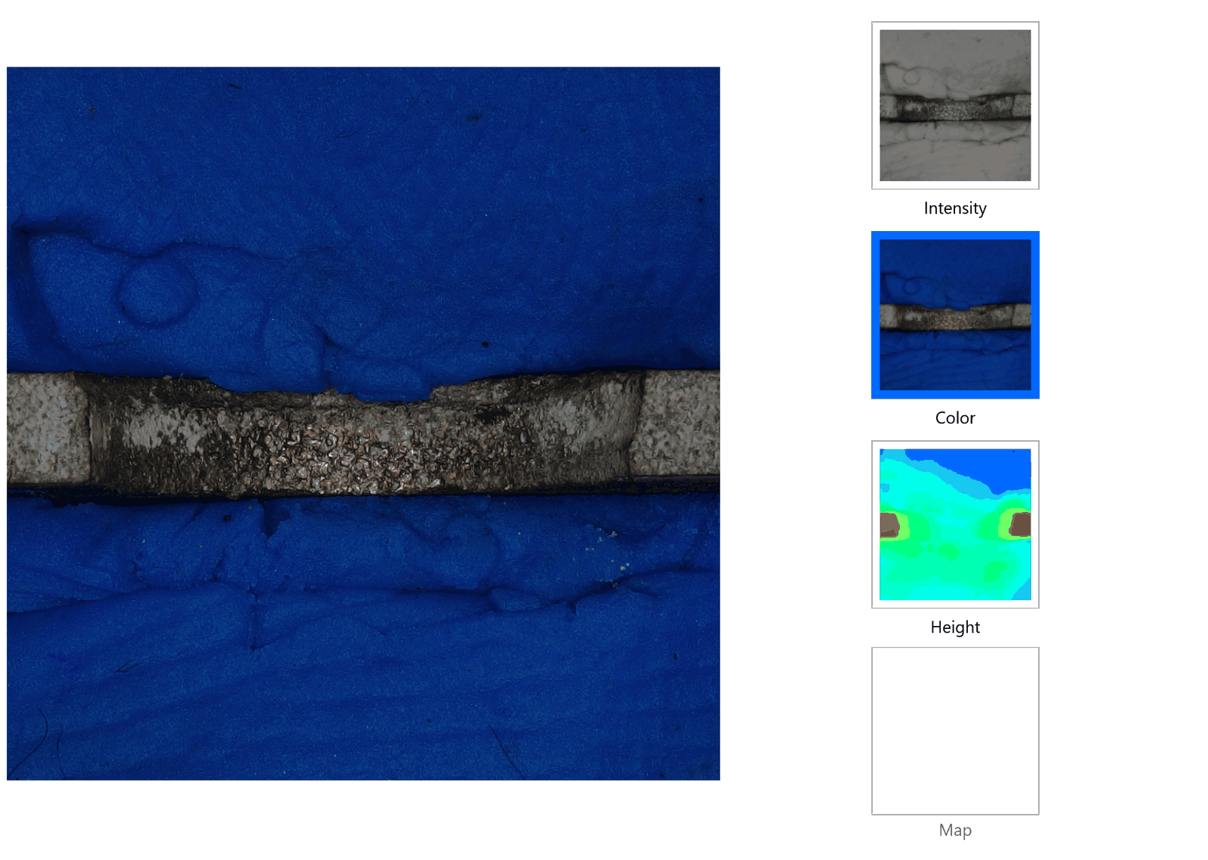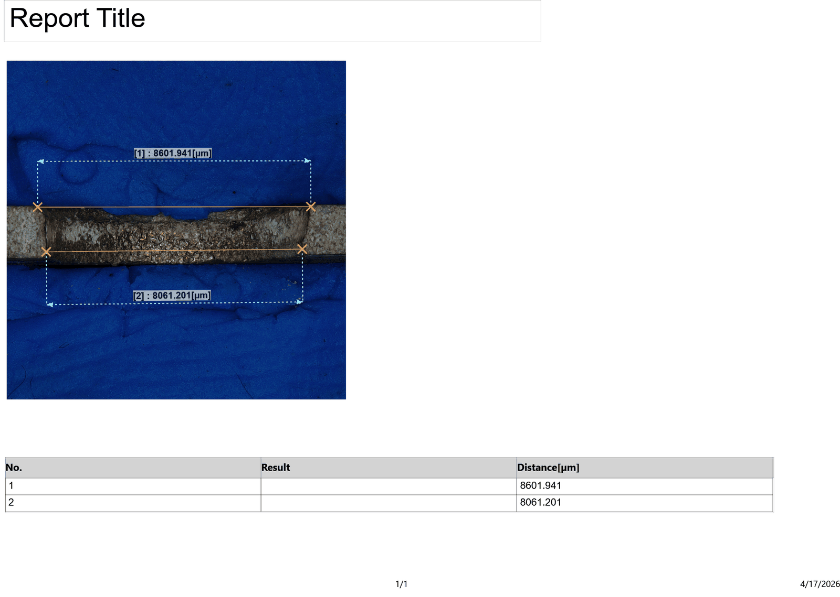
Figure 4.27: Cross-sectional profilometer result — Run 9 (Wt = 8.602 mm, Wb = 8.061 mm, θ = 2.124°)
Taper Angle Analysis: Run 9, which achieves the minimum ROC, also returns the second-lowest taper angle at 2.124°. The low Ip = 4 A limits thermal loading at both entry and exit, and the Wt−Wb difference of 541 µm is moderate. This combination of low ROC and low taper makes Run 9 the best overall condition for dimensional and geometric accuracy simultaneously among all nine trials.

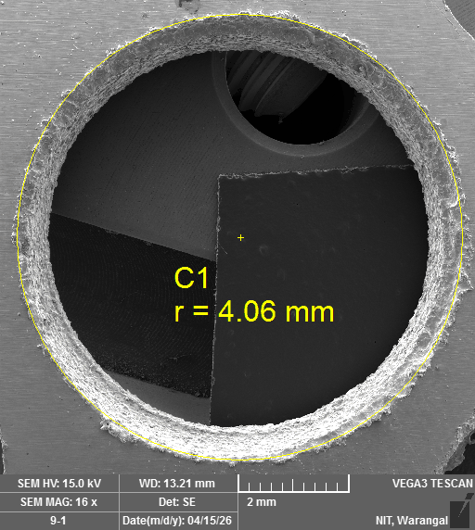
Figure 4.44 & 4.45: SEM images of drilled hole surface — Run 9 (TESCAN VEGA3, 15 kV, WD = 13.21 mm, 16–17×)
SEM Morphology: Run 9 presents a well-formed hole with a tight, circular boundary similar in quality to Run 7. The low Ip = 4 A condition produces fine craters and minimal globule formation, and the peripheral zone is narrow. The combined profilometric and SEM evidence for Run 9 consistently indicates the best-controlled machining outcome in the experimental set, with minimum overcut, low taper, and clean hole morphology.

4.9 SEM Morphology — Common Features Across All Runs
Despite the variation in parameter settings across the nine runs, the SEM images share a set of morphological features that are characteristic of EDM processing of Nitinol under near-dry conditions. These common features are described below before discussing the systematic variation with process parameters.

Overlapping discharge craters are present on all hole surfaces. Each crater represents a single spark event rapid localised melting followed by expulsion and partial re-solidification of material. The craters in NDEDM are typically shallower and smaller in diameter than those in conventional flooded EDM at equivalent energy levels, because the compressed-air stream in the mist cools the molten pool more quickly, reducing the extent of melt before solidification. The overlapping pattern confirms the stochastic distribution of spark positions around the hole perimeter during the multi-pulse drilling process.

Re-solidified Nitinol globules are visible at the periphery of all nine holes. These spherical or near-spherical particles form when molten Nitinol ejected from a crater does not have sufficient velocity to travel far from the discharge site and instead re-deposits on the surrounding surface before being evacuated by the dielectric mist. The size and number density of these globules increase with Ip, consistent with larger melt volumes at higher discharge energies. In flooded EDM, a greater fraction of these particles would be washed away by the bulk dielectric flow; in NDEDM, the limited dielectric volume means more particles remain near the hole edge, which is a consistent finding across all runs in this study.

The peripheral heat-affected zone the band of material surrounding the hole boundary that has been thermally modified without being completely eroded is visible in all SEM images as a region of altered surface contrast. This zone is narrowest in the low-Ip runs (1, 7, 9) and widest in the high-Ip runs (2, 6, 8), confirming the expected relationship between discharge energy and HAZ extent. In no run was large-scale cracking, delamination, or spalling observed on the Nitinol surface, indicating that the selected parameter range does not cause catastrophic thermal damage to the 2 mm plate, and that NDEDM is a structurally safe process for this workpiece-electrode combination.

Chapter 5

CONCLUSION

5.1 Summary of the Study
The present work set out to characterise the dimensional and geometric accuracy of holes drilled by near-dry electrical discharge machining in 2 mm thick Nitinol (Ni55.7–Ti44.2 wt%) shape memory alloy plates. A solid copper electrode of 8 mm diameter was used throughout, and the dielectric medium was an Air + EDM oil mist produced by an MQL system. Nine drilling trials were conducted following a Taguchi L9 orthogonal array with peak current (Ip: 4, 5, 6 A), pulse-on time (Ton: 50, 60, 70 µs), and pulse-off time (Toff: 30, 35, 40 µs) as the three control parameters. Two primary performance metrics were evaluated for each trial: radial overcut (ROC), measured from top-view 3D surface profilometry, and taper angle (θ), calculated from cross-sectional profilometry using θ = tan⁻¹[(Wt − Wb) / 2t]. SEM imaging provided supplementary morphological evidence for all nine drilled specimens.

5.2 Conclusions Drawn from the Experimental Investigation
The following conclusions are drawn from the complete experimental dataset, graphical analysis, and parametric study:

- Near-dry EDM with Air + EDM oil mist successfully drilled through 2 mm Nitinol plates in all nine experimental runs without any workpiece fracture, stent-edge delamination, or catastrophic surface damage. This confirms that NDEDM is a viable and process-stable route for precision drilling of thin Nitinol sheets over the tested parameter range.

- Radial overcut varied from a minimum of 0.028 mm (Run 9: Ip = 4 A, Ton = 60 µs, Toff = 35 µs) to a maximum of 0.200 mm (Run 6: Ip = 6 A, Ton = 50 µs, Toff = 40 µs), with a dataset mean of 0.092 mm. The ratio between the best and worst ROC values exceeds seven, indicating a strong sensitivity of dimensional accuracy to parameter selection.

- Taper angle ranged from a minimum of 1.985° (Run 1: Ip = 4 A, Ton = 50 µs, Toff = 30 µs) to a maximum of 6.285° (Run 6: Ip = 6 A, Ton = 50 µs, Toff = 40 µs), with a mean of 3.852°. Positive taper (entry diameter exceeding exit diameter) was observed in every run without exception.

- Peak current (Ip) was unambiguously the most dominant parameter for both responses. Elevating Ip from 4 A to 6 A raised the average ROC by 219% (from 0.0485 mm to 0.1527 mm) and the average taper angle by 124% (from 2.600° to 5.824°). The physical mechanism is the increase in plasma channel diameter and thermal gradient along the hole depth at higher discharge energies. For applications where dimensional and geometric accuracy are primary requirements, Ip = 4 A is the unambiguous preferred setting.

- Pulse-on time (Ton) showed a secondary and non-monotonic influence on ROC, with the minimum mean ROC occurring at Ton = 60 µs. For taper angle, Ton = 60 µs also yielded the minimum mean taper, suggesting a slight optimum at the intermediate pulse duration level. The non-linearity is partly attributable to the confounding structure of the L9 array.

- Pulse-off time (Toff) showed the clearest secondary trend for taper angle: longer Toff consistently produced higher average taper angles (3.208° at 30 µs, 3.957° at 35 µs, 4.390° at 40 µs). This trend is attributed to debris settling within the drilled hole during the extended off-period, which reduces discharge frequency near the exit end and increases the entry-exit diameter asymmetry. For minimising taper angle, the shorter Toff = 30 µs is preferred.

- Run 6 (Ip = 6 A, Ton = 50 µs, Toff = 40 µs) produced simultaneously the worst ROC and the worst taper angle in the entire set, identifying it as the single parameter combination to be avoided when geometric accuracy is required. The combination of maximum peak current with shortest pulse duration and longest off-time creates high-energy, short-duration sparks in a fully recovered gap a condition that maximises lateral plasma expansion and entry-side thermal loading.

- A moderate positive correlation (R² ≈ 0.56) was found between ROC and taper angle across all nine runs, consistent with both responses being governed primarily by discharge energy but with some degree of independent modulation by Ton and Toff. This partial decoupling means that the two responses cannot be simultaneously minimised by a single parameter combination, and the relative priority must be specified based on the application.

- SEM examination of all nine drilled hole surfaces confirmed the characteristic EDM morphology: overlapping discharge craters, re-solidified Nitinol globules at the periphery, and a heat-affected zone whose width increases with Ip. No large-scale cracking or delamination was observed at any experimental condition, confirming structural safety of the NDEDM process for 2 mm Nitinol plates.

- On the basis of the complete experimental and analytical evidence, the recommended NDEDM conditions for precision drilling of Nitinol with Air + EDM oil are: Ip = 4 A, Ton = 60 µs, Toff = 35 µs for applications where minimum radial overcut is the primary criterion (ROC = 0.028 mm), or Ip = 4 A, Ton = 50 µs, Toff = 30 µs for applications where minimum taper angle is the primary criterion (θ = 1.985°).

REFERENCES
[1] Ho K H, Newman S T. State of the art electrical discharge machining (EDM). International Journal of Machine Tools and Manufacture. 2003;43(13):1287–1300.
[2] Rajurkar K P, Sundaram M M, Malshe A P. Review of electrochemical and electrodischarge machining. Procedia CIRP. 2013;6:13–26.
[3] Otsuka K, Wayman C M (editors). Shape Memory Materials. Cambridge University Press; 1998.
[4] Weinert K, Petzoldt V. Machining of NiTi based shape memory alloys. Materials Science and Engineering A. 2004;378(1–2):180–184.
[5] Lin Y C, Yan B H, Chang Y S. Machining characteristics of Ti alloy using a combined EDM and USM process. Journal of Materials Processing Technology. 2000;104(1–2):171–177.
[6] Shabgard M R, Seyedzavvar M, Oliaei S N B. Influence of input parameters on characteristics of the EDM process. Strojniski Vestnik – Journal of Mechanical Engineering. 2011;57(9):689–696.
[7] Singh S, Maheshwari S, Pandey P C. Investigations into EDM of hardened tool steel using different electrode materials. Journal of Materials Processing Technology. 2004;149(1–3):272–277.
[8] Kunieda M, Lauwers B, Rajurkar K P, Schumacher B M. Advancing EDM through fundamental insight into the process. CIRP Annals – Manufacturing Technology. 2005;54(2):64–87.
[9] Tzeng Y F, Lee C Y. Effects of pulse duration on electric discharge machining performance. International Journal of Advanced Manufacturing Technology. 2000;16(7):520–527.
[10] Lee S H, Li X P. Study of the effect of machining parameters on machining characteristics in EDM of tungsten carbide. Journal of Materials Processing Technology. 2001;115(3):344–358.
[11] Liu X, Chu P K, Ding C. Surface modification of titanium, titanium alloys and related materials for biomedical applications. Materials Science and Engineering R. 2004;47(3–4):49–121.
[25] Joshi S N, Pande S S. Development of an intelligent process model for EDM. International Journal of Advanced Manufacturing Technology. 2009;45(3–4):300–317.

