**SQL TASK 3: LIBRARY DATABASE**

1. DATABASE

Create Database

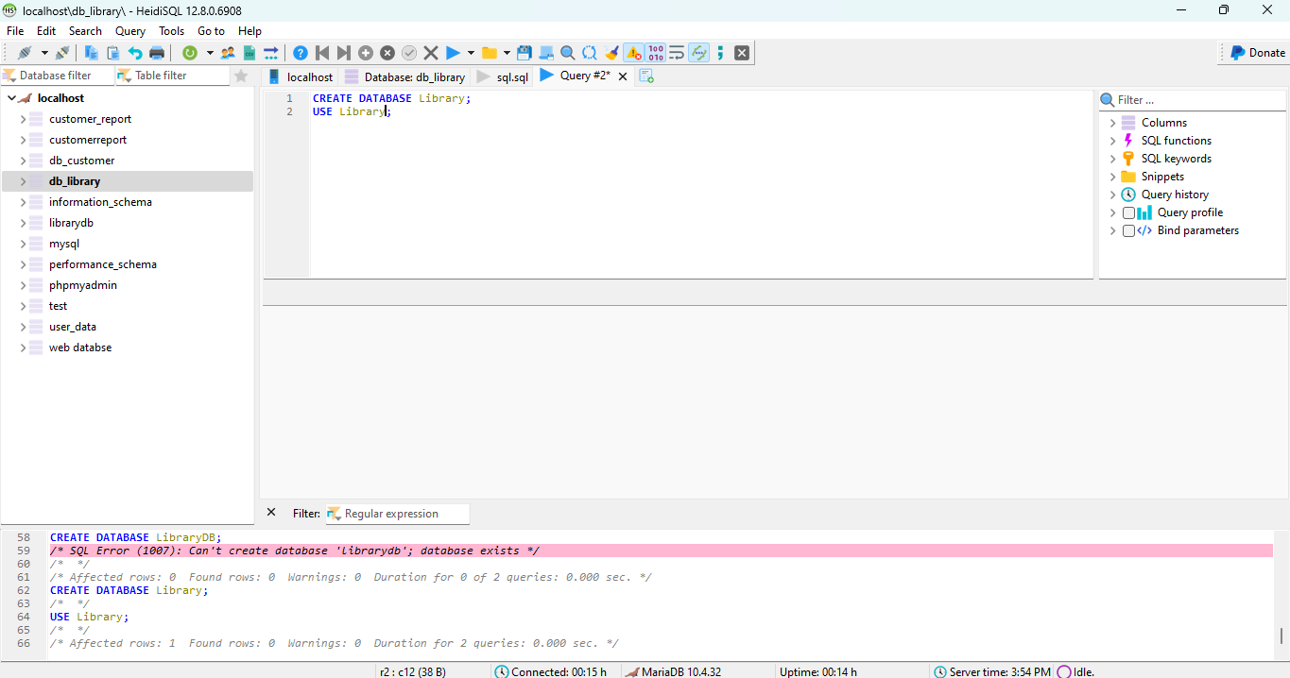

1. TABLE

Create Book Table

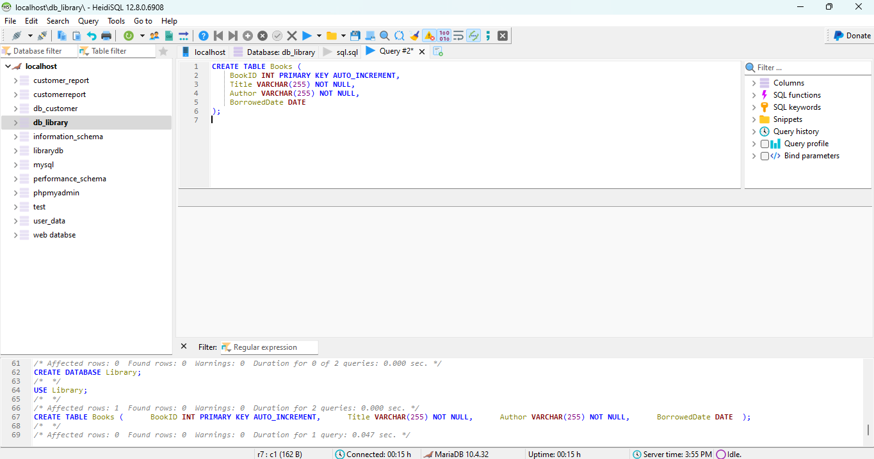

1. DATA ENTRY

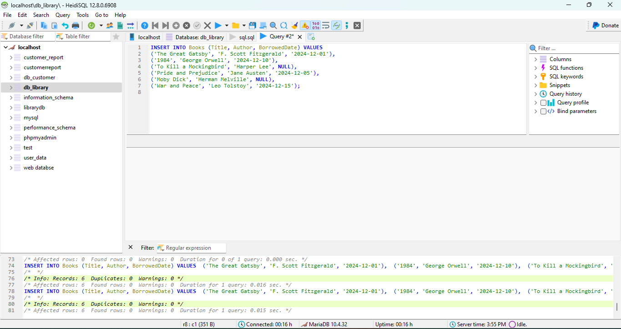

1. BASIC QUERIES

List of all books

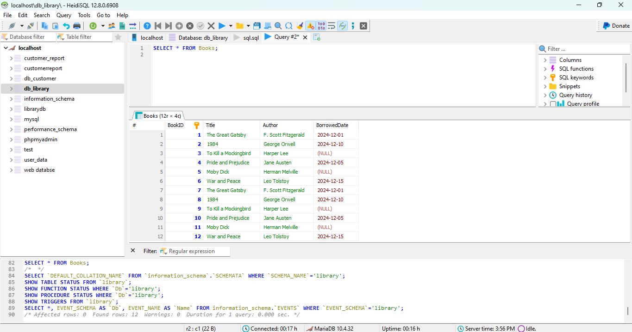

Find books by author

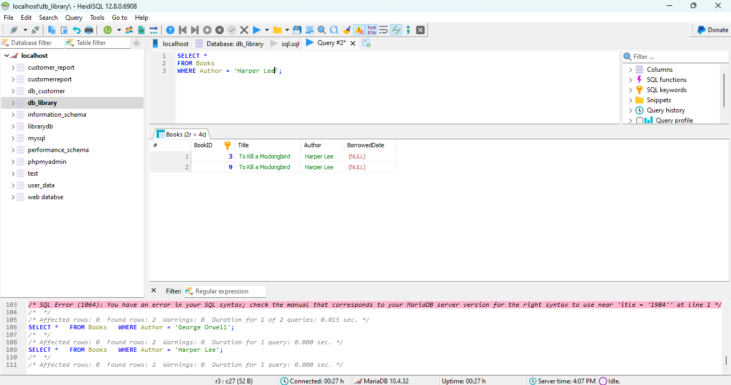

Find books borrowed on a specific date

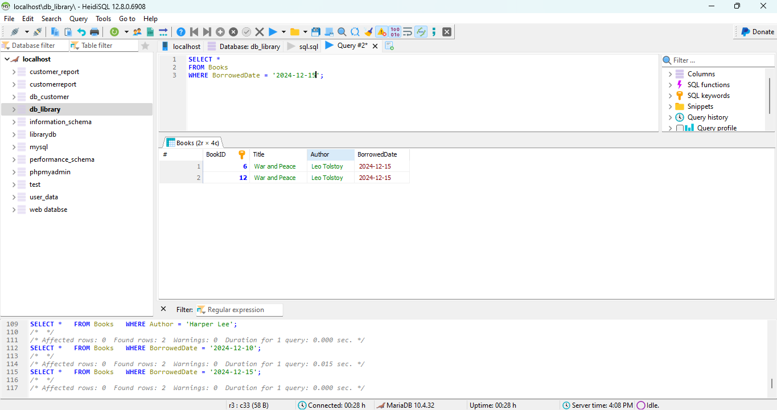

Find books borrowed after a certain date

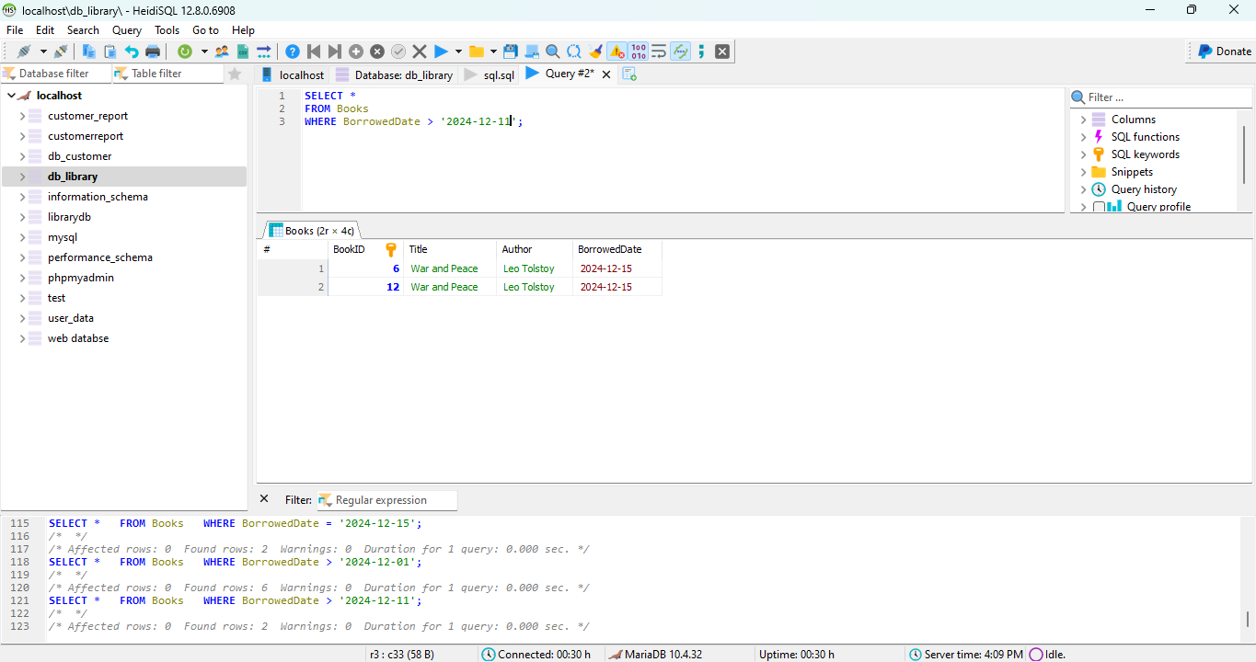

5. DATA MANIPULATION

Update borrowed date

Delete a book

Re-add a deleted book