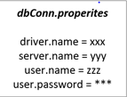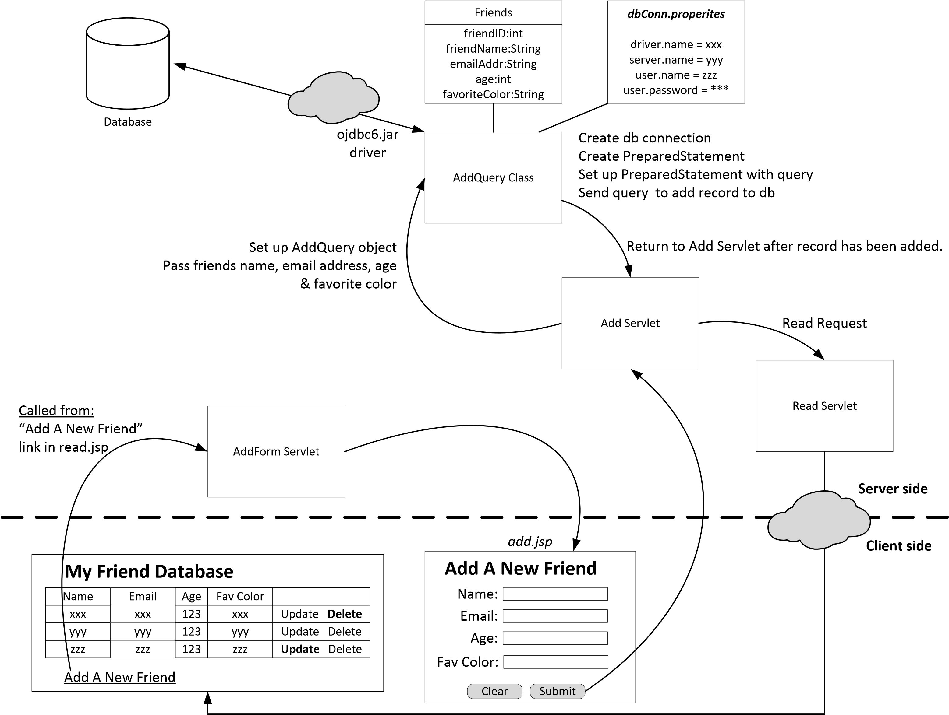

Called From:

Add a new Asset in read.jsp

My Assets Database

1 Real Estate California Condo $400,000 4/1/2018 |Update|Delete

2 Vehicle 2013 Jeep Patriot $12,000 3/20/2018 |Update|Delete

Add a new Asset

Details

DETAILSID: NUMBER(6)

ASSETID: VARCHAR2(20)

NAME: VARCHAR2(20)

LOCATION: VARCHAR2(20)

PROFITABILITY: VARCHAR2(20)

DESCRIPTION: VARCHAR2(20)

Assets

ASSETID: NUMBER(6)

CATEGORY: VARCHAR2(20)

NAME: VARCHAR2(20)

VALUE: VARCHAR2(20)

DATEOFPURCHASE: VARCHAR2(20)

Pass all attributes except Primary Keys

Add a new Asset

Category:

Name:

Value:

DateofPurchase:

Location:

Profitability:

Description: