Assessment of Basic Language and Learning Skills - Revised
VISUAL PERFORMANCE
TASK | SCORE | TASK NAME | TASK OBJECTIVE | QUESTION | EXAMPLES | CRITERIA | NOTES
B 1 | 0 1 2 3 4  0 1 2 3 4  0 1 2 3 4  0 1 2 3 4 | Puzzle with a single-piece type of inset | When given single, uniquely- shaped pieces from an inset puzzle; the student will put the puzzle pieces into the puzzle frame. | Can the student put single, uniquely-shaped puzzle pieces into a frame board? | 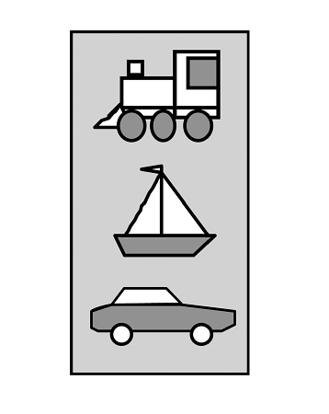 | 4= places 5 pieces presented as group by looking and positioning, 3= 3 pieces presented as group by looking and positioning 2= 5 pieces handed separately using trial and error 1= places up to 3 pieces handed separately using trial and error
B 2 | 0 1 2 3 4  0 1 2 3 4  0 1 2 3 4  0 1 2 3 4 | Form box | When provided a form box or shape sorter and its pieces, the student will be able to put the pieces into the corresponding holes in the form box. | Can the student put pieces in a form box or shape sorter? |  | 4= 6 pieces by looking at piece then visually locating the corresponding hole, 3= 4 pieces by look and locate, 2= 4 pieces using trial and error approach, 1= 2 pieces by trial and error
B 3 | 0 1 2 3 4  0 1 2 3 4  0 1 2 3 4  0 1 2 3 4 | Match identical objects to sample | When given an object the student will match to an identical object in an array of three items. | Can the student match objects to an identical object presented in an array of three items? |  | 4= at least 10 objects to objects in a display of 8 items, 3= at least 5 objects to objects in a display of 4 items, 2= at least two objects to objects in a display of 2 items, 1= can match one object to an identical object in a display of 2 items | Modified
B 4 | 0 1 2  0 1 2  0 1 2  0 1 2 | Match objects to pictures | When given an item, the student will match the object to one of three pictures in an array. | Can the student match objects to corresponding pictures? |  | 2= can match three items in succession, 1= can match a single item per task presentation
B 5 | 0 1 2 3 4  0 1 2 3 4  0 1 2 3 4  0 1 2 3 4 | Match identical pictures to sample | When given a picture, the student will match to an identical picture in an array of three pictures. | Can the student match pictures to an identical picture presented in an array of three pictures? |  | 4= at least 10 pictures to pictures in a display of 8 pictures, 3= at least 5 pictures to pictures in display of 4, 2= at least two pictures to pictures in a display of 2, 1= can match one picture to an identical picture in a display of 2 pictures | Modified

Assessment of Basic Language and Learning Skills - Revised
VISUAL PERFORMANCE (Continued)
TASK | SCORE | TASK NAME | TASK OBJECTIVE | QUESTION | EXAMPLES | CRITERIA | NOTES
B 6 | 0 1 2  0 1 2  0 1 2  0 1 2 | Match pictures to objects | When given a picture of an item, the student will match the picture to one of three objects in an array. | Can the student match pictures of objects to corresponding objects? |  | 2= can match three items in succession, 1= can match a single item per task presentation
B 7 | 0 1 2  0 1 2  0 1 2  0 1 2 | Fluent matching | When given a group of ten pictures of items, the student will match those pictures to an identical picture in an array of ten pictures in quick succession. | Is the student able to match pictures to an identical picture in an array of ten pictures in a one-after-the-other manner? | When given a stack of pictures, student matches each one to another in an array of pictures in rapid succession | 2= can match at least 10 items in 30 seconds, 1= can match 5 separate items in 15 seconds | New
B 8 | 0 1 2 3 4  0 1 2 3 4  0 1 2 3 4  0 1 2 3 4 | Sort non- identical items | When given a variety of non- identical objects or pictures representing three items, and given an array of sample items for each of the three items, the student will sort non identical items into the appropriate groups (e.g., all the dogs, all the trees, all the people). | Can the student sort non- identical items into piles when samples of those items are displayed in an array (e.g., dogs, trees, people)? | Student is given a mixed set of various pictures of dogs and trees and a sample of each is placed on the table. The student sorts pictures by placing dogs on the pile of dogs and the trees on the pile of trees. | 4= given 20 items (5 each of 4 items), can sort 10 or more types of items into an array of 4 samples, 3= given 12 items (3 each of 4 items), can sort at least 6 types of items into array of 4 samples, 2= given 6 items (2 each of 3 items), can sort at least 4 types of items into array of 3 samples, 1=given 4 items (2 each of 2 items), can sort 2 types of items into an array of 2 samples | Modified. Note: This skill does not require the student to receptively know the class of the items. It requires only visual matching of similar, non-identical items.
B 9 | 0 1 2 3 4  0 1 2 3 4  0 1 2 3 4  0 1 2 3 4 | Block designs on picture card | When given a block design card, student will place the blocks in the appropriate location on the design card disregarding extra blocks. | Can the student do block designs on a picture card? |  | 4= can quickly complete designs with 6 or more blocks (some extras), 3= 4 or more blocks (some extras), 2= can do up to 4 blocks (no extras), 1= can do designs using 2 blocks (no extras) | Modified
B 10 | 0 1 2 3 4  0 1 2 3 4  0 1 2 3 4  0 1 2 3 4 | Puzzles with multiple connecting pieces in an inset-type frame | When given uniquely-shaped, connecting puzzle pieces which fit into an irregularly shaped inset frame, the student will complete the puzzle. | Can the student complete puzzles with uniquely-shaped connecting pieces which fit into an irregularly- shaped inset frame? | 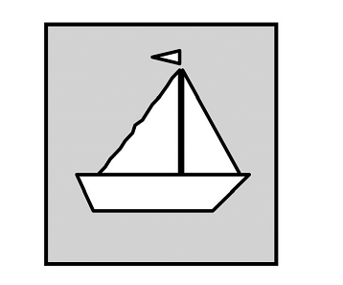 | 4= 4 puzzles with 8 pieces, 3=4 puzzles with 5 pieces, 2=2 puzzles with 5 pieces, 1= 1 puzzle with at least 5 pieces
B 11 | 0 1 2 3 4  0 1 2 3 4  0 1 2 3 4  0 1 2 3 4 | Puzzles with a square-edged border frame | When given a square-edged framed puzzle, the student will complete the puzzle. | Can the student complete puzzles with connecting pieces which fit into a square-edged frame? | 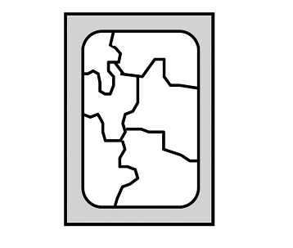 | 4= 3 puzzles with 5 pieces, 3=3 puzzles with 4 pieces, 2=3 puzzles with 3 pieces, 1=3 puzzles with at least 2 pieces | Note: The pieces may either connect to each other (like a jig saw puzzle), or they may slide next to each other without connecting.

Assessment of Basic Language and Learning Skills - Revised
VISUAL PERFORMANCE (Continued)
TASK | SCORE | TASK NAME | TASK OBJECTIVE | QUESTION | EXAMPLES | CRITERIA | NOTES
B 12 | 0 1 2 3 4  0 1 2 3 4  0 1 2 3 4  0 1 2 3 4 | Block designs from picture | When given a block design card, student will place blocks to make the design shown on the card. | Can the student do block designs from looking at a picture of a design? |  | 4= can quickly complete designs with 6 or more pieces (some extra blocks), 3= 4 or more parts (extras), 2= can do up to 4 pieces (no extras), 1= can do designs using 2 blocks (no extra blocks)
B 13 | 0 1 2 3 4  0 1 2 3 4  0 1 2 3 4  0 1 2 3 4 | Sequence pattern to match a visual model | When given a visual sequence pattern consisting of items (e.g., colored blocks), the student will arrange items to match the pattern. | Can the student match a pattern of visual stimuli? |  | 4= can match sequence of 8 pieces comprised of 4 different items when given extra pieces, 3= 8 pieces of 4 items with no extras, 2= 6 pieces of three items with no extras, 1= 6 pieces of two items with no extras
B 14 | 0 1 2 3 4  0 1 2 3 4  0 1 2 3 4  0 1 2 3 4 | Puzzles with multiple pieces which must be juxtaposed | When given irregularly- shaped, non-interlocking puzzle pieces, student will correctly juxtapose the pieces to form a picture. | When there is no frame, can the student juxtapose (i.e., place together) non-interlocking puzzle pieces to make a picture? | 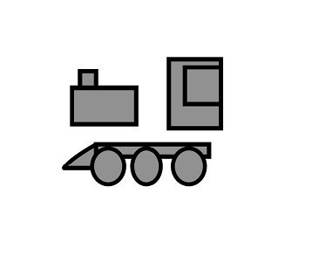 | 4= 4 puzzles with 5 pieces, 3=4 puzzles with 4 pieces, 2=2 puzzles with 3 pieces, 1= 1 puzzle with at least 3 pieces
B 15 | 0 1 2 3 4  0 1 2 3 4  0 1 2 3 4  0 1 2 3 4 | Jigsaw puzzles | When given a standard jigsaw puzzle (interlocking pieces without a frame), the student will correctly complete the puzzle. | Can the student complete standard jigsaw puzzles (i.e., interlocking pieces without a frame)? | 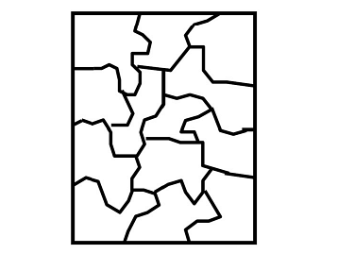 | 4= at least four puzzles with 12 pieces, 3= two puzzles with 12 pieces, 2= two puzzles with 8 pieces, 1= one puzzle with at least 8 pieces
B 16 | 0 1 2 3 4  0 1 2 3 4  0 1 2 3 4  0 1 2 3 4 | Match associated pictures | Given an array of items or pictures, the student will be able to match an item that is associated with one of the items in the array (e.g., match a bat to picture of a ball). | When given a display of objects or pictures and given a different item, can the student match the item from the display that is associated with the item being presented (e.g., match a bat to a ball when shown an array of a ball, a cup, and a shoe)? | bat and a ball; cup and juice; socks and shoes; knife, fork, spoon and plate; shirt, hat and pants | 4= can match at least 2 related pictures for 20 or more items, 3= 2 related pictures for 10 items, 2= 1 related picture for 10 items, 1= can match at least 1 related picture for 5 items | New. See Appendix 1: Association List

Assessment of Basic Language and Learning Skills - Revised
VISUAL PERFORMANCE (Continued)
TASK | SCORE | TASK NAME | TASK OBJECTIVE | QUESTION | EXAMPLES | CRITERIA | NOTES
B 17 | 0 1 2 3 4  0 1 2 3 4  0 1 2 3 4  0 1 2 3 4 | Sort by function | When provided with a sample of two items that have different functions and shown a demonstration of matching another item that has the same function, the student will be able to sort additional pictures that have the same functions with the correct sample items. | When provided with a model of items that are used for a certain function, can the student sort pictures of items into groups of items that have the same function (e.g., scissors with ones you cut with, pen with things you write with)? | When shown a pen and a bottle of bubbles and the placement of a crayon on the pen and a candle on the bubbles, student continues to place other pictures on things you write with and things you blow on the correct piles. | 4= at least 5 items from 4 functions , 3= at least 5 items from 3 functions, 2= at least 5 items from 2 functions, 1= at least 2 items from 2 functions | New
B 18 | 0 1 2 3 4  0 1 2 3 4  0 1 2 3 4  0 1 2 3 4 | Sort by feature | When provided with a sample of two of items that have different features/parts and shown a demonstration of matching another item that has the same feature/part, the student will be able to sort additional pictures that have the same features/parts with the correct sample items. | When provided with a model of items that have a certain feature/part, can the student sort pictures of items into groups of items that have the same feature/part (e.g., dog with the ones that have tails, car with the ones that have wheels, blue items with blue items, striped items with other things that have stripes)? | When shown a monkey and a car and the placement of a dog on the monkey and a bicycle on the car, student continues to place other pictures on things with tails and things with wheels. | 4= at least 5 items from 4 features/parts, 3= at least 5 items from 3 features/parts, 2= at least 5 items from 2 features/parts, 1= at least 2 items from 2 features/parts | New
B 19 | 0 1 2 3 4  0 1 2 3 4  0 1 2 3 4  0 1 2 3 4 | Sort by class | When provided with a sample of three different classes of items and shown a demonstration of matching another member of each class, the student will be able to sort additional pictures that match the class to which the item belongs. | Can the student sort pictures of items into classes to which the item belongs when provided with a model of items from each class (e.g., dog with other animals, shirt with other clothing)? | When shown a cat and a shoe and the placement of a dog on the cat and a shirt on the shoe, student continues to place other pictures of animals and clothing on the correct piles. | 4= at least 5 items from 4 classes, 3= at least 5 items from 3 classes, 2= at least 5 items from 2 classes, 1= at least 2 items from 2 classes | New
B 20 | 0 1 2 3 4  0 1 2 3 4  0 1 2 3 4  0 1 2 3 4 | Delayed replication of a sequence | After having been shown a model of items in a specific sequence and then having the model removed, the student will be able to replicate the sequence. | Can the student replicate a sequence of items after having been shown a model of items in a specific sequence and then having the model removed? | After showing a pattern of three items and then remove the display, the student replicates the pattern. | 4= immediately, with three items after 5 second delay,3= three items with two second delay or two items with 5 second delay, 2= two items in two seconds without prompts, 1= two items with 2 second delay with only verbal or gestural prompts

Assessment of Basic Language and Learning Skills - Revised
VISUAL PERFORMANCE (Continued)
TASK | SCORE | TASK NAME | TASK OBJECTIVE | QUESTION | EXAMPLES | CRITERIA | NOTES
B 21 | 0 1 2 3 4  0 1 2 3 4  0 1 2 3 4  0 1 2 3 4 | Delayed finding a sample | When shown a specific item and it is removed, and five items are then presented (one being the same as the original item), the student will be able to find the initial item. | Can the student find an item which had previously been shown to the student after it has been removed, and then presented in an array of three items (one being the same as the original item)? | After showing the student a picture of a cat, hide the picture, wait a few seconds, present pictures of a dog, cat, and bird and say "Find the same" or "Find it" | 4= after 5 second delay, can find any one of 10 items within 3 seconds, when presented an array of 5 items, 3= after 3 second delay, can find any one of 5 items within 3 seconds, 2= after 3 second delay, can find any one of 5 items within 3 seconds, when presented an array of 3 items, 1= after 2 second delay, can find any one of 3 items within 3 seconds, when presented an array of 2 items | Modified
B 22 | 0 1 2 3 4  0 1 2 3 4  0 1 2 3 4  0 1 2 3 4 | Extend a sequence pattern | When given a model of items in a specific sequence (regular and irregular), the student will be able to continue adding items in the correct sequence (e.g., ABABAB, ABCABC, ABBABB, AABAAB, ABBCABBC). | Can the student continue adding items in the correct sequence when given a model of items in a specific sequence? | When an arrangement of blocks are displayed in a pattern (e.g., a red block, blue block, red block, blue block, etc.) the student continues to add a red block, then a blue block, etc. | 4= continues an irregular pattern with at least 3 different stimuli with irrelevant pieces present, 3= three items in a regular sequence with extra irrelevant pieces present, 2= three items in a regular sequence, 1= two items in an alternating sequence | Modified
B 23 | 0 1 2  0 1 2  0 1 2  0 1 2 | Replicate simple 3-dimensional objects | Given a set of blocks or other items and a model of a simple 3-dimensional object (e.g., a house, car), the student will be able to arrange the blocks or other items to replicate the structure. | When given a simple 3- dimensional model, can the student arrange blocks and other items to make a duplicate structure (e.g., a house, car)? | When shown a model, the student builds a simple house using blocks. | 2= can replicate 2 objects using at least 6 blocks or other items, 1= can replicate 2 objects using at least 3 blocks or other items
B 24 | 0 1 2  0 1 2  0 1 2  0 1 2 | Dependent matching sequence | The student will be able to observe a person placing multiple identical objects on a table and then place a different item on each of those items immediately after each one of the first type of item has been placed. | If a person put a set of identical items on a table, is the student able to place a second item on each of those placed items immediately after each of the first items was placed on the table? | For each napkin placed on a table, the student immediately places a spoon on the napkin; after each instructor- placed white block the student adds a blue block; for every juice container put on a table, the student immediately puts a straw next to each container | 2= can immediately place an item on a corresponding item for a series of at least 6 responses, 1= can immediately place an item on a corresponding item for a series of at least 3 responses | New

Assessment of Basic Language and Learning Skills - Revised
VISUAL PERFORMANCE (Continued)
TASK | SCORE | TASK NAME | TASK OBJECTIVE | QUESTION | EXAMPLES | CRITERIA | NOTES
B 25 | 0 1 2 3 4  0 1 2 3 4  0 1 2 3 4  0 1 2 3 4 | Seriation | When given a model of the start and end of a continuum, student will be able to arrange additional task stimuli in the appropriate order by size, quantity, shade of color, and sequence. | Can the student arrange items in a logical order (i.e., by size, quantity, shade of color, sequence of completion, order -- ABC's, 123's)? | 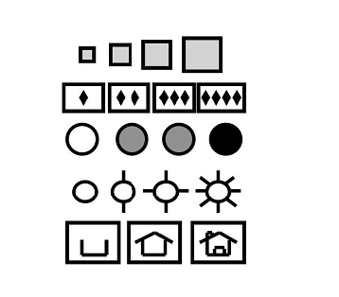 | 4= can arrange at least four sets of items for each of the four specified attributes, 3= two sets of items for three attributes, 2= two sets of items for two attributes, 1= two sets of items for one attribute
B 26 | 0 1 2 3 4  0 1 2 3 4  0 1 2 3 4  0 1 2 3 4 | Picture sequences | The student will be able to arrange a set of picture cards in the appropriate sequence. | Can the student arrange pictures depicting a logical sequence of events? | Places four pictures of washing hand sequence in order: Turn on water, use soap, rinse hands, dry hands with towel | 4= can arrange at least five sets of four items in a sequence, 3= five sets of items with a three-card sequence, 2= three sets of items with a three-card sequence, 1= two sets of items with a three-card sequence
B 27 | 0 1 2  0 1 2  0 1 2  0 1 2 | Mazes | The student will be able to draw a line from the start to the end of simple mazes. | Can the student draw a line from the start to the end of simple mazes? |  | 2= can draw a line from start to end in a maze which has 3 choice points for selecting the correct path, 1= can draw a line in a maze which has only 1 choice point for selecting the correct path

