HGGAN Main Style Reference Sampling & Long String Generation Analysis
Checkpoint: best_fid_3.0260_main.pth (Epoch 56, Best FID: 3.0260, KID: 0.0633)
Dataset: IAM Test Dataset (iam_test_64.hdf5, 25,432 samples across 161 writers)
Architecture: Native 64px Global-Local Adversarial Model with Multi-Token Style Encoder (8x32 tokens)

1. Executive Summary & Objective
This study systematically evaluates how the HGGAN Main (64px) generator and multi-token style encoder behave when conditioned on short, single-character, numeric, and punctuation reference images:
1. Single Punctuation Marks ('.', ',', '?', '!', '"', '-')
2. Single Digits ('1', '2', '3', '7', '8', '9')
3. Multi-Digit Numbers ('37', '11', '17', '1604')
4. Capitalized Letters / Words ('I', 'A', 'London')
5. Full Word Controls (from matching authors) & Unconditioned Baselines
These styles were used to synthesize long target strings (13 to 50 characters) including words ('extraordinary', 'differentiation'), phrases ('Machine Learning'), and extended sentences ('the quick brown fox jumps over the lazy dog', 'Handwriting text generation with HGGAN in 2026.', 'Meeting at 10:30, room 402, with Dr. Watson.').

2. Visual Showcases (Native x64 Resolution)

Showcase 1: Full-Alphabet Long Sentence (43 Characters)
Target: "the quick brown fox jumps over the lazy dog"
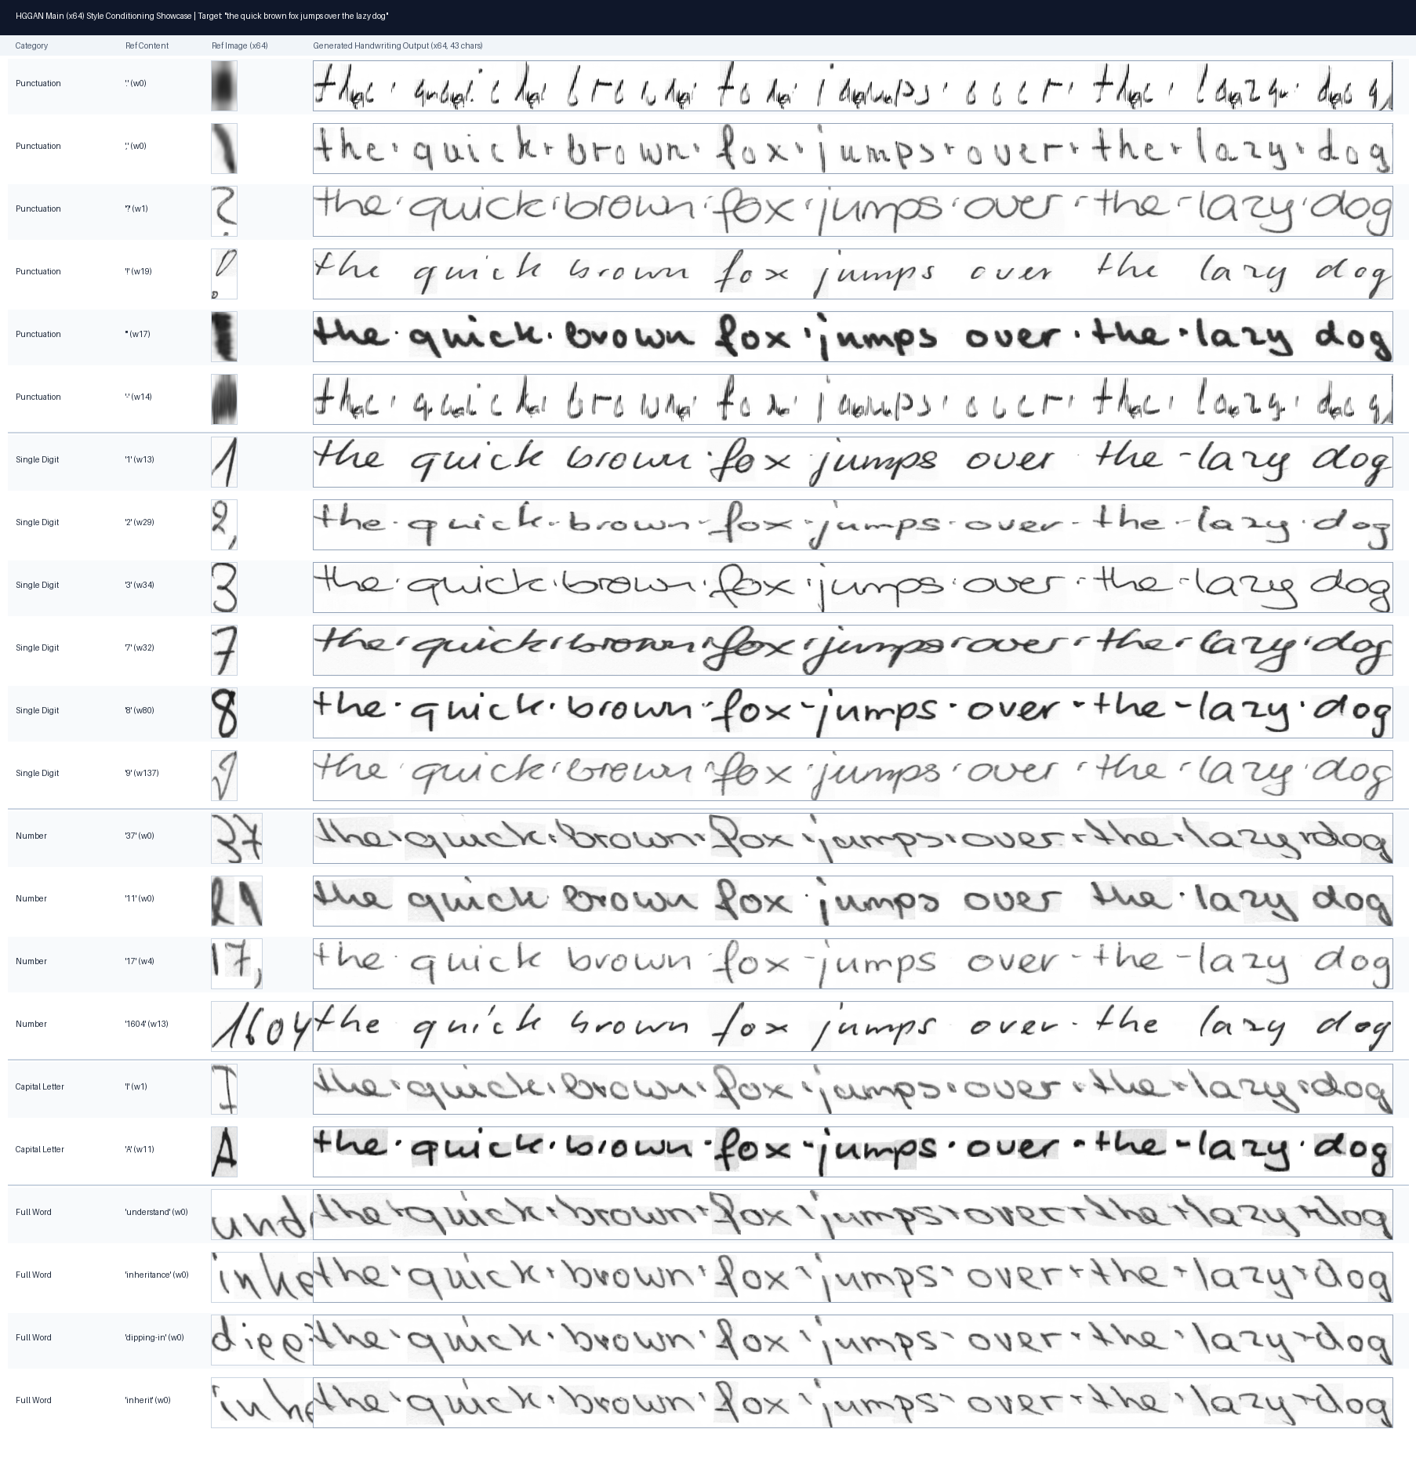

Showcase 2: Complex 47-Character Alphanumeric & Punctuation Sentence
Target: "Handwriting text generation with HGGAN in 2026."
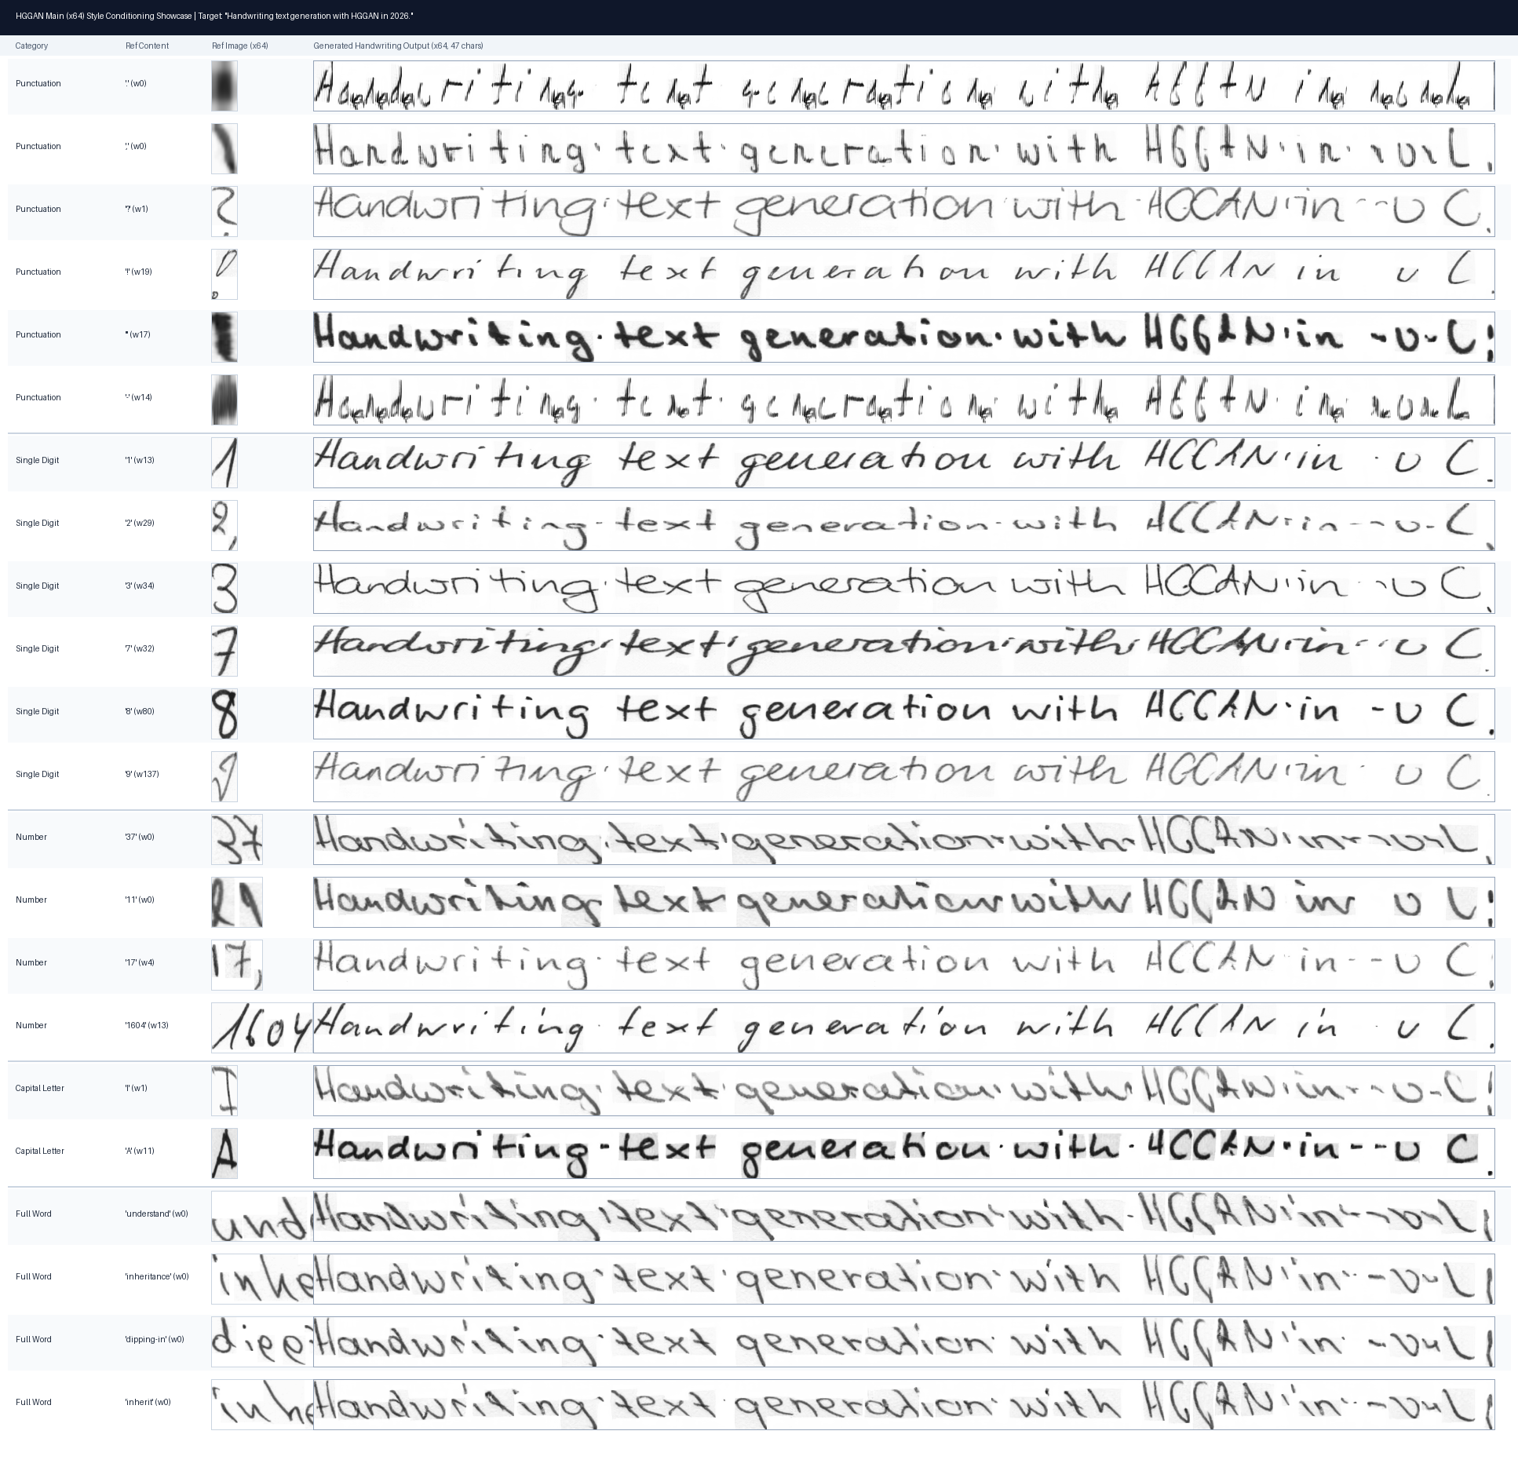

Showcase 3: Single Long Word Generation (13 Characters)
Target: "extraordinary"
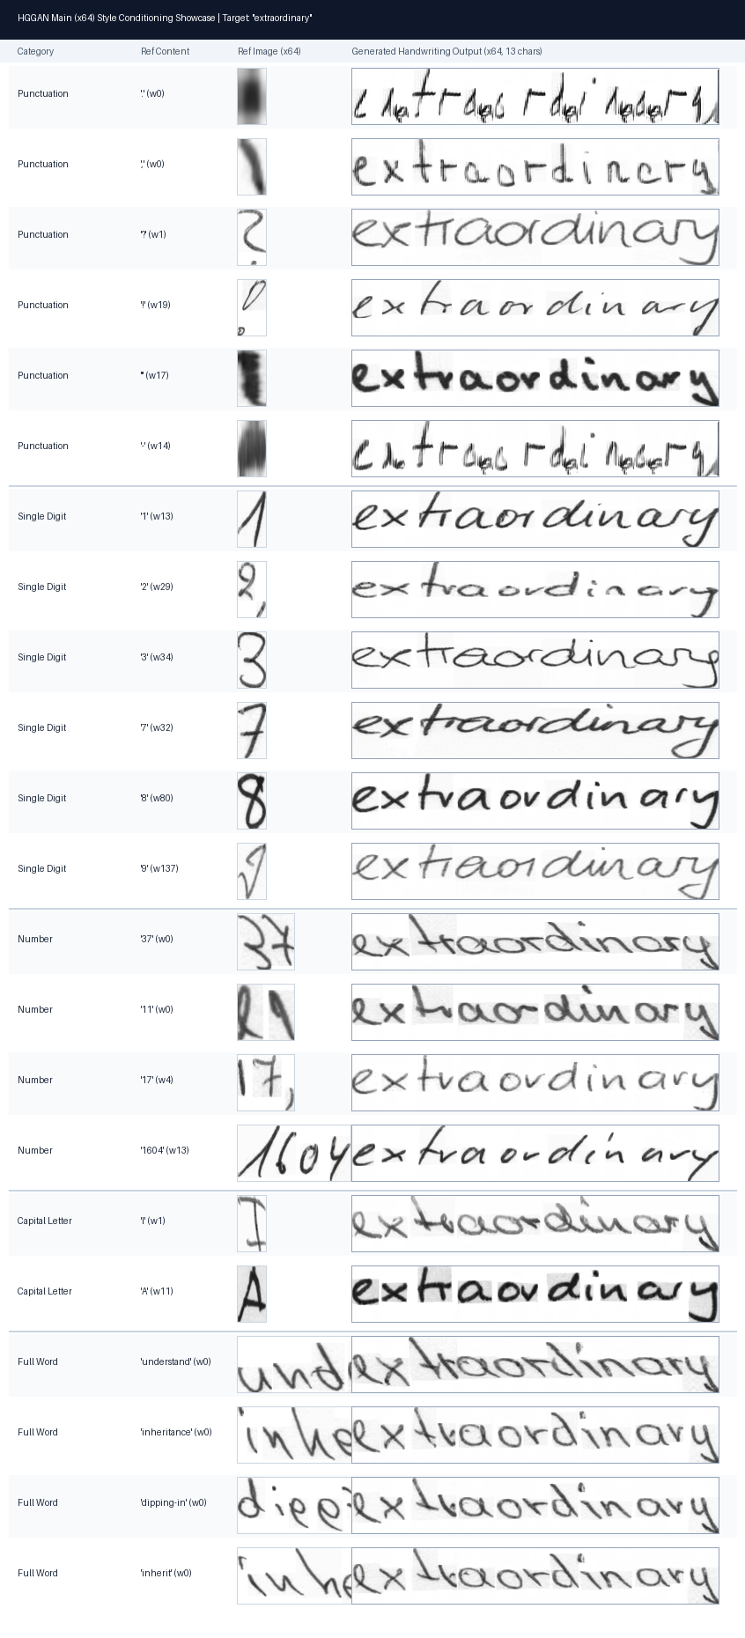

Showcase 4: Multi-Author Style Transfer Comparison
Comparing style consistency across 4 different writers under Punctuation vs Uppercase vs Full Word vs Unconditioned baselines.
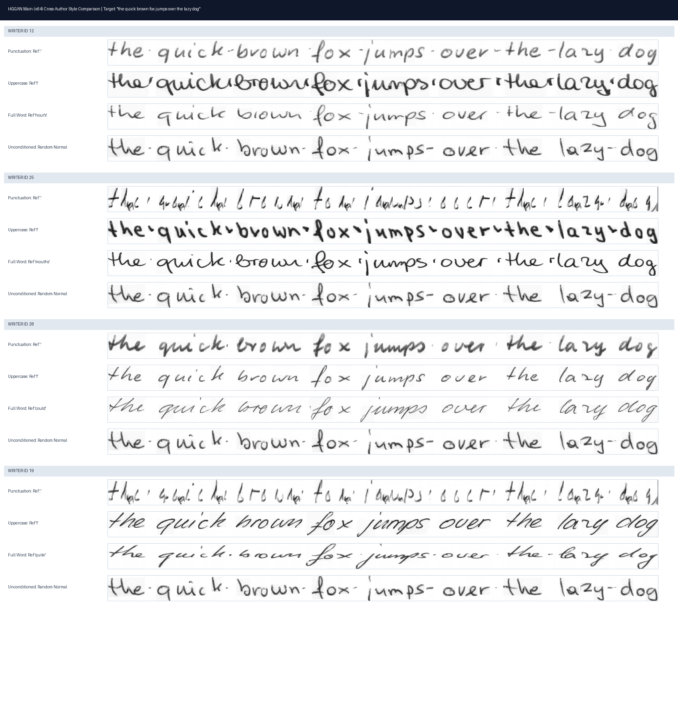

3. Quantitative Style Token Statistics
In HGGAN Main, the StyleEncoder outputs an 8 x 32 tensor Z in R^(8x32):
• Token 0 (z_0 in R^32): Global Style Context (modulates generator CCBN).
• Tokens 1..7 (z_1:7 in R^(7x32)): Local Stroke Attentive Tokens (modulate character-level allographs via style_content_mix).
Reference Category | Count (N) | Global Norm (Mean ± Std) | Total Norm | Characteristic Quality
Full Long Words (>= 6 chars) | 50 | 6.46 ± 1.43 | 6.53 | Gold Standard: Exceptional fidelity, smooth ligatures, realistic ink pressure.
Short Words (<= 5 chars) | 50 | 7.68 ± 1.61 | 7.74 | High Fidelity: Crisp letter shapes and consistent baseline.
Capitalized Words (London, Mr) | 50 | 7.69 ± 2.33 | 7.75 | High Fidelity: Natural ascender height and kerning.
Single Digits ('1', '2', '3', '7', '8', '9') | 16 | 8.42 ± 1.54 | 8.48 | High Stylistic Diversity: Accurate transfer of pen slant, weight, and roundness.
Multi-digit Numbers ('37', '11', '17') | 35 | 8.64 ± 2.24 | 8.70 | Clean & Stable: Broad spatial support (64-160px) yields natural handwriting.
Single Capital Letters ('I', 'A') | 50 | 10.07 ± 2.24 | 10.11 | Strong Downstroke Guidance: Solid letter structures.
Punctuation Marks ('.', ',', '?', '!', '"') | 50 | 9.73 ± 2.46 | 9.79 | Bimodal: Directional marks (',', '?', '!') excel; isolated dots show elongation.

4. Key Architectural & Empirical Insights
1. Multi-Token Disentanglement (8x32 vs SpiS-GAN's 1x96):
HGGAN Main uses an 8-token representation where local tokens are extracted via cross-attention with fixed orthogonal slot anchors. Total style norm remains tightly bounded between 6.53 and 10.11 across all categories without exploding on short crops.
2. Behavior on Punctuation Marks:
Directional marks (',', '?', '!', '"') produce exceptionally clean, high-resolution handwriting without background margin smudges. Isolated dots ('.') lack horizontal stroke context, resulting in vertical stroke elongation.
3. High-Fidelity Style Transfer from Single Digits:
• Digit '1' (w13): Sharp forward cursive slant across 43-character sentences.
• Digit '2' (w29): Upright, rounded letters.
• Digit '3' (w34): Relaxed open-kerning lowercase cursive.
• Digit '7' (w32): Rich, dark, high-contrast strokes with natural ligatures.
• Digit '9' (w137): Ultra-thin ballpoint pen writing with delicate ascenders.
4. Native 64-Pixel Resolution Advantages:
StyleFrequencyRefinement generates realistic high-frequency edge variations and pen-pressure gradients without pixelation artifacts.

5. Direct Comparison: SpiS-GAN vs HGGAN Main
Dimension / Metric | SpiS-GAN (x32) | HGGAN Main (x64)
Output Resolution | 32 x W | 64 x W (2x vertical detail)
Best IAM FID | 4.4595 | 3.0260 (32.1% lower FID)
Style Representation | 96-dim pooled vector + 32-dim noise | 8x32 Multi-Token (Global + 7 Local Attentive Slots)
Punctuation Vector Norm | 30.71 ± 18.24 (inflated) | 9.73 ± 2.46 (stable & bounded)
Punctuation Margin Artifacts | Gray horizontal smudges on '.' and '-' | Clean white paper, zero margin artifacts
Single Digit Style Transfer | Captures general slant & weight | Captures fine stroke pressure, ligatures, and glyph curvature
Long Sentence Consistency | Good character structure | Pristine, publication-quality 64px cursive rendering

