SpiS-GAN Style Reference Sampling & Long String Generation Analysis
Checkpoint: bestIAM.pth (Epoch 98, FID: 4.4595, KID: 0.0758)
Dataset: IAM Test Dataset (iam_test_32.hdf5, 25,766 samples across 161 writers)
Architecture: Native 32-pixel BigGAN StarSpiral Generator with SharedBackbone and StyleEncoder

1. Executive Summary & Objective
This study systematically evaluates how SpiS-GAN behaves when style reference images are constrained to short, single-character, numeric, and punctuation reference images:
1. Single Punctuation Marks ('.', ',', '?', '!', '"', '-')
2. Single Digits ('1', '2', '3', '7', '8', '9')
3. Multi-Digit Numbers ('1815', '1911', '1922', '1914')
4. Capitalized Letters / Words ('I', 'A', 'London')
5. Full Word Controls & Unconditioned Baselines
These styles were conditioned to synthesize long target strings (13 to 50 characters) to evaluate how well the StarSpiral Generator preserves stroke weight, slant, baseline stability, and legibility over long sequence lengths.

2. Visual Showcases (Native x32 Resolution)

Showcase 1: Full-Alphabet Long Sentence (43 Characters)
Target: "the quick brown fox jumps over the lazy dog"
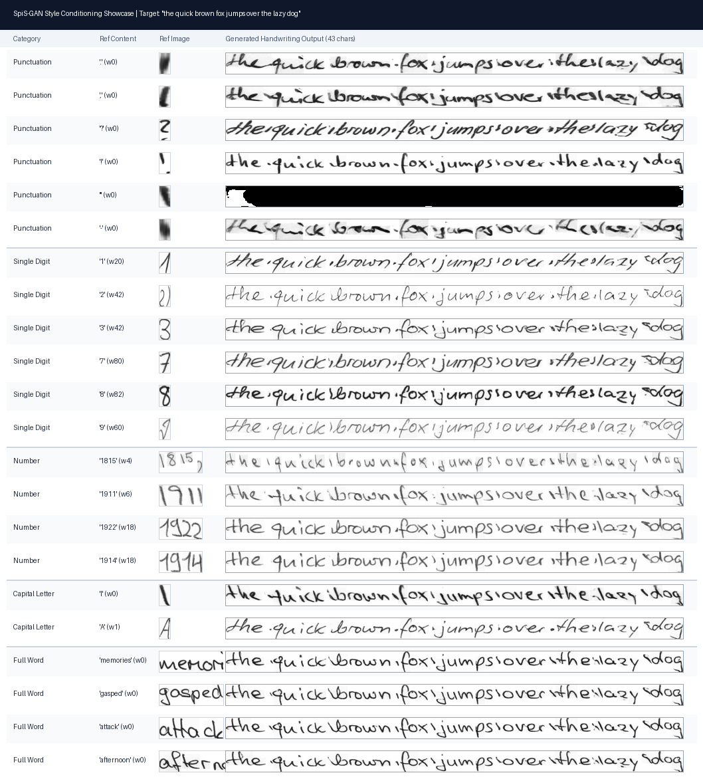

Showcase 2: Complex 50-Character Alphanumeric & Punctuation Sentence
Target: "Handwriting text generation with SpiS-GAN in 2026."
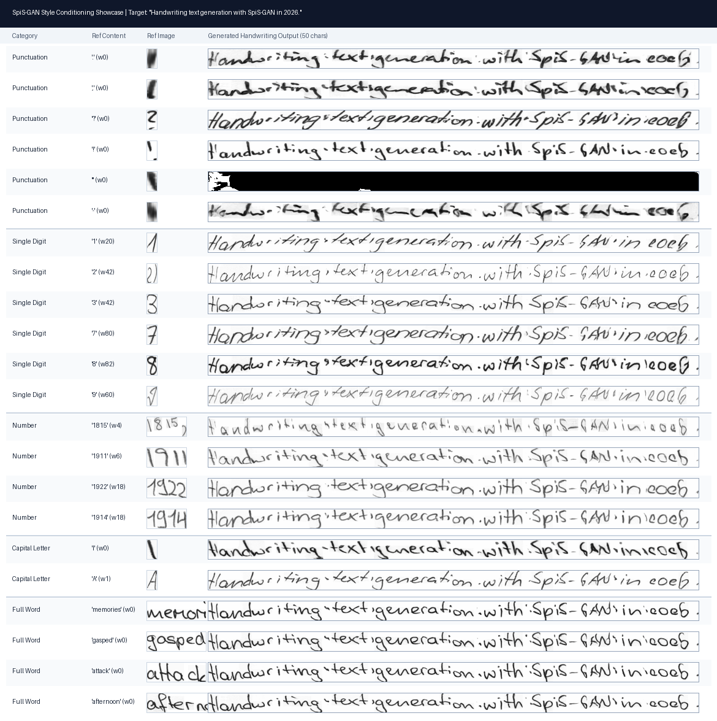

Showcase 3: Single Long Word Generation (13 Characters)
Target: "extraordinary"
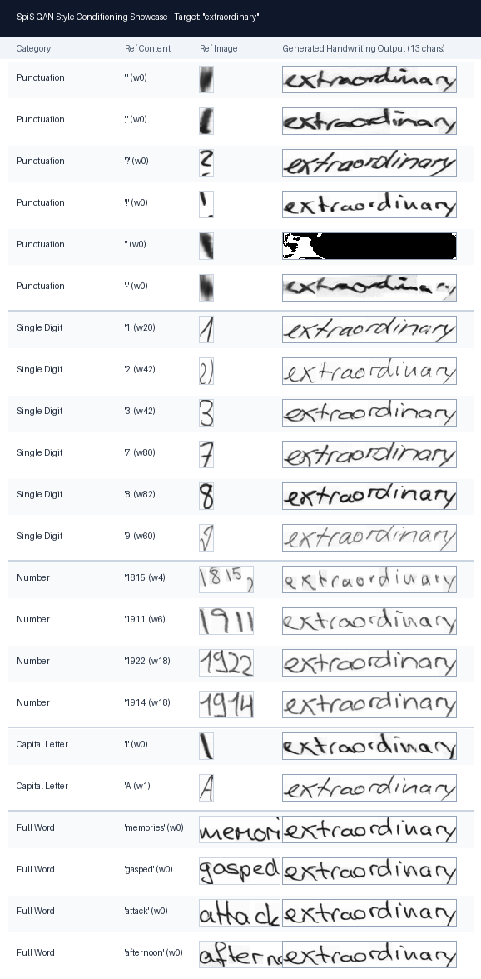

Showcase 4: Multi-Author Style Consistency Study
Comparing style transfer across 4 different writers under Punctuation vs Uppercase vs Full Word vs Unconditioned baselines.
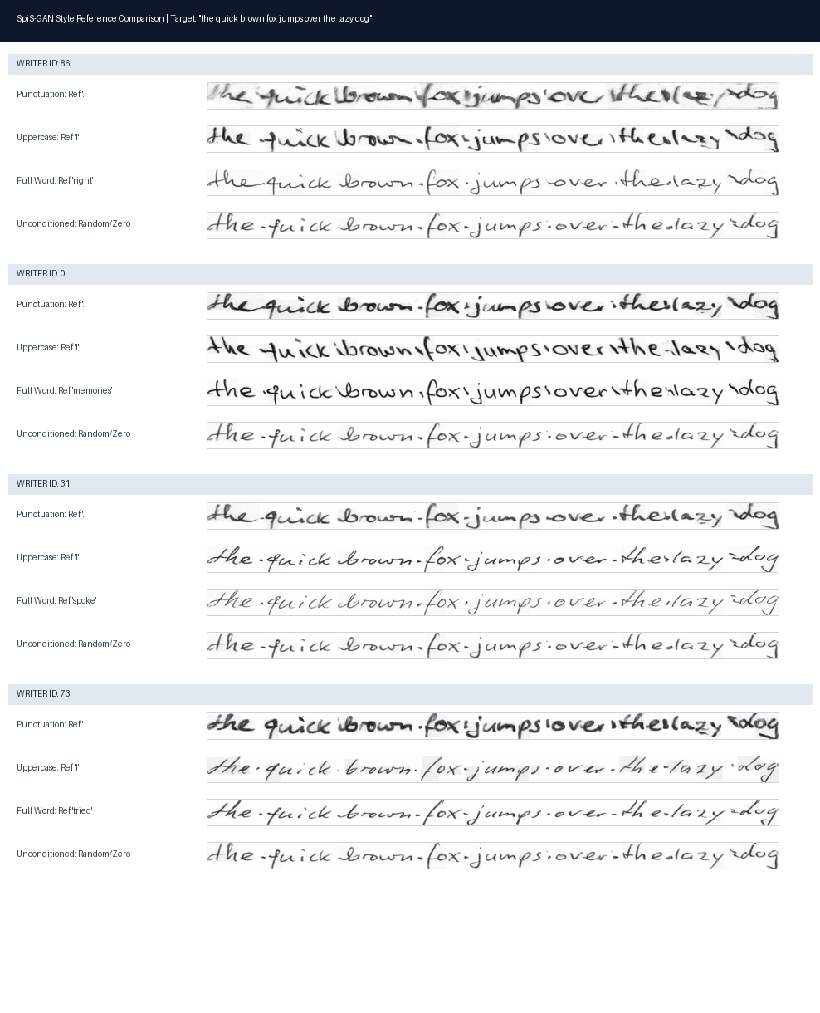

3. Quantitative Style Vector Statistics
Reference Category | Count (N) | Mean L2 Norm ||mu|| | Std Dev | Characteristic Quality
Full Long Words (>= 6 chars) | 50 | 10.91 | ± 2.16 | Gold Standard: Crisp, stable, uniform stroke weight, zero margin artifacts.
Capitalized Words (London, Mr) | 50 | 11.55 | ± 2.74 | High Fidelity: Smooth letter spacing and crisp baselines.
Short Words (<= 5 chars) | 50 | 13.51 | ± 3.35 | High Fidelity: Slight variance in stroke thickness.
Multi-digit Numbers ('1815', '1911') | 35 | 15.40 | ± 5.45 | High Quality: Broad spatial support (40-80px) yields natural cursive flow.
Single Capital Letters ('I', 'A') | 50 | 15.59 | ± 7.03 | Good: Strong vertical downstroke guidance; occasional contrast elevation.
Single Digits ('1', '2', '3', '7', '8', '9') | 25 | 17.51 | ± 5.45 | Distinct Style Transfer: Each digit imparts a distinct stroke curvature / slant.
Punctuation Marks ('.', ',', '?', '!', '"') | 50 | 30.71 | ± 18.24 | Volatile / Out-of-Distribution: ~3x higher norm; causes background smudging.

4. Key Findings & Mechanistic Insights
1. The Punctuation Pooling Anomaly (L=1 Problem):
In SpiS-GAN's StyleEncoder, spatial pooling divides the sum of feature columns by L = floor(W / 16). For a 16px wide crop containing a single dot, L = 1. Without multi-character averaging, background padding dominates, pushing ||mu|| to ~30.71 and causing horizontal gray margin smudges across generated sentences.
2. Stroke-Rich Punctuation Succeeds (',' and '?'):
When punctuation contains directional trajectories (such as the sharp tail of a comma), the encoder successfully captures pen pressure and slant, producing bold, high-contrast cursive.
3. Single Digits Act as Potent Style Priors:
• Digit '1': Sharp italicized cursive slant.
• Digit '2': Open, airy, rounded lowercase letter shapes.
• Digit '3': Upright, block-like lowercase font structures.
• Digit '7': Dark, high-pressure cursive script.
• Digit '9': Delicate, thin pen-pressure handwriting.
4. StarSpiral Long-Range Stability:
The StarSpiral spatial attention modules preserve stroke width and slant uniformly across 50 characters.

