Toxicology tutorial questions – Instructions

Set up:

4 videos: Toxidrome, pAproach, Tylenol/Acetaminophen, TCA, toxic alcohol

Each student should bring headphones and have individual web access.

Step 1

Assign student sequentially to watch one of 4 videos and takes own notes (15-20 minutes, video 2 is the longest)

Step 2

Form groups of 6-8.

As a group, someone from the group must have viewed each video.

(For example, there can be 2 students who viewed video 1, 1 student who viewed video 2, 1 who viewed video 3, 2 who viewed video 4).

Step 3

They work on the questions as a group for 45 minutes. They are allowed to consult other sources and the facilitator. They can also refer back to the videos.

Each student contributes what he/she has learned from own video. The facilitator circulates around to ensure muddy points are cleared up. This is usually the bulk of the in-class discussion.

Step 4

The whole class then goes through the scenarios together quickly with the facilitator highlighting important points. (10 minutes)

Scenario 1

A 20 yo female calls her family because she had taken ‘some drugs’. She is brought into the Emergency Department.

**Q1. What history do you want to know?**

**Q2. What physical exam characteristics do you look for in order to decide whether she has a toxidrome or not?**

**Q3. List the vital signs and physical exam if she had ingested**

Cocaine

Oxycodone

Dimenhydrinate (Gravol)

Amityptyline

MDMA (Ecstasy)

Her physical exam shows HR 130, BP 160/100, RR 20, Sat 99%, Temp 37.9. She is agitated. Her pupils are large.

**Q4. How do you differentiate between sympathomimetic and anticholinergic toxidromes?**

**Q5. Her skin is warm. Her armpits are wet. She admitted to taking a few pills of MDMA (Ecstasy). How should we treat her?**

**Q6. What monitoring does she require?**

Scenario 2

A 40 yo M with a history of depression is brought in by EMS because of a suicidal attempt about 3 hours ago. He called the EMS himself and was found beside a few bottles with no labels. He had no idea what the pills were since they belong to his housemate. He was sleepy and slow to answer questions.

You put him on a cardiac monitor. HR 100, BP 120/70, RR 24, Sat 98%. He is very sleepy and you cannot wake him up.

**Q1. What are universal antidotes and what one(s) would we use it now?**

His blood sugar level is 2.5 mmol/L (45 mg/dL)

**Q3. How would you manage that?**

His level of consciousness increases with the administration of the medication.

**Q4. What further history do you want to know?**

You are unable to get further history. His physical exam does not reveal a toxidrome.

**Q5. What investigations would you order?**

**Q6. What pills can we see on x-ray?**

**Q7. What ECG abnormalities do we look for on ECG in a poisoned patient?**

The patient’s lab work is as follow

ABG: pH 7.25, HCO3 10, pCO2 25, pO2 200

**Q8. What is the abnormality on the ABG?**

**Q9. His other bloodwork includes: Na 140, K 4, Cl 100, HCO3 10. Calculate his anion gap.**

**Q10. What potential toxins can give this bloodwork results?**

**Q11. What cause osmol gap?**

His serum osmolality is 300. BS 5 mmol/L (90 mg/dL), BUN 10

**Q12. What is his osmol gap and is that normal/abnormal?**

**Q13. What are the drugs that give increased anion gap metabolic acidosis and normal osmol gap?**

**Q14. What is the most likely cause of this patient’s presentation?**

Scenario 3

Objective: Tylenol overdose, approach, decontamination, treatment

A 55 yo M comes in after an overdose. He states he has taken 50 tablets of 500 mg Acetaminophen 2.5 hours ago. His family brought him in.

**Q1. What is the toxic dose for acetaminophen?**

**Q2. What is the upper limit for number of Extra strength tylenol for this patient if he is 70kg?**

**Q3. In what circumstances would we give him activated charcoal?**

**Q4. What are the 4 stages of acetaminophen toxicity?**

**Q5. What bloodwork would you order for this patient?**

**Q6. What lab abnormality would you expect to have at this point?**

**Q7. What is the antidote for acetaminophen toxicity?**

**Q8. How would you decide to start the antidote?**

**Q9. Here is the Rumack-Matthew nomogram. How do you use it in our patient?**

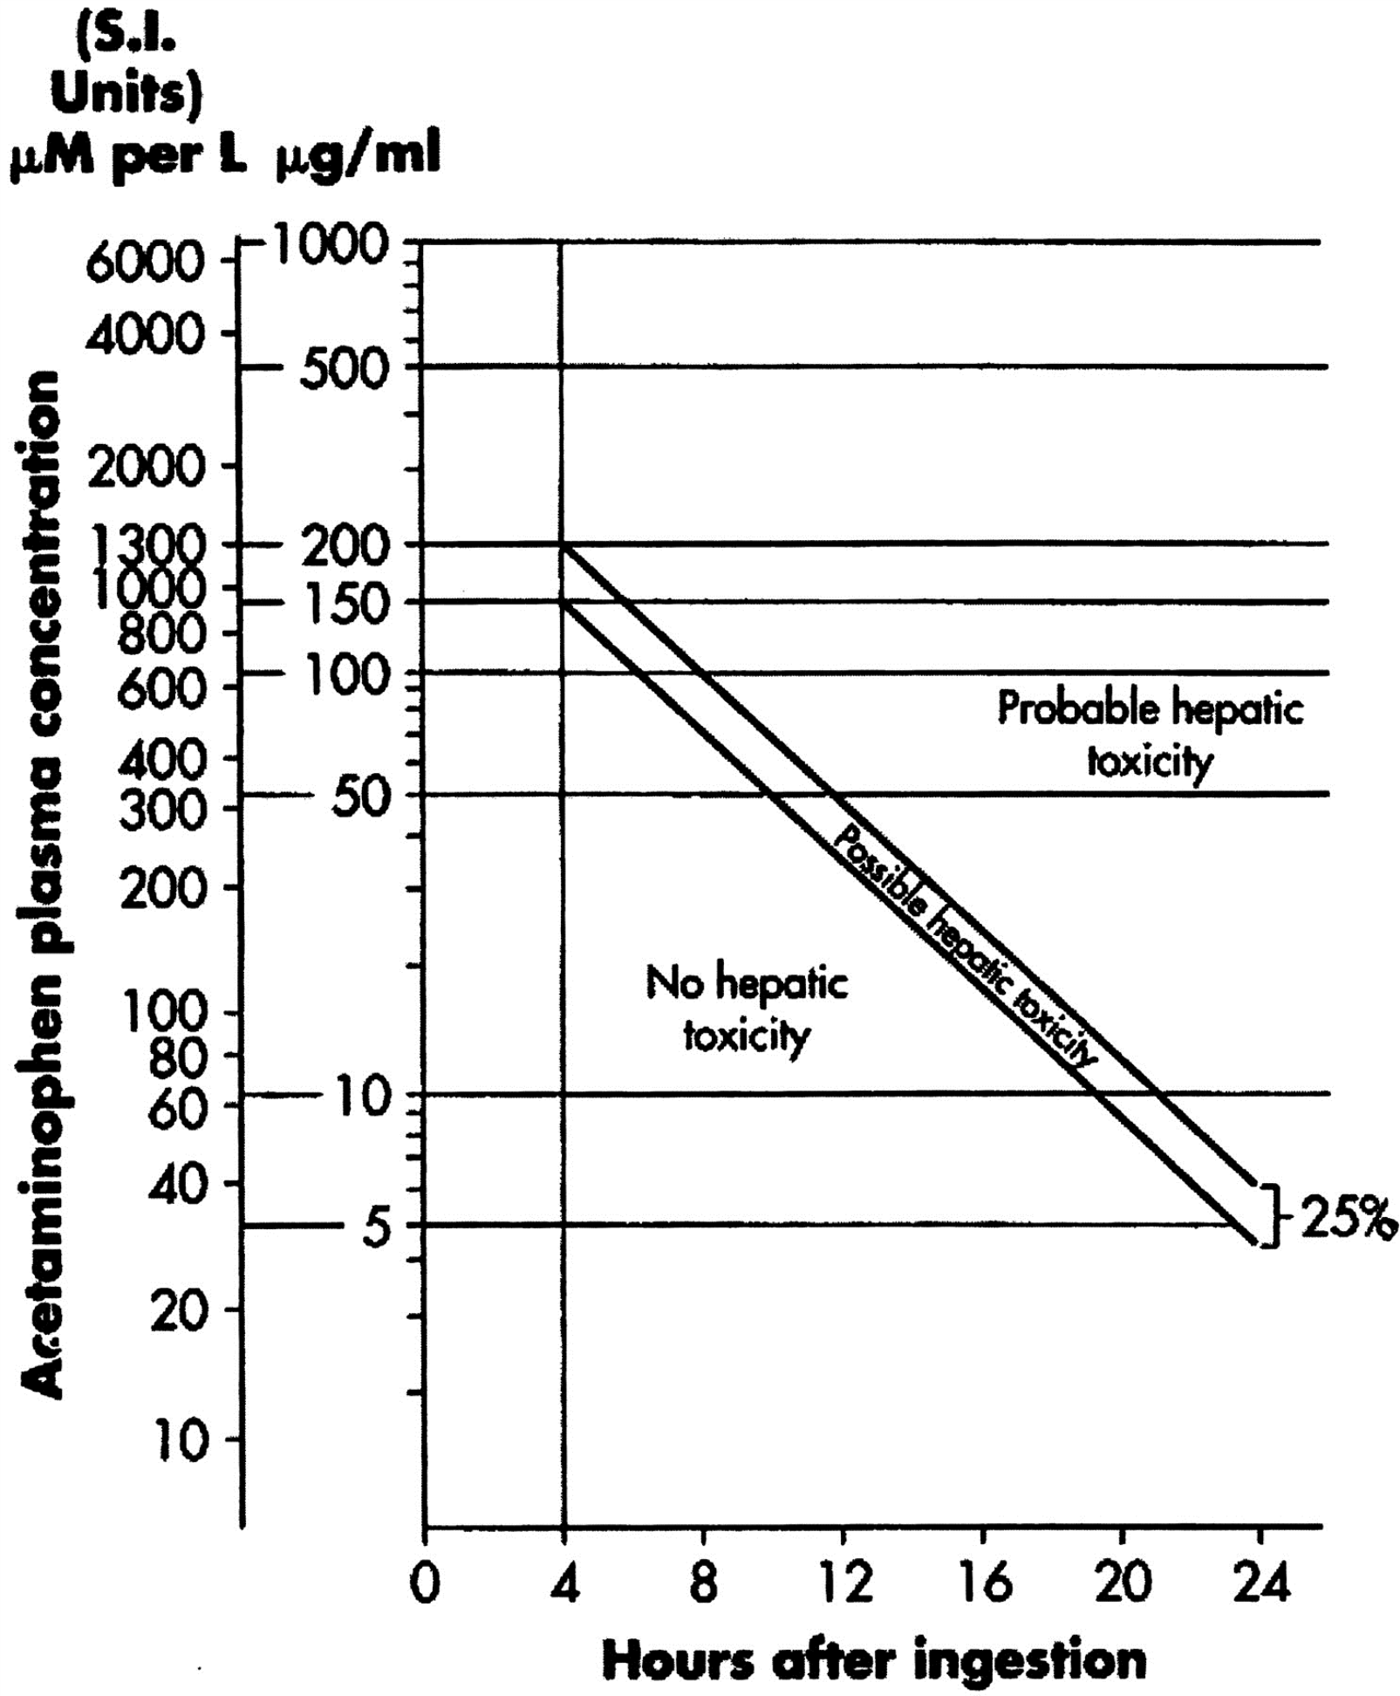

**Q10. Our patient’s 3-hour level is 600 uM/L. Should we start treatment?**

Scenario 4

A 20 yo F was found with decreased level of consciousness by her family member. There were a few empty bottles beside her. The family will go home and bring the empty bottle.

Her VS are: HR 100, RR 25, BP 120/80, O2 sat 100%. She is incoherent and you are unable to get a history. She is put on a cardiac monitor.

**Q1. Should we give her the universal antidote?**

While you request bloodwork and more history from family, you read the patient’s suicide note. It states she was under a lot of stress and would like to die.

**Q2. Would you put her on a Form 1? What authority does a Form I give you?**

**Q3. What investigations would you order?**

**Q4. Interpret her ABG: pH 7.15, HCO3 8, pCO2 23, pO2 200**

**Q5. Calculate her anion gap. Na 145, Cl 95, HCO3 8. Is it abnormal?**

**Q6. Calculate her osmol gap. BUN 10, Glucose 10 (180 mg/L), measure osmol 340**

**Q7. What toxins could have caused these lab abnormalities?**

**Q8. The family brought in an empty bottle of windshield washer fluid with antifreeze. How would you treat the patient?**

**Q9. How do the antidotes for toxic alcohols work?**