NETWORK TOPOLOGY VISUALIZER
Config-Derived Network Mapping — Solution Proposal
Prepared for network engineering
Version 0.7 prototype · enterprise design recommendation

Executive Summary
This proposal describes a tool that turns network device configuration files into an interactive, hierarchical topology map — automatically, offline, and without inventing anything the configs do not state. It is aimed at network engineers who today reconstruct topologies by hand in Visio or draw.io every time a site changes, and at the organizations that need those diagrams to be accurate, current, and consistent across many locations.
A working prototype already exists. It ingests both a normalized JSON schema and raw text configs (Cisco IOS-style, FortiOS, and similar), extracts the fields engineers actually read off show commands, draws the standard cloud → router → SD-WAN → switch → wireless → endpoint hierarchy, and lets the user click any device for its full detail. Links between devices are only drawn when the files themselves justify them, and each inferred link carries the exact evidence that produced it.
The recommendation that follows explains the approach, walks through a simple worked example built from sample configs, and lays out a phased path to an enterprise-grade deployment.

The Problem
Network documentation drifts. Diagrams are drawn once during a project, then fall out of date the moment a circuit is swapped, a VLAN is added, or a site is refreshed. When an incident happens at 2 a.m., the diagram on file is often wrong in exactly the way that matters. The underlying issue is that the diagram and the configuration are maintained separately — the configuration is the source of truth, but the picture is hand-made.
For organizations running many similar sites — retail, franchise, branch networks — the problem multiplies. Each site should look the same, but small deviations creep in, and there is no fast way to see them side by side.
The goal of this tool is simple: the configuration should draw the diagram. If the configs are the truth, the topology derived from them is the truth too.

Solution Overview
The tool is a single, self-contained application that runs entirely in the browser with no server, no install, and no data leaving the machine. An engineer uploads one or more configuration files; the tool parses them, and renders a clean topology arranged in the standard layered hierarchy.

Three principles
- Render only what was uploaded. No device appears on the map unless it came from a file. There are no assumed gateways, no placeholder cloud, no default devices.
- Never invent a link. A connection is drawn only when it is declared in the data, inferred from concrete file evidence (and shown dotted, with that evidence attached), or set manually by the engineer.
- Trace every claim. Each device shows which file it came from; each inferred link quotes the config line that justified it. Nothing on the map is unexplained.

Worked Example — A Simple Site
The diagram below was generated from a small set of sample configs: an edge router, a core switch, an access point, and two endpoints (a POS workstation and a VoIP phone). It illustrates the standard hierarchy the tool produces — cloud at the top, then routing, switching, and endpoints at the bottom.
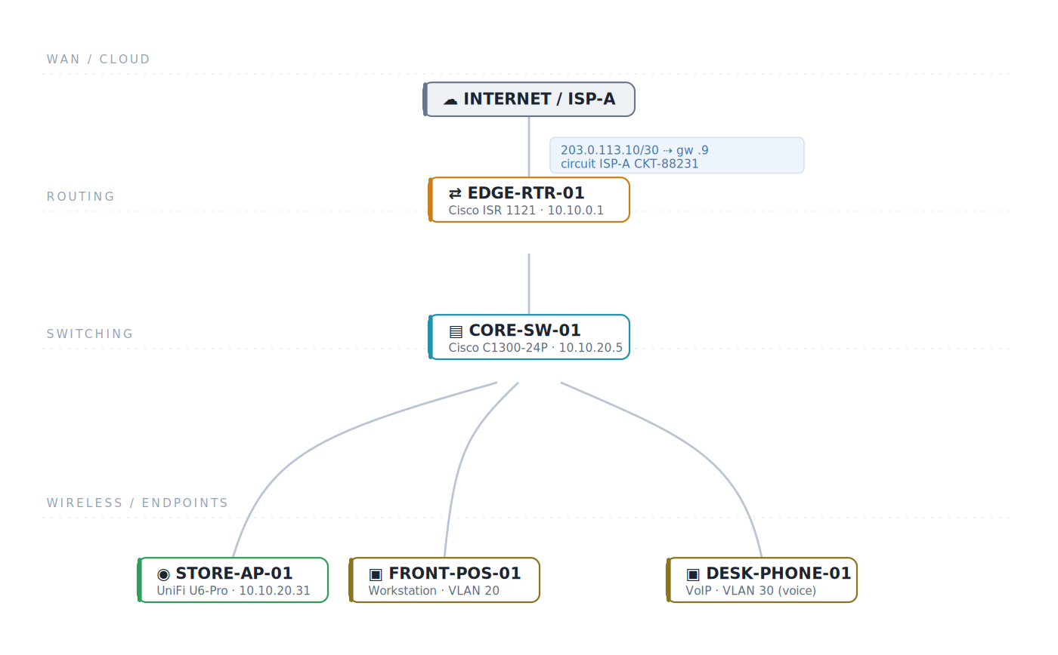
Figure 1 — Topology derived from the sample configuration set. The WAN edge (public IP, gateway, and circuit ID) is labelled directly on the cloud-to-router link.
Every element traces back to the files. The router's WAN block came from its ip address and ip route 0.0.0.0 lines; the switch-to-router link was confirmed because the switch's default gateway resolves to the router's LAN interface. The endpoints appear because they were present in the data, connected to the switch as declared.

How It Works

1 · Normalized schema
Every parser, regardless of vendor, produces the same normalized device record. This decouples the map from any one vendor's format: add a new parser, and the rest of the tool is unchanged. The schema captures identity, WAN side, LAN side, routing (L3), switching (L2), interfaces, neighbors, and the declared uplink.

2 · Config parsing
Text configs are parsed client-side with strictly literal extraction — only values physically present in the file are used. Optional one-line directives (! topo-id, ! topo-type, ! topo-uplink) let an engineer declare identity and links explicitly. Where a type is not declared, a heuristic guesses it and flags the guess rather than presenting it as fact.

3 · Evidence-based linking
Connections are established in priority order, strongest evidence first:
- CDP / LLDP neighbors — pasted neighbor output is physical ground truth; the strongest link source.
- Gateway match — a device's default gateway resolves to exactly one other uploaded device's interface.
- Interface description — a port description literally names another uploaded device.
Declared and manual links are solid; inferred links are dotted and can be toggled off. Ambiguous evidence draws nothing — the tool would rather show no link than a wrong one.

4 · Rendering
The map lays devices into fixed tiers so topology reads top-to-bottom the way engineers expect. Clicking any device opens a detail panel; search filters by hostname, IP, or MAC; a WAN-side overview lists every circuit in one table; and the whole topology exports to JSON so manual fixes are preserved and re-loadable.

Data Captured — Industry-Standard Fields
The detail view shows the same information an engineer reads off a live device, grouped by function. The tables below summarize what is captured per device class.

Router (Layer 3)
Group | Fields
Identity | vendor · model · serial · OS / firmware · uptime · mgmt IP · base MAC
WAN side | public IP · gateway · circuit ID · NAT / PAT · overlay tunnels · SLA
Routing | router-id · AS number · OSPF / BGP / EIGRP / static · default route
Redundancy | HSRP / VRRP group · virtual IP
Interfaces | name · description · IP / VLAN · speed / duplex · state

Switch (Layer 2)
Group | Fields
Identity | vendor · model · serial · firmware · uptime · mgmt IP · mgmt VLAN
Switching | VLAN database · STP mode / root / priority · VTP domain & mode
Aggregation | EtherChannel (Po) groups · stack members
Power | PoE budget / used
Neighbors | CDP / LLDP adjacencies — local port ↔ remote device & port

Multi-Site Standardization
For organizations that deploy the same design repeatedly, the tool includes a site template driven by a single site number. Following the pattern of established multi-site lab designs, one variable stamps out an entire standard site — cloud, router, SD-WAN, switch, access point, and endpoints — with consistent naming (sN-*) and non-overlapping addressing (100.127.N.0/30 transit, 10.N.x.0/24 LANs). Sites stand side by side without collisions, and the whole build exports as one file.
This turns the tool from a documentation aid into a design-standardization aid: the reference topology becomes the blueprint every new site is built and checked against.

Enterprise Considerations
Dimension | Approach
Security | Fully offline; configs never leave the browser. Suitable for handling sensitive running-configs without a data-egress review.
Trust | No invented data or links; every element is traceable to a file. Inferred links are visually distinct and evidence-backed.
Portability | Single self-contained file. No server, no install, no dependencies. Runs from a share, a laptop, or an air-gapped host.
Consistency | Normalized schema + site templates enforce one standard across all sites and vendors.
Extensibility | New vendor = new parser to the same schema; the map and UI are untouched.

Recommended Roadmap
Phase | Focus | Outcome
1 — Foundation (done) | Schema, text + JSON ingest, tiered map, detail panels, evidence-based links, WAN overview, site templates | Working prototype for single-site use
2 — Vendor fit | Tune parsers against real sanitized configs for the vendors in use; validate against known-good diagrams | Trusted extraction on production formats
3 — Ground truth | Prioritize CDP / LLDP neighbor ingest; optional SNMP / API discovery for live topology | Confirmed physical links, not just inferred
4 — Scale & governance | Multi-site dashboards, drift detection against the standard template, role-based access & audit | Fleet-wide, standards-enforced documentation

Recommendation
Proceed with Phase 2. The foundation is proven; the highest-value next step is to tune the parsers against a small set of real, sanitized configuration files from the vendors actually deployed, and to validate the generated topology against a diagram known to be correct. That single exercise converts the prototype from a promising demo into a tool engineers trust with production data.
In parallel, begin capturing show cdp neighbors detail / show lldp neighbors detail alongside each config. Neighbor data is the difference between a topology that is inferred and one that is confirmed, and it is the single most effective input for accuracy at scale.

Prepared as a design recommendation. The accompanying prototype (network_topology_map.html) is a runnable companion to this document.

