ELECTRICPE - LEAD-TO-DELIVERY FUNNEL ANALYSIS

Key Insights
- Conversion Rate: 81.2% overall; strong funnel efficiency with minimal drop-offs.
- Cancellation Rate: 27.1%; mainly due to price (22.5%) and financing issues (18%).
- Customer Satisfaction: Avg Rating 4.86/10; NPS -53.08; indicates poor post-booking experience.
- Delivery Performance: Avg TAT = 10.58 days; main delay in Booking to Delivery (4.46 days).
- Store Insights: Consistent conversion across stores; Delhi MBC has highest cancellations (29.3%).

Tables
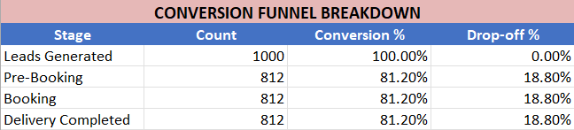
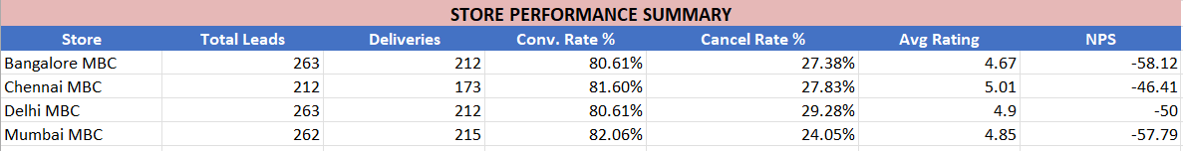
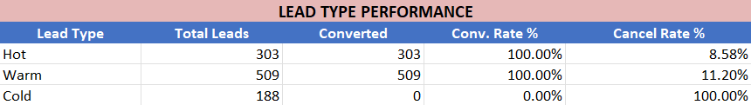
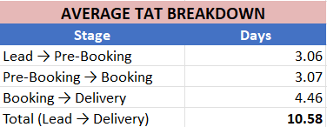
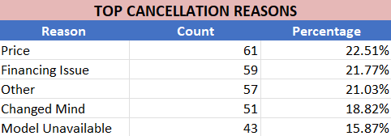

Operational Gaps
- Delays during delivery phase.
- High cancellations due to price and finance constraints.
- Weak follow-up communication post-booking.
- Low NPS and rating reflect service dissatisfaction.

Recommendations & Action Plan
A. Lead Conversion
- Introduce personalized follow-ups and lead scoring.
- Offer time-bound discounts and referral incentives.
B. Delivery TAT Improvement
- Implement real-time delivery tracking.
- Optimize logistics and set internal TAT benchmarks (<3 days per stage).
C. Service & Follow-ups
- Automate customer updates post-booking.
- Create a service dashboard to monitor resolutions.
D. Cancellation Reduction
- Launch flexible financing options (EMI, pay-later).
- Set up a retention call system for cancellation prevention.
E. Customer Satisfaction
- Conduct staff training on customer handling.
- Build feedback-to-action loops to convert detractors to promoters.

