LegalEase: AI-Powered Legal Document Generator & Analyzer
LegalEase is an AI-driven legal assistant that simplifies legal documentation. It helps users generate customizable legal documents like employment contracts, lease agreements, and NDAs from simple inputs.Built using FastAPI and Generative AI, it provides three core capabilities: automated document generation, intelligent summarization, and key clause analysis. Users can preview, edit, and export documents in TXT, DOCX, and PDF formats.By breaking down complex legal language into structured sections and simplified summaries, LegalEase makes legal documents easy to understand and manage, without needing legal expertise. Note: For assistance only, not a replacement for professional legal advice.Scenarios:
Scenario 1 Scenario 1: Employment Contract Generation
A startup founder needs an employment contract for a new employee. The founder selects “Employment Contract” and enters details such as the employee’s name, job role, compensation, responsibilities, and effective date. LegalEase uses this information to generate a structured employment contract. The founder can review and edit the document before downloading it in PDF format.
Scenario 2: A freelancer receives a lengthy Non-Disclosure Agreement (NDA) from a client. The freelancer provides the document content to LegalEase for analysis. The system generates a simplified summary and identifies important clauses, including confidentiality requirements, duration, obligations, and termination conditions, helping the user understand the key terms of the agreement more easily.

Scenario 3: A landlord wants to prepare a residential lease agreement for a tenant. The landlord enters details such as the property information, tenant details, rental terms, and effective date. LegalEase generates a structured lease agreement based on the provided information. The landlord can preview and edit the document before downloading the final agreement in DOCX or PDF format
Scenario 4: Legal Document Analysis
A user wants to quickly understand an existing legal document without reading the entire document manually. The user provides the document to LegalEase for analysis. The system identifies key clauses, important terms, and relevant conditions and presents them along with a simplified summary, making the document easier to review and understand.

Pre-requisites
- FastAPI Framework Knowledge: FastAPI Documentation
- Google Generative AI Familiarity: Google Generative AI Documentation
- Streamlit for Frontend: Streamlit Documentation
- Python Programming Proficiency: Python Official Documentation
- Document Processing Knowledge: Basic understanding of DOCX/PDF processing
- Environment Setup: Python, FastAPI, Uvicorn, Streamlit, Google Generative AI SDK, python-docx, FPDF, Pillow, Requests and python-dotenv

Project Workflow
Activity 1: Model Selection and System Architecture
- 1.1: Research and select the AI model Research and select a suitable Generative AI model for legal document generation, summarization, and key-clause analysis.
- Evaluate the selected model based on its text generation quality, context handling, accuracy, and ability to produce structured outputs.

1.2: Define architecture
- Frontend: Streamlit for user input, document preview, editing, analysis, and downloads.
- Backend: FastAPI to process API requests and communicate with the AI module.
- AI Integration: Generative AI model for document generation, summarization, and clause analysis.
- Formatting Modules: DOCX, PDF, and TXT generation.
1.3: Set up development environment
- Install the required Python packages.
- Configure the environment variables.
- Securely store the AI API key in the .env file.

Activity 2: Core Functionalities Development
2.1: Implement core generation features
- Legal document creation
- Editable document preview
- Legal document summarization
- Key-clause extraction
- Format and export as .txt, .docx, and .pdf
2.2: Build FastAPI backend
- Endpoint /generate to process document-generation requests
- Endpoint /summarize for document summarization
- Endpoint /analyze for key-clause analysis
- Accept document type, parties, terms, and dates
- Return AI-generated results

Activity 3: main.py & API Logic
3.1 Create and Configure main.py
- Initialize FastAPI
- Root endpoint
- Include API router
3.2 Handle Document Generation and Analysis Logic
- Pydantic request models
- /generate
- /summarize
- /analyze
- AI generator integration
Activity 4: Frontend with Streamlit
4.1 Design User Interface
- Page configuration
- Logo/title
- Input fields
- Buttons
4.2 Dynamic Preview and Analysis
- Generate document
- Summarize document
- Analyze key clauses
- Editable preview
- Download TXT/DOCX/PDF

Activity 5: Deployment
5.1 Prepare Application
- Virtual environment
- Install dependencies
- .env
- requirements.txt
5.2 Test Local Deployment
- Start FastAPI
- Start Streamlit
- Test all functions

Activity 6: Conclusion
MILESTONE 1: Model Selection and Architecture – LegalEase
Activity 1.1: Research and Select the Appropriate Gener In this milestone, the focus is on selecting a suitable Generative AI model for the LegalEase application and defining the overall system architecture. This milestone establishes the technical foundation required for legal document generation, document summarization, and key-clause analysis.
The proposed system architecture integrates a Streamlit frontend, FastAPI backend, Generative AI processing module, and document formatting components to generate, analyze, and export structured legal documents.
ative AI Model
1. Understand the Project Requirements
LegalEase is designed to provide AI-assisted legal document generation and document understanding capabilities.
The system must process user-provided information such as:
- Document type
- Parties involved
- Terms and conditions
- Effective dates
- Legal document content
The selected AI model should support:
- Structured document generation
- Context-aware text processing
- Legal text summarization
- Identification of important clauses
- Generation of clear and organized responses
2. Explore Generative AI Model Documentation
The available Generative AI model capabilities are reviewed to identify a suitable model for the application.
The selected model should support:
- Long-form text generation
- Structured prompting
- Context-aware responses
- Document analysis
- Summarization
- Consistent output formatting
3. Evaluate Model Performance
The model is evaluated based on its ability to:
- Generate structured legal documents from user inputs
- Understand multiple input parameters
- Summarize lengthy legal content
- Identify important clauses and terms
- Produce readable and organized responses

Select the Appropriate Model
The evaluation focuses on the functional requirements of the LegalEase application. The generated content is intended to assist users with legal document preparation and understanding and is not a substitute for professional legal advice.

Selected Model: Google Gemini Generative AI
Google Gemini Generative AI is selected as the AI component for LegalEase because it can be integrated into the Python application through an API and supports multiple natural language processing tasks.
The model will be used for:
- Legal document generation
- Legal document summarization
- Key-clause analysis
- Structured content generation
The selected Gemini model serves as the primary Generative AI component for generating and analyzing legal documents within the LegalEase application.

Activity 1.2: Define the Architecture of the Application

1. Architectural Diagram
The LegalEase application consists of the following major components:
- Frontend: Streamlit provides the user interface for document input, user interaction, document preview, editing, and downloading.
- Backend: FastAPI handles API requests and acts as the communication layer between the frontend and the AI processing module.
- AI Core: Google Gemini Generative AI performs legal document generation, summarization, and key-clause analysis.
- Analysis Module: Processes legal document content to generate simplified summaries and identify important clauses, terms, obligations, and conditions.
- Document Output Module: Formats the generated or analyzed content into structured documents and supports export in formats such as TXT, DOCX, and PDF.
- Formatting Modules: DOCX, PDF, and TXT generation.

Updated Architecture Flow

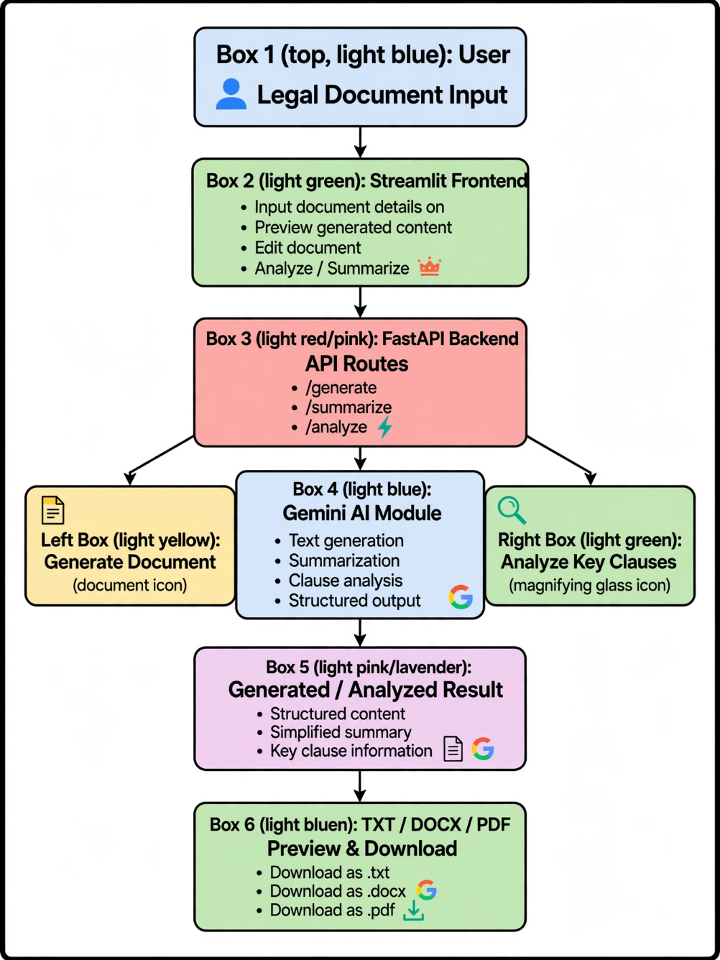

Component Responsibilities
Component | Responsibility
Streamlit | User interface and interaction
FastAPI | Backend API processing
Gemini AI | Generation and analysis
Summarization Module | Simplifies legal text
Clause Analysis | Identifies important clauses
DOCX Module | Word document generation
PDF Module | PDF document generation
TXT Module | Plain-text export

Activity 1.3: Set Up the Development Environment

Environment Setup and Dependency Installation

1. Install Python and Pip
Python 3.x and pip are required to develop and run the LegalEase application.

2. Create a Virtual Environment
A separate virtual environment is created to manage project dependencies and maintain an isolated development environment.
python -m venv venv
Activate the virtual environment on Windows:
venv\Scripts\activate

3. Install FastAPI and Uvicorn
FastAPI is used to develop the backend API, while Uvicorn serves the FastAPI application.
pip install fastapi uvicorn

4. Install Streamlit
Streamlit is used to create the frontend and provide an interactive user interface.
pip install streamlit

5. Install Google Generative AI SDK
The Google Generative AI SDK is installed to integrate the Gemini model with the LegalEase application.
pip install google-genai

6. Install Additional Libraries
The following libraries provide additional functionality required by the application:
pip install python-docx fpdf2 Pillow requests python-dotenv

7. Set Up Application Structure
The modified LegalEase project can use the following structure:

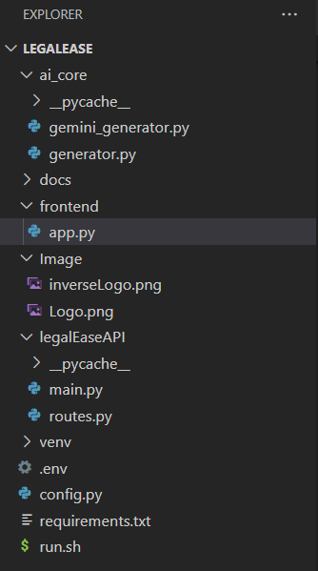

. Main Modules

gemini_generator.py
Handles AI-based legal document generation, document summarization, and key-clause analysis using the Generative AI model.

generator.py
Provides supporting functions required for document generation, formatting, and content processing.

main.py
Initializes and configures the FastAPI application and its core backend services.

routes.py
Defines the API endpoints used for legal document generation, summarization, and clause analysis.

app.py
Provides the Streamlit user interface through which users interact with the LegalEase application.

Image/
Contains the application logo and other image resources used by the application.

docs/
Contains project documentation and supporting documents related to LegalEase.

.env
Stores environment variables, including the Generative AI API key and other sensitive configuration values.

config.py
Contains the application's configuration settings and environment-related parameters.

requirements.txt
Lists all the Python packages and dependencies required to install and run the LegalEase application.

run.sh
Provides a shell script for starting and running the LegalEase application

MILESTONE 2: Core Functionalities Development
Activity 2.1: Develop the Core Functionalities
1. Legal Document Generation
Functionality: Generate structured legal documents such as contracts, agreements, NDAs, and lease documents based on user inputs including document type, parties, terms, and effective dates.
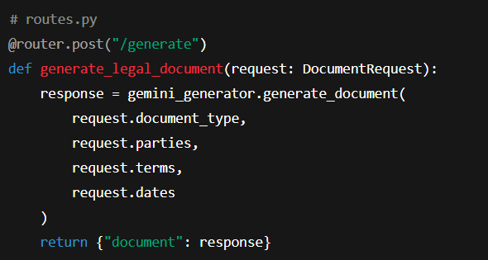

The generated document is created using the selected document type and the information provided by the user. The AI module processes the input and returns structured legal content with appropriate sections and clauses.

2. Document Output Formatting
Functionality: Convert AI-generated legal text into structured .docx, .pdf, and .txt files with appropriate formatting, headings, tables, and document branding.
- format_docx(text, doc_type)
- format_pdf(text, doc_type)
- format_html_preview(text)
These functions are used for:
- DOCX: Microsoft Word formatting with headings, logo, terms table, and footer.

- PDF: Formatted PDF generation with headings, terms, headers, and footers.
- HTML Preview: Displays the generated document using Streamlit styling.

3. Document Summarization
Functionality: Provides an AI-generated summary of lengthy legal documents to help users understand the main information quickly.
The summarization module processes the supplied legal text and produces a concise summary containing the major points, obligations, terms, and important information.

4. Key-Clause Analysis
Functionality: Analyzes the legal document and identifies important clauses and terms that may require careful review.
The analysis can identify sections related to:
- Payment terms
- Duration
- Confidentiality
- Responsibilities
- Termination
- Important obligations

5. User Interaction & Recommendations
Functionality: Accepts user preferences and document details through the Streamlit interface and uses them to generate customized legal content.

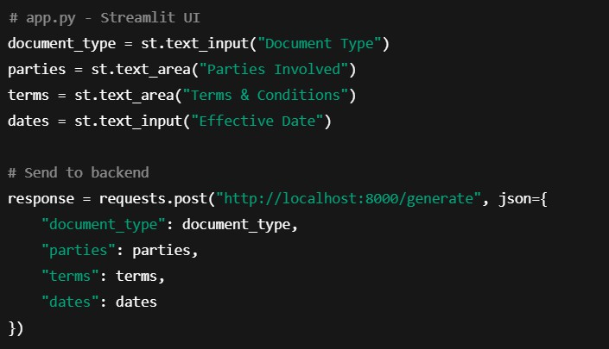

The interface collects:
- Document type
- Parties involved
- Terms and conditions
- Effective date
The supplied information is sent to the FastAPI backend for AI processing.

6. Editable Document & Download
Functionality: Provides editable generated text and allows users to download the final document in .txt, .docx, and .pdf formats.
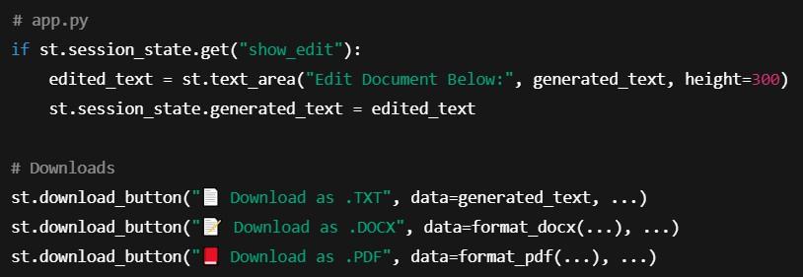

The user can review and modify the generated content before exporting the final document.

Activity 2.2: Implement the FastAPI Backend
1. Define Routes in FastAPI
The FastAPI backend provides separate routes for document generation and the newly added document-analysis features.
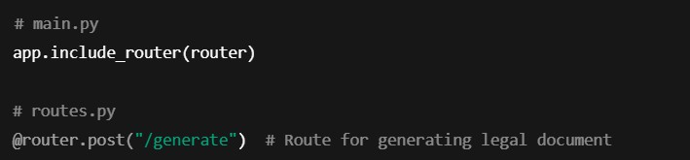

The primary API operations are:
/generate → Legal document generation
/summarize → Legal document summarization
/analyze → Key-clause analysis

2. Process User Input
Handled via Pydantic & Streamlit Forms:
The backend receives the required document information from the Streamlit interface and validates the incoming request.

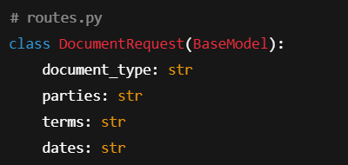

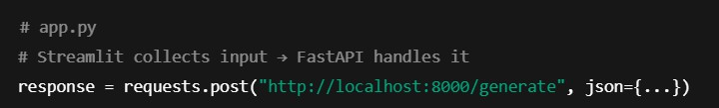

The main input parameters include:
- document_type
- parties
- terms
- dates
For summarization and clause analysis, the legal document text is passed to the corresponding API operation.

3. Integrate Gemini API Calls
The Gemini API is integrated with the backend AI module to process the user request.
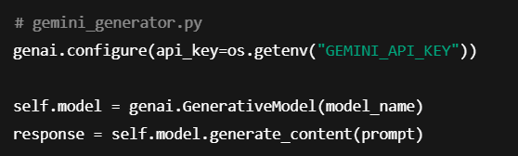

MILESTONE 3: API Logic Integration
In Milestone 3, the focus is on designing and integrating the backend API logic that powers legal document generation using the Gemini Generative AI model. This milestone establishes a functional connection between the frontend user inputs and the AI-powered document generation system, which forms a core component of the LegalEase application.
The backend is developed using FastAPI, which processes user requests, communicates with the Gemini model, and returns the generated legal document content to the frontend. This integration enables LegalEase to transform user-provided details into structured legal documents efficiently

Activity 3.1: Create and Configure main.py
This step involves initializing the FastAPI application, setting up the base endpoint for health-checks, and including modular API routes.

Steps:
- initialize the FastAPI app
  - Define a root (/) endpoint to verify the service is running
  - Include routes from the routes.py module
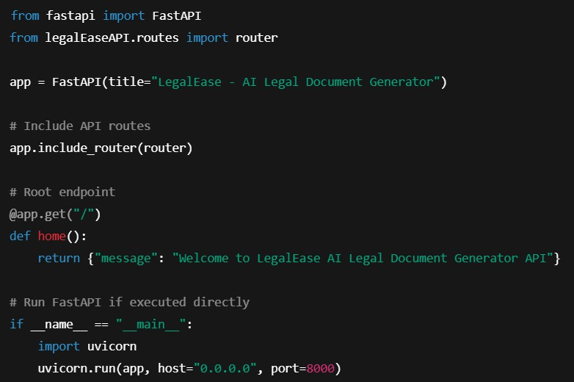

Activity 3.2: Handle Document Generation Logic in routes.py
This task handles user inputs from the frontend and sends them to the Gemini model for document generation.
Step 1:

  - Define a Pydantic DocumentRequest model to validate incoming data.
  - Initialize the GeminiDocumentGenerator from ai_core.gemini_generator.
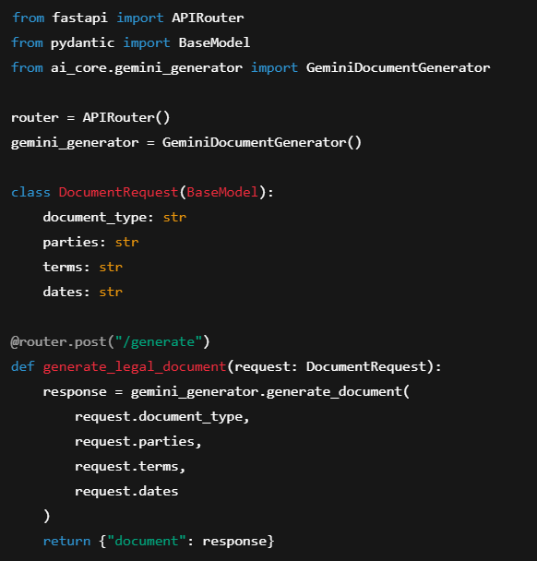
  - Create a POST endpoint (/generate) to accept user input and return generated legal content.

MILESTONE 4: Frontend Development – LegalEase

Milestone 4 focuses on creating a responsive and user-centric web interface for LegalEase using Streamlit. This milestone enables users to easily input legal details, generate AI-powered documents, preview the results, make inline edits, and download documents in multiple formats (TXT, DOCX, PDF) with rich formatting and embedded branding.

Activity 4.1: Designing and Developing the User Interface Step 1: Streamlit Page Configuration and Layout Setup
- Configured Streamlit app with:
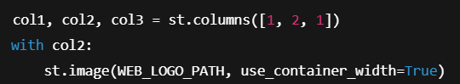
  - Added a three-column layout using st.columns to center-align the company logo
Step 2: Header and Title
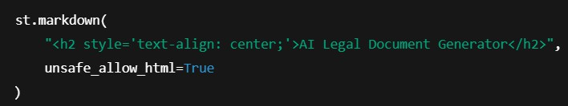
  - Displayed a subtle center-aligned title under the logo:

Step 3: User Input Interface

  - Created intuitive inputs for:
    - document_type: type of legal document

    - parties: involved stakeholders
    - terms: semicolon-separated clauses
    - dates: effective date

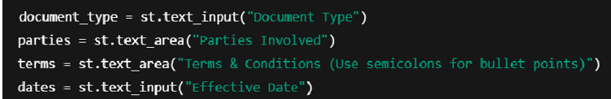

Activity 4.2: Creating Dynamic Previews and Export Options Step 1: Generate Document with Backend AI
• On clicking "Generate Document", a POST request is sent to the FastAPI backend:

• AI-generated content is sanitized and displayed dynamically:

Step 2: HTML Preview Rendering
• The output is previewed in an elegant dark-themed scrollable card with semantic HTML:

Step 3: Editable Document Preview
• The user can click "Edit Document" and modify the generated content using a text area:

Step 4: Multi-Format Download Options
Users can download the document as:
- .txt (Plain Text)
- .docx (Formatted Word Document with logo, headings, and table)
- .pdf (Branded PDF with logo and footer)

Core Functions & Utilities sanitize_text(text)
  - Removes special characters and typographic quotes to ensure clean formatting.
format_docx(text, doc_type)

  - Uses python-docx to:
    - Embed logo
    - Add titles, paragraph formatting
    - Auto-generate a Terms table from semicolon-separated input
format_pdf(text, doc_type)

  - Utilizes FPDF with custom header/footer:
    - Center-aligned logo
    - Bold headings for sections
    - Bullet-style terms
format_html_preview(text)

  - Converts output to stylized HTML blocks for inline display.

MILESTONE 5: Deployment

In Milestone 5, the focus is on deploying the LegalEase application locally using FastAPI as the backend and Streamlit as the frontend. This milestone involves setting up a virtual environment, configuring dependencies, and verifying that all modules—from the Gemini API integration to document generation and downloads—work seamlessly in a real-world local environment. This ensures your system is production-ready and paves the way for cloud deployment in future stages.

Activity 5.1: Preparing the Application for Local Deployment Step 1: Set Up a Virtual Environment
To ensure environment isolation and consistent dependency management, create and activate a virtual environment:
Step 2: Install Dependencies
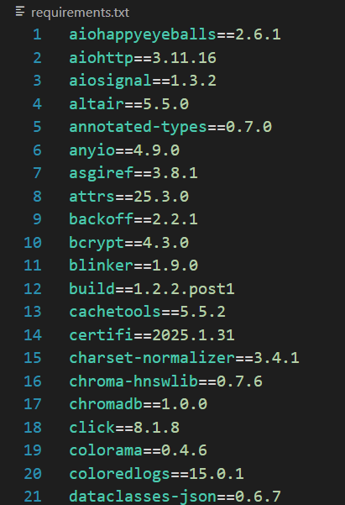
Ensure that the backend (FastAPI) and frontend (Streamlit) dependencies are installed from a requirements.txt:pip install -r requirements.txt

Step 3: Configure Environment Variables
Create a .env file to securely store your Gemini API key
Activity 5.2: Testing and Verifying Local Deployment Step 1: Launch the FastAPI Backend
Start the backend server using Uvicorn:
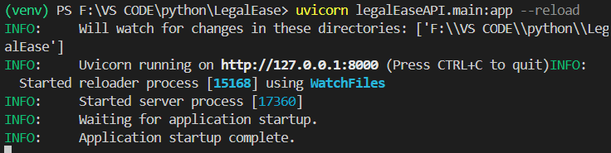
Step 2: Launch the Streamlit Frontend
Run the app.py file to start the LegalEase UI:
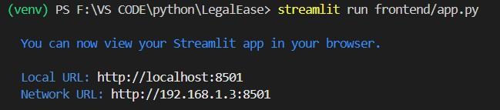
Step 3: Test All Functionalities
  - Input document type, parties, terms, and date.
  - Press Generate Document to get AI-generated legal content from Gemini.
  - Use built-in options to:
    - Preview in dark mode HTML
    - Edit the text
    - Download in .txt, .docx, and .pdf formats
  - Check for:
    - Proper layout with logo and footer
    - Clean formatting of bullet points
    - Correct embedding of terms in the document

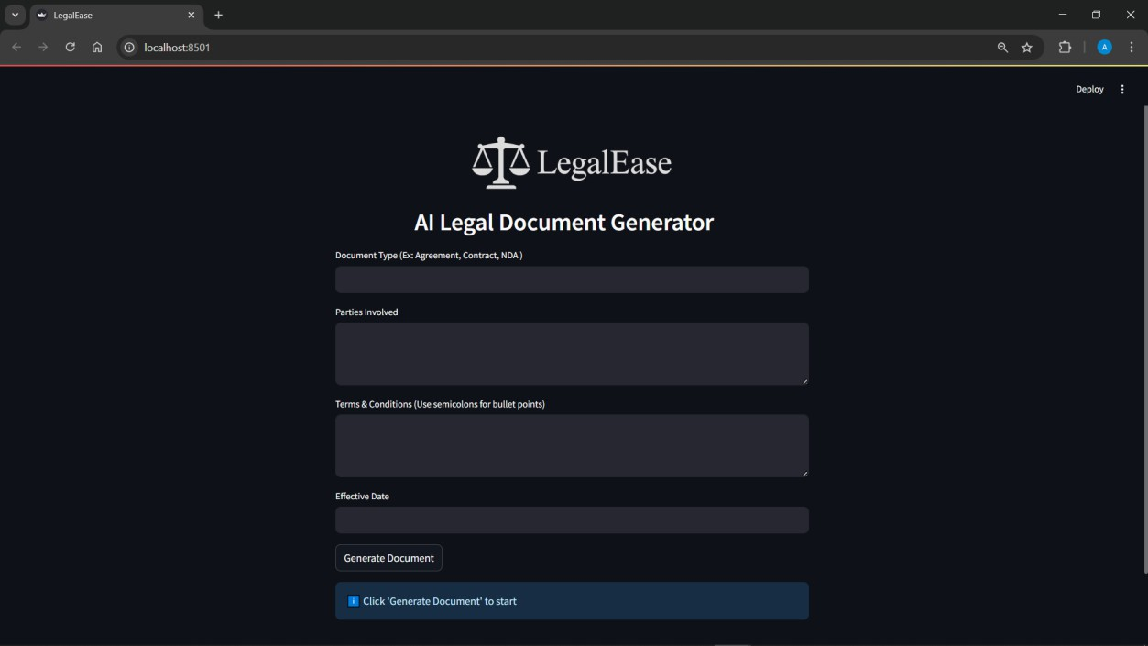
Exploring LegalEase

Document Type

Purpose: Type of legal document to generate. Examples:
  - Agreement
  - Contract
  - NDA (Non-Disclosure Agreement)
  - Lease Agreement
  - Employment Offer Letter Example input: Freelance Work Contract

Parties Involved
Purpose: Names and roles of the individuals or entities involved in the document. Examples:

  - John Doe (Freelancer), ABC Corp (Client)
  - Alice Smith (Tenant), XYZ Realty (Landlord)
Example input: Jane Doe (Service Provider), TechNova Inc. (Client)

Terms & Conditions (Use semicolons for bullet points)
Purpose: Specific clauses or rules that define the agreement. Separate each bullet point using a semicolon.
Examples:
• Payment to be made within 30 days of invoice;
• The provider agrees to deliver work by the agreed deadline;
• Confidentiality must be maintained at all times;
• Either party may terminate with 15 days notice

2. Effective Date
Purpose: The date when the agreement becomes legally valid. Examples:
• SEP 26 2026
• 26/09/2026
• SEP 26, 2026

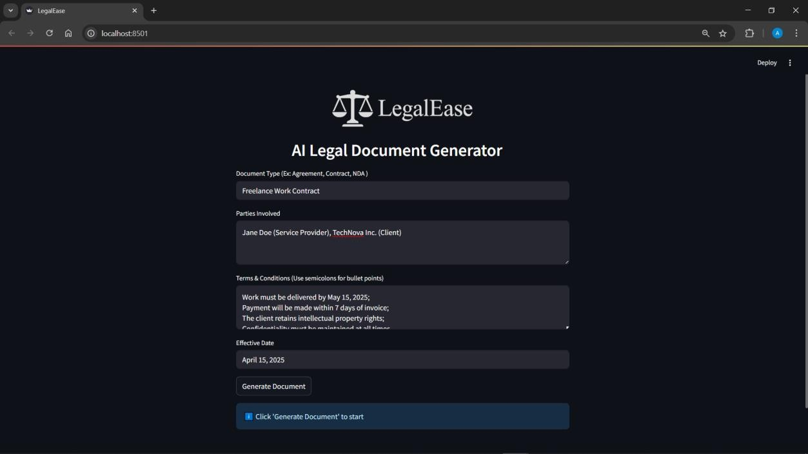

Document Generated
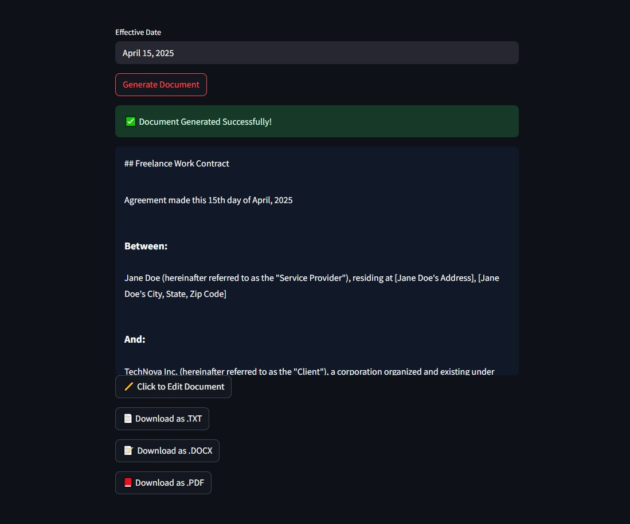

Editing the Document
If the user wants to edit the document, they can do so by clicking on the “ Click to Edit Document” Botton. A new window opens up where the document can be edited.

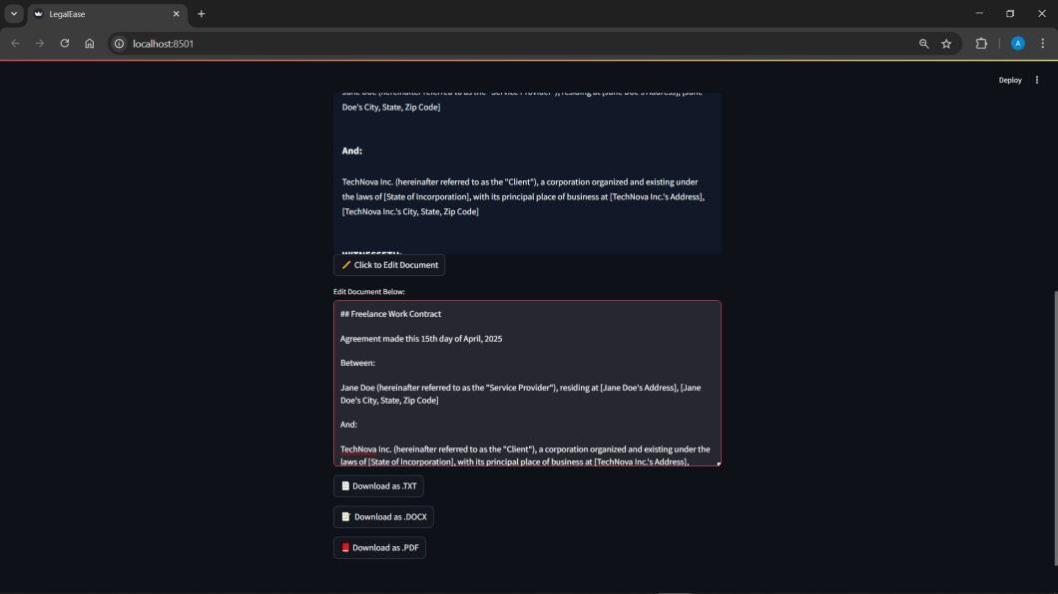

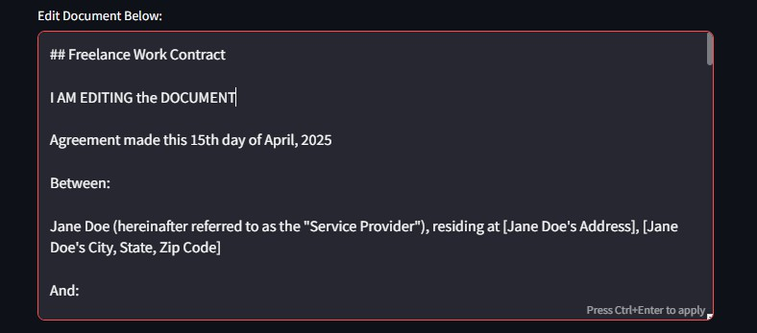

Downloading/ Saving the Generated Document
We can Download and save the documents in any of the following formats.
.txt
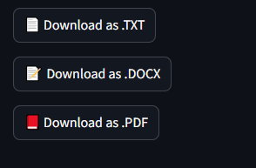

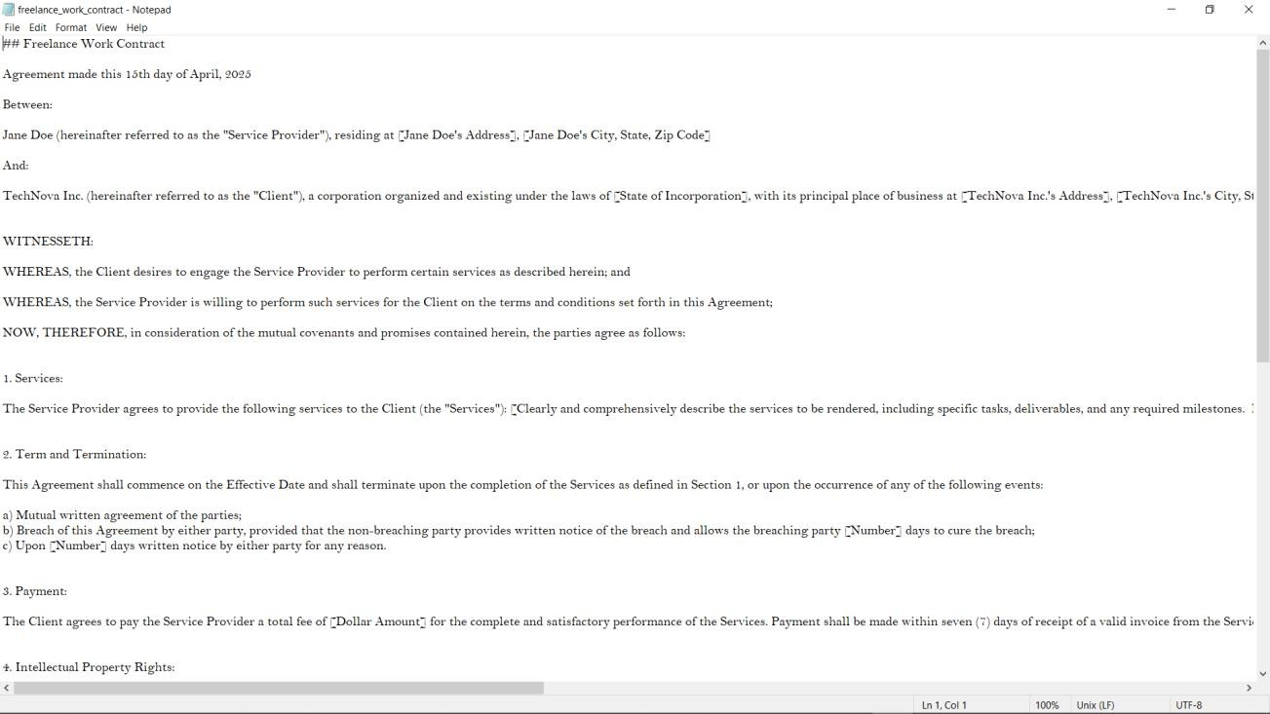

.docx
The document provided inculcates the use of the logo (front page) as well as the footer in the last page

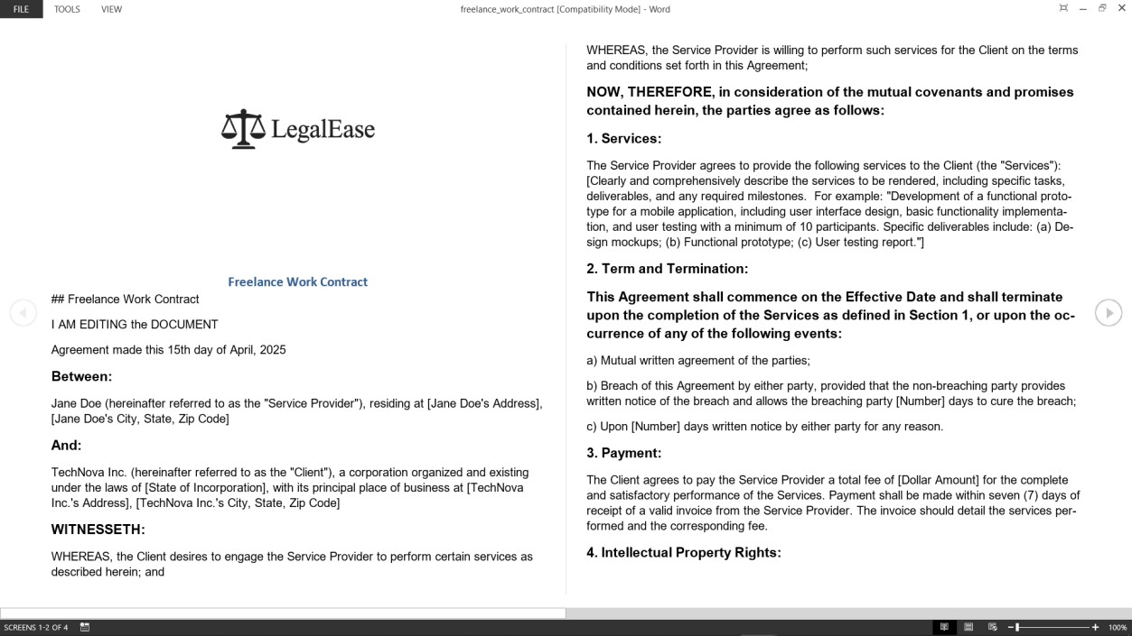

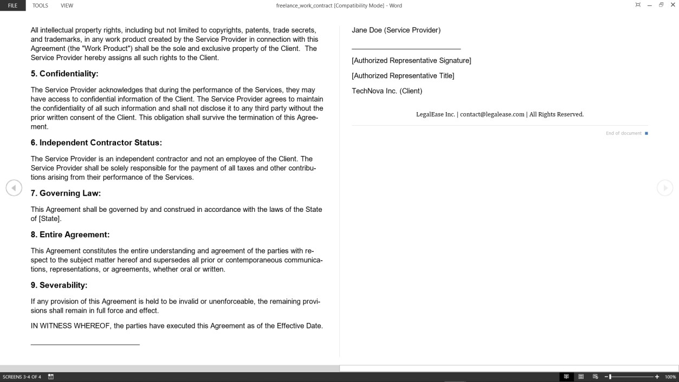

.pdf
This format provided the user with a well formatted and ready to use legal document with Logo and Footer on all the pages.

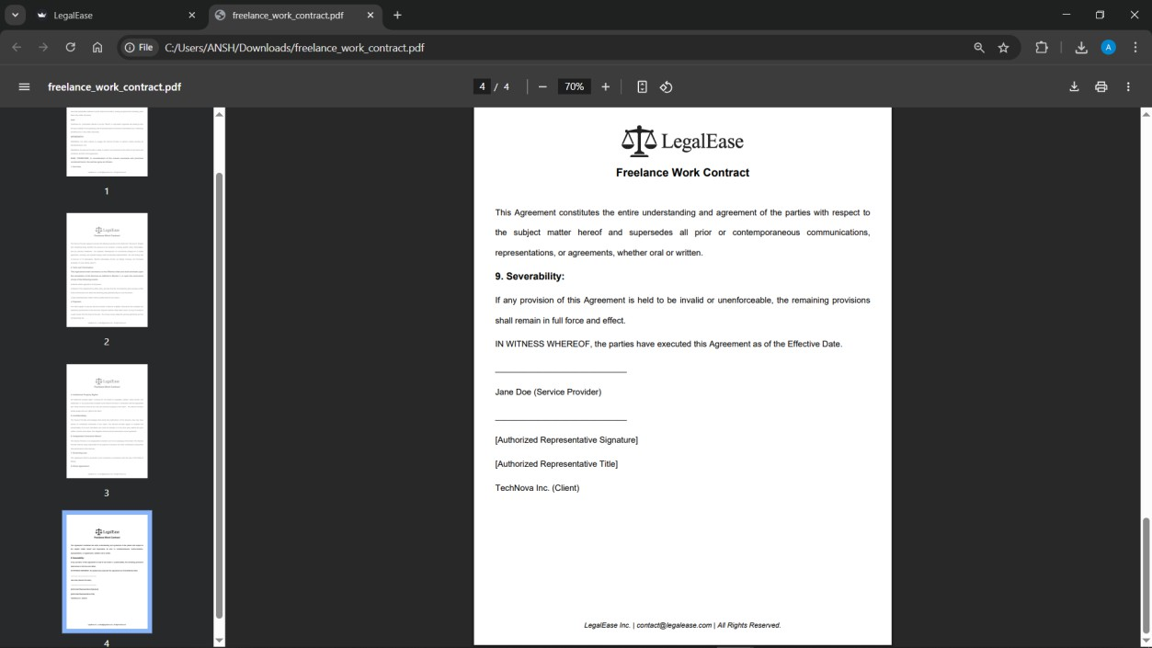

Conclusion
LegalEase represents a transformative step in bridging the accessibility gap in legal services through the power of artificial intelligence. This project demonstrates how emerging technologies can simplify complex legal language, providing users—regardless of legal background—with a clear, concise understanding of legal documents. By integrating advanced natural language processing (NLP) models with user-centric design, LegalEase empowers individuals to navigate legal content with confidence, thereby promoting inclusivity and informed decision-making.

The platform's ability to analyze and simplify legal text, highlight key clauses, and provide plain-language summaries enhances comprehension and reduces dependency on costly legal consultations for basic understanding. This democratization of legal knowledge is critical in a world where legal literacy remains low, especially among marginalized populations. Furthermore, LegalEase supports multilingual capabilities, ensuring broader reach and utility across different regions and demographics.

From a technical standpoint, LegalEase showcases efficient integration of backend AI models, including document parsing, summarization algorithms, and user-friendly web interfaces. The project's architecture is designed to ensure scalability, data privacy, and real-time responsiveness—key elements for any modern SaaS solution. Through iterative development, testing, and feedback, the system has been refined for optimal performance and user satisfaction.

In conclusion, LegalEase is more than a technological tool—it is a

for legal empowerment. By fostering transparency, accessibility, and understanding, it upholds the principle that legal information should be a public good, not a privileged catalyst resource. Future enhancements could include deeper contract analysis, integration with legal databases, and personalized recommendations. With continued innovation and support, LegalEase has the potential to revolutionize how people interact with the law, making justice more approachable for all.

