SL LAB ASSIGNMENT:13

# app.js

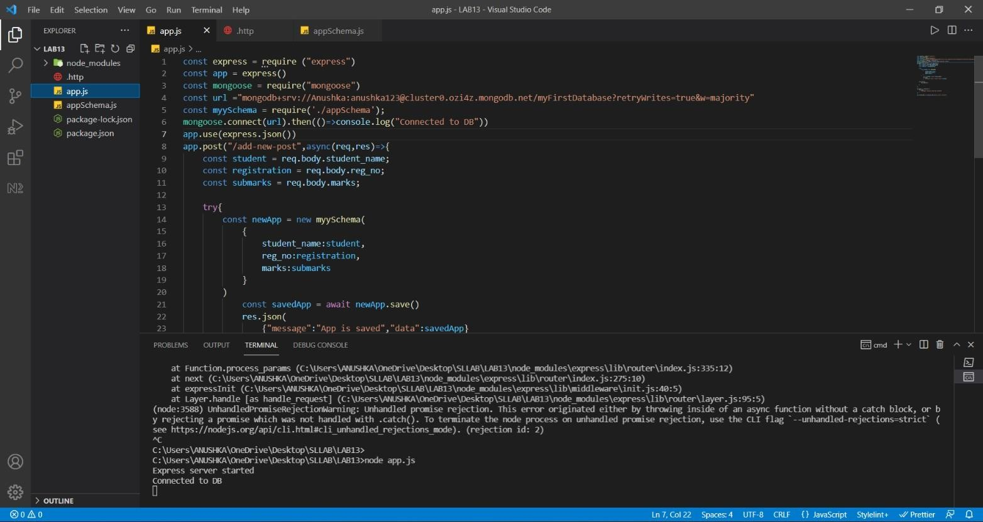

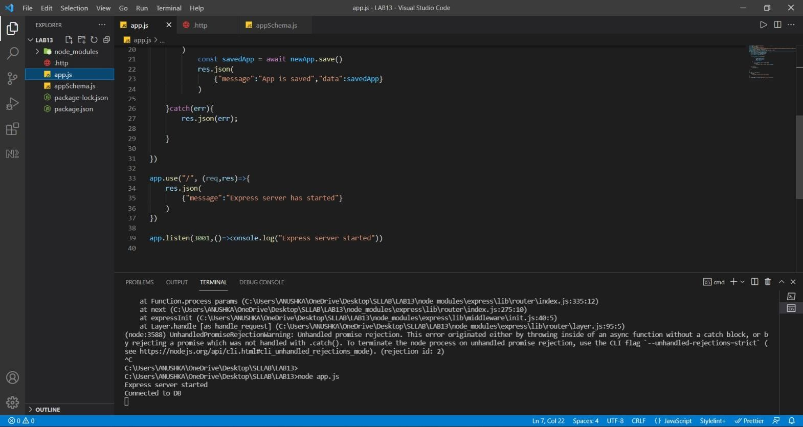

# Schema.js

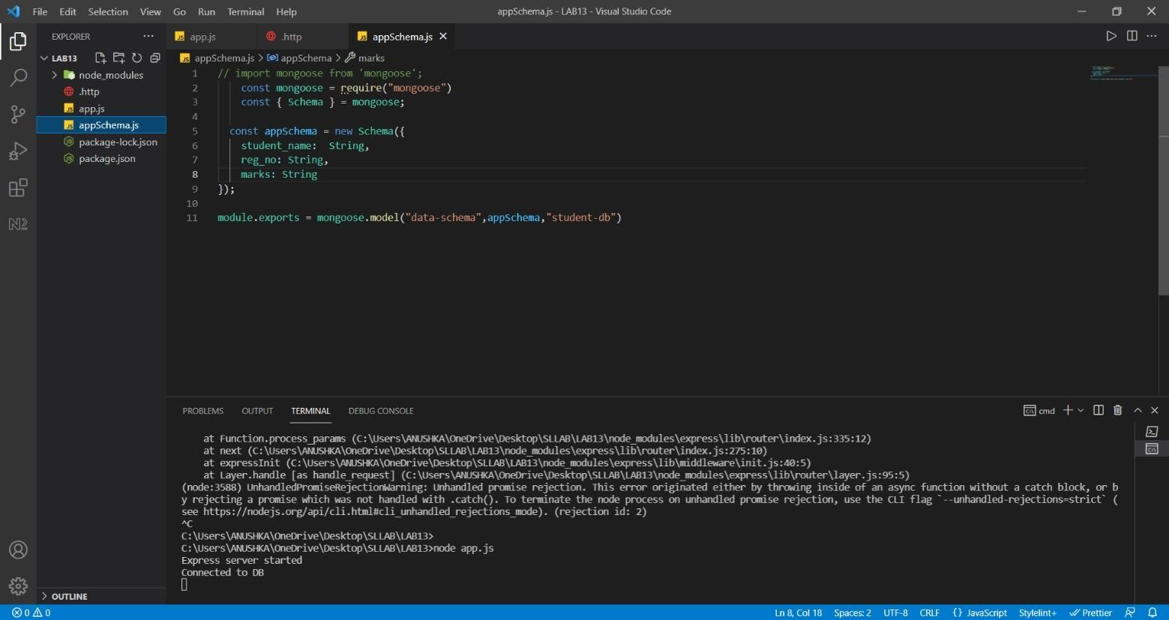

.http file

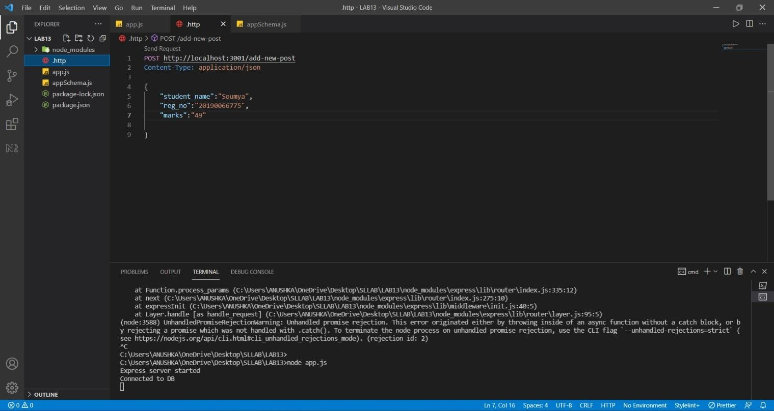

**Screenshot of database,**

**Github repository:** [**https://github.com/rr412/SLlab-13-mongodatabase**](https://github.com/rr412/SLlab-13-mongodatabase)

**Name: Rishu Ranjan**

**Reg no :201900412**