YUVA INTERN
TASK 4
DATA SCIENCE TOOL MASTERY PROJECT
Student Performance Analysis and Score Prediction

Submitted by | Ramesh Singh
Course | BCA - 5th Semester
College | Bhupal Nobles University, Udaipur
Program | Yuva Intern - Data Science
Project type | Practical Data Science Portfolio Project
Dataset | Synthetic educational practice dataset
Submission document prepared for Task 4. No internship dates, certificates, approvals, or external endorsements are claimed.

Declaration
I, Ramesh Singh, submit this report as my practical learning project for Yuva Intern Task 4. The project demonstrates a reproducible data science workflow using Python and commonly used data science libraries. The dataset included with the project is synthetic and was created for practice. The analysis and model results are generated by running the included code.

Acknowledgement
I would like to acknowledge the Yuva Intern program for providing an opportunity to practise data science tools and build a portfolio project. I also acknowledge the open-source Python community and the documentation of the libraries used in this project.

Abstract
This project demonstrates an end-to-end beginner-friendly data science workflow. A structured student-performance practice dataset is loaded with Pandas, inspected and cleaned, explored with descriptive statistics and correlation, and visualized with Matplotlib. A Random Forest regression model from Scikit-learn is trained to estimate a final exam score from study hours, attendance, previous exam score, assignment average and sleep hours. The work demonstrates practical tool usage, model evaluation and clear communication of limitations.

1. Introduction
Data science combines programming, statistics, data handling, visualization and machine learning to extract useful patterns from data. This project uses an educational example to practise the complete workflow rather than demonstrating only isolated library commands.

2. Objectives
- Use Python as the main programming language for a data science workflow.
- Use NumPy and Pandas to create, load, inspect and prepare tabular data.
- Use descriptive statistics and correlation for exploratory data analysis.
- Create clear visualizations with Matplotlib.
- Train a regression model using Scikit-learn and evaluate it on held-out test data.
- Package the code, dataset, outputs and instructions as a reusable portfolio project.

3. Tools and Libraries
Tool / Library | Purpose | Use in this project
Python | Programming language | Project logic, functions and execution
NumPy | Numerical operations | Reproducible synthetic data generation
Pandas | Tabular data handling | CSV loading, cleaning, summaries and correlation
Matplotlib | Data visualization | Scatter plot, histogram and feature-importance chart
Scikit-learn | Machine learning | Train/test split, Random Forest and evaluation metrics
VS Code / Terminal | Development environment | Editing, installing packages and running the script

4. Dataset Description
The dataset contains 150 practice records and six numeric columns. It is synthetically generated using a fixed random seed so that the project can be reproduced. It does not contain names, contact details or real student records.
Column | Meaning
study_hours_per_day | Approximate daily study hours
attendance_percent | Attendance percentage
previous_exam_score | Previous exam score out of 100
assignment_average | Assignment average out of 100
sleep_hours | Approximate sleep hours per day
final_exam_score | Target final exam score out of 100

5. Methodology / Workflow
- Data creation and loading: create a reproducible CSV practice dataset and load it using pandas.read_csv().
- Inspection: review the first rows, dataset dimensions, data types, missing values and descriptive statistics.
- Cleaning: remove duplicate rows and missing values; validate score and attendance ranges.
- Exploratory analysis: inspect relationships and score distribution using summaries, correlation and charts.
- Model preparation: separate the target final_exam_score from the input features.
- Training and testing: split the records into 80% training and 20% test data with random_state=42.
- Modeling: train a RandomForestRegressor with 250 trees and a fixed random state.
- Evaluation: calculate MAE, RMSE and R-squared on the held-out test set.
- Portfolio packaging: save source code, requirements, dataset, charts and run instructions.

6. Exploratory Data Analysis and Results
The average final score in the generated practice dataset is 69.80/100. The practice pass-rate calculation (score at least 40) is 96.7%. These are descriptive results from synthetic records only.
The feature with the strongest positive correlation with final score in this generated dataset is 'study_hours_per_day' (correlation 0.872). Correlation describes association and does not prove that one factor causes a score change.
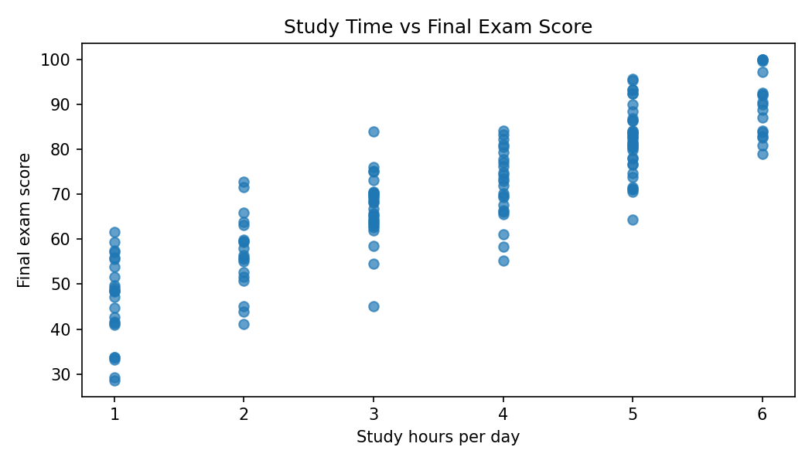
Figure 1. Daily study hours compared with final exam score.
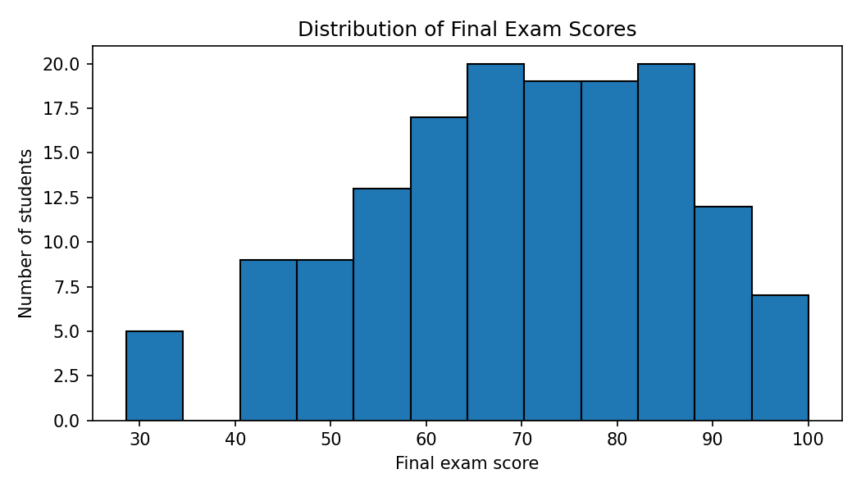
Figure 2. Distribution of final exam scores.

7. Machine Learning Model and Evaluation
A Random Forest Regressor was selected because it can model non-linear relationships and provides feature-importance estimates. The test set was kept separate from training to estimate performance on unseen records.
Metric | Result
Mean Absolute Error (MAE) | 6.25
Root Mean Squared Error (RMSE) | 7.59
R-squared (R²) | 0.837
MAE is the average absolute prediction error in score points. RMSE gives greater weight to larger errors. R-squared measures the proportion of test-target variation explained by the model; it can be negative on a weak model and should not be interpreted as proof of real-world accuracy.
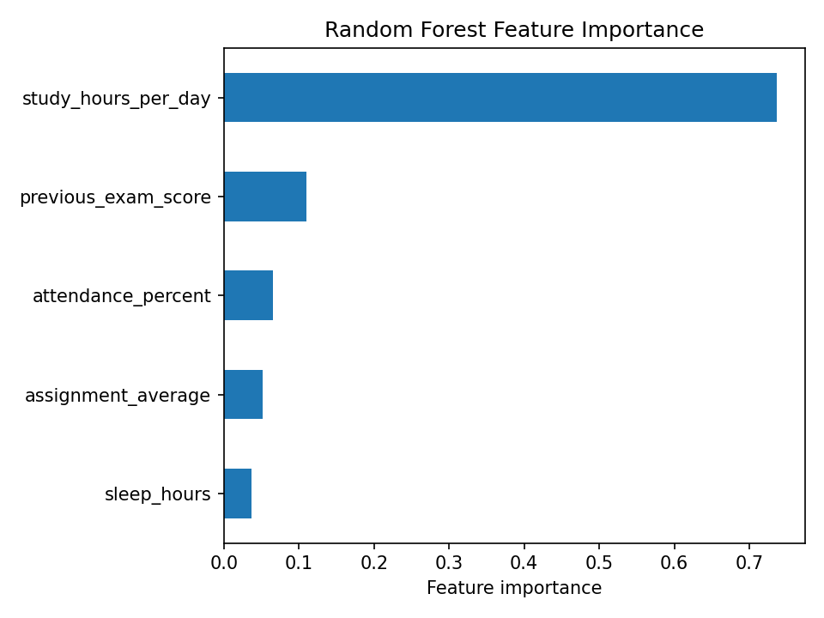
Figure 3. Feature importance estimated by the fitted Random Forest model.

8. Practical Exercises Demonstrated
- Read a CSV file and preview records using Pandas.
- Check missing values, duplicate rows, ranges and descriptive statistics.
- Calculate correlations and summarize the target variable.
- Create a scatter plot and histogram with Matplotlib.
- Split data into training and testing subsets.
- Fit a Random Forest regression model and calculate three evaluation metrics.
- Save generated charts in a dedicated output folder.

9. How to Run the Project
- Install Python 3.10 or later and open the project folder in Visual Studio Code.
- Open Terminal → New Terminal.
- Install dependencies using: python -m pip install -r requirements.txt
- Run the program using: python main.py
- If the Windows Python launcher is configured instead, use: py main.py
- Check the terminal for dataset summary and evaluation metrics; check outputs/ for charts.

10. Project Structure
student-performance-data-science/\n├── main.py\n├── requirements.txt\n├── README.md\n├── data/\n│ └── student_performance.csv\n└── outputs/\n ├── study_vs_score.png\n ├── score_distribution.png\n ├── feature_importance.png\n └── sample_run.txt

11. Limitations and Responsible Use
- The data is synthetic and does not represent a real institution or real students.
- Model metrics on synthetic data do not establish performance on real educational data.
- The feature relationships were generated for practice; correlation and feature importance do not establish causation.
- A real deployment would require permission, privacy safeguards, representative data, bias checks, validation and human oversight.
- The model is a learning demonstration, not a tool for grading, admissions or other high-impact decisions.

12. Conclusion
The project demonstrates practical use of key data science tools across data loading, cleaning, exploration, visualization, machine learning and evaluation. It is packaged so that another learner can reproduce the workflow in VS Code. The work provides a foundation for extending the project with a real, authorized dataset, cross-validation, model comparison and a dashboard.

13. References
- Python documentation: https://docs.python.org/3/
- NumPy documentation: https://numpy.org/doc/
- Pandas documentation: https://pandas.pydata.org/docs/
- Matplotlib documentation: https://matplotlib.org/stable/
- Scikit-learn documentation: https://scikit-learn.org/stable/

Appendix A - Main Program
The complete runnable source code is included as main.py in the accompanying project ZIP. The following is the main workflow:
df = pd.read_csv(DATA)
df = df.drop_duplicates().dropna()
X = df.drop(columns=["final_exam_score"])
y = df["final_exam_score"]
X_train, X_test, y_train, y_test = train_test_split(
X, y, test_size=0.20, random_state=42
)
model = RandomForestRegressor(
n_estimators=250, random_state=42, max_depth=6
)
model.fit(X_train, y_train)
predictions = model.predict(X_test)
print(mean_absolute_error(y_test, predictions))
print(mean_squared_error(y_test, predictions) ** 0.5)
print(r2_score(y_test, predictions))

Appendix B - Sample Execution
Verified local run completed successfully (exit code 0). The same script prints dataset preview, missing-value counts, descriptive statistics, test metrics (MAE 6.25, RMSE 7.59, R² 0.837) and saves three charts.

Student Submission Checklist
- Upload the .docx report in the Yuva Intern Task 4 report upload field.
- Optionally upload the project to GitHub and paste the repository URL in the GitHub project URL field.
- Keep the ZIP and project files as supporting material; the page specifically requests a Word report (.doc or .docx).
- Before final submission, open the Word file once and confirm your name and college details are correct.

