YUVA INTERN — TASK 2
HANDS-ON DATA LAB IMPLEMENTATION
Student Performance Data Analysis
Submitted by: Ramesh Singh
Course: BCA 5th Semester
College: Bhupal Nobles University, Udaipur
Task: Hands-On Data Lab Implementation

1. Introduction
This project demonstrates a complete data-analysis workflow using Python. The work includes loading a CSV dataset, inspecting data quality, cleaning missing and invalid values, calculating descriptive statistics, examining correlations, comparing attendance groups and generating charts.

2. Dataset description
The dataset contains 120 fictional student records with student ID, study hours, attendance percentage, assignments completed, previous score and final score. It is synthetic practice data created for this project and does not contain real student information. A few missing values and one impossible attendance value were intentionally included to demonstrate data cleaning.

3. Tools and libraries
Python; Pandas for CSV handling and tabular analysis; NumPy for numerical operations; Matplotlib for charts; Visual Studio Code for execution.

4. Methodology and cleaning
- Loaded the source CSV with pandas.read_csv().
- Inspected missing values in the numeric columns.
- Changed attendance values outside 0–100 into missing values.
- Filled missing numeric values using the median of each column.
- Kept attendance and final scores within the valid 0–100 range.
- Exported cleaned data, descriptive statistics, correlations and five charts.

5. Specific code examples
data = pd.read_csv(DATA)
missing_before = data.isna().sum()
data.loc[~data["attendance_percent"].between(0, 100),
"attendance_percent"] = np.nan
for col in data.select_dtypes(include="number").columns:
data[col] = data[col].fillna(data[col].median())
stats = data[["hours_studied", "attendance_percent",
"assignments_completed", "previous_score",
"final_score"]].describe().round(2)
correlation = data.select_dtypes(include="number").corr()

6. Descriptive statistical analysis
The following table is generated from the cleaned 120-row dataset. Mean represents the average; standard deviation indicates spread; quartiles describe the distribution.
Measure | Hours | Attendance | Assignments | Previous | Final
mean | 3.73 | 77.49 | 6.66 | 58.36 | 78.2
std | 1.15 | 11.46 | 2.42 | 14.2 | 10.16
min | 1.2 | 52.2 | 3.0 | 25.3 | 53.8
25% | 3.0 | 69.03 | 4.0 | 48.58 | 71.9
50% | 3.8 | 76.3 | 7.0 | 60.8 | 77.9
75% | 4.53 | 83.68 | 9.0 | 68.53 | 84.85
max | 7.0 | 100.0 | 10.0 | 90.6 | 100.0
Rows analysed: 120. Final-score mean: 78.20; median: 77.90; standard deviation: 10.16; minimum: 53.8; maximum: 100.0.

7. Correlation findings
- final_score: r = 1.000
- hours_studied: r = 0.523
- previous_score: r = 0.448
- attendance_percent: r = 0.341
- assignments_completed: r = 0.335
The correlation coefficient ranges from -1 to +1. A positive value indicates that higher values tend to occur together; a negative value indicates an inverse association. These results describe this synthetic dataset only and do not prove causation.

8. Generated charts and observations

Score distribution
The histogram shows how the 120 final scores are distributed across score intervals. It helps identify the central score range and whether scores are spread widely or clustered.
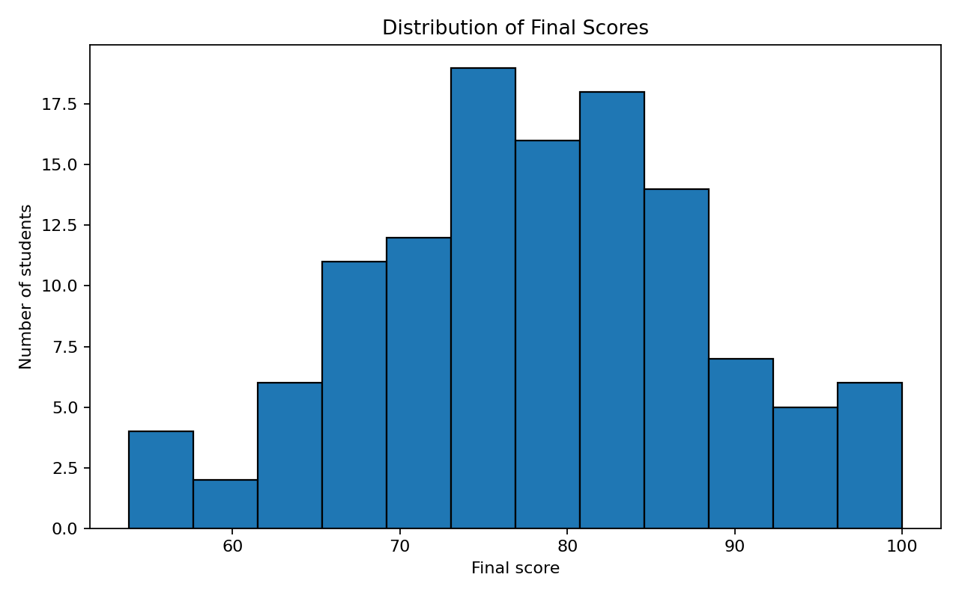

Study hours versus final score
The scatter plot and fitted trend line help inspect whether students reporting more study hours tend to have higher final scores. Individual points show variation around the overall pattern.
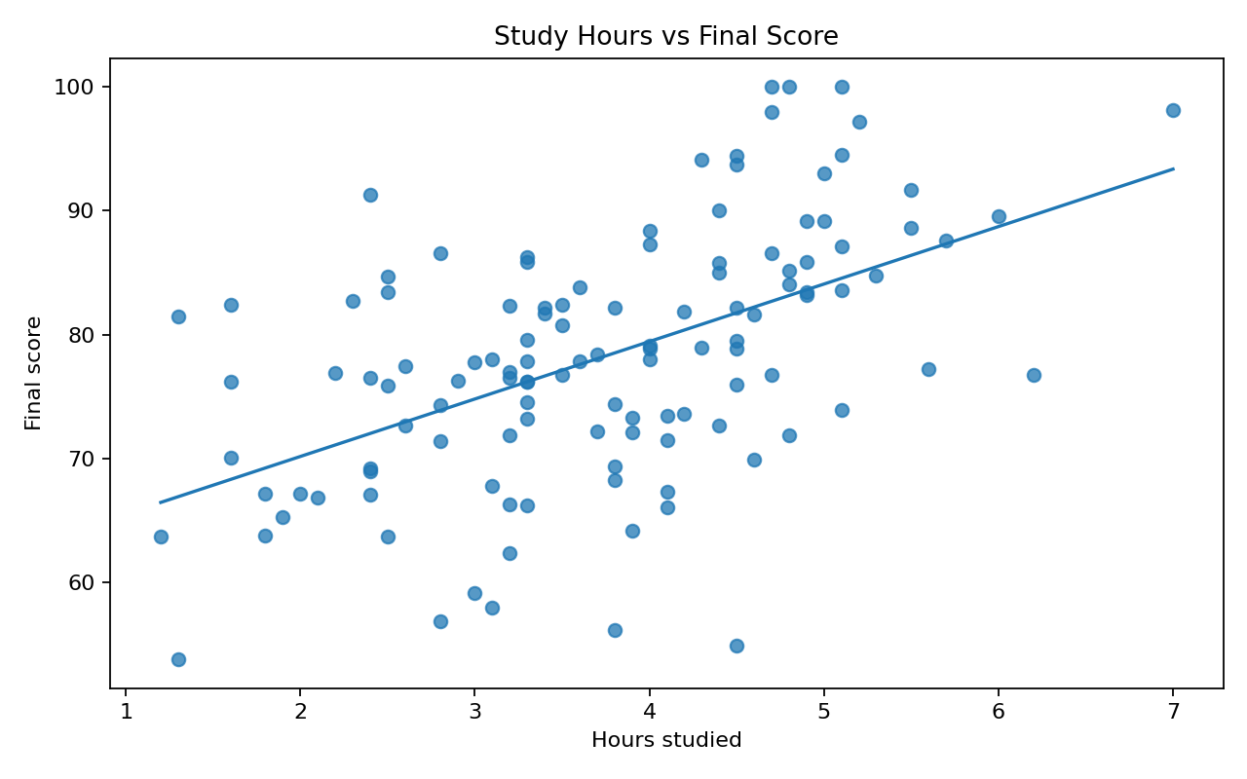

Attendance versus final score
The scatter plot compares attendance percentage with final score. The fitted line summarizes the overall linear direction, while the spread indicates that attendance is not the only factor related to scores.
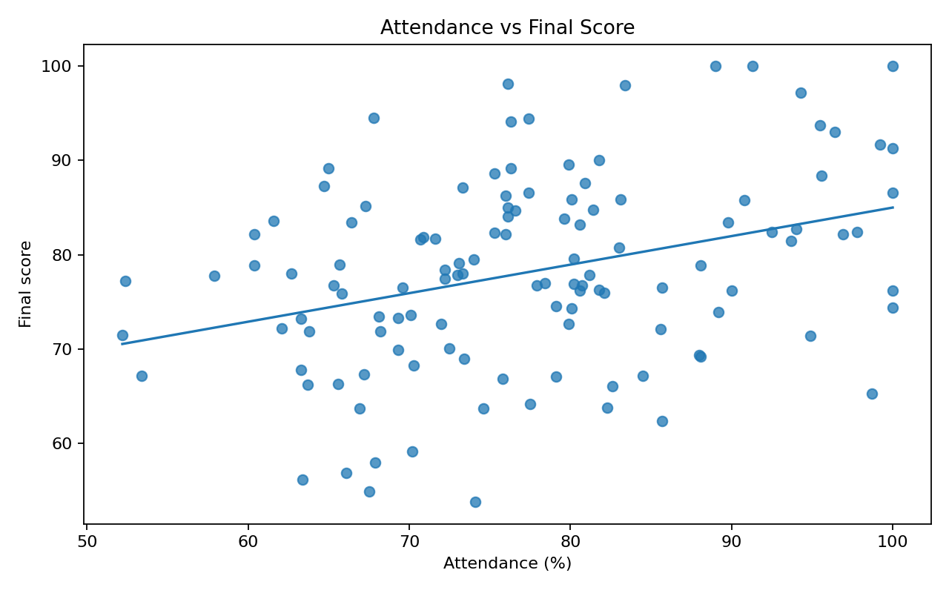

Correlation matrix
The annotated matrix displays pairwise Pearson correlation coefficients. Values nearer +1 show stronger positive association, values near 0 show weaker linear association, and values nearer -1 show stronger negative association.
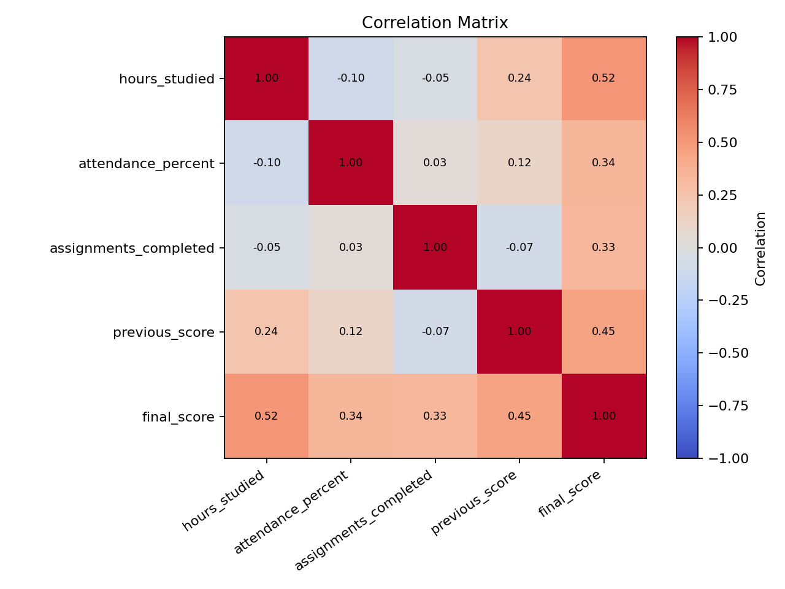

Average score by attendance group
The bar chart compares mean final scores across attendance bands. Groups with fewer records should be interpreted cautiously; the chart is descriptive rather than causal.
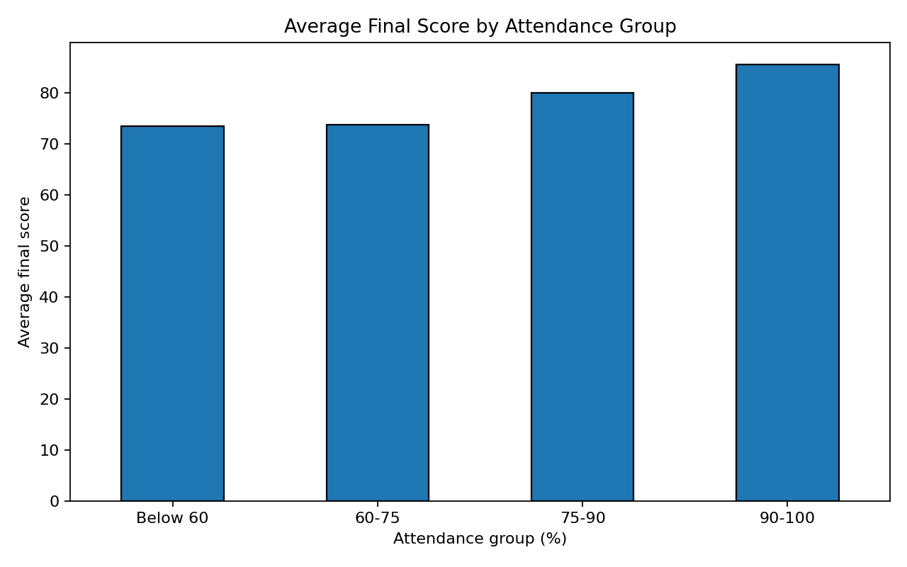

9. Conclusion
The project demonstrates a reproducible end-to-end data lab: data import, validation, cleaning, descriptive statistics, correlation analysis, group comparison and visualization. The program saves its outputs automatically, making the analysis repeatable. Since the dataset is synthetic, findings are for demonstrating analytical methods and should not be generalized to real students.

10. Evidence required for resubmission
The evaluator specifically requested concrete evidence. Before submitting, the student must capture genuine screenshots from their own VS Code run: (1) project files and main.py, (2) terminal command and SUCCESS output, (3) generated outputs folder, (4) readable chart windows, and (5) final GitHub repository page. Put these screenshots in an evidence/ folder and upload them to GitHub. The report does not pretend that these personal execution screenshots have already been captured.

11. Reproduction instructions
Open the project folder in VS Code, install dependencies with `python -m pip install -r requirements.txt`, and execute `python main.py`. The program generates the cleaned CSV, descriptive statistics CSV, analysis summary TXT and five PNG charts in outputs/.

