ANALYTICS REPORT & INSIGHTS DOCUMENTATION
Project: Student Performance Analytics and Insights

Student Details
- Name: Ramesh Singh
- Course: BCA – 5th Semester
- College: Bhupal Nobles University, Udaipur
- Internship Program: Yuva Intern
- Task: 5 – Analytics Report & Insights Documentation
- Dataset: Synthetic practice dataset (500 records)

1. Executive Summary
This project demonstrates a complete student-performance analytics workflow using 500 synthetic practice records. The analysis calculates performance indicators, examines relationships among study hours, attendance, assignment scores and previous scores, compares attendance groups, and creates visualizations. The average final score is 47.33/100 and the score-based pass rate (final score >= 40) is 78.40%. A Random Forest regression model is evaluated on a held-out test set as a demonstration, not as a real-world decision system.

2. Business Objective and Questions
Objective: demonstrate how structured analysis can help an educational stakeholder understand student performance patterns and identify areas where additional academic support may be useful.
- What are the average and median final scores?
- How do attendance groups compare in average final score?
- Which measured factor has the strongest correlation with final score?
- What patterns are visible between daily study hours and final score?
- How accurately does a simple regression model estimate scores on a held-out test set?

3. Dataset and Data Preparation
The included CSV contains 500 synthetic records and the columns student_id, study_hours_per_day, attendance_percent, assignment_score, previous_score and final_score. The dataset was generated for this project because no real student records were supplied. The program checks required columns, removes duplicate rows, converts numeric fields and excludes rows with missing required values. No real student identity or confidential record is used.

4. Methodology
- Descriptive analytics: count, mean, standard deviation, minimum, quartiles and maximum.
- Correlation analysis: measure linear association between input factors and final score.
- Group analysis: compare average final scores for attendance below 60%, 60–75%, and above 75%.
- Visualization: create a histogram, attendance comparison, scatter plot and correlation chart.
- Predictive demonstration: train/test split and RandomForestRegressor evaluation using MAE, RMSE and R-squared.

5. Key Metrics and Findings
Metric | Result
Records analyzed | 500
Average final score | 47.33/100
Median final score | 47.46/100
Average attendance | 77.35%
Average study time | 3.19 hours/day
Score-based pass rate (>=40) | 78.40%
Strongest absolute correlation | study_hours_per_day (0.391)
Average final score by attendance group:
- Below 60%: 42.62/100
- 60-75%: 45.83/100
- Above 75%: 48.76/100
Model evaluation on the held-out test set: MAE = 5.609, RMSE = 7.129, and R-squared = 0.513. These scores describe performance on this synthetic dataset only.

6. Visualizations
Figure 1. Distribution of final scores.
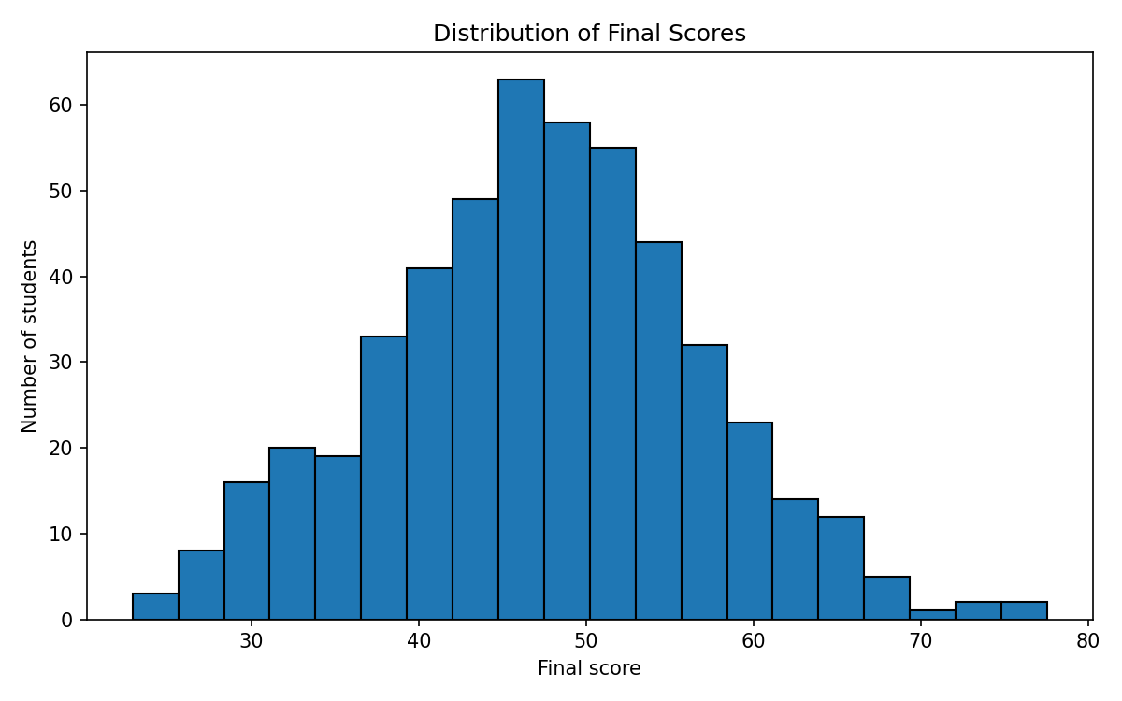
Figure 2. Average final score by attendance group.
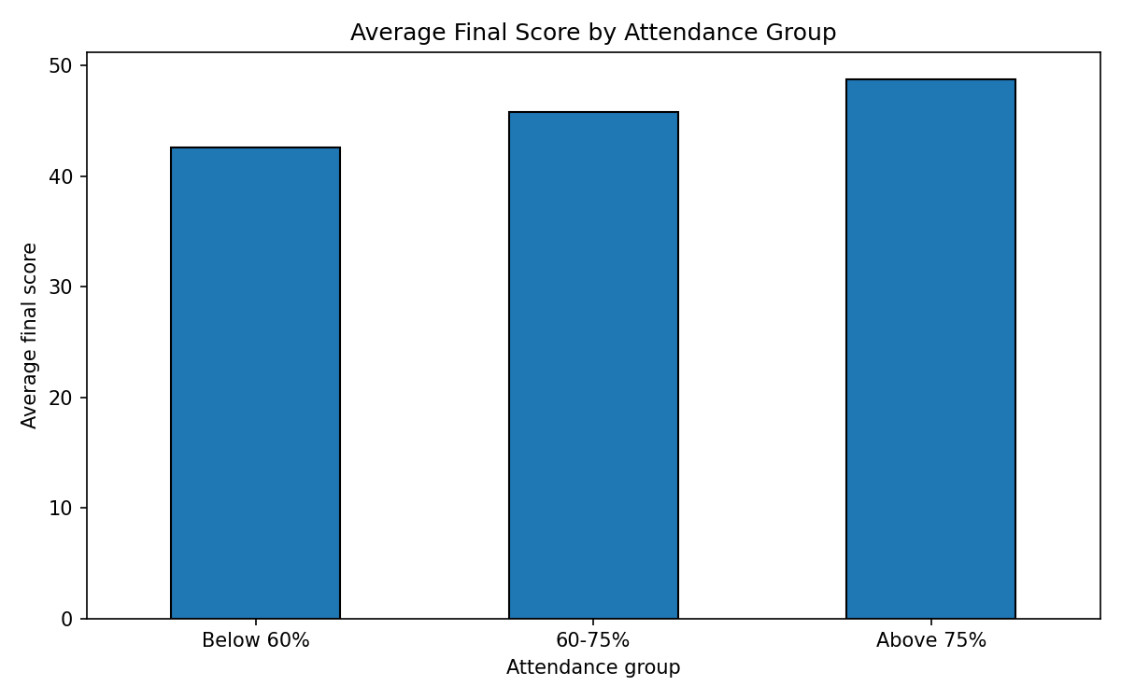
Figure 3. Relationship between daily study hours and final score.
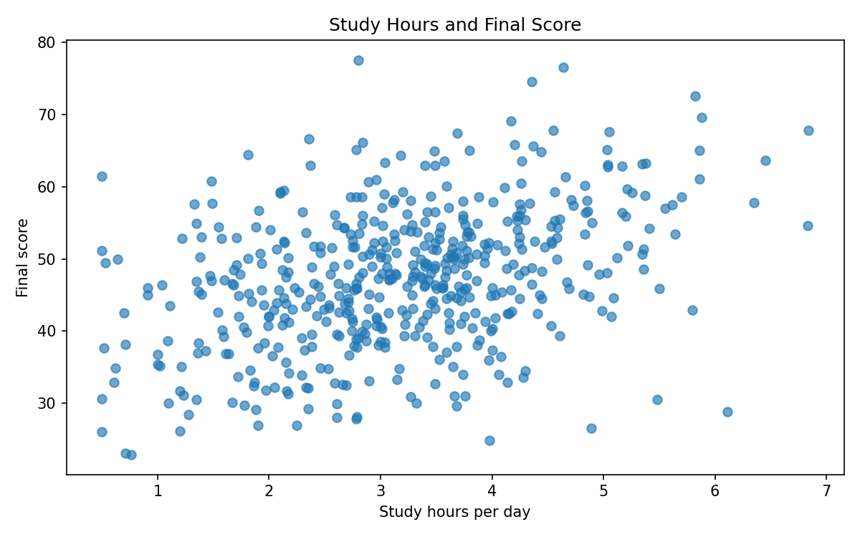
Figure 4. Correlation of measured factors with final score.
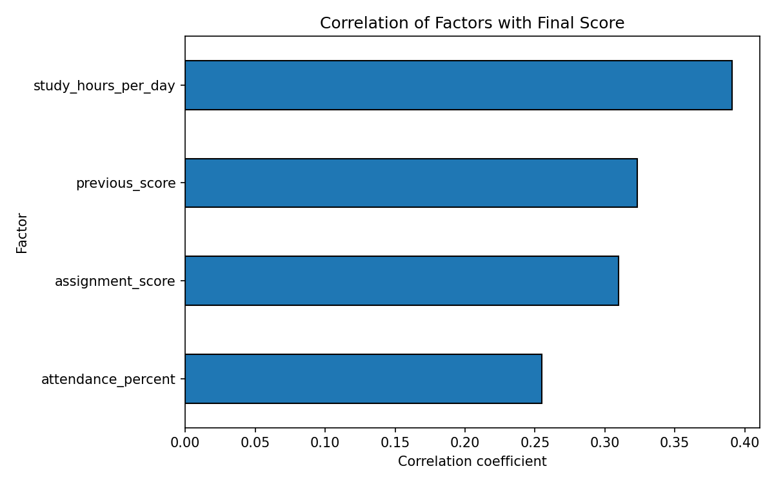

7. Business Insights
The summary metrics provide a high-level view of the synthetic cohort. Attendance-group averages help identify whether lower-attendance groups may need closer review. Correlation results show which variables move most closely with final score in this dataset. These are associations and do not establish that one factor causes a change in another. Charts make distributions and patterns easier to communicate to a non-technical stakeholder.

8. Actionable Recommendations
- Review students with low attendance and offer timely academic support.
- Encourage a consistent study routine and check progress at regular intervals.
- Use assignment feedback to identify specific topic-level learning gaps.
- Compare performance trends over time before deciding whether an intervention is effective.
- Use real data only with appropriate permission, privacy safeguards and institutional review.

9. Limitations and Responsible Use
The dataset is synthetic and intended only for demonstration. It may not represent the behavior of any real student group. Correlation is not causation, and the predictive model should not be used to grade, rank, admit or make decisions about real students. Real-world use would require validated data, stakeholder review, fairness checks and privacy protection.

