電腦網路導論 HW2

-B04901110 林冠宇

1. [Socket Programming - TCP]

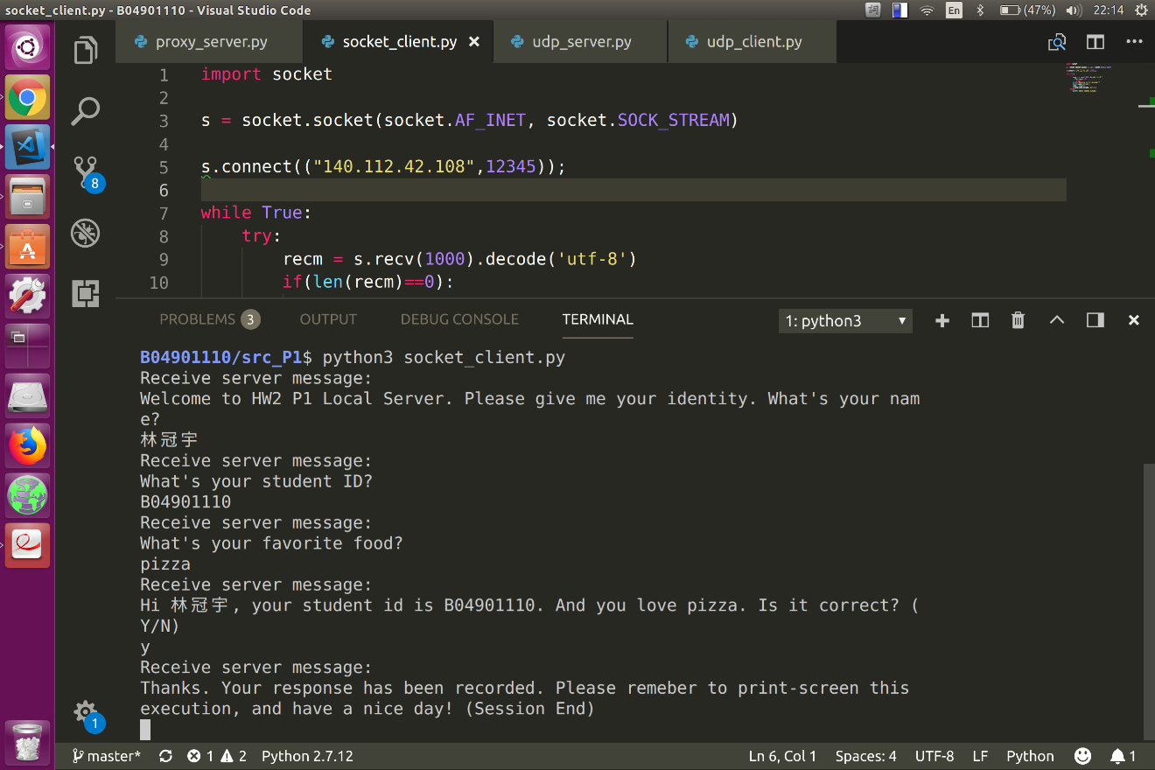

1. (a)Run on same machine: 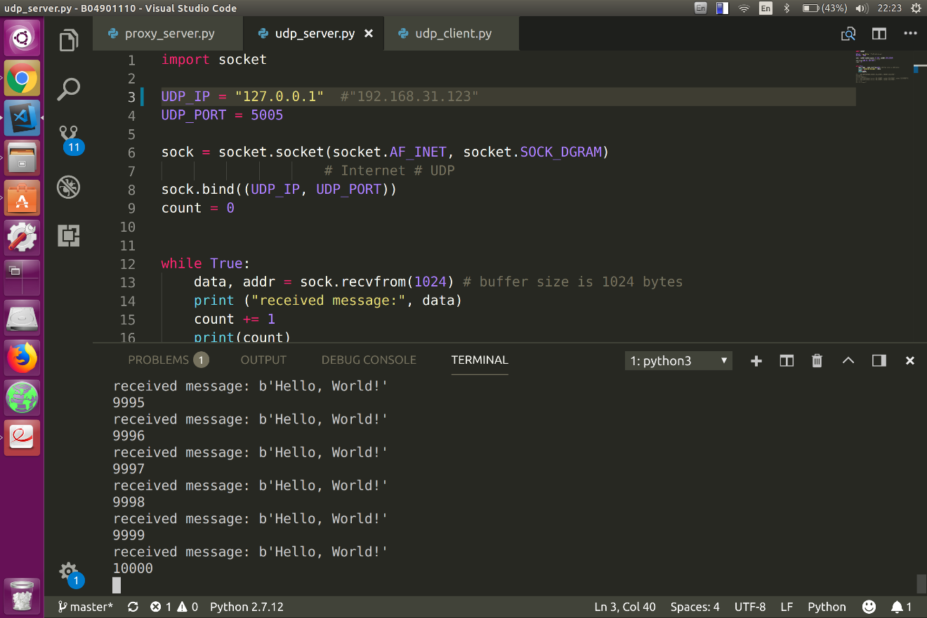

how many packets will the server receive? 10000

And how many of them are lost? 0

(b)Run on different machine -1:

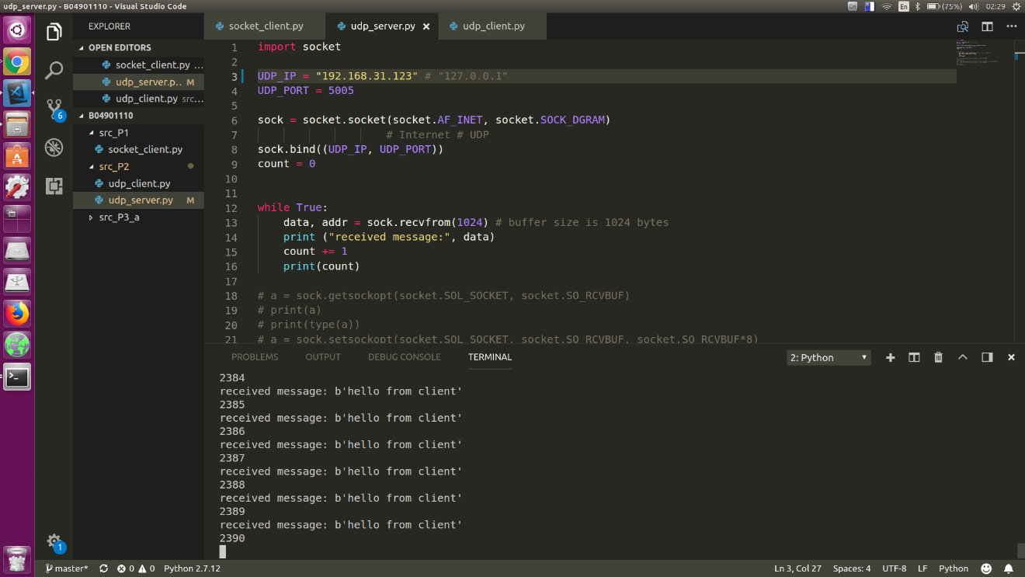

The loss rate is about 76% which is quite unacceptable, therefore I add (time.sleep(0.0001)) after each packet sent, and below is the improved result.

(b)Run on different machine -2 (improved):

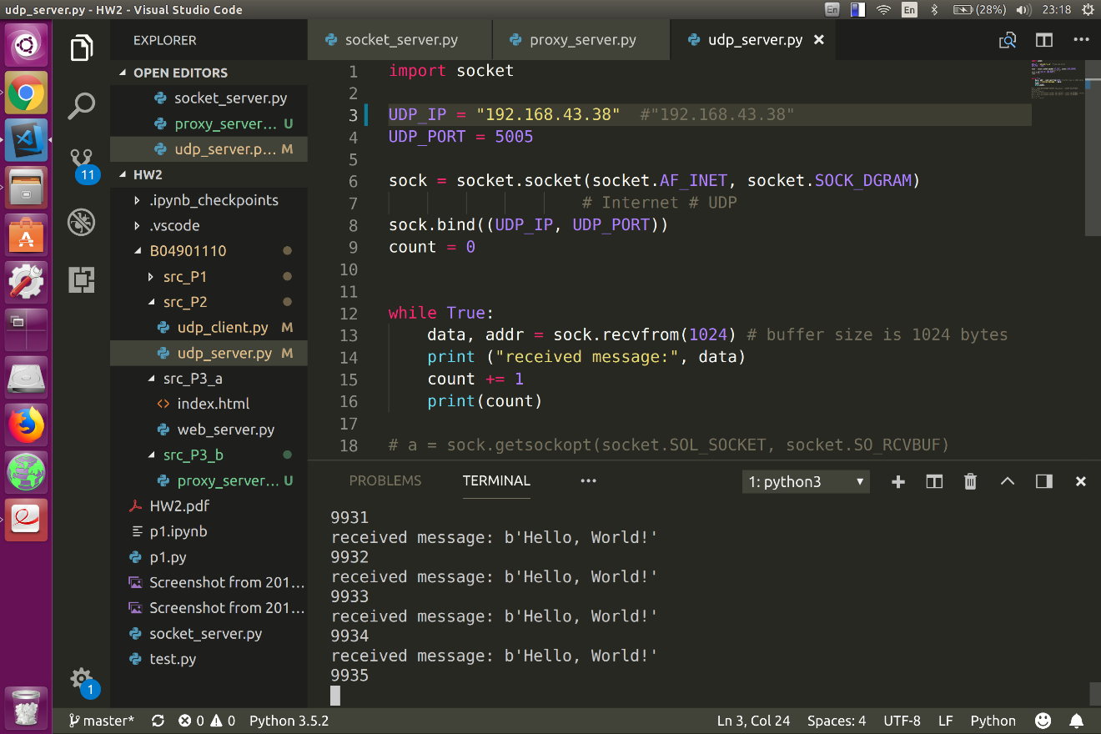

Which is much better than the previous experiment.

1. (a) if requested file exist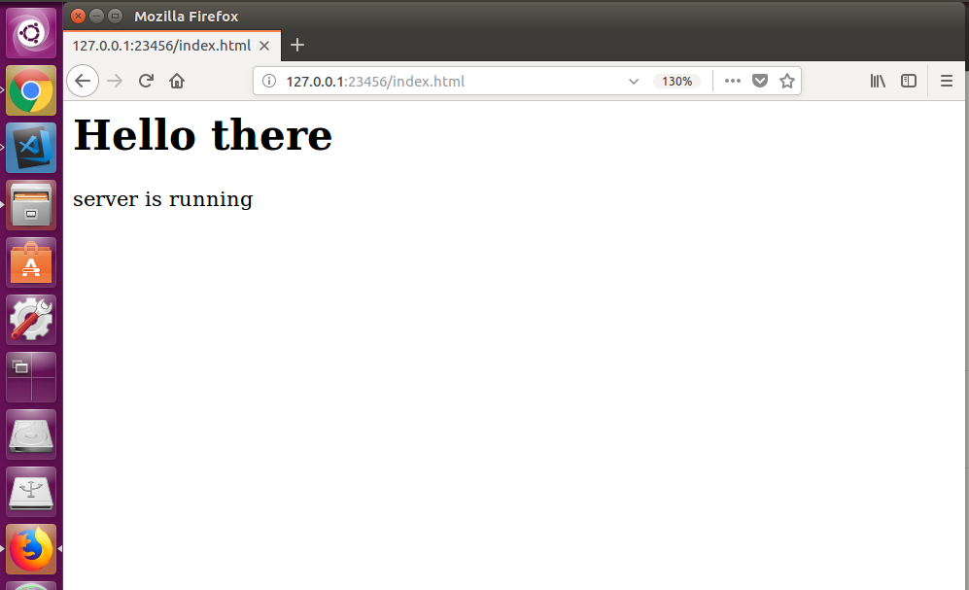

If request file is not in the server



(b) proxy succeeded in requesting file from the web server implemented in 3(a) after the first request from the client

And then send to client after the second request from the client