電腦網路導論 HW3

電機三 林冠宇 B04901110

-IPv6

Internet Protocol version 6，a new version of Internet Protocal

Difference from IPv4

Number of identifier bits: 32 -> 128

Address expression: (ex) 140.112.2.3 -> 1079:3:6ED4::44:72BE

Safety: IPSec not open by default -> IPSec open by default

QoS: not available in headers -> available in headers

Format:

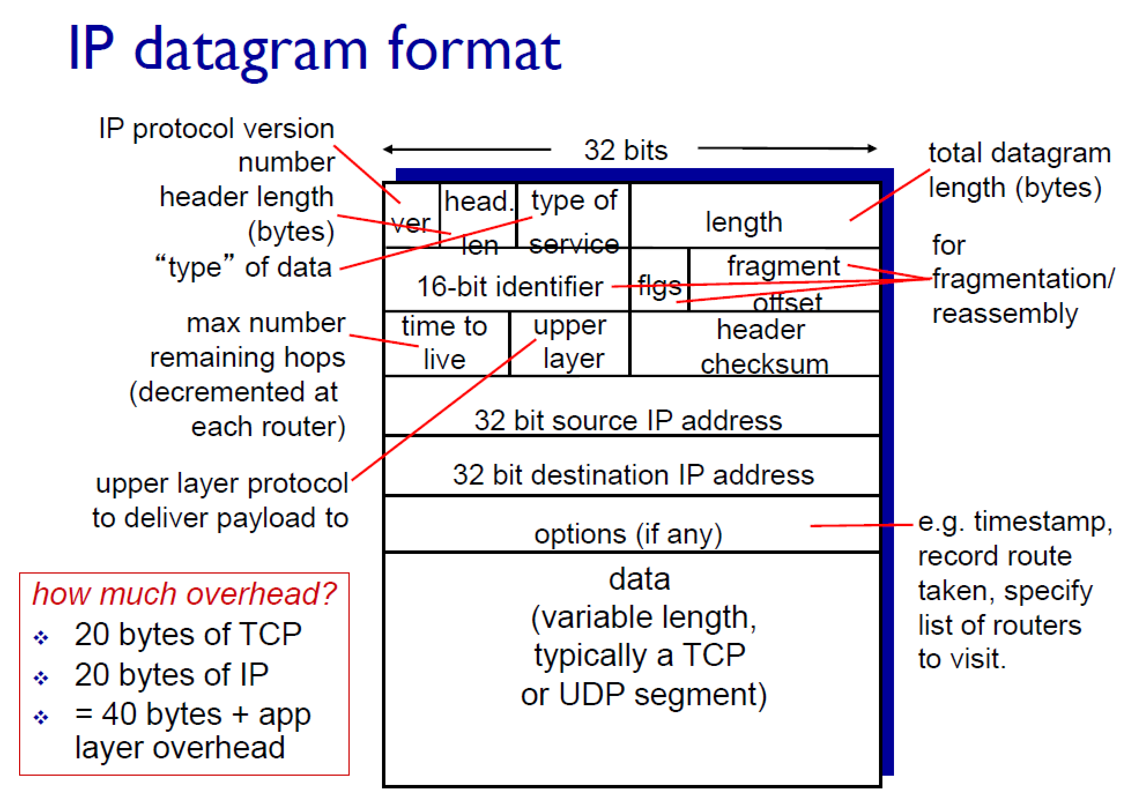

🡪

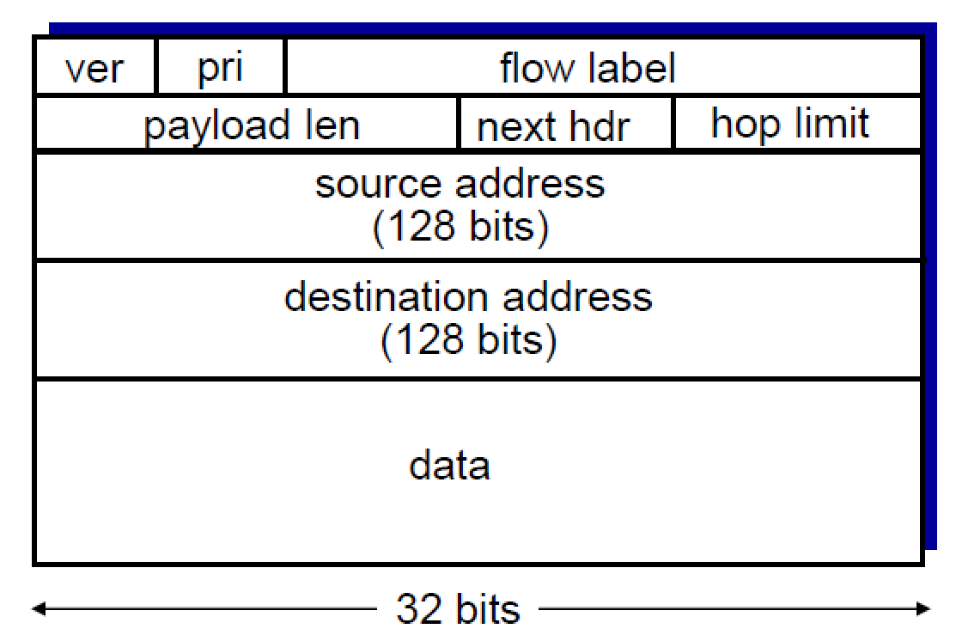

Hand written Part

