DCLAB team08 使用手冊

組員: 陳建良， 林冠宇， 陳延昊

1. After fpga is inserted with our program, click the lower right button to start.

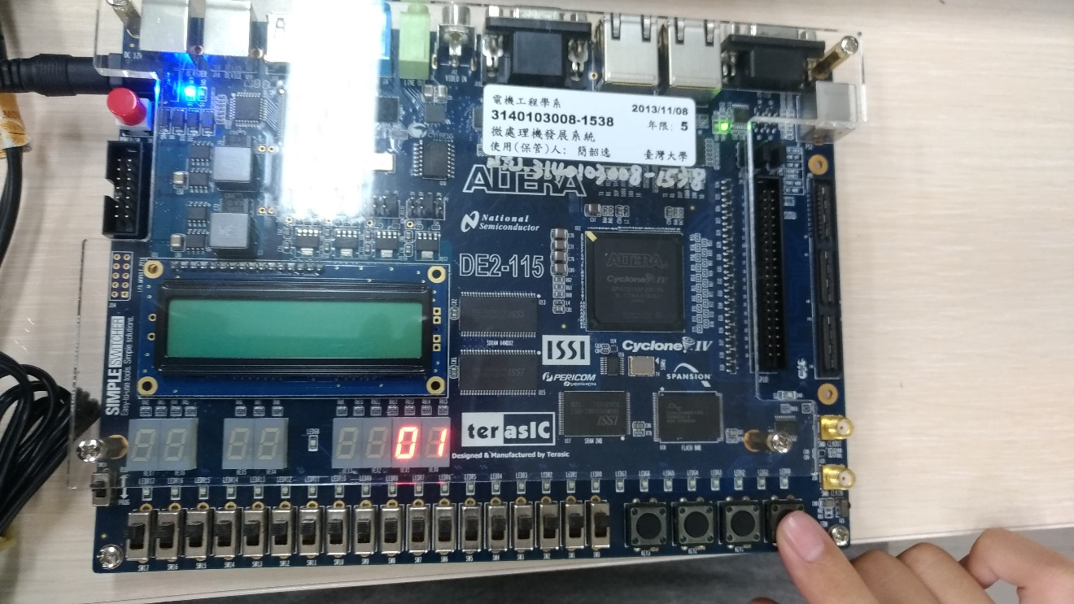

1. After pressing the button, the number on seven-segment display would start to flip,

that is, the number displayed would keep refreshing (ex: 01 -> 13 -> 10 -> 02 -> ....) until about 7 seconds after we press the button.

1. The integer numbers displayed are always within [1,15], which is a requisite in SPEC.
2. If we then press the lower right button again, the process would repeat, ie, numbers on the display board flip, and then the flipping frequency decrease, and finally freeze at a certain number.