Below we will illustrate how to initialize a project then compile, and finally output the program to FPGA

1. Click “New project wizard”

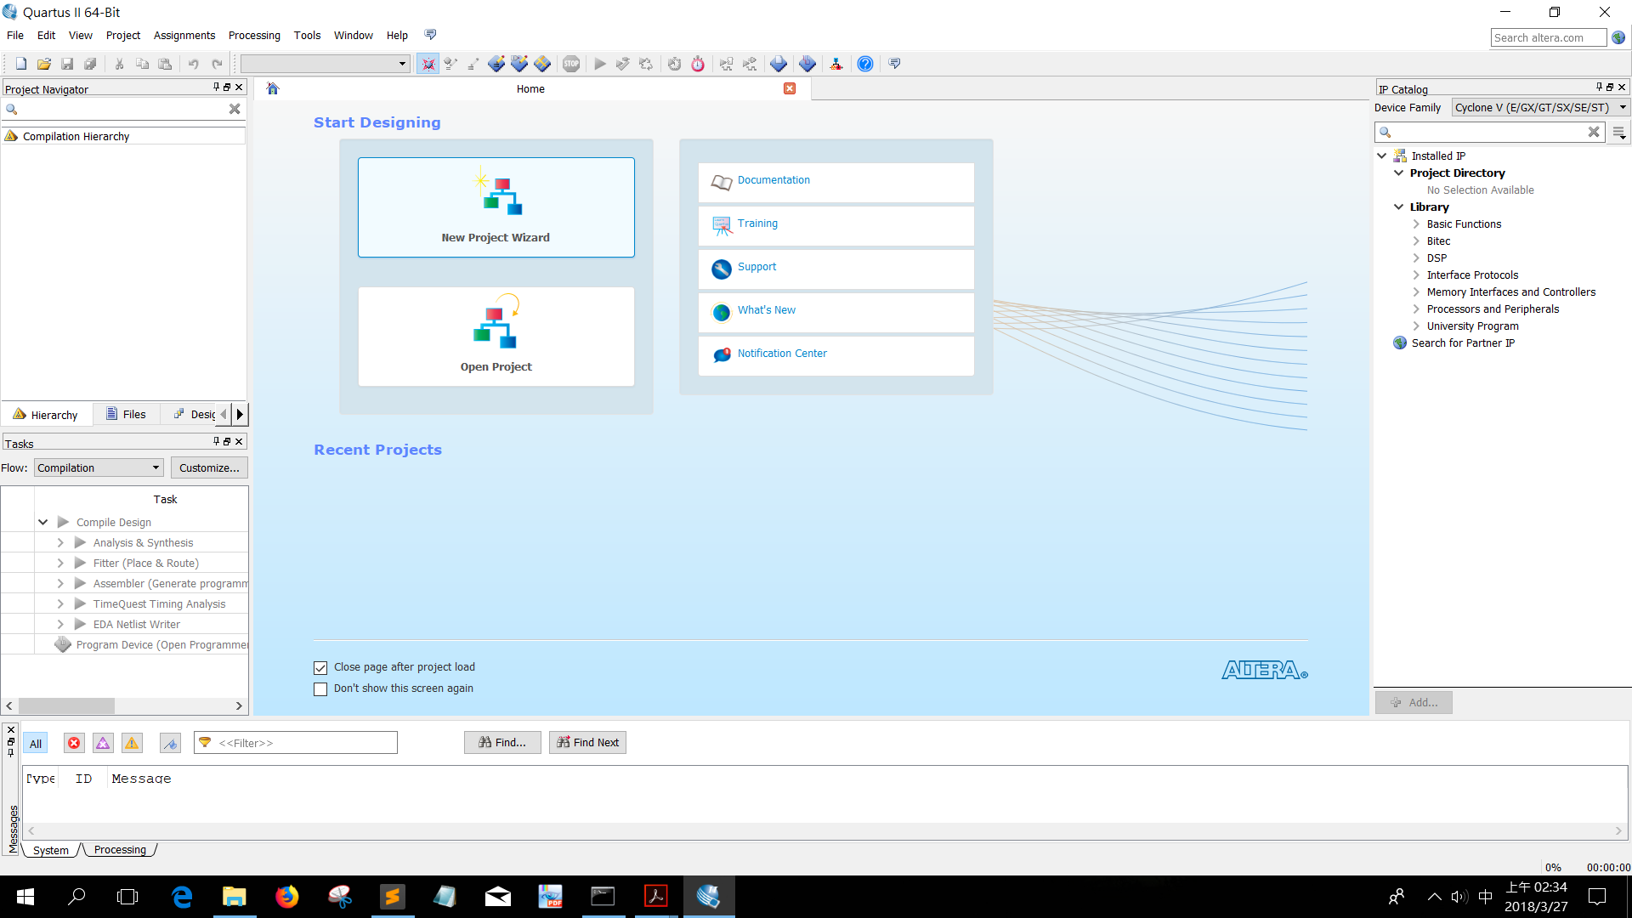

2.click next

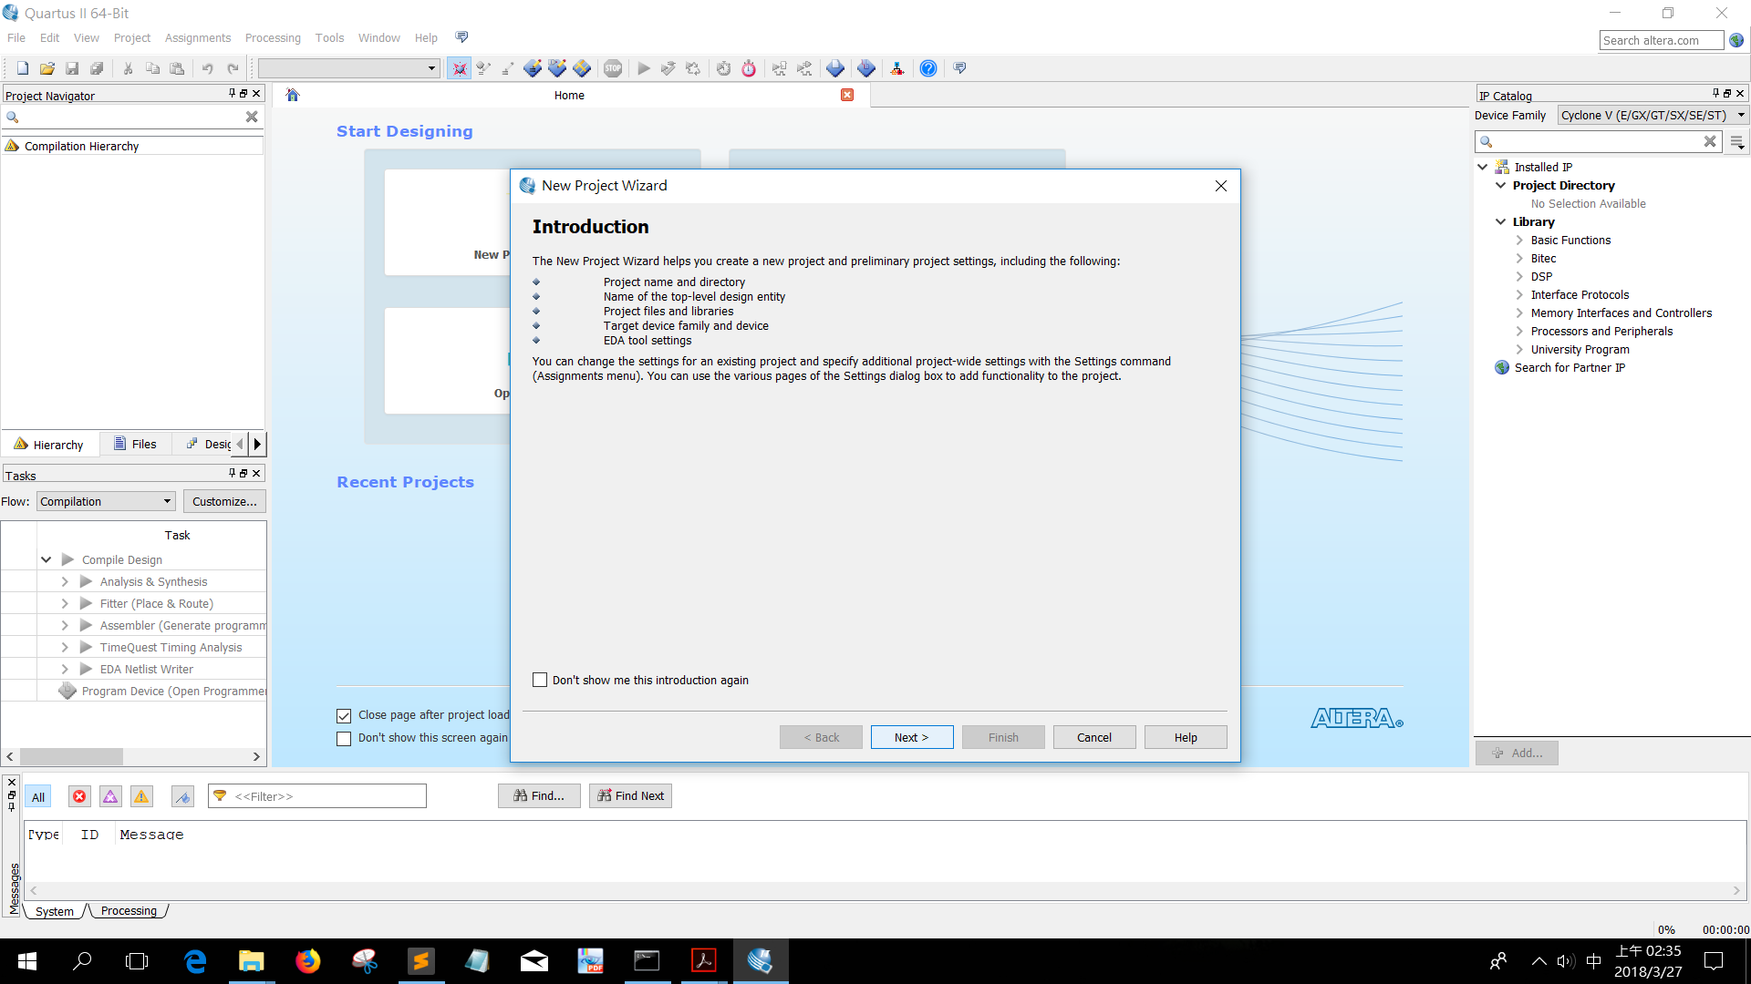

1. Choose the DE2_115 directory, and set the name of the project DE2_115,

Otherwise, there will be some issues

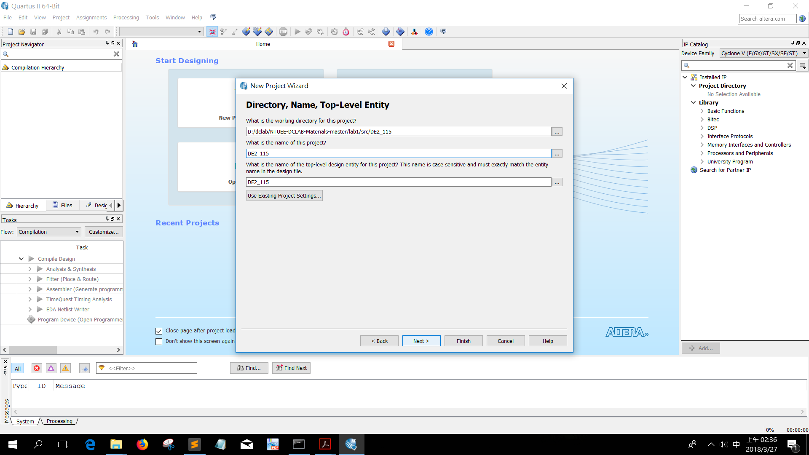

1. Choose the first one or second one.

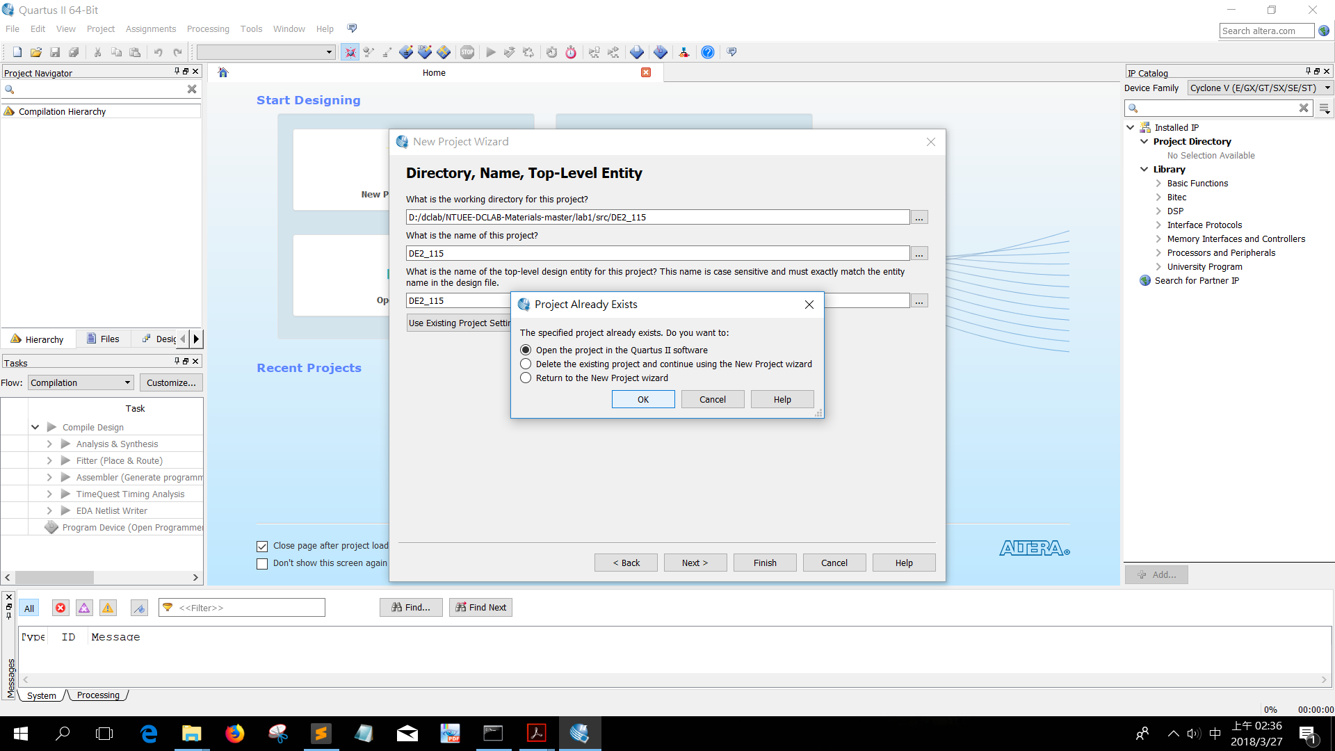

1. Click compile button

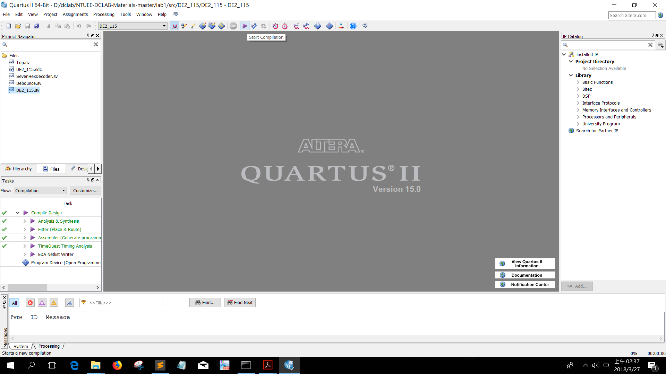

1. It may take a while to compile. After compile, click programmer button

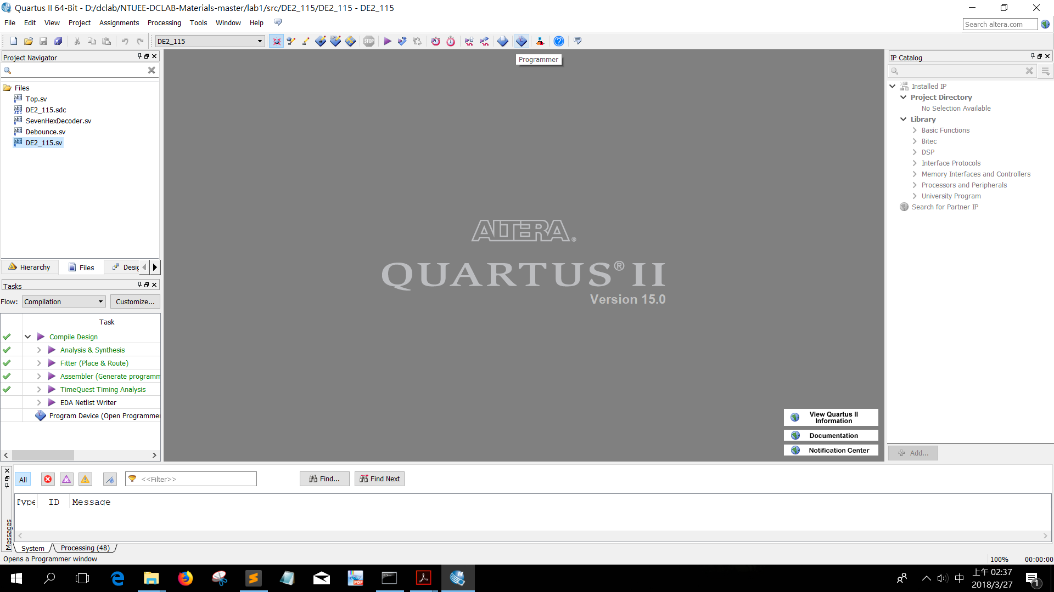

1. Click “add files”

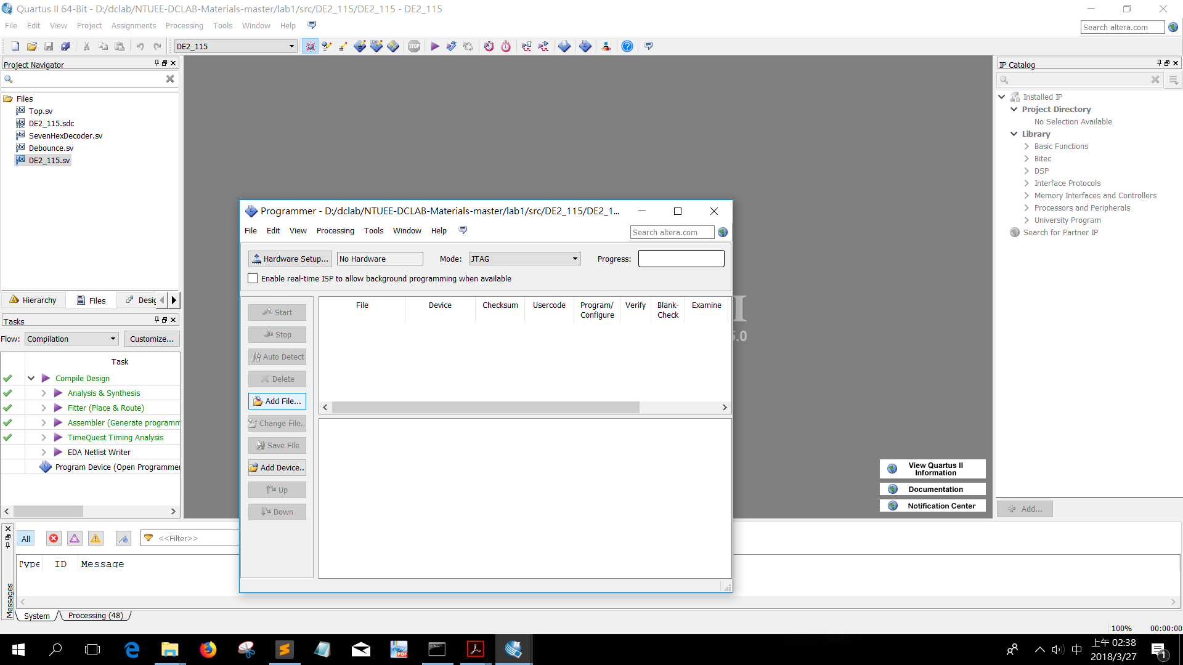

1. Choose the directory “output_files”

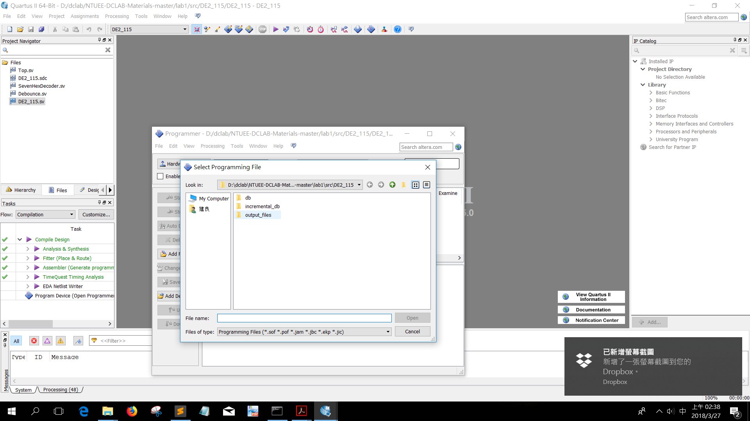

1. Choose the DE2_115.sof

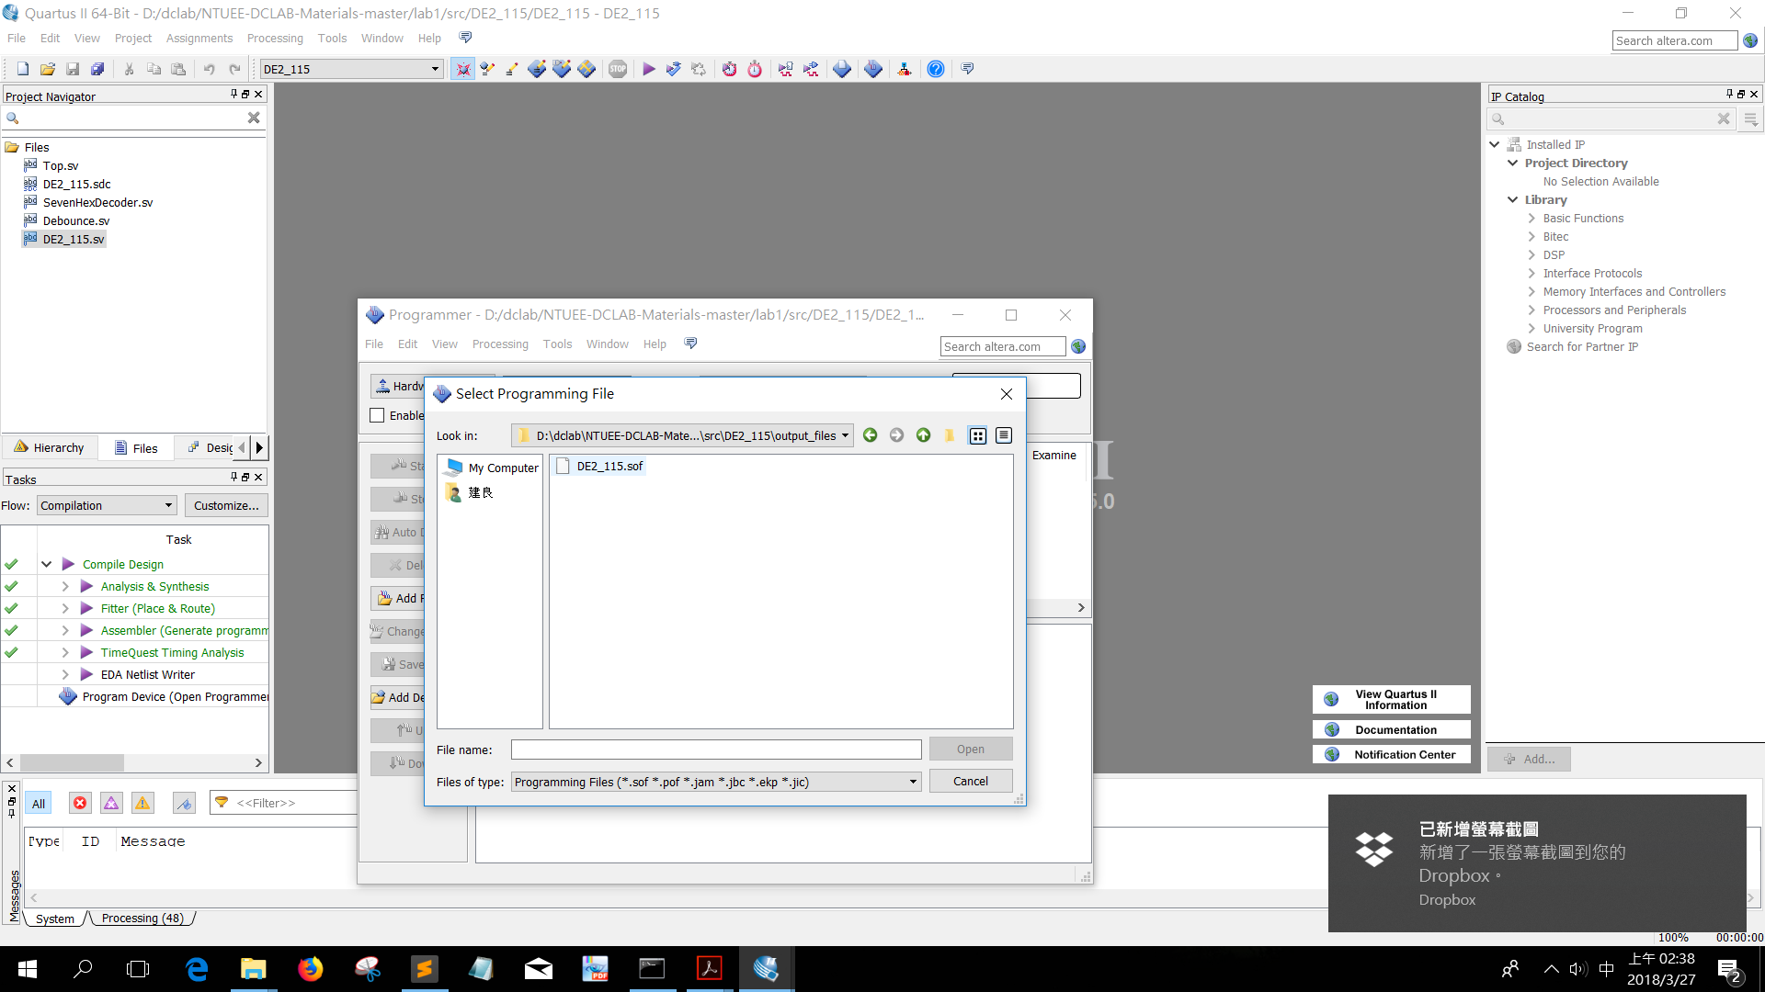

1. Click start

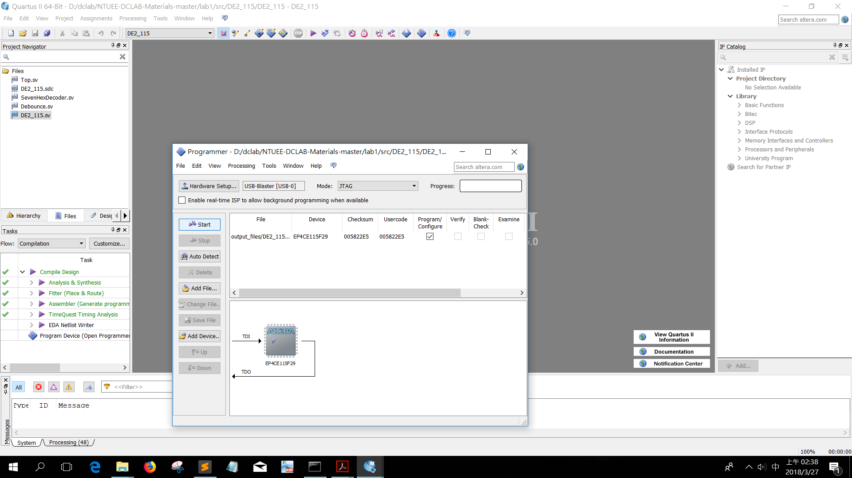

1. After progress bar reveals 100% complete, all the program insertion work is done and it’s time to operate the FPGA borad!!

