DCLab lab3 manual

team08 陳建良 陳延昊 林冠宇

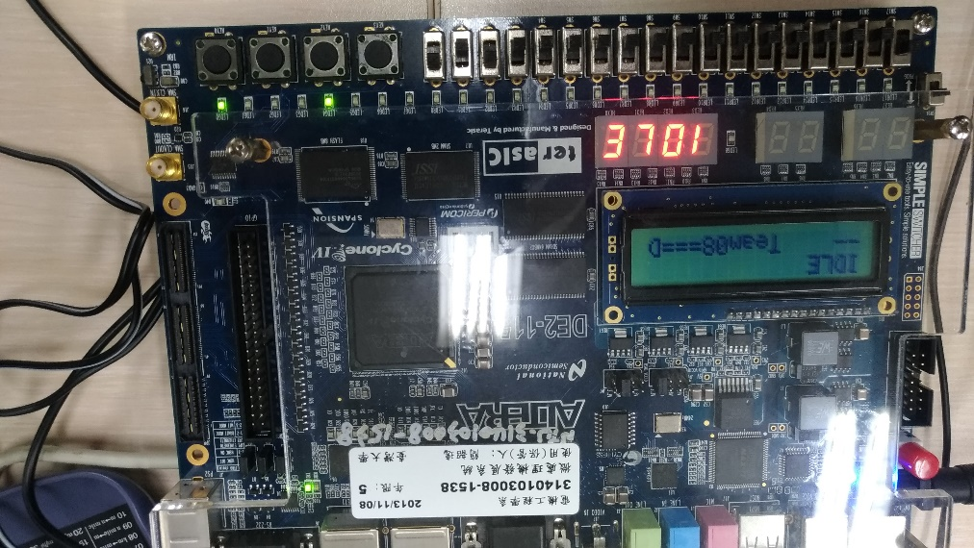

After the program had been inserted into FPGA, it would enter the “IDLE” state, in which nothing can be done yet. (see the above picture)

First, the keys that are useful for this project are

SW17 - to control whether to slow down or speed up the speed of playing the sound

SW0 - to control whether the tone would remain when speed up or slow down

SW2~8 - to control the multiples of speed-up rate or slow-down rate

KEY1 - to return to “IDLE” state whenever necessary

KEY2 – 1. To enter “HOLD” state to be ready to record sound

2. to start to record and/or end recording

3. to PAUSE/ resume when playing the sound

KEY3 - to start to PLAY the sound

The simplest operation flow is:

1. Press KEY1 to enter “IDLE” state
2. Press KEY2 to enter “HOLD” state
3. Press KEY2 to start and end recording sounds
4. Press KEY3 to play the sound recorded
5. When sound is still playing, the user can at will speed up or slow down (by flipping SW17), moderate their rate (by flipping SW2~8), and even choose whether to remain the tone or not (by flipping SW0).

Ex1: by flipping SW3 and SW0, we can play the sound at 3 times of its original rate and meanwhile remain its tone.

EX2: by flipping SW17 and SW4, we can play the sound at 4 times slower than it should have, and not remain its tone.

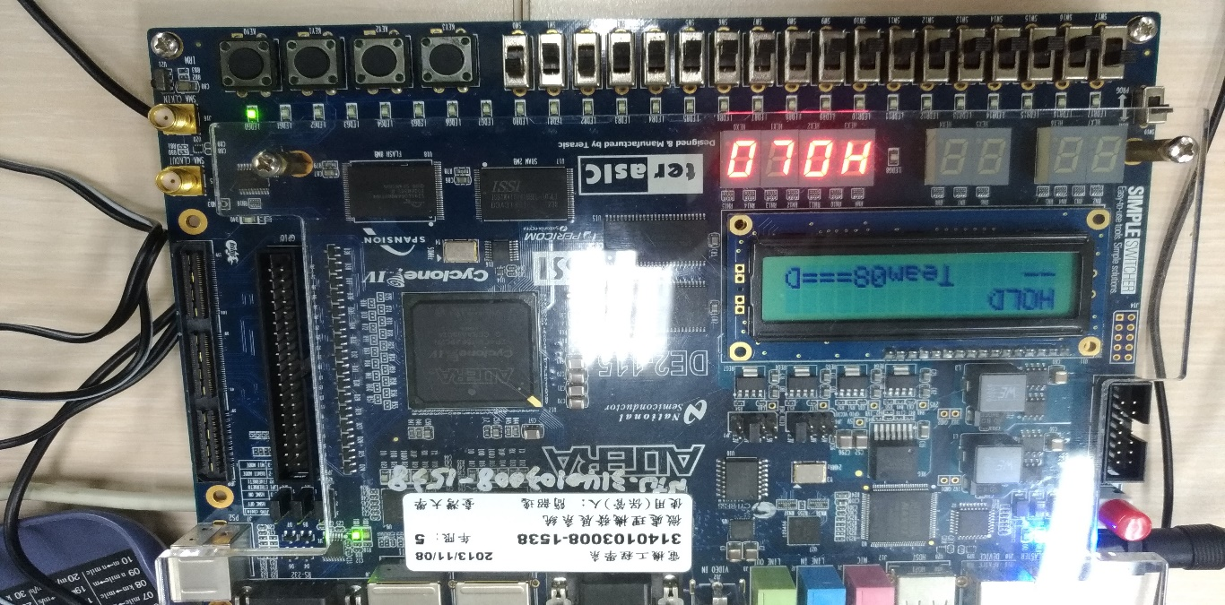Below is a series of illustration

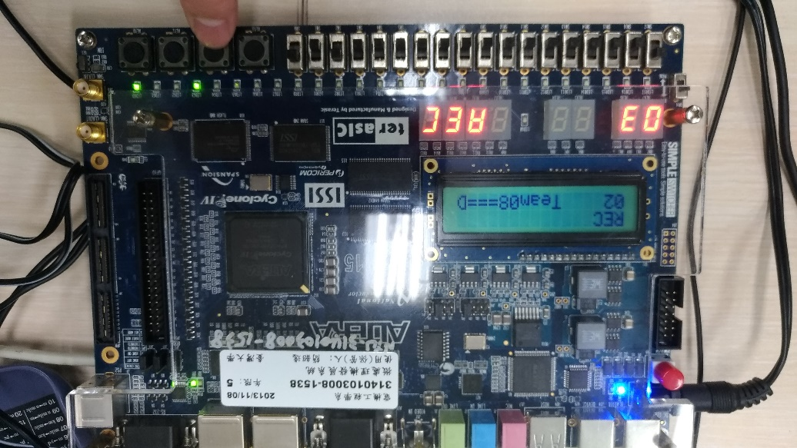

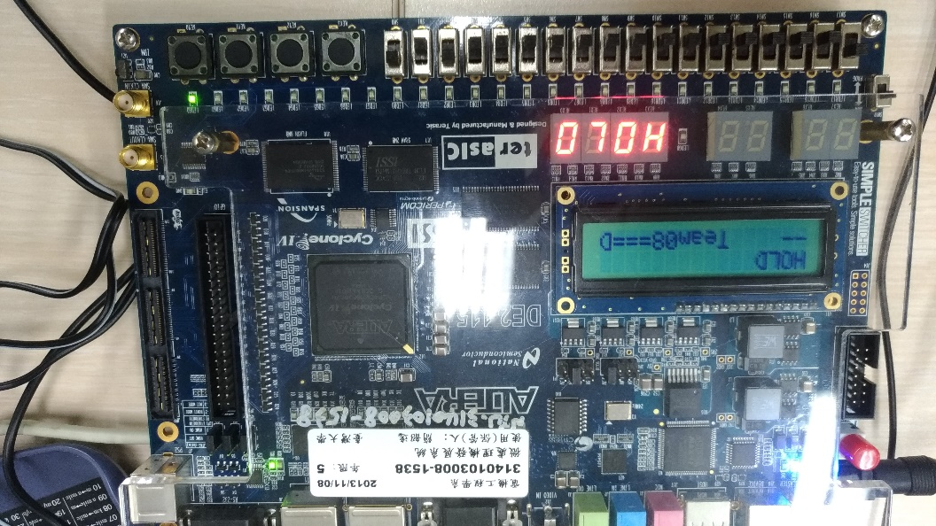

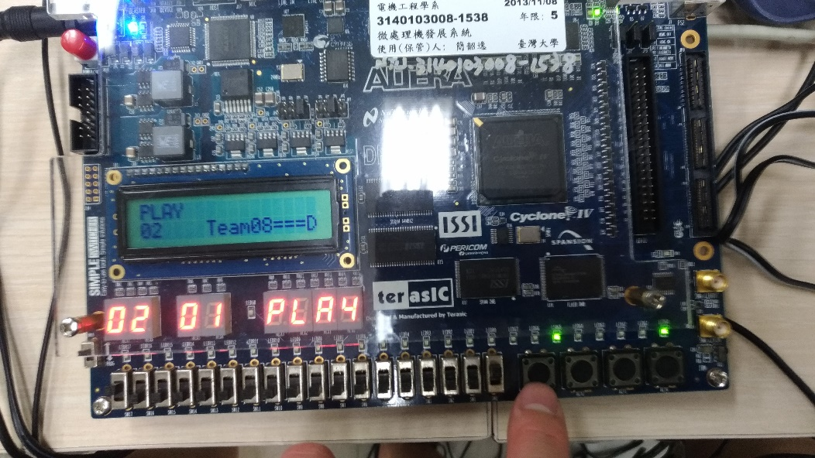

Alternatively, you can slow down by twice slower than the original rate

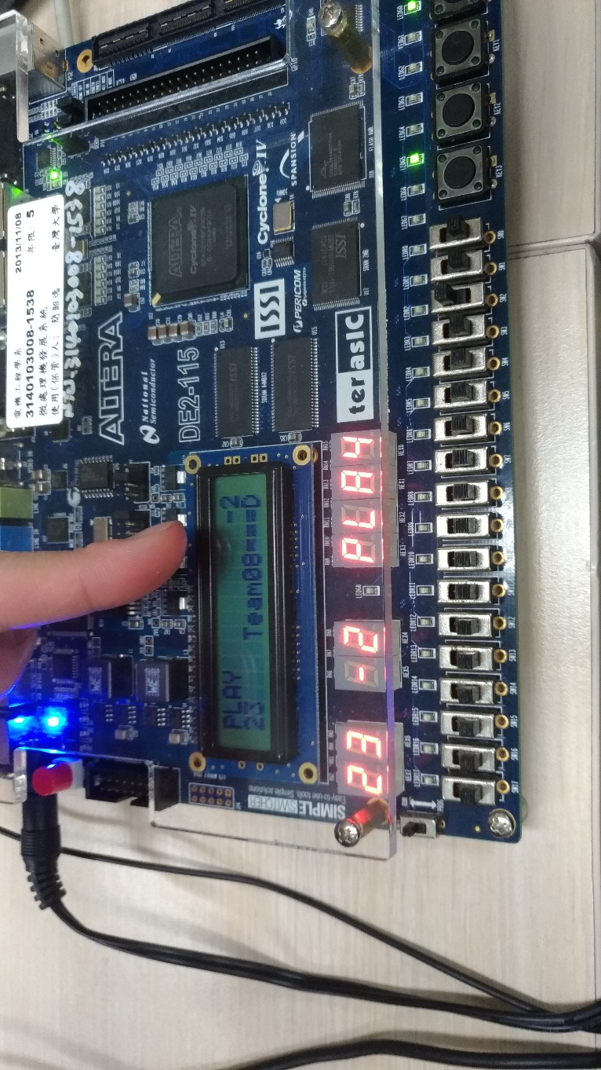

Or speed up at twice faster of the original rate

