ARCHITECTURE

A) FRONT END

* Login page

Features:- sign in , sign up , forgot password.

* Home page

Features:- time-table,attendance,hall-ticket, marks,course-content.

* Time-Table

Features:- back.

* Attendance

Features:- semester,back.

* Hall-ticket

Features:- back.

* Marks

Features:- semester,back.

* Course-content

Features:- semester,back.

* Sign-up

Features:- submit,back.

* Resetpassword

Features:- cancel,continue.

* Forgotpassword

Features:- cancel , continue.

B) BACK END

Directly connected to each frames so there is no requirement for backend.

C) Databases

Name:- user_info (privacy)

Table- data(id,password,phno);

Name:- student

Table- student(id,name,email,branch,semester);

Table- attendance(id,semester,percentage)

Table- course-content(semester,branch,subjects,credits);

Table- hallticket(id,fileloc);

Table- timetable(semester,branch);

D) OVERVIEW

It is a tool that helps students access information about exams and otherstuff.

Students can:

* Access their Hall tickets
* View their Time-table
* View their Grades and CGPA
* View their Course Content
* Check if they are eligible to write exams i.e check their attendance

B)

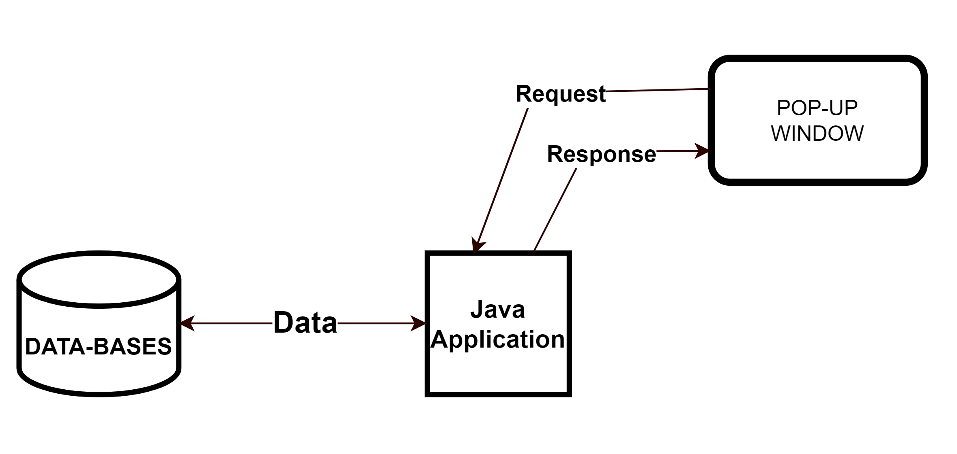

C)

