ARCHITECTURE VERSION 2

A) FRONT END

* Login page

Features:- sign in , sign up , forgot password.

This page is used to sign in , sign up and change password.

Buttons will redirect you to the respective pages.

* Home page

Features:- time-table,attendance,hall-ticket, marks,course-content.

This page is used to display time-table,attendance,hall-ticket,marks , course-content of the respective student.

Buttons will redirect you to the respective pages.

* Time-Table

Features:- back.

Button will redirect you to the respective page.

* Attendance

Features:- semester,back.

Drop down will give you semester selection.

Button will redirect you to the respective page.

* Hall-ticket

Features:- back.

Button will redirect you to the respective page.

* Marks

Features:- semester,back.

Drop down will give you semester selection.

Button will redirect you to the respective page.

* Course-content

Features:- semester,back.

Drop down will give you semester selection.

Button will redirect you to the respective page.

* Sign-up

Features:- submit,back.

Submit will create a new user back takes you back to the home screen.

* Resetpassword

Features:- cancel,continue.

Cancel will cancel the change password process continue will proceed forward.

* Forgotpassword

Features:- cancel , continue.

Cancel will cancel the change password process continue will proceed forward.

B) BACK END

Directly connected to each frames so there is no requirement for backend.

C) Databases

Name:- user_info (privacy)

Table- data(id(primary key)(unique),password,phno);

Name:- student

Table- student ( id-varchar(unique) , name-varchar , email-varchar , branch-varchar , semester-int); (id primary key)

Table- attendance (id-varchar(unique), semester-int ,percentage - int) (id , semester together foreign key)

Table- course-content(semester-int , branch-varchar , fileloc); (semester,branch foreign key)

Table- hallticket (id varchar (unique) , fileloc);

Table- timetable (year-int , branch-varchar , fileloc); (year,branch foreign key)

D) OVERVIEW

It is a tool that helps students access information about exams and otherstuff.

Students can:

* Access their Hall tickets
* View their Time-table
* View their Grades and CGPA
* View their Course Content
* Check if they are eligible to write exams i.e check their attendance

B)

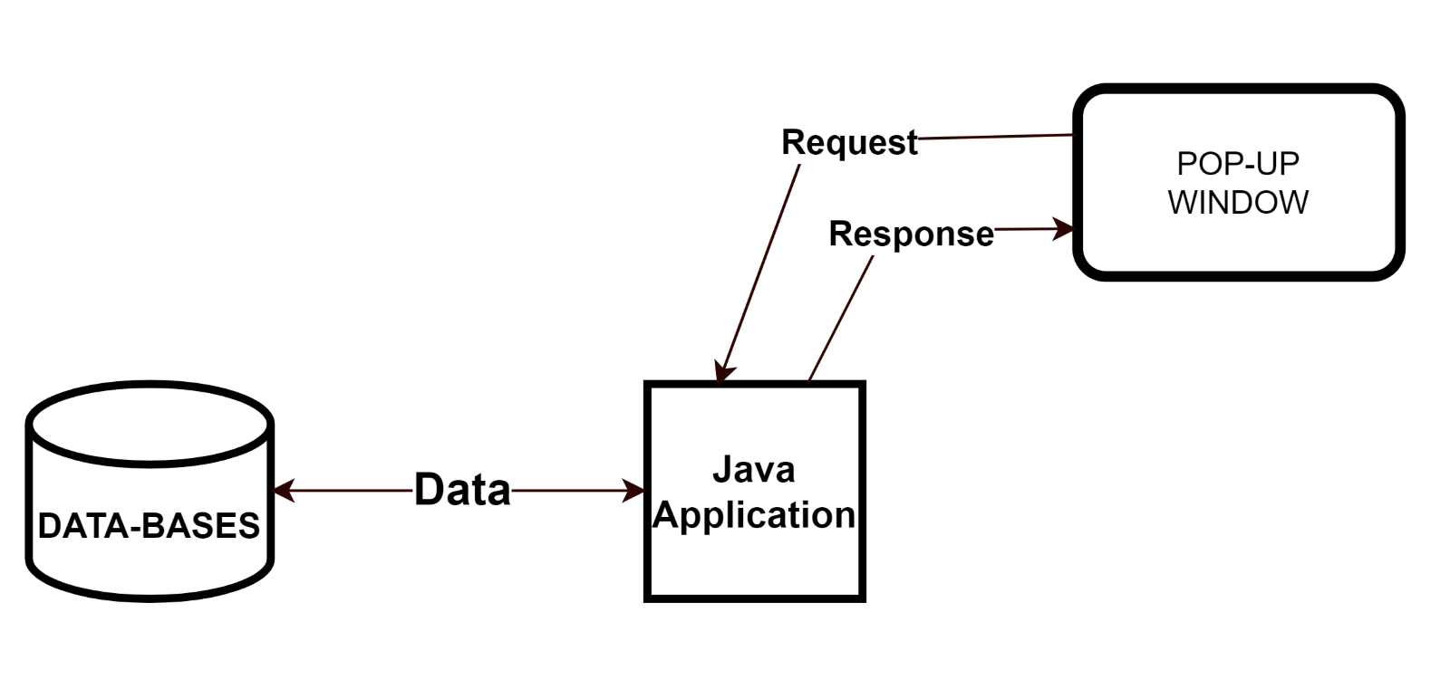

C)

